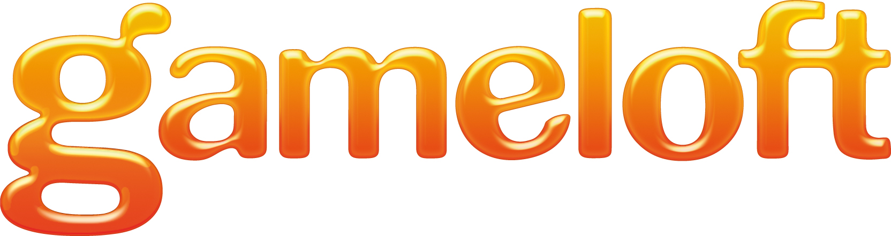

Game design doc for GL Live & Facebook

Index
1General 3
2Association of GL live and Facebook account 3
Flowchart of association after registration 4
Flowchart of association in GL live profile 5
Flowchart of association when add GL live addon on Facebook 6
3Trophies 7
Trophy on iphone: 7
Trophy on Facebook 7
4Leaderboards 9
Entrance of Leaderboards 9
leaderboard 9
User detail 10
Leaderboard on facebook 10
5Notifications on Facebook Profile wall 11

General
This doc mainly introduces the Leaderborads, Trophy and notifications on facebook profile wall.

Association of GL live and Facebook account
Every GL live account can be associated a Facebook account, it can be done after registration(it's not mandatory), or associate in profile screen.
User must set the mail of Facebook address as his GL live E-mail address to associate.
Once the association is done, user can set the Facebook's avatar as his GL avatar
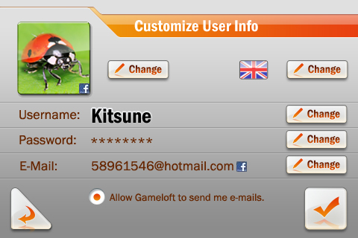
If user set his Facebook avatar as his GL live avatar, there will be a mark "f"
If the GL live associated the Facebook account, there's also a "f" after the E-mail address
When user add the GL live addon on Facebook, he also can associates a GL live account to the Facebook account

Flowchart of association after registration
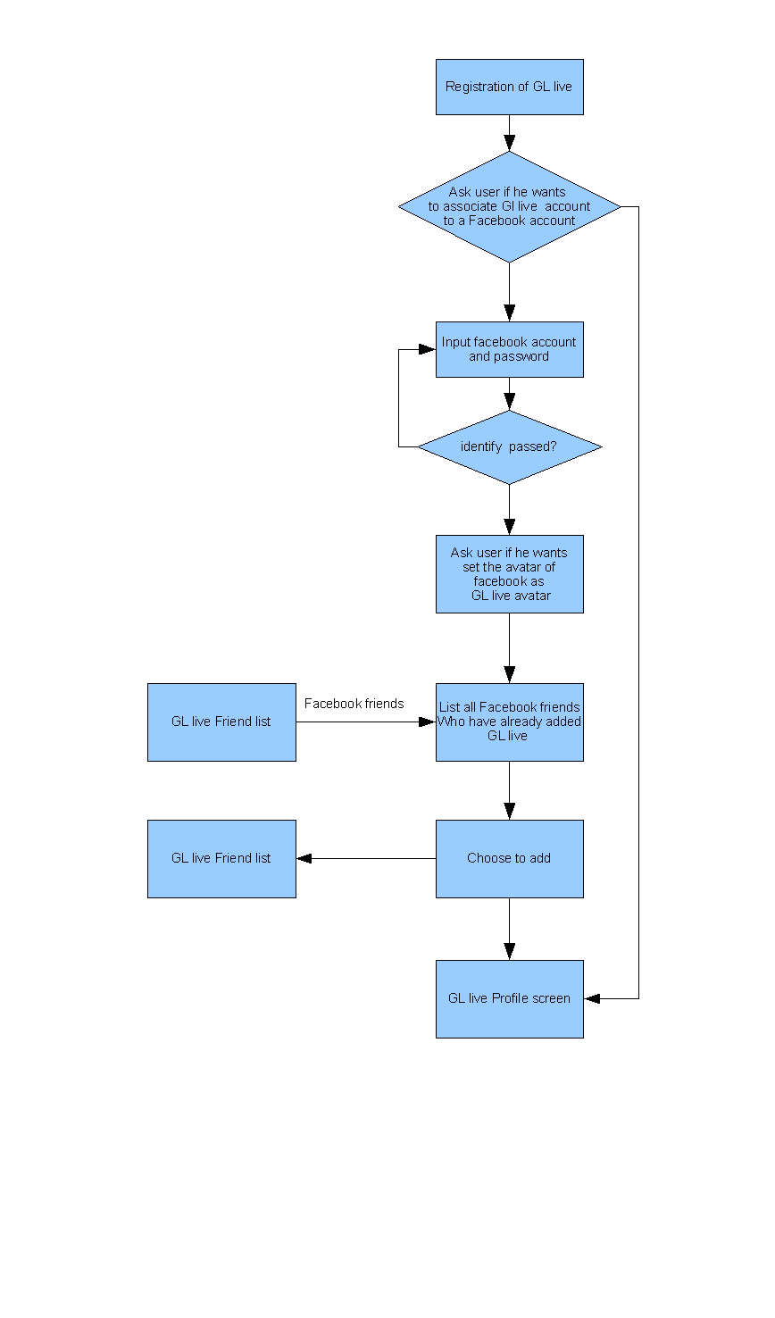

After registration, it will list all his facebook friends who have already added GL live module. User can add them easily, and there's a entrance in friend list as well, user also can find his facebook friend here.

Flowchart of association in GL live profile
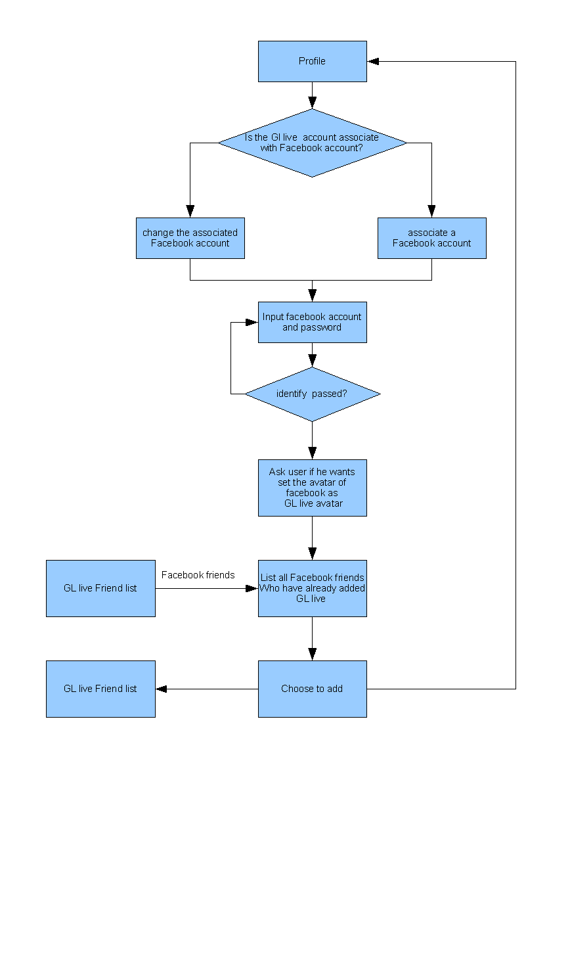

Flowchart of association when add GL live addon on Facebook

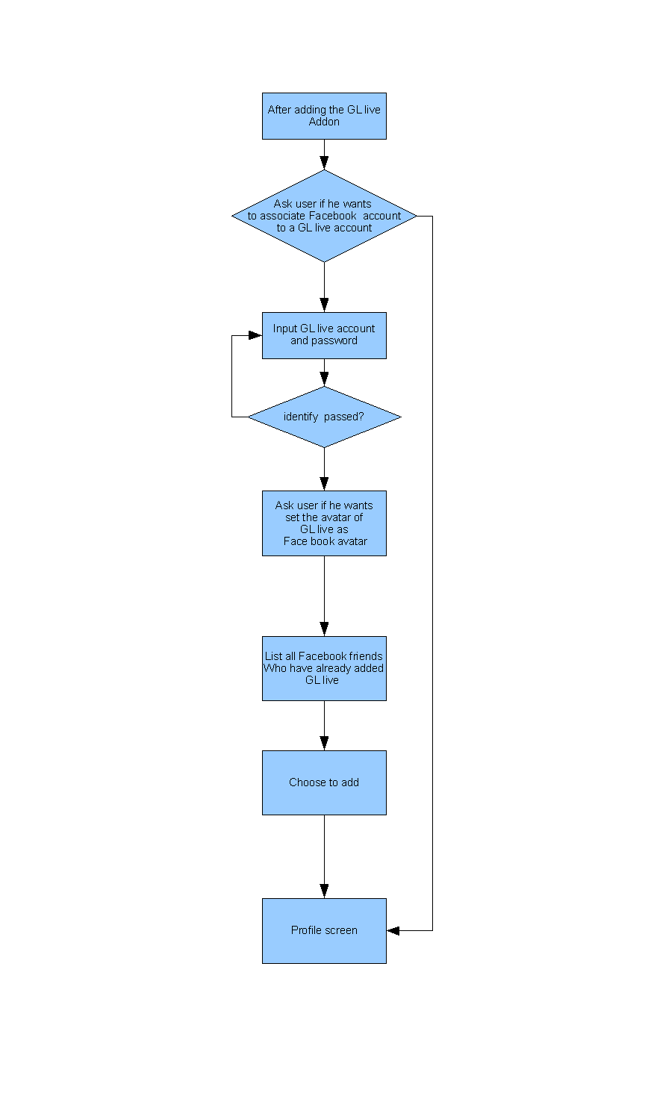

Trophies
It recorded all games you have played and the trophies you unlocked for each game.

Trophy on iphone:
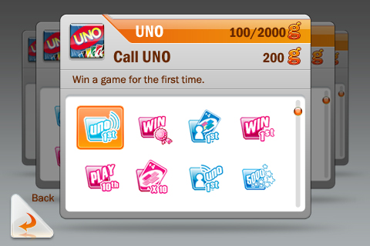
As same as the trophy system that we already have.

Trophy on Facebook
There will be a trophy page on face book,user can see his&his friends' trophies here.
All data is same as it's on iphone. Like the Who has the biggest brain

On iphone:
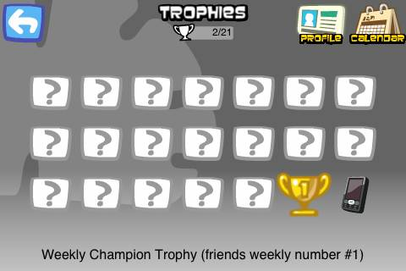
On web page:
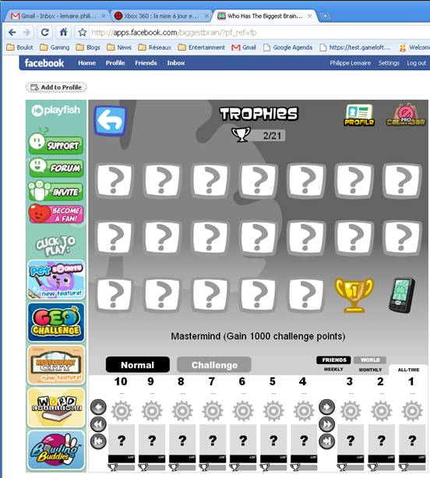

Leaderboards

Entrance of Leaderboards
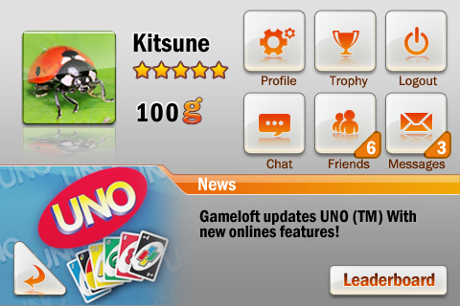
The entrance of leaderboard on the right bottom of main page.

leaderboard
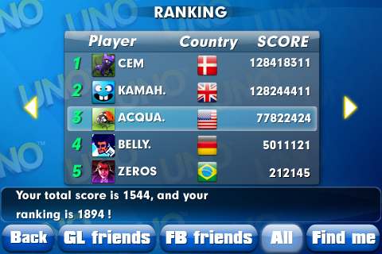
If you go to the leaderboard of UNO, as the picture shows, we can see player's rank, avatar,name, country and score And there are some buttons on the bottom.
- GL friend: Only list the users of your GL live friend on the board.
- Facebook friend: Only list the users of your Facebook friend on the board.
- All: List all player of UNO live.
- Find me: find the user on leaderboard and display the higher 2 users and lower one users around user. Once user touch it, the button will switch to "See Top"
- See Top: The leaderboard will display top 5 players in all/Gl live friends/Facebook friends. Once user touch it, the button will switch to "Find me".

User detail
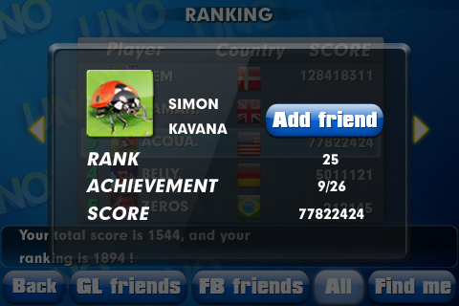
We can touch a player on leaderboard to enter the user's detail screen, here we can see username, real name (only if friend on facebook), the avatar, ranking, number of trophies unlocked and have a + button to add(if not is GL live friend) as friend from the leaderboards.

Leaderboard on facebook

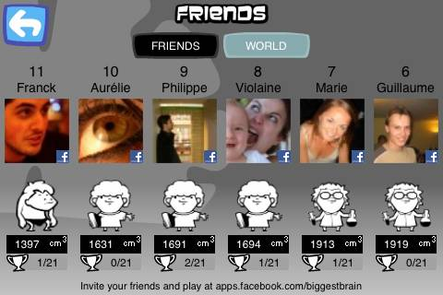
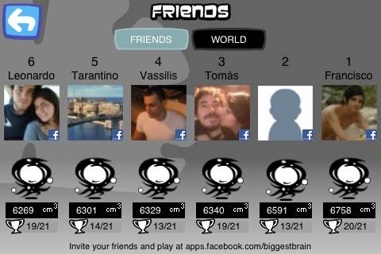
All data of GL live should be available on facebook web page, that means user can check the leaderboard on facebook as it on GL live like how it works on "Who has the biggest brain"
On iphone:

On facebook:
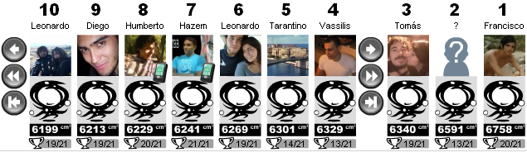

Notifications on Facebook Profile wall
There should be an option to set whether the informations of GL live display on user's profile wall.
If set it to yes, these information will be released on profile wall:

- ranking
if user is out of top 100
When User gains every 50 ranks will update a message: "User is now among the top 250 Uno players in the world!! That’s above 85% of Uno players!! Can you beat that?"
if user is in top 100
Then user'score are entered top 100 ,50,20,10 or 1 will update a message: "Amazing! Philippe just entered the top xxx in Uno™ iPhone!"
- trophy
When user A unlocked a trophy ill update a message:"User A has earned the " Call UNO" trophy in GL live"

