Task 2: CityPoint Room Hire Test log (Jamie Gallagher)
Description of test | Test data to be used (if required) | Expected outcome | Actual outcome | Comments and intended actions
Room booking  Seeing if all rooms show up correctly | Default Filter | All rooms should show up | All rooms show up | 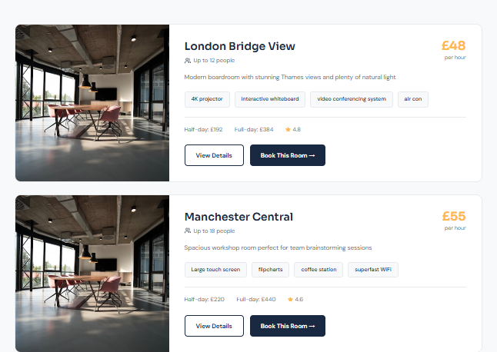  PASS
Room booking  Seeing if rooms get filtered depending on Number of Rooms filter | 5 rooms | Only facilities which have 5 rooms linked to them in the model should show up | Only one unavailable facility shows up as it has 5 rooms linked to it | 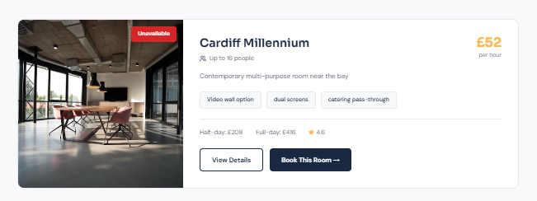  PASS
Room Booking  Seeing if rooms get filtered depending on Price Range Filter | (All numbers of rooms)  Price Range: 20-40 | Only facilities/rooms which cost a minimum of £20 and a maximum of £40 per hour should be displayed on the page | Only facilities/rooms which cost a minimum of £20 and a maximum of £40 per hour are displayed on the page | 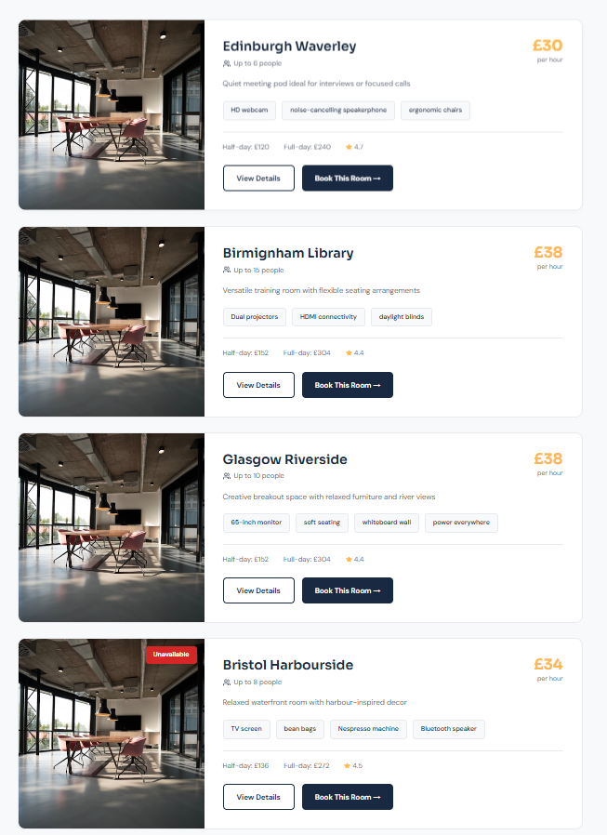  Pass
Room Booking  Seeing if rooms get filtered depending on Rating filter | (All numbers of rooms)  (Any Price Range)  Rating Filter: (Highest to Lowest) | Facilities/rooms should be displayed on the page from highest to lowest | Facilities/rooms are displayed on the page from highest to lowest | 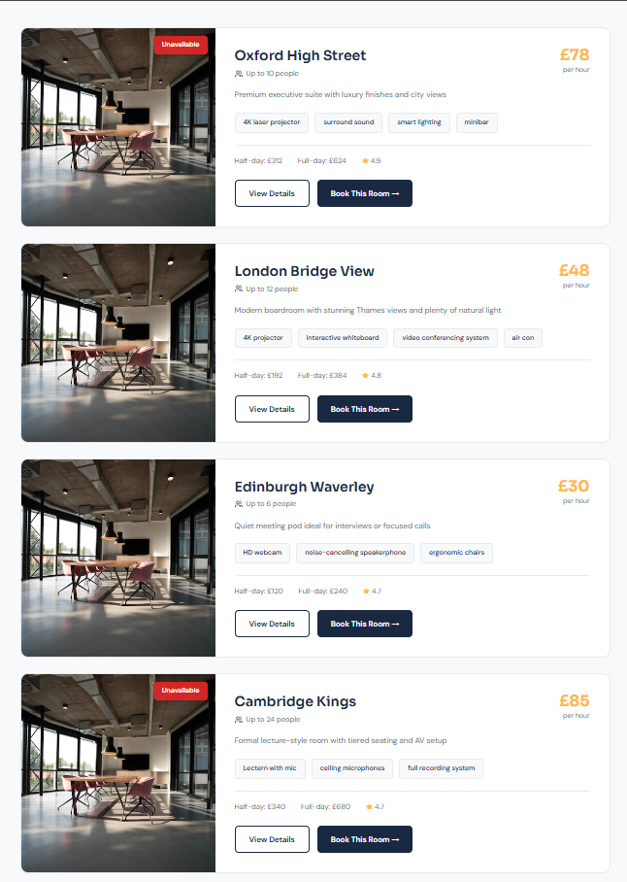  Pass
Room Booking  Seeing if users can create bookings | Booking Date: 09/02/2026  Start Time: 12:00  End Time: 13:00  RoomId: 1 | The user should be able to make a booking for a room | The user can make a booking for a room | 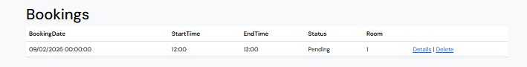  Pass
Room Booking  Seeing if users can create bookings for past dates | Booking Date: 01/01/0001  Start Time: 00:00  End Time: 00:00  RoomId: 1 | The user should be alerted with an appropriate amber error message | The user is alerted with an appropriate amber error message | 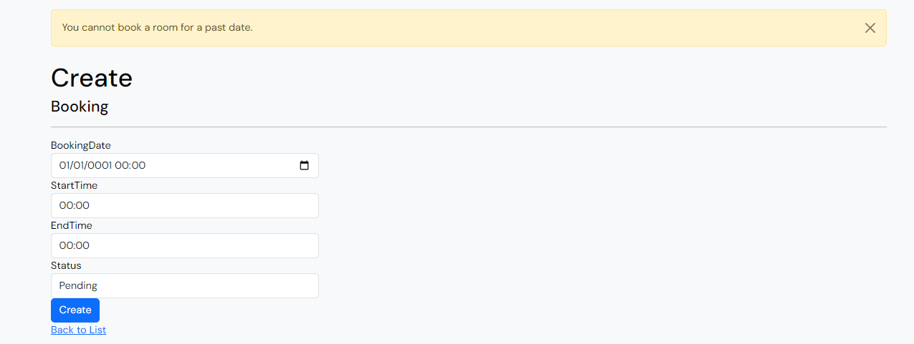  Pass
Room Booking  Seeing if users can create bookings on rooms with existing confirmed time slots | Booking Date: 11/02/2026  Start Time: 09:00  End Time: 11:00  RoomId: 5 | There is already a booking on this room in the time slot selected which status is confirmed. When the user creates the booking, it should give them an appropriate error message. | The user is provided with an appropriate error message. | Pass
Admin Dashboard  Manage Room  Seeing if non admin users can access staff only page (ManageRoom) | Not logged into admin account | The user should be rejected to view the page | The user is rejected to see the page, provided an appropriate error message, whilst still able to access navbar to make their way back to other pages. | Pass
Admin Dashboard  Manage Room  Seeing if non admin users can access staff only page (ManageRoom) | Not logged into admin account | The user should be rejected to view the page | The user is rejected to see the page, provided an appropriate error message, whilst still able to access navbar to make their way back to other pages. | Pass  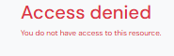
Admin Dashboard  Index  Seeing if non admin users can access staff only page (Index) | Not logged into admin account | The user should be rejected to view the page | The user is rejected to see the page, provided an appropriate error message, whilst still able to access navbar to make their way back to other pages. | Pass
Admin Dashboard  Manage Booking  Seeing if non admin users can access staff only page (ManageBooking) | Not logged into admin account | The user should be rejected to view the page | The user is rejected to see the page, provided an appropriate error message, whilst still able to access navbar to make their way back to other pages. | Pass
Admin Dashboard  Manage Room  Seeing if admin users can access staff only page (ManageRoom) | Logged into admin account  Email: admin@example.com  Password: Admin@123 | The user should be granted access to the page | The user is granted full access to the page. | Pass  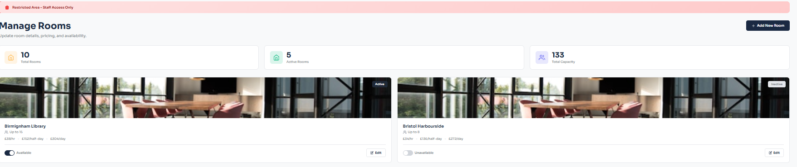
Admin Dashboard  Index  Seeing if admin users can access staff only page (Index) | Logged into admin account  Email: admin@example.com  Password: Admin@123 | The user should be granted access to the page | The user is granted full access to the page. | Pass  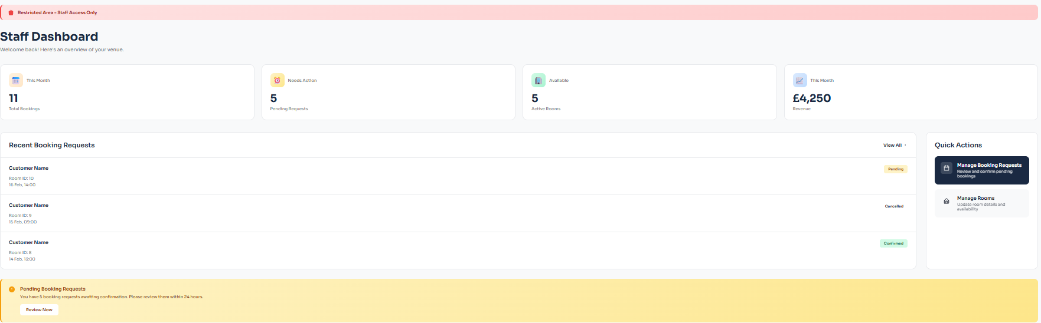
Admin Dashboard  Manage Bookings  Seeing if admin users can access staff only page (ManageBookings) | Logged into admin account  Email: admin@example.com  Password: Admin@123 | The user should be granted access to the page | The user is granted full access to the page. | Pass  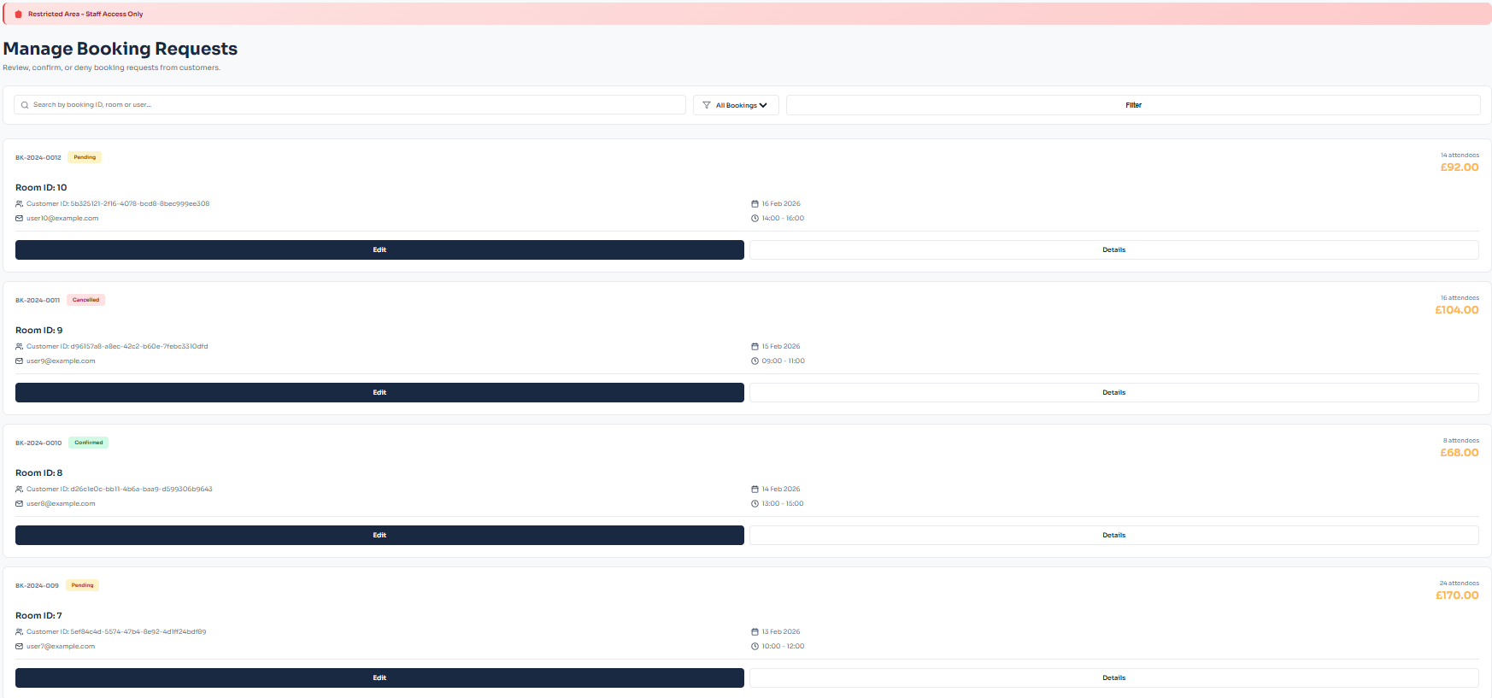
Rooms  Create  Seeing if user who’s not logged into an admin account can manually input page URL to view Create Room page | Not logged into admin account | The user should be rejected to view the page | The user is rejected to view the page | Pass
Rooms  Edit  Seeing if user who’s not logged into an admin account can manually input page URL to view Edit Room page | Not logged into admin account | The user should be rejected to view the page | The user is rejected to view the page | Pass
Rooms  Details  Seeing if user who’s not logged into an admin account can manually input page URL to view Details Room page | Not logged into admin account  RoomId: 1 | The user should be taken to the details page of that specific room | The user is taken to the details page of that specific room | Pass  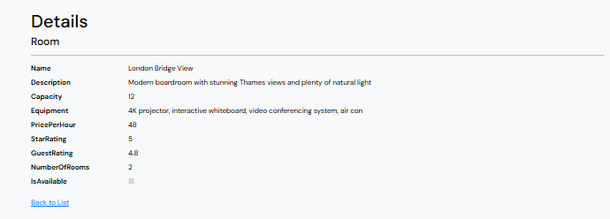
Account Checking if a user can register | EMAIL: newaccount@ gmail.com PASSWORD: ThisIsAPassword123!! PASSWORD CONFIRM: ThisIsAPassword123!! | The user account gets created, and the user is automatically redirected to the login page | Upon registration, the user account gets created and we get redirected to the login pag | Pass
Account Checking if the login page Remember me button functions | EMAIL: administrator@ citypointroomhire.com PASSWORD: l5zgGCO?9eV`jVU=9@b_W :pX,W0)eQX^4bB:`4`& | When refreshing the website or leaving and reentering we are still logged in. | Both when refreshing or leaving and coming back to the website we are still logged into the account | Pass
Account Checking if the login page has an error handling for username and password. | EMAIL: administrator@ notanaccount.com PASSWORD: l5zgGCO?9eV`jVU=9@b_W :pX,W0)eQX^4bB:`4`& | The page displays an error saying that we have incorrect credentials. | We received an error saying our login attempt was invalid | Pass
Account Checking if a user can log in | EMAIL: administrator@ citypointroomhire.com PASSWORD: l5zgGCO?9eV`jVU=9@b_W :pX,W0)eQX^4bB:`4`& | The user gets logged in and is taken to the main landing page. | After inputting credentials and pressing login, we get taken to the index page | Pass
Account Checking the register page has error handling for incorrect email input. | EMAIL: newaccount PASSWORD: ThisIsAPassword123!! PASSWORD CONFIRM: ThisIsAPassword123!! | The page  displays an  error saying  that our email  must be an  email address. | We receive the error telling us the reason for the failure | Pass  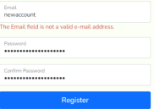
Account Checking the register page has error handling for incorrect Password | EMAIL: newaccount@ gmail.com PASSWORD: thisisapassword PASSWORD CONFIRM: thisisapassword | The page displays an error saying that we are missing the required character types. | We receive the error telling us the reason for the failure | Pass  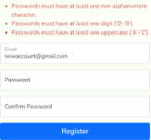
Account Checking the register page has error handling for mismatched passwords | EMAIL:  newaccount@  gmail.com  PASSWORD:  ThisIsAPassword123!!  PASSWORD CONFIRM:  ThisIsAPassword | The page displays an error saying that we mismatched passwords | We receive the  error telling us  the reason for  the failure | 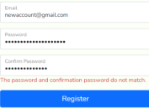
Navigation buttons Clicking on the logo |  | The website navigates the user to the landing page | The website navigates the user to the page | Pass
Navigation buttons Clicking on the ‘Home’ Button |  | The website navigates the user to the landing page | The website navigates the user to the page | Pass
Navigation buttons Clicking on the ‘Rooms’ Button |  | The website navigates the user to the Rooms page | The website navigates the user to the page | Pass
Navigation buttons Clicking on the ‘Contact Us’ Button |  | The website navigates the user to the Contact Us page | The website navigates the user to the page | Pass
Navigation buttons Clicking on the ‘Booking Policies’ Button |  | The website navigates the user to the Booking Policies page | The website navigates the user to the page | Pass
Navigation buttons Clicking on the ‘Accessibility’ Button |  | The button should provide a drop down, and when clicking the Accessibility page button it should take the user to the Accessibility page | The website navigates the user to the page | Pass
Navigation buttons Clicking on the ‘Account’ Button |  | The website navigates the user to the Account page | The website navigates the user to the page | Pass
Navigation buttons Clicking on the ‘Logout’ Button |  | The website navigates the user to the Logout page | The website navigates the user to the page | Pass
Accessibility  Check if the main landing page scales to the user’s screen size | Inspect element device toolbar | For Desktop, Tablet and mobile the  page and its contents should scale and  change position to fit neatly within the  screen space | The page neatly switches layouts depending on the user’s device | Pass
Accessibility  Check if the Rooms landing page scales to the user’s screen size | Inspect element device toolbar | For Desktop, Tablet and mobile the  page and its contents should scale and  change position to fit neatly within the  screen space | The page neatly switches layouts depending on the user’s device | Pass
Accessibility  Check if the Contact Us page scales to the user’s screen size | Inspect element device toolbar | For Desktop, Tablet and mobile the  page and its contents should scale and  change position to fit neatly within the  screen space | The page neatly switches layouts depending on the user’s device | Pass
Accessibility  Check if the Booking Policies page scales to the user’s screen size | Inspect element device toolbar | For Desktop, Tablet and mobile the  page and its contents should scale and  change position to fit neatly within the  screen space | The page neatly switches layouts depending on the user’s device | Pass
Accessibility  Check if the Accessibility page scales to the user’s screen size | Inspect element device toolbar | For Desktop, Tablet and mobile the  page and its contents should scale and  change position to fit neatly within the  screen space | The page neatly switches layouts depending on the user’s device | Pass
Accessibility  Check if the Account page scales to the user’s screen size | Inspect element device toolbar | For Desktop, Tablet and mobile the  page and its contents should scale and  change position to fit neatly within the  screen space | The page neatly switches layouts depending on the user’s device | Pass
Accessibility  Check if the Logout page scales to the user’s screen size | Inspect element device toolbar | For Desktop, Tablet and mobile the  page and its contents should scale and  change position to fit neatly within the  screen space | The page neatly switches layouts depending on the user’s device | Pass
Accessibility  Check if the ‘Toggle Dark Mode’ button in the hamburger menu at the navbar for ‘Accessibility’ enables Dark Mode (consistent through all pages as its in _Layout) | Clicked ‘Toggle Dark Mode’ Button once  (from default setting which is disabled) | The colours on the page should be inverted to a darker feel, being easier on the eyes | The page neatly switches to a darker colour scheme | Pass  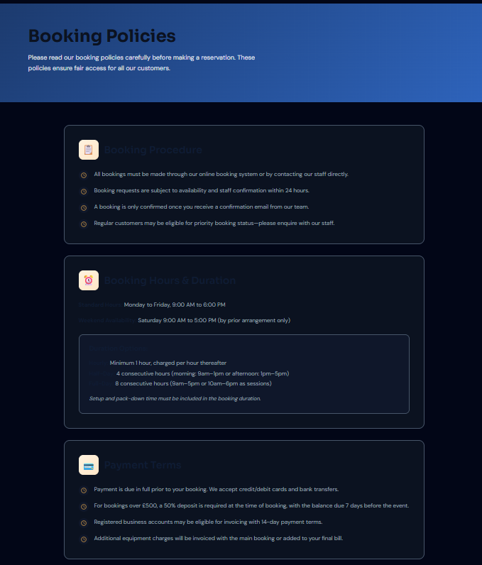
Accessibility  Check if the ‘Increase Font Size’ button in the hamburger menu at the navbar for ‘Accessibility’ increases page font size (consistent through all pages as its in _Layout) | Clicked ‘Increase Font Size’ Button once (from default setting) | Text on the page should be increased. | Text on the page is increased. | Pass  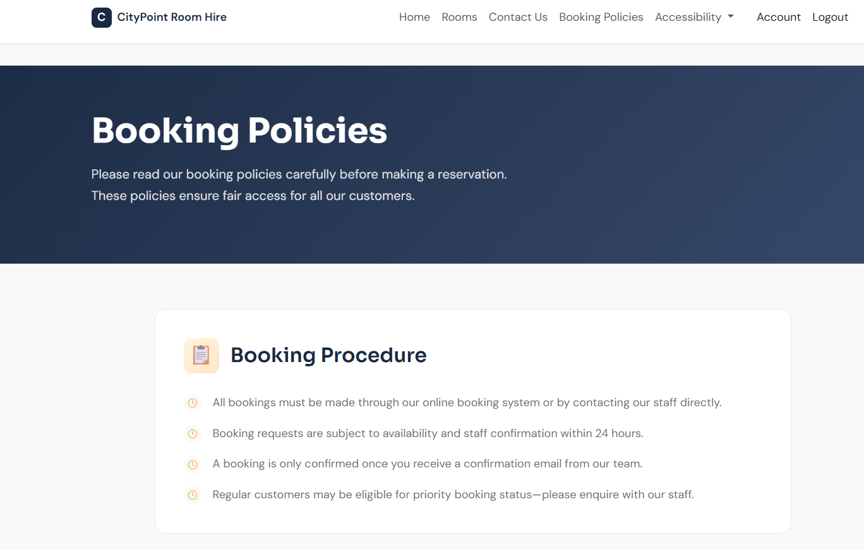
Accessibility  Check if the ‘Decrase Font Size’ button in the hamburger menu at the navbar for ‘Accessibility’ increases page font size (consistent through all pages as its in _Layout) | Clicked ‘Decrase Font Size’ Button once (from default setting) | Text on the page should be decreased. | Text on the page is decreased. | Pass  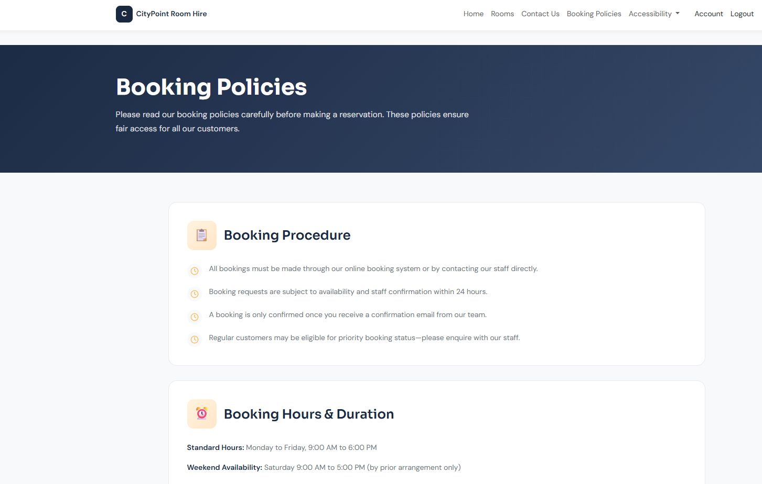
Accessibility  Check if the ‘High Contrast Mode’ button in the hamburger menu at the navbar for ‘Accessibility’ enables High Contrast mode (consistent through all pages as its in _Layout) | Clicked ‘High Contrast Mode’ Button once (from default setting which is disabled) | The colours on the page should be inverted to a high contrast | The page neatly switches to a high contrast colour scheme | Pass  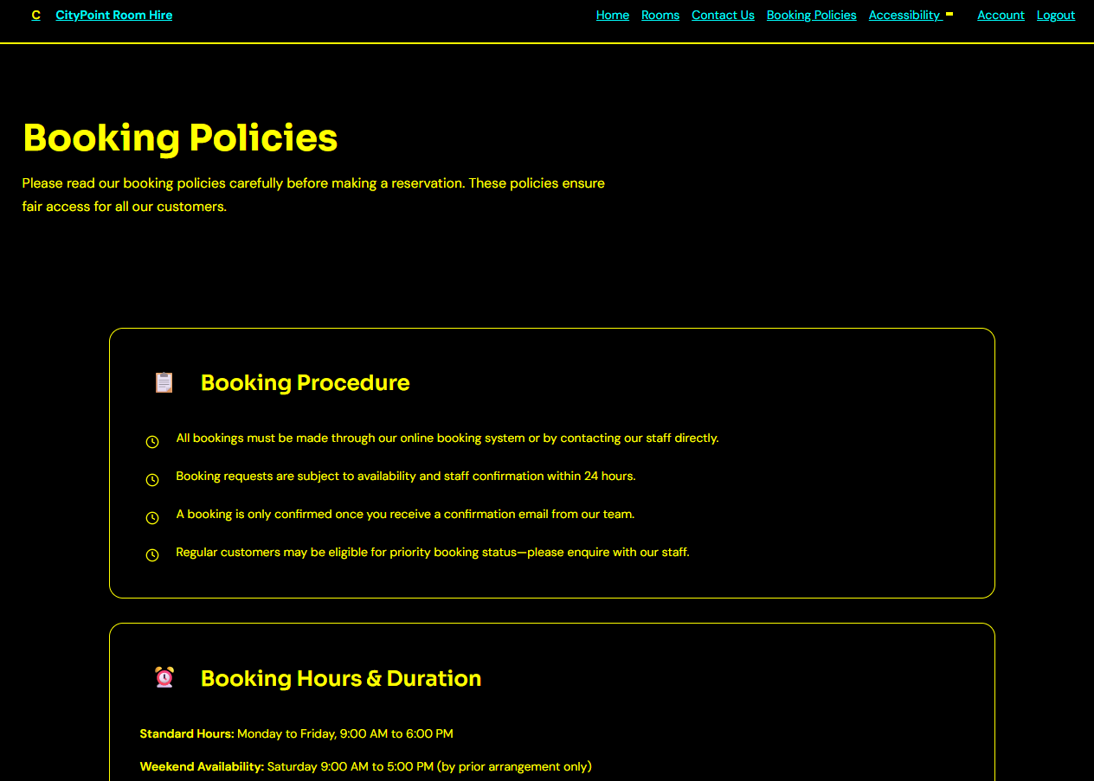
Accessibility  Check if the ‘Read Aloud’ button in the hamburger menu at the navbar for ‘Accessibility’ makes on page text read aloud through TTS (consistent through all pages as its in _Layout) | Clicked ‘Read Aloud’ Button once | Page contents should be read aloud | Page contents are read aloud | Pass
Add more rows and tables as required.

