Design Documentation Template

Introduction
The purpose of this document is to visually show how I will be moving forward with the solution I have planned for CityPoint Room Hire. This will include the visual designs, where a sitemap will show all pages which are linked together to give a clear demonstration on how navigation throughout the website will function. Alongside this, there will be a wireframe design for each page which I currently plan on implementing into the website with clear annotation on choices I made such as the colour scheme, font style, font size and why I made these decisions. I will also demonstrate the algorithm design, data requirements design, test strategies which will take place on the website and flowcharts which demonstrate the logic of some of the functional requirements in the solution.

Sitemap
Login:
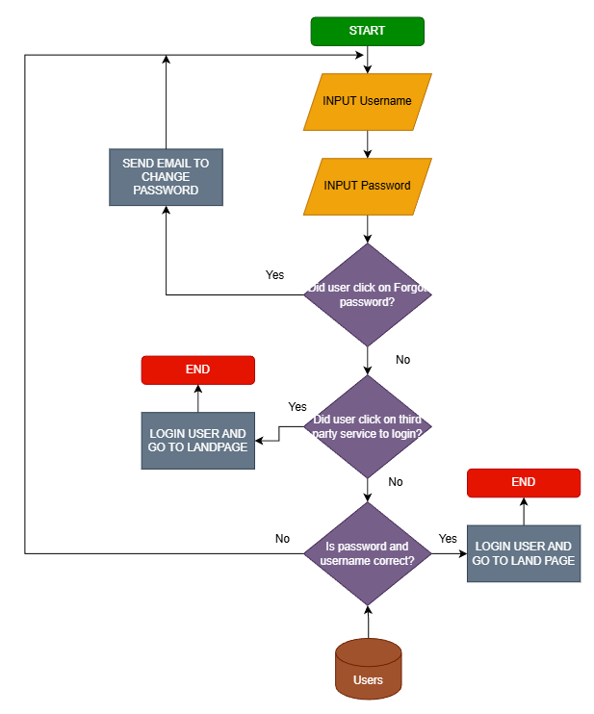
The login function starts by asking the user a prompt for their username and password, which the system will check if the user clicked on separate options like forgot password or if third party services were used to login, if they did it will take them to the appropriate action such as sending a reset link to their email or taking them to a third-party service like google to request a login attempt. If not, then the system will check if the password and username match the one in the SQL database. If it does not match, a suitable error message will be provided to the user telling them what they did wrong. If the prompts are filled correctly, it will log the user in and send them back to the landing page.

Register:
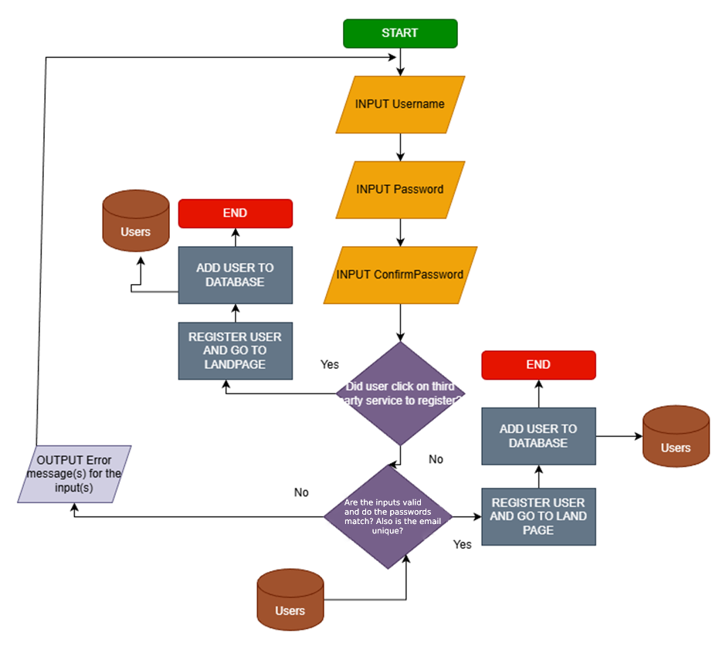
The user should be provided a prompt to enter the username and password of their existing account into the system, which will check if the user clicked on any other options like did the user click on third party services to register? If they did then it will take them to for example a google authentication page to log in, which is external from the website. Otherwise, it will take check if the details the user inputted is valid like if the passwords and usernames match and the email isn’t already registered to an account, if everything is correct then the system will register the user and send them to the landing page, adding their account details to the SQL database.

Wireframe Designs (With annotation under each image)
- Sitemap
- Wireframe Designs for each page
- Annotate each design with the following
  - Colour Scheme
  - Font Style
  - Font Size
  - Why are you making these decisions? Keep in mind the target audience

Algorithm Design (Flowcharts)
- Introduction to the complex problems you will be writing algorithms for
  - List the problems for example login system
- The pseudocode or flowcharts for each problem
  - Minimum of 3
  - Maximum of 5
  - Need to explain what the algorithm is doing and the process of it

Data Requirements Design
- Introduction to the concept of ASP .Net Core MVC and the use of it for your system architecture
- The importance of models needs to be explained and how it represents the backend
- Design each model individually
- For each model
  - Name of the Model – e.g. Environment, User
  - Name of the fields
  - Data type of the field
- At the end of each table, justify why you are using the particular model and why that set of data is needed to be stored

Test Strategy
- Make sure to fill out the template they gave you and resave it as mentioned
Date of test |  | Component to be tested | Type of test to be carried out | Prerequisites and dependencies
Can leave this blank | Every page, button, form, validation and more |  | Acceptance testing, alpha testing, beta testing, black box testing and white box testing | What needs to be completed before the test can be run

