Website 1:
https://www.seasonalroots.com/

Seasonalroots is a co-operative producer who uses a green and white colour scheme. They have an account registration page, alongside information of producers and more. 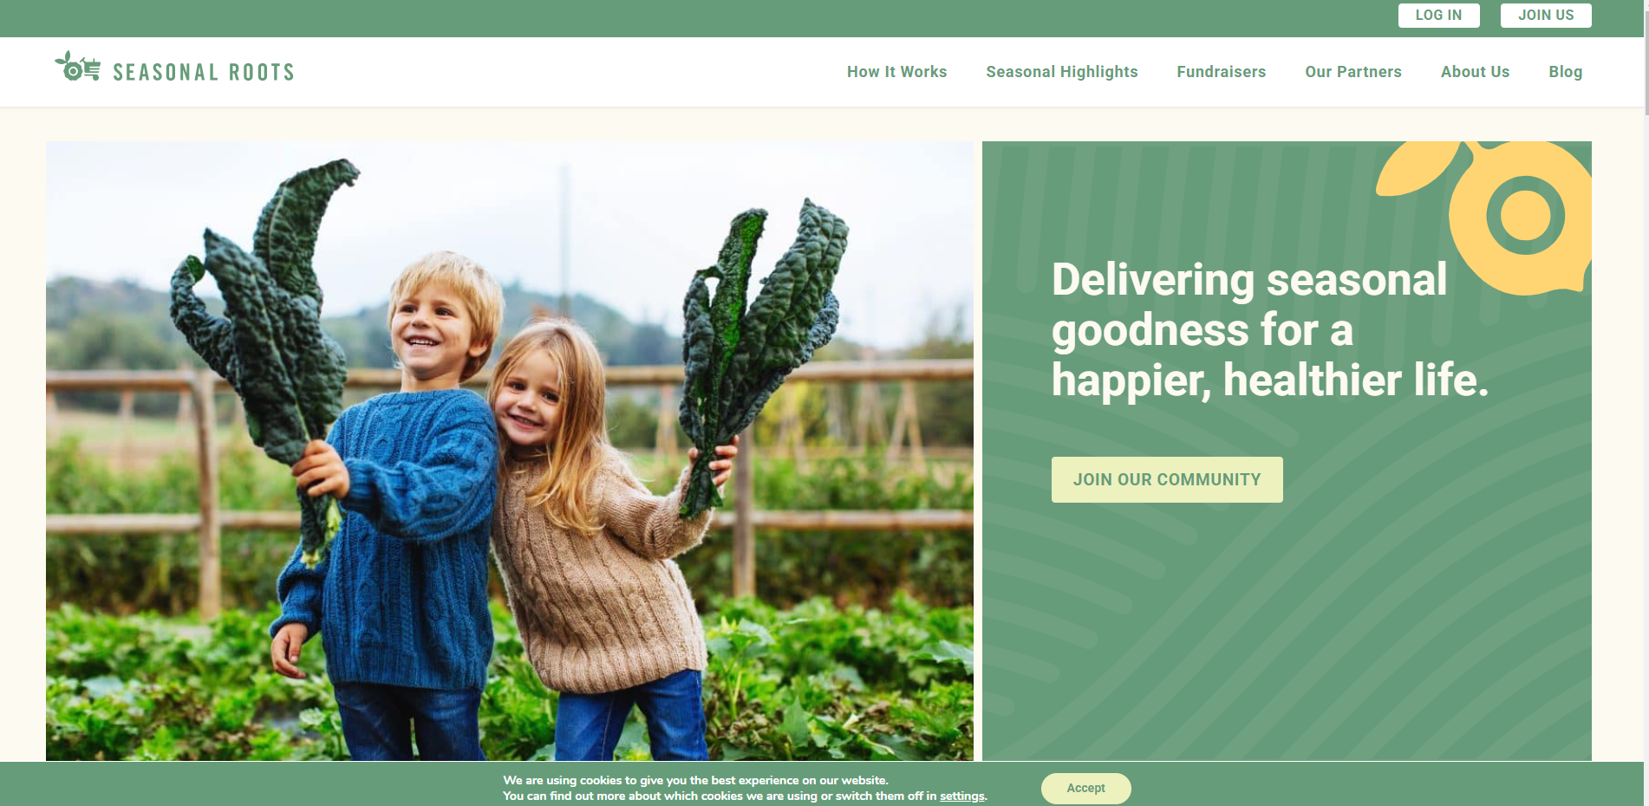
Seasonalroots is membership based rather than order based, providing customers produce every few weeks.

Website 2:
https://theproducebox.com/
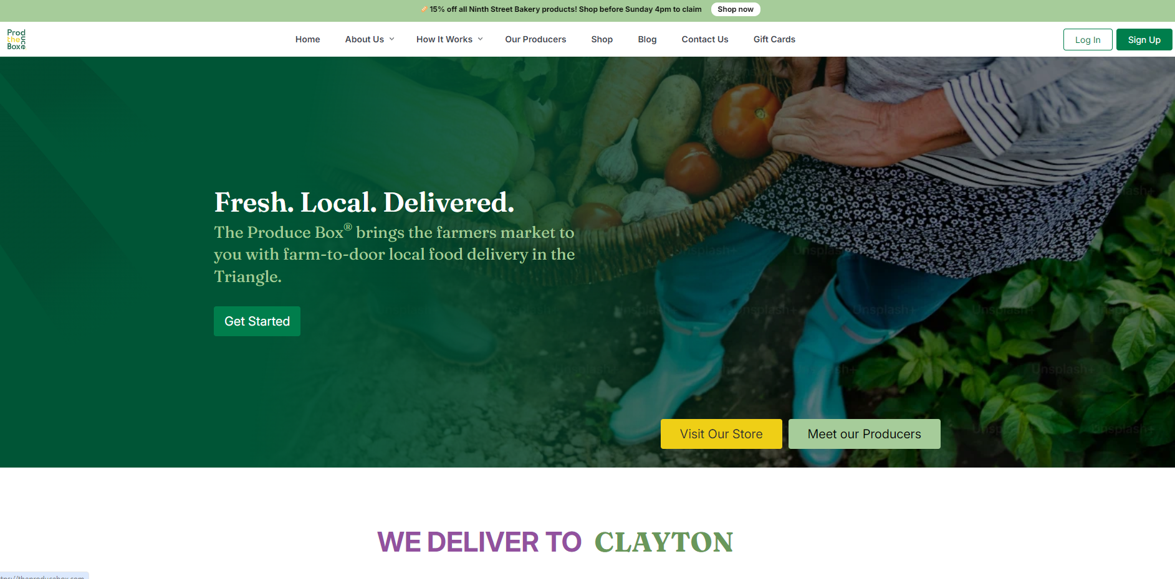
The produce box is another co-operative produce website which has a lot of common conventions. It uses the same type of layout but feels very modern instead. It encourages members to sign up, with an account registration system. It also gives information regarding producers, how the business works and you can browse products and make purchases from the website. This website feels very industry standard and modern with plenty of functionalities like only being able to add items on a registered account and more.

Comparigng the two websites, its clear that an order system with account registration is industry standard. Not only this, but a presentable website using colours like white and green seem to be inviting and match the theme of a co-operative produce website, so I will keep this in mind when developing the solution and coming up with a visual design.

