Design Documentation Template
Introduction to Document
- What is this document about and what will it include

Visual Designs
- Sitemap
- Wireframe Designs for each page
- Annotate each design with the following
  - Colour Scheme
  - Font Style
  - Font Size
  - Why are you making these decisions? Keep in mind the target audience

Algorithm Design

Flowcharts
Here is a legend/keys of the processes I am using, as they are shaped and colour coded.
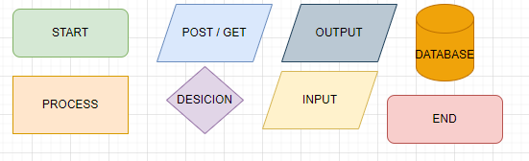
Register: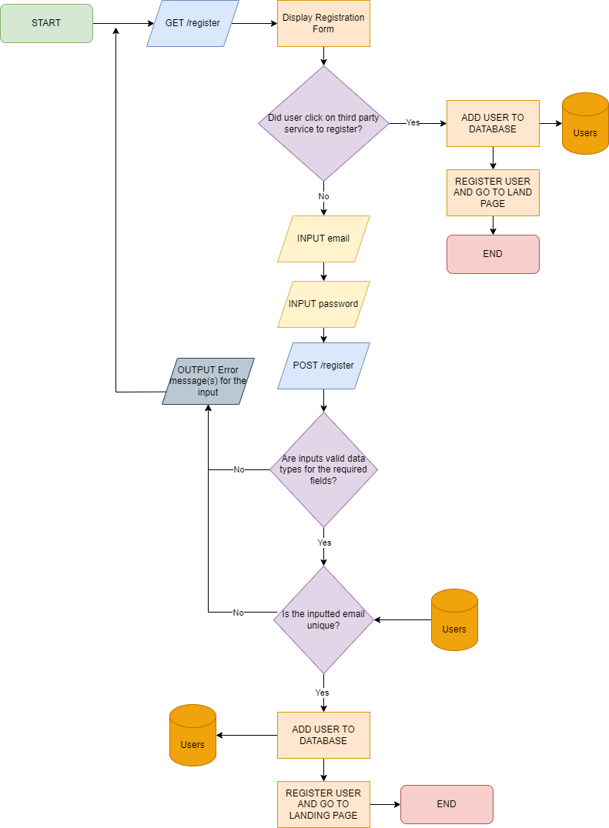
The register function starts by using HTTP GET method to display the web content to the user, this loads the register page which allows the user to submit a form so they can register their account. When the page is loaded, the user is able to pick between using a third-party service to register an account or registering through the solution. If the user picks a third-party service, email and password management will be handled by the third party service and will be submit the users data to the database, then taking them to the landing page and completing the function. Otherwise, the user will have to input their email and password through the submission form. Once the user has entered inputs into the field, the submissions will POST, it will be checked if the if the inputs in the data fields are valid inputs. If they aren’t the user will be provided with an adequate error message. It also checks if the email inputted is unique by accessing the Users database and checking if the email exists. If it does exist, an adequate error message will be displayed to the user. Otherwise, the password will be hashed and the user’s data will be added to the User database, they will be then taken to the home page and the function will end.

Login: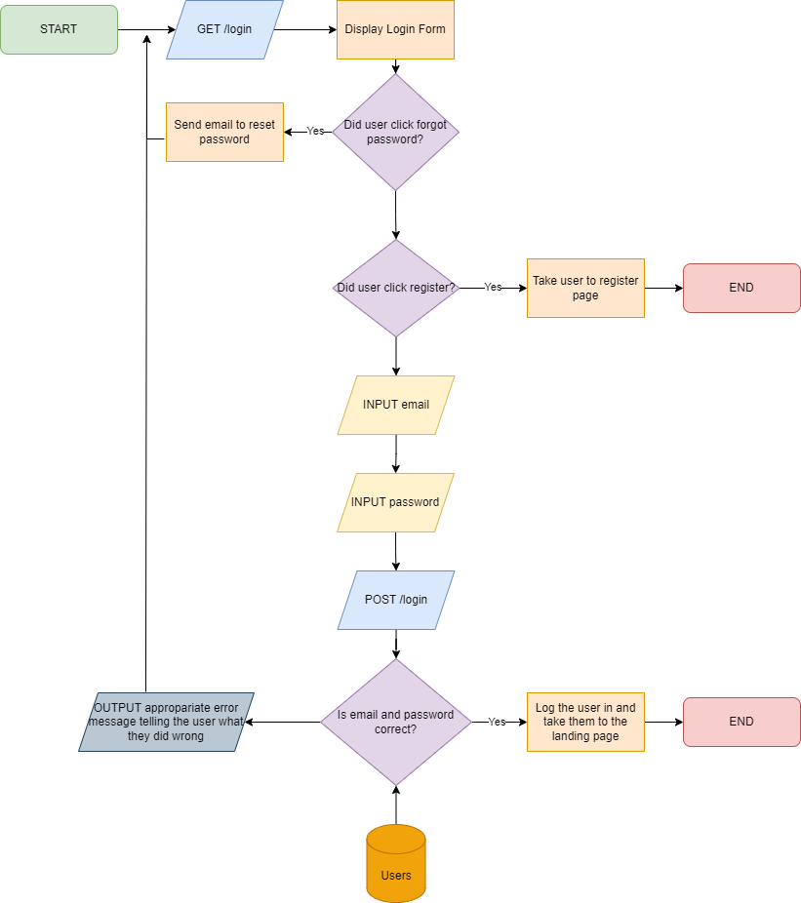
The login function starts by using GET method which allows web content to be displayed to the user. Once the login form is displayed to the user, we need to know if the user clicked forgot password or not. If the user did click forgot password, a password reset will be sent to the email. If the user clicked register, they will be taken to the register page and the function will again end. Otherwise, the user will need to input their login credentials, POST method will then be used to submit the form. Making use of the Users database, the email and password will be validated to see if they match with a user from the Users database. If it isn’t then the user will be displayed with an adequate error message display what they did wrong. Otherwise, the user will be logged in to their account and taken to the landing page, ending the function.

Data Requirements Design

MVC Design Diagram
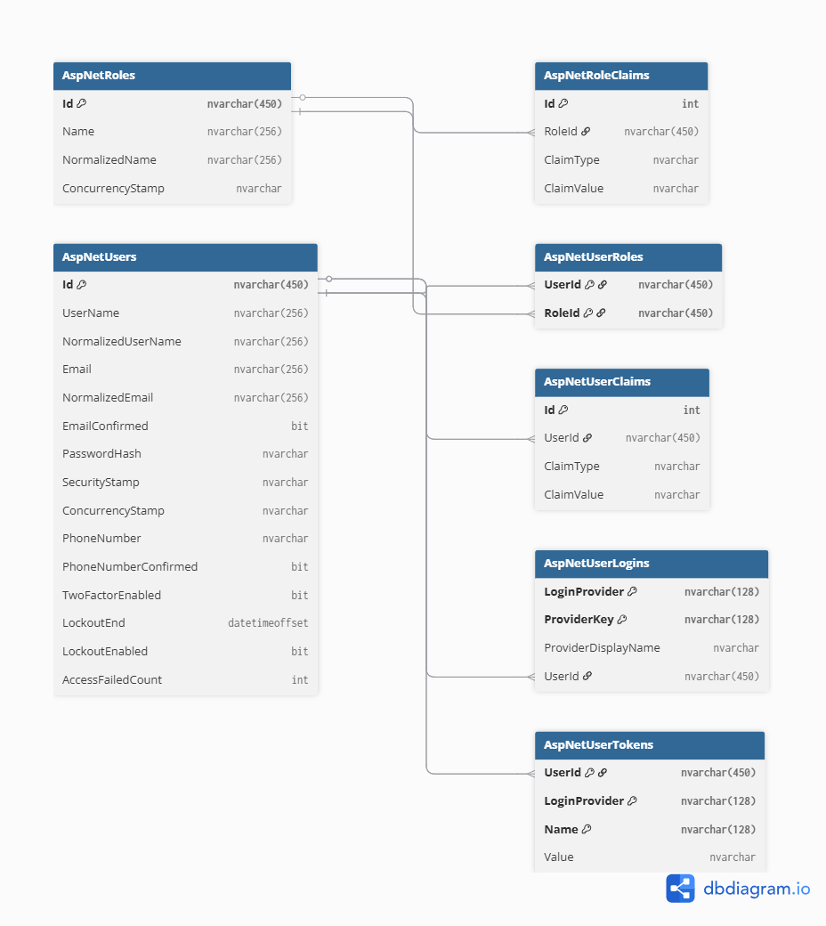

MVC System Data Dictionary
Table: AspNetRoleClaims
Data Property | Data Type | Purpose | PK/FK | Field Size | Required?
Id | INT | Unique identifier for each role claim record | PF | 10 digits | Yes
RoleId | NVARCHAR | References the role associated with the claim. | FK | 50 characters | Yes
ClaimType | NVARCHAR | Specifies the type/category of the claim | N/A | 100 characters | No
ClaimValue | NVARCHAR | This will store the values associated with the claim. | N/A | 255 characters | No

Table: AspNetRoles
Data Property | Data Type | Purpose | PK/FK | Field Size | Required?
Id | NVARCHAR | Unique identifier for each role | PK | 50 characters | Yes
Name | NVARCHAR | A name of the role readable for humans | N/A | 50 characters | No
NormalizedName | NVARCHAR | Normalised rolenames used for lookups and uniqueness | N/A | 50 characters | No
ConcurrencyStamp | NVARCHAR | Tokens which are used to detect concurrent updates to role records | N/A | 100 characters | No

Table: AspNetUserClaims
Data Property | Data Type | Purpose | PK/FK | Size | Required?
Id | INT | Unique identifier for each user claim record | PK | 10 digits | Yes
UserId | NVARCHAR | References the user which is associated to the claim | FK | 50 characters | Yes
ClaimType | NVARCHAR | Specifies the type/category of the claim | N/A | 100 characters | No
ClaimValue | NVARCHART | Stores values associated with the claim | N/A | 255 characters | No

Table: AspNetUserLogins
Data Property | Data Type | Purpose | PK/FK | Size | Required?
LoginProvider | NVARCHAR | Identifies external authentication providers such as google or Microsoft. | PK | 50 characters | Yes
ProviderKey | NVARCHAR | Unique key provided by external authenticator. | PK | 100 characters | Yes
ProviderDisplayName | NVARCHAR | Display name of external authentication provider. | N/A | 100 characters | No
UserId | NVARCHAR | References the user associated with the external login | FK | 50 characters | Yes

Table: AspNetUserRoles
Data Property | Data Type | Purpose | PK/FK | Size | Required?
UserId | NVARCHAR | References the user which is assigned to the role | PK/FK | 50 characters | Yes
RoleId | NVARCHAR | References the user which is assigned to the role | PK/FK | 50 characters | Yes

Table: AspNetUsers
Data Property | Data Type | Purpose | PK/FK | Size | Required?
Id | NVARCHAR | Unique identifier for each user | PK | 50 characters | Yes
UserName | NVARCHAR | Users login username | N/A | 50 characters | No
NormalizedUserName | NVARCHAR | Normalised (uppercase) usernames used for lookups and uniqueness | N/A | 50 characters | No
Email | NVARCHAR | Users email address | N/A | 100 characters | No
NormalizedEmail | NVARCHAR | Normalised (uppercase) emails used for lookups and uniqueness | N/A | 100 characters | No
EmailConfirmed | BIT | Indicates whether the user has confirmed their email address | N/A | 1 | Yes
PasswordHash | NVARCHAR | Hashed password for authentication | N/A | 255 characters | No
SecurityStamp | NVARCHAR | Token used to invalidate sessions when credentials change | N/A | 100 characters | No
ConcurrencyStamp | NVARCHAR | Token used to detect concurrent updates to the user record | N/A | 100 characters | No
PhoneNumber | NVARCHAR | Users phone number | N/A | 20 characters | No
PhoneNumberConfirmed | BIT | Indicates whether or not the users phone number has been confirmed | N/A | 1 | Yes
TwoFactorEnabled | BIT | Indicates whether or not two factor authentication has been enabled | N/A | 1 | Yes
LockoutEnd | DATETIMEOFFSET | Date and time when user lock out ends | N/A | N/A | No
LockoutEnabled | BIT | Indicates whether or not lock out is enabled for the user | N/A | 1 | Yes
AccessFailedCount | INT | Number of consecutive failed login attempts | N/A | 10 digits | Yes

Table: AspNetUserTokens
Data Property | Data Type | Purpose | PK/FK | Field Size | Required?
UserId | NVARCHAR | References the user which is associated to the token | PK/FK | 50 characters | Yes
LoginProvider | NVARCHAR | Identifies the authentication provider which is associated with the token | PK | 50 characters | Yes
Name | NVARCHAR | Name of the token (like authenticator key) | PK | 50 characters | Yes
Value | NVARCHAR | Stores the token value | N/A | 255 characters | No

- Introduction to the concept of ASP .Net Core MVC and the use of it for your system architecture
- The importance of models needs to be explained and how it represents the backend
- Design each model individually
- For each model
  - Name of the Model – e.g. Environment, User
  - Name of the fields
  - Data type of the field
- At the end of each table, justify why you are using the particular model and why that set of data is needed to be stored
Test Strategy
- Make sure to fill out the template they gave you and resave it as mentioned
Date of test |  | Component to be tested | Type of test to be carried out | Prerequisites and dependencies
Can leave this blank | Every page, button, form, validation and more |  | Acceptance testing, alpha testing, beta testing, black box testing and white box testing | What needs to be completed before the test can be run

