Greenfield Local Hub Development Diary
GREENFIELD LOCAL HUB
Jamie gallagher

Development Documentation
Development Diary

Version System

0.X.X – This shows that a major change has been implemented.
X.0.X – This shows that a few changes have been made.
X.X.0 – This shows that a small change or changes have been made.

Version 0.0.0 – Creating and setting up the project with ASP.NET 9.0 MVC (Model View Controller)
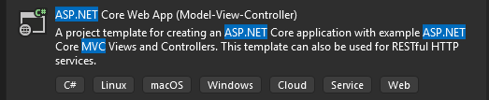
Picking the correct project template, we are going to make us of ASP.NET Core Web App MVC (Model View Controller) due to the great foundation it provides to build on. We give it the project name GFLHApp (short for Greenfield Local Hub Application). We select the framework .NET 9.0 due to the fact it is the latest version with long-term support on Visual Studio 2022 as of currently, and we select individual accounts to register and login in, which creates all the user database for us and all the functionality, being able to edit and customize it for our needs.
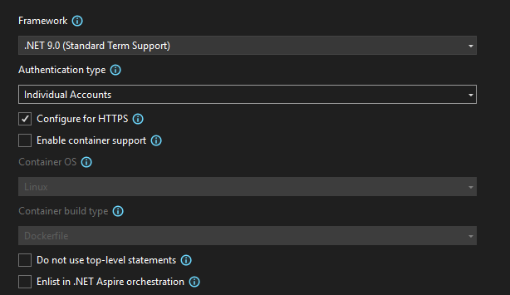
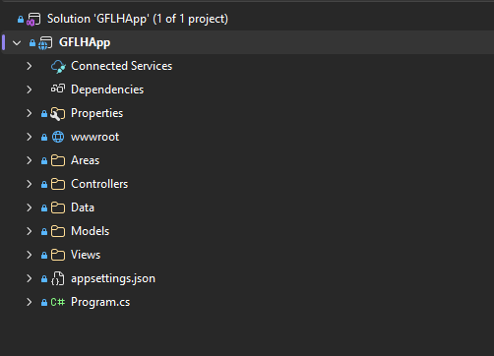
Then by pressing the Create button, the project is created, we first install base packages (typically to version 9.0.12 as it is the latest for .NET 9.0) to allow us to have extra functionality, and so that we wont have to add new migrations later on in the project.

Now we run the following commands into the Package Manager Console to install these base packages:
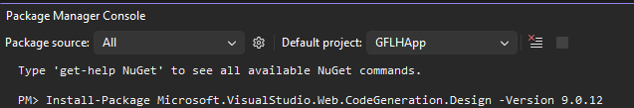
Now we run the website to see if everything works as expected.

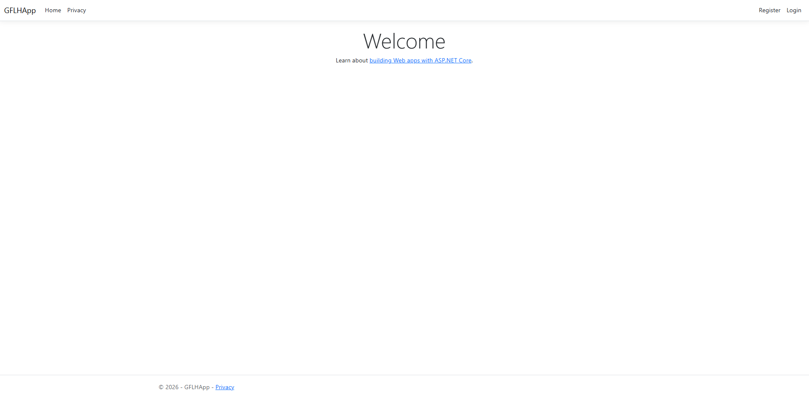
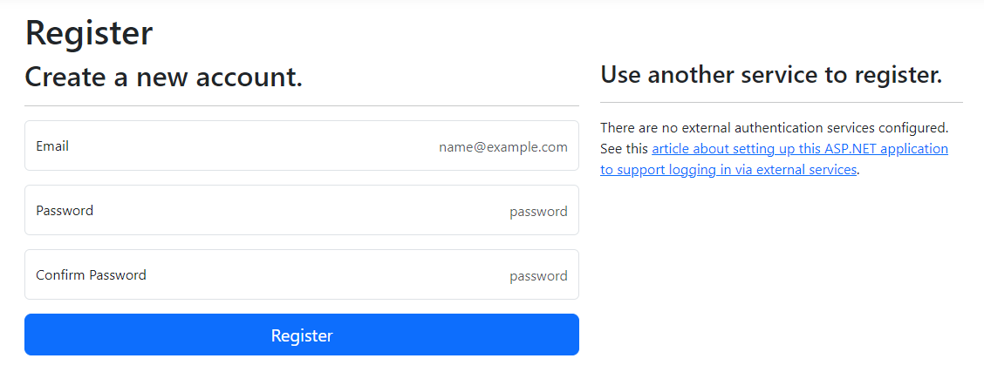
Main views seem to load as expected, however, although it may seem like it is working, upon attempting to register, I am faced with a migration error.
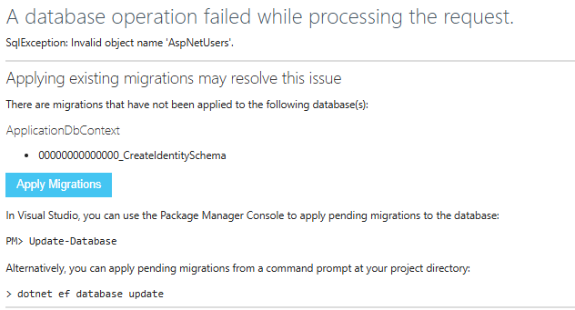
To resolve this error, we must add and update a migration, as it creates the SQL database, and any new models while also updating any changes made. We first run in the Package Manager Console:
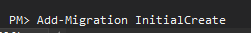
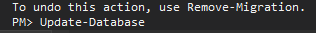
Due to it being our first migration on the solution, we name it ‘InitialMigration’ due to it being industry standard naming convention, afterwards we will name our migrations based off the basic migration reasons which are simple to keep track of.
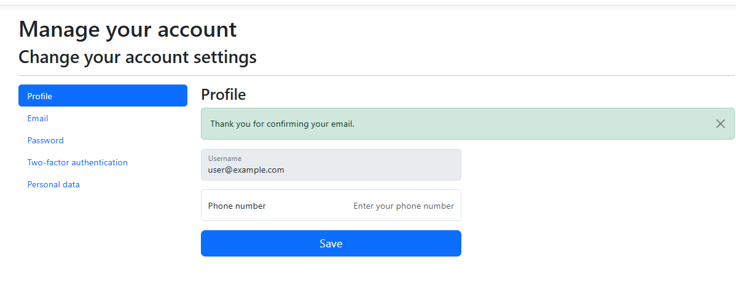
Now that a migration is added, we can create users accounts without the error occurring. This is why we made use of individual accounts, because its given us a user database with a customizable account creation system. Not only this, but it provides amazing security as it has been tested and coded by professionals in the industry.

Version 0.0.1 – Creating all models required

During Task 1, with the designs, I decided to change some of my data types of the models around. They’re minor changes but still needed to be paid attention to. I changed data types and added new attributes, I also removed and added new models. These are my models before and after, represented in a data dictionary.

Table: Address [BEFORE]
Data Property | Data Type | Purpose | PK/FK | Field Size | Required?
addressId | INT | Unique identifier for each address | PK | 10 digits | Yes
userId | NVARCHAR | References the user who owns the address | FK | 50 characters | Yes
line1 | VARCHAR | First line of the address | N/A | 100 characters | Yes
line2 | VARCHAR | Second line of the address (optional) | N/A | 100 characters | No
city | VARCHAR | City of the address | N/A | 50 characters | Yes
postcode | VARCHAR | Post code related to the address | N/A | 10 characters | Yes

Table: basket [BEFORE]
Data Property | Data Type | Purpose | PK/FK | Field Size | Required?
basketId | INT | Unique identifier for each basket | PK | 10 digits | Yes
userId | NVARCHAR | References the user who owns the basket | FK | 50 characters | Yes
createdAt | DATETIME | Date and time the basket was created | N/A | N/A | Yes

Table: basketProducts [BEFORE]
Data Property | Data Type | Purpose | PK/FK | Field Size | Required?
basketProductsId | INT | Unique identifier for basket-product relationship | PK | 10 digits | Yes
basketId | INT | References the basket | FK | 10 digits | Yes
productsId | INT | References the product | FK | 10 digits | Yes
productQuantity | INT | Numeric number of amount of the product in basket | N/A | 10 digits | Yes

Table: products [BEFORE]
Data Property | Data Type | Purpose | PK/FK | Field Size | Required?
productsId | INT | Unique identifier for each product | PK | 10 digits | Yes
itemName | VARCHAR | Name of product | N/A | 100 characters | Yes
itemPrice | DECIMAL | Price of the product | N/A | Precision 10,2 | Yes
imagePath | VARCHAR | Image of the product | N/A | 255 characters | No
quantityInStock | INT | Amount of stock available | N/A | 10 digits | Yes
available | BOOLEAN | Indicates if product is available | N/A | 1 | Yes
category | VARCHAR | Category of the product (e.g. vegetables, dairy) | N/A | 50 characters | Yes
producerName | VARCHAR | Name of the producer/farm supplying the product | N/A | 100 characters | Yes
description | VARCHAR | Description providing details about the product | N/A | 255 characters | No

Table: orderProducts [BEFORE]
Data Property | Data Type | Purpose | PK/FK | Field Size | Required?
orderProductsId | INT | Unique identifier for order-products relationship | PK | 10 digits | Yes
orderId | INT | References the order | FK | 10 digits | Yes
productsId | INT | References the product | FK | 10 digits | Yes
productQuantity | INT | Quantity of the product in order | N/A | 10 digits | Yes
productPrice | DECIMAL | Price of product at time of order | N/A | Precision 10,2 | Yes

Table: loyalty [BEFORE]
Data Property | Data Type | Purpose | PK/FK | Field Size | Required?
loyaltyId | INT | Unique identifier for loyalty record | PK | 10 digits | Yes
userId | NVARCHAR | References the user | FK | 50 characters | Yes
pointsTotal | INT | Total loyalty points earned | N/A | 10 digits | Yes

Table: loyaltyTransaction [BEFORE]
Data Property | Data Type | Purpose | PK/FK | Field Size | Required?
loyaltyTransactionId | INT | Unique identifier for transaction | PK | 10 digits | Yes
loyaltyId | INT | References loyalty account | FK | 10 digits | Yes
orderId | INT | References related order | FK | 10 digits | Yes
pointsChange | INT | Amount of points added or removed | N/A | 10 digits | Yes
transactionTimestamp | DATETIME | Time of transaction | N/A | N/A | Yes
transactionCategory | VARCHAR | Type or transaction (earn/redeem) | N/A | 50 characters | Yes

Table: order [BEFORE]
Data Property | Data Type | Purpose | PK/FK | Field Size | Required?
orderId | INT | Unique identifier for every order | PK | 10 digits | Yes
userId | NVARCHAR | References the user which placed the order | FK | 50 characters | Yes
addressId | INT | References the delivery address | FK | 10 digits | Yes
datePlaced | DATETIME | The date and time the order record was created | N/A | B/A | Yes
createdAt | DATETIME | Time and date the order record was created | N/A | N/A | Yes
status | VARCHAR | Current order status (for example shipped or pending) | N/A | 50 characters | Yes
orderTotal | DECIMAL | Total cost of the order | N/A | Precision 10.2 | Yes

This is my new data dictionary:

Table: basket [BEFORE]
Data Property | Data Type | Purpose | PK/FK | Field Size | Required?
BasketId | INT | Unique identifier for each basket | PK | 10 digits | Yes
UserId | NVARCHAR | References the user who owns the basket | FK | 450 characters | Yes
CreatedAt | DATETIME | Date and time the basket was created | N/A | N/A | Yes
Status | BOOLEAN | Indicates if the basket is active or complete | N/A | 1 | Yes

I added the Status attribute as I plan to implement logic for the basket being active or complete through controller backend.

Table: BasketProducts
Data Property | Data Type | Purpose | PK/FK | Field Size | Required?
BasketProducts | INT | Unique identifier for basket-product relationship | PK | 10 digits | Yes
BasketId | INT | References the basket | FK | 10 digits | Yes
ProductsId | INT | References the product | FK | 10 digits | Yes
ProductQuantity | INT | How many of each product is in the basket | N/A | 10 digits | Yes

Table: OrderProducts
Data Property | Data Type | Purpose | PK/FK | Field Size | Required?
OrderProductsId | INT | Unique identifier for order-products relationship | PK | 10 digits | Yes
orderIdOrderId | INT | References the order | FK | 10 digits | Yes
ProductsId | INT | References the product | FK | 10 digits | Yes
productQuantity | INT | Quantity of the product in order | N/A | 10 digits | Yes

The product price seemed unnecessary in development so I removed it, as I felt like it was over complicating the system unnecessarily.

Table: Orders
Data Property | Data Type | Purpose | PK/FK | Field Size | Required?
OrdersId | INT | Unique identifier for every order | PK | 10 digits | Yes
UserId | NVARCHAR | References the user which placed the order | FK | 450 characters | Yes
OrderDate | DATE | Date the order was placed | N/A | N/A | Yes
DeliveryMethod | VARCHAR | Selected delivery method | N/A | 50 characters | No
Delivery | BOOLEAN | Indicates if delivery was selected | N/A | 1 | Yes
Collection | BOOLEAN | Indicates if collection was selected | N/A | 1 | Yes
OrdersTotal | DECIMAL | Total cost of the order | N/A | Precision 10.2 | Yes
TrackingStatus | VARCHAR | Current order tracking status | N/A | 50 characters | Yes
DateOfCollection | DATE | Date the order will be collected | N/A | N/A | No
BillingLine1 | VARCHAR | First line of billing address | N/A | 100 characters | Yes
BillingLine2 | VARCHAR | Second line of billing address | N/A | 100 characters | No
BillingCity | VARCHAR | Billing city | N/A | 50 characters | Yes
BillingPostcode | VARCHAR | Billing postcode | N/A | 10 characters | Yes
DeliveryLine1 | VARCHAR | First line of delivery address | N/A | 100 characters | No
DeliveryLine2 | VARCHAR | Second line of delivery address | N/A | 100 characters | No
DeliveryCity | VARCHAR | Delivery city | N/A | 50 characters | No
DeliveryPostcode | VARCHAR | Delivery postcode | N/A | 10 characters | No

AddressId is removed as a foreign key, along with the Address model as a whole, as I am no longer making use of the address table. I believe it is more simple, easier and efficient for this project to just have the address information within the orders table to avoid conflict between controllers. So for this reason, I added the attributes from that model here. Not only this, but I made Delivery information a nullable selection for two reasons; firstly, the user may choose selection which wouldn’t require a delivery address, I also implemented billing address, and plan on implementing logic so that the user can select so that the billing address is the same as the delivery address for ease of use. On this topic, I have also added attributes for billing address information to the model as it is seen in industry standard checkout systems and e-commerce applications to have billing address information separate from delivery address information. Apart from this, within this model I also changed up some data types and naming conventions, and also added different attributes from the old table as I believed they’re more logical for an order system.
Table: Producers
Data Property | Data Type | Purpose | PK/FK | Field Size | Required?
ProducersId | INT | Unqiue identifier for each producer | PK | 10 digits | Yes
UserId | NVARCHAR | References the user account of the product | FK | 450 characters | Yes
ProducerName | VARCHAR | Name of producer | N/A | 100 characters | Yes
ProducerEmail | VARCHAR | Email of producer | N/A | 100 characters | Yes
ProducerInformation | VARCHAR | Information about the producer | N/A | 500 characters | Yes

I added this whole model new, this wasn’t in the first database design. I made it to link producers to the creation of products through the use of UserId. Producers will be able to access the dashboard also through this way.
Table: Products
Data Property | Data Type | Purpose | PK/FK | Field Size | Required?
ProductsId | INT | Unique identifier for each product | PK | 10 digits | Yes
ProducersId | INT | References the producer who created that product | FK | 10 digits | Yes
ItemName | VARCHAR | Name of product | N/A | 100 characters | Yes
ItemPrice | DECIMAL | Price of the product | N/A | Precision 10,2 | Yes
ImagePath | VARCHAR | Image of the product | N/A | 255 characters | No
QuantityInStock | INT | Amount of stock available | N/A | 10 digits | Yes
Available | BOOLEAN | Indicates if product is available | N/A | 1 | Yes
Category | VARCHAR | Category of the product (e.g. vegetables, dairy) | N/A | 50 characters | Yes
Description | VARCHAR | Description providing details about the product | N/A | 255 characters | No

I removed the ProducerName attribute as it is no longer necessary with the use of ProducersId being linked as a foreign key, as this is where we will grab Producer data from and link it to the product.

Apart from this, I removed the Loyalty and LoyaltyTransaction models as I realized that a loyalty system through controller logic will be more suitable for the project, and will be better to develop.
Here is the new database being used represented in a database diagram:
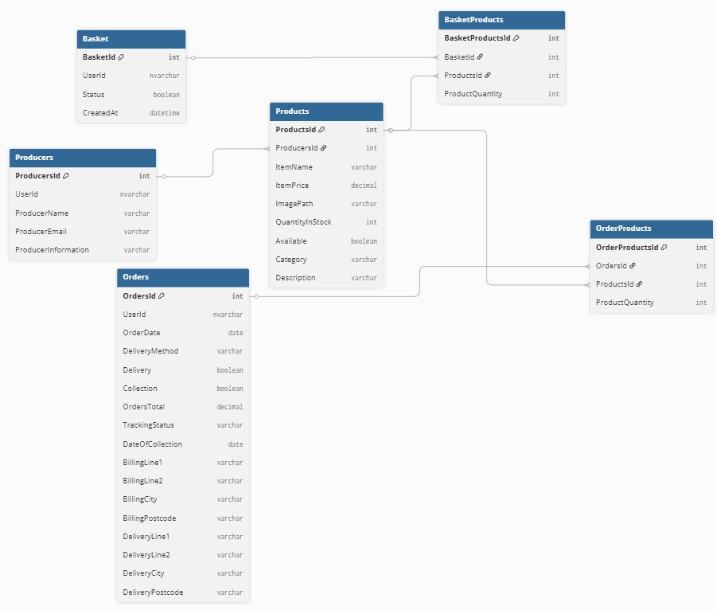

We now make the Model files with appropriate names and the data which they’ll store. This is an example from the Basket model. From this, I scaffold each model one by one, preventing the solution explorer from being untidy and making the organization and navigation of the solution easier. Although, we need to scaffold the identity pages to allow us to edit the register, sign up pages and more.
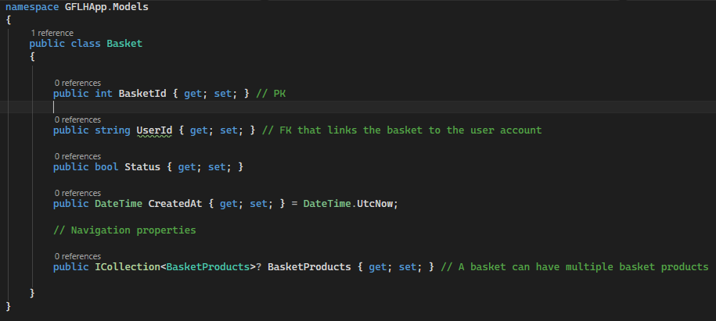

After completing each model, this is how it looks.
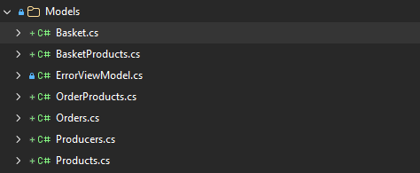
I then have to scaffold each model one by one, which will prevent the solution from being untidy and making it more organized and easy to navigate. Although, we need to scaffold the identity pages to allow us to edit the register, sign up pages and more. So, what we need to do is add an Identity to the Areas/Identity folder and override all the files.
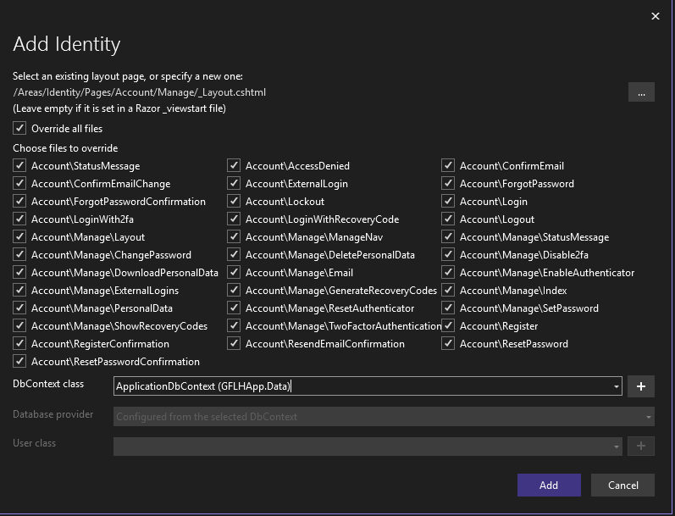
Upon selecting ApplicationDbContext and clicking add, this has been done sucessfuly.

I’ll now make a new migration and update the database as I have added my models as controllers, and scaffolded the identity.
Upon migration, I faced an error. This is because I have datatypes saved as decimal, but I didn’t tell EF core how precise they should be in the database. Usually, it would resort to something such as decimal(18,2) but I want to make use of decimal(10,2). To avoid this issue, I added the following code inside of ApplicationDbContext so that the wrong data isn’t used:

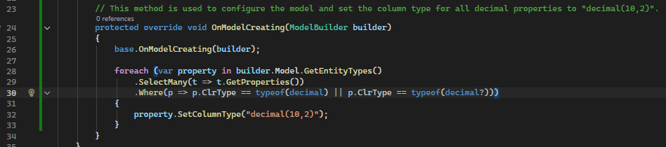
Because of this, I had to remove the previous migration.
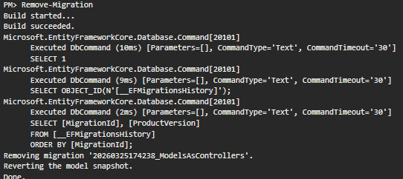

Now when I try to migrate again, and also update the database, the error is no longer present.

Here is how the identity scaffolded looks:
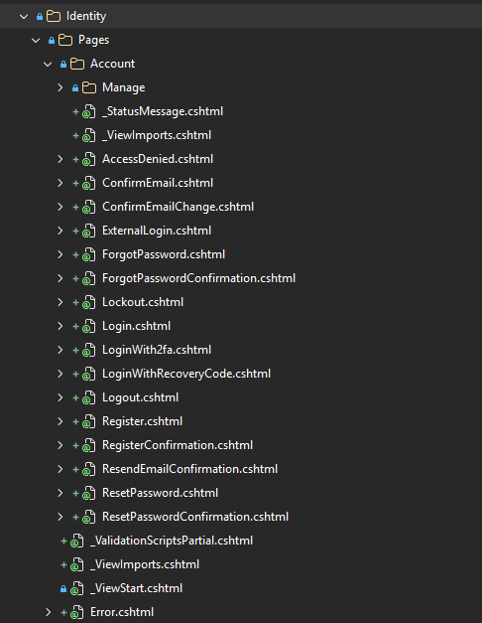
This now lets us edit all pages shown whenever we need. Not only this, but I chose to scaffold it now rather than later so its all organized into one folder which is rarely opened. However, when working on such as the HTML of the solution, we are required to open the whole folder with all other pages which would have been created when scaffolding, which is messy and a hassle to navigate through, with the biggest reason for not scaffolding so soon being able to focus on the features one by one, making sure its complete fully without providing broken or incomplete features before continuing.

Version 0.2.1 – Seeding Users and Roles

First of all, we must create a class called SeedData.cs inside of the Data folder to be able to seed users and roles.
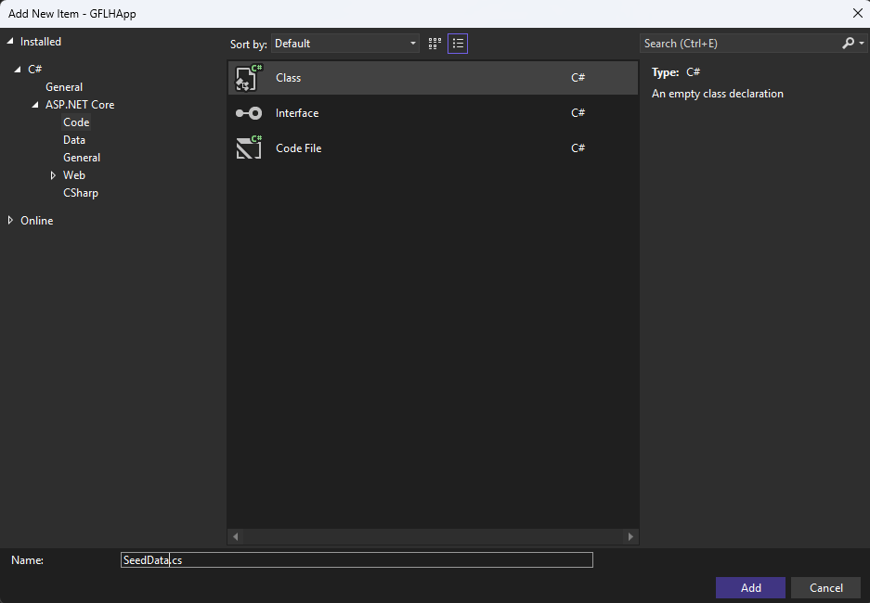
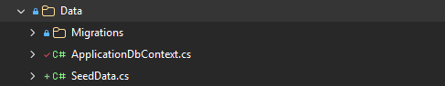

Within SeedData, we first have to create the method, I am going to call it SeedUsersAndRoles
Within this method, we must create the roles:
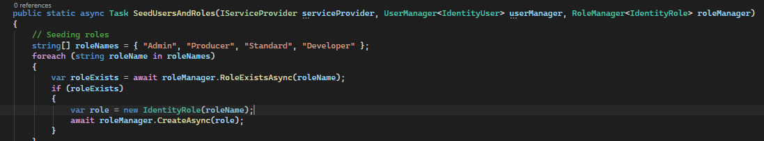
Underneath that same method, we are going to add different users. First of all, we start by adding an admin:
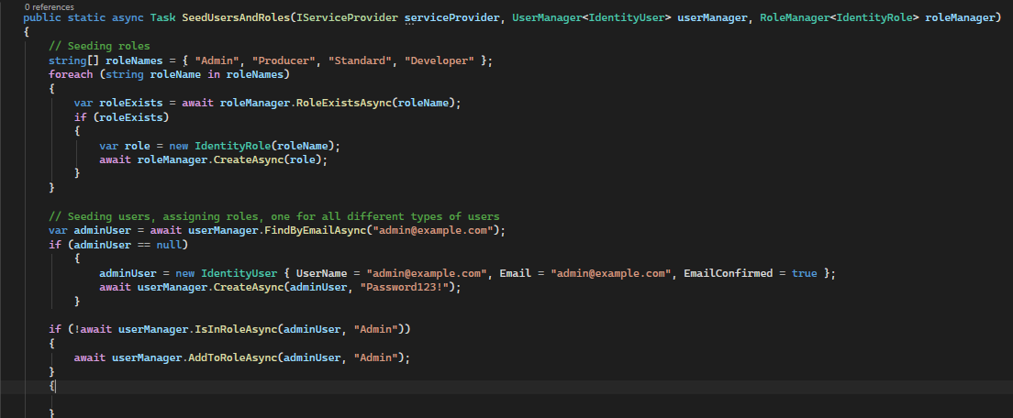

Then I added 5 different producers:
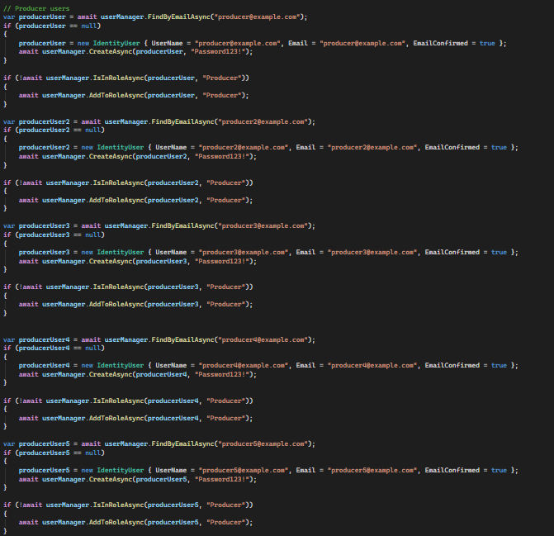
Then I seeded a normal and a developer user:
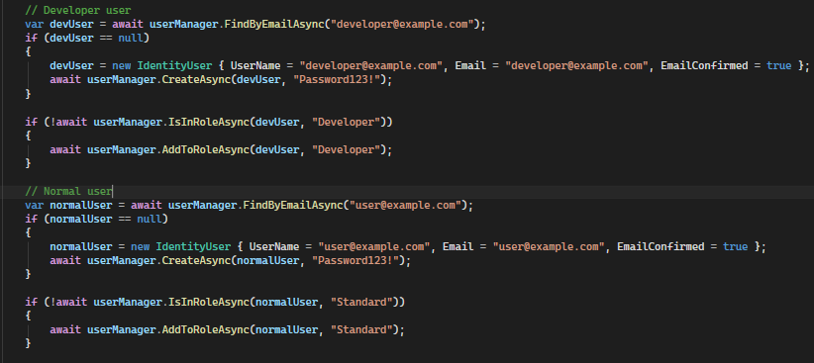

Once all of these are added to the SeedData.cs file, I then have to add the following code into program.cs
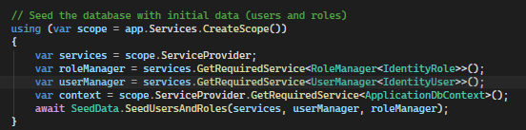

I update database just incase, once I run the program it lets me login as a seeded role.


Version 0.2.2 – Seeding Producers (data)

In the SeedData.cs program, underneath the previous method made, we are going to seed producers.
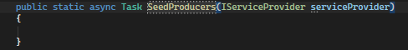
First, within this method we want to write code which will find the supplier in which you want to link.
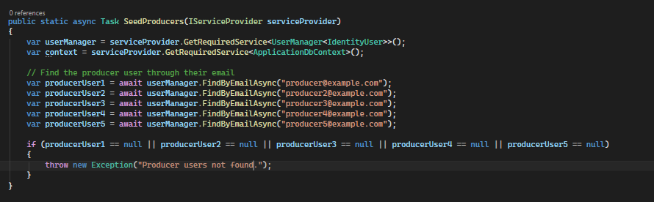
Then I added producers with a function at the end to save each producer to the database:
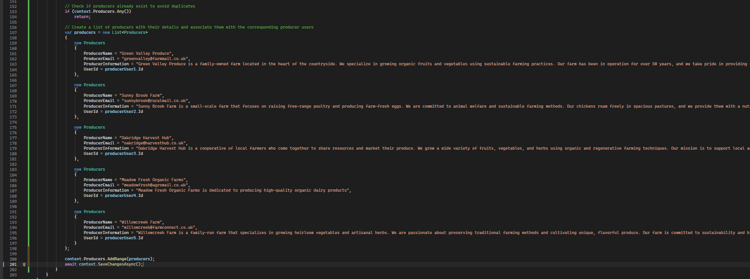
We then add these changes to program.cs:

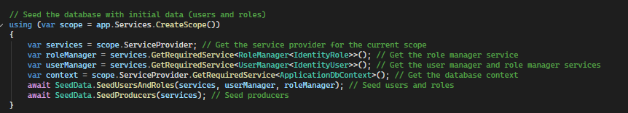

Then we run the web application to ensure changes made were successful.
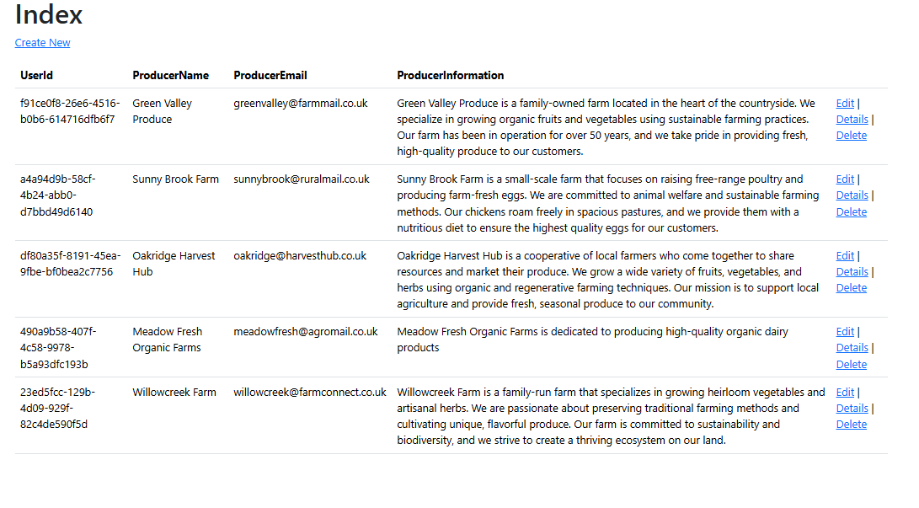
As you can see, all seeded data has been outputted onto the solution successfully.

Version 0.2.3 – Seeding Products (data)

First we are going to create a new method for seeding products.
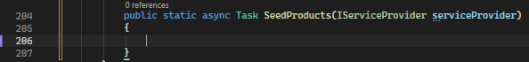
Then we code so that we can link the producers to products:
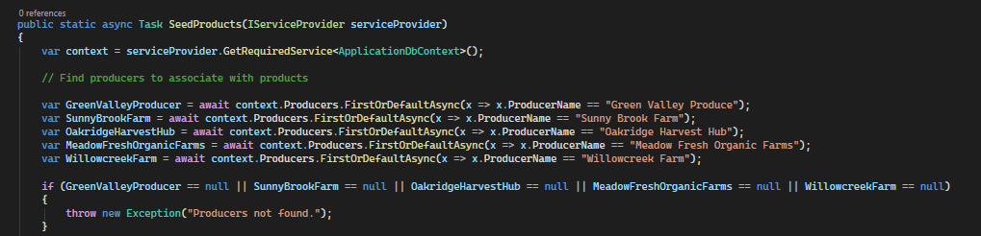

Then we seed the products and add code to add them to the database, here are a few examples:

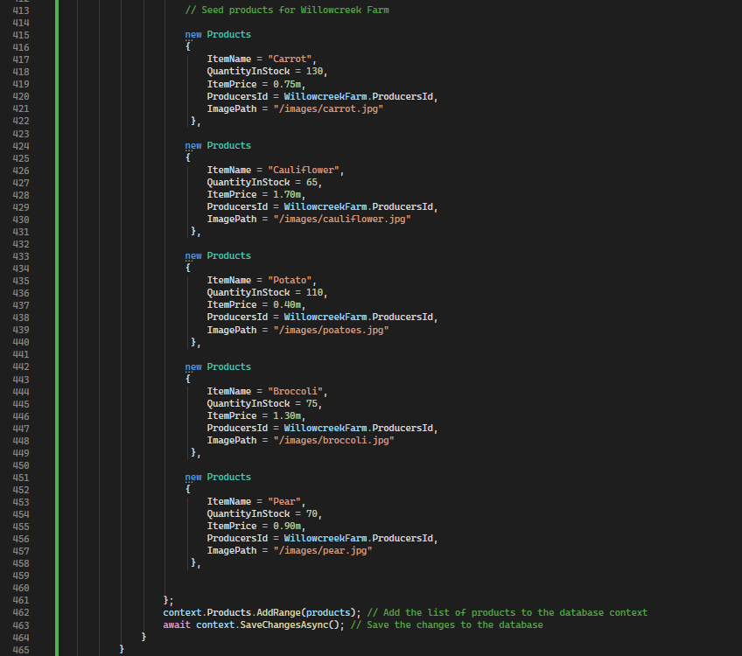

We then add these changes to Program.cs:
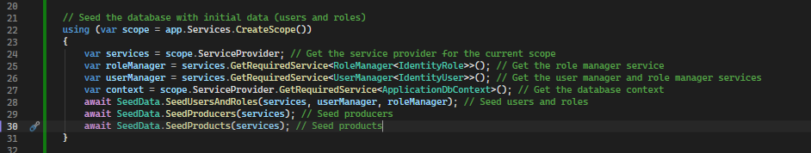

Now, if I run the program, I should be able to see the Products that I have seeded on the products page.
Upon running the program, I ran into this error.
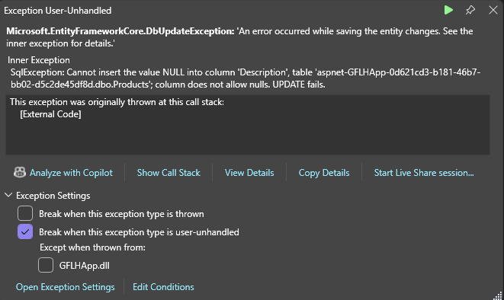
It seems that I need to add a description to each of the products. I will also run into the same error if I don’t fill out the rest of the fields, such as category.
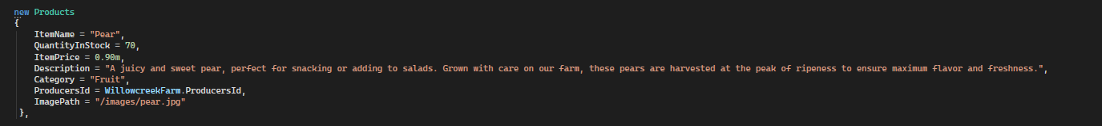
Now that description and category have been added, we can try and run the program again.
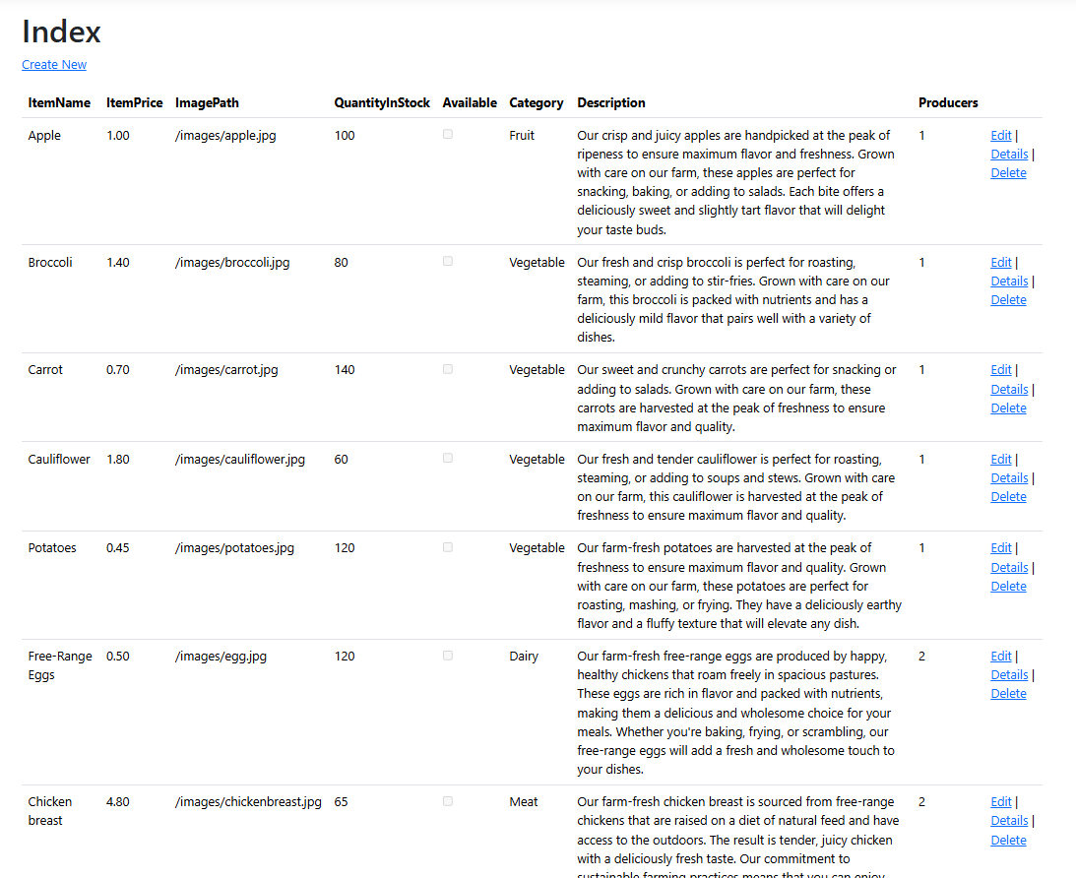
As we can see, the data has been successfully outputted onto the Products page. Although there are two things to note. First of all, available is set as empty for each product. For now, this is fine as we’re going to implement backend logic so that the QuantityInStock will affect the status of the product. Aside from this, ImagePath does not currently load the image as it is not displayed in an img tag at the moment. We will keep it this way for now, as they will not be displayed correctly anyways due to a lack of CSS in the program at this stage of development, which will cause the images to load at incorrect sizes. We will change this later on also.
