Task 1: Activity B – AI Log
AI model used | Gemini 3
Problem to be solved | Prompts used | Output generated | Review of generated code
I wanted to generate an image of an apple to be used for the website without copyright issues | Please generate me an image of an apple with a white background which is suitable for an e-commerce system | 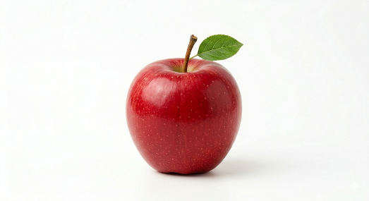 | N/A
I wanted to generate an image of broccoli to be used for the website without copyright issues | Please generate me an image of broccoli with a white background which is suitable for an e-commerce system | 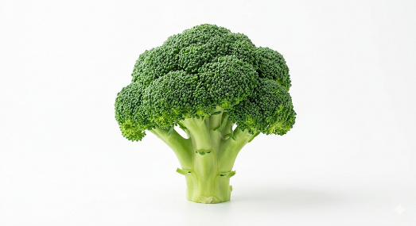 | N/A
I wanted to generate an image of a carrot to be used for the website without copyright issues | Please generate me an image of a carrot with a white background which is suitable for an e-commerce system | 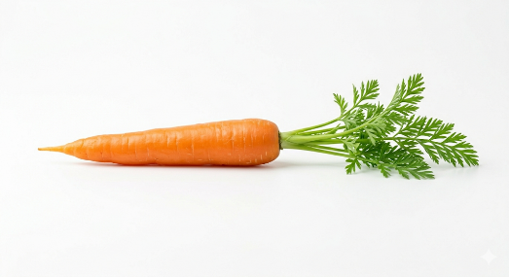 | N/A
I wanted to generate an image of cauliflower to be used for the website without copyright issues | Please generate me an image of cauliflower with a white background which is suitable for an e-commerce system | 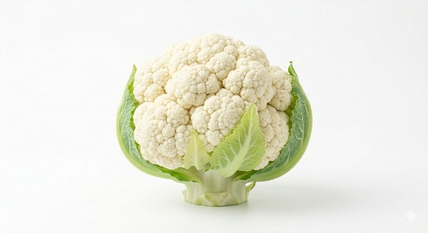 | N/A
I wanted to generate an image of cheese to be used for the website without copyright issues | Please generate me an image of cheese with a white background which is suitable for an e-commerce system | 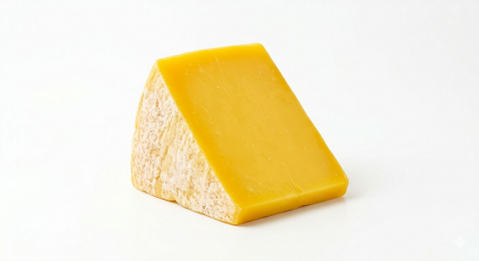 | N/A
I wanted to generate an image of chicken breast to be used for the website without copyright issues | Please generate me an image of chicken breast with a white background which is suitable for an e-commerce system | 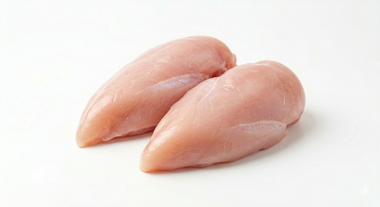 | N/A
I wanted to generate an image of an egg to be used for the website without copyright issues | Please generate me an image of an egg with a white background which is suitable for an e-commerce system | 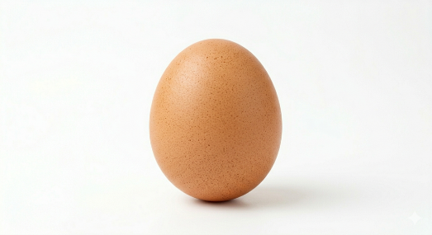 | N/A
I wanted to generate an image of milk to be used for the website without copyright issues | Please generate me an image of milk with a white background which is suitable for an e-commerce system | 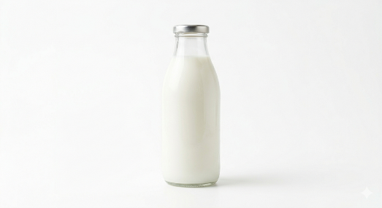 | N/A
I wanted to generate an image of mince meat to be used for the website without copyright issues | Please generate me an image of mince meat with a white background which is suitable for an e-commerce system | 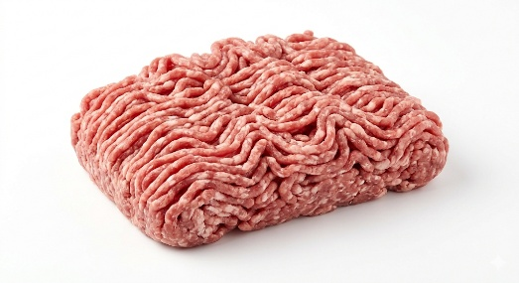 | N/A
I wanted to generate an image of a pear to be used for the website without copyright issues | Please generate me an image of a pear with a white background which is suitable for an e-commerce system | 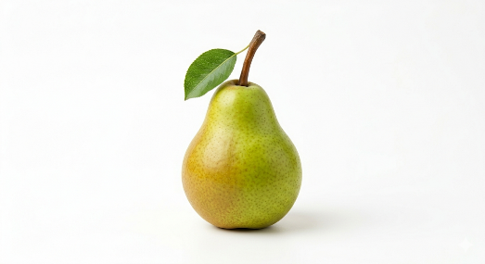 | N/A
I wanted to generate an image of a potato meat to be used for the website without copyright issues | Please generate me an image of a potato with a white background which is suitable for an e-commerce system | 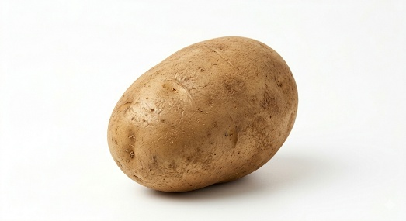 | N/A
I wanted to generate an image of a raspberry to be used for the website without copyright issues | Please generate me an image of a raspberry with a white background which is suitable for an e-commerce system | 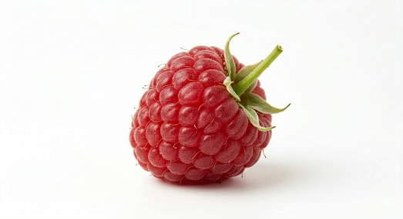 | N/A
I wanted to generate an image of a strawberry to be used for the website without copyright issues | Please generate me an image of a strawberry with a white background which is suitable for an e-commerce system | 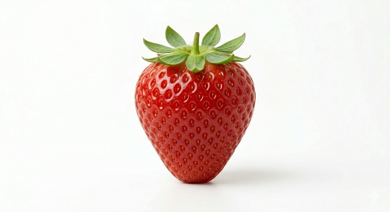 | N/A
I wanted to generate an image of yogurt to be used for the website without copyright issues | Please generate me an image of yogurt with a white background which is suitable for an e-commerce system | 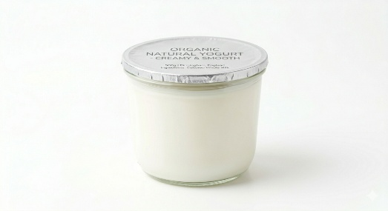 | N/A
I wanted to generate an image of a man holding a basket of fruit vegetables to be used for the website without copyright issues. | Please generate me an image of a man holding a basket of fruit vegetables with a white background which is suitable for an e-commerce system. Please ensure that the main focus of the image is the basket and the face isn’t shown. | 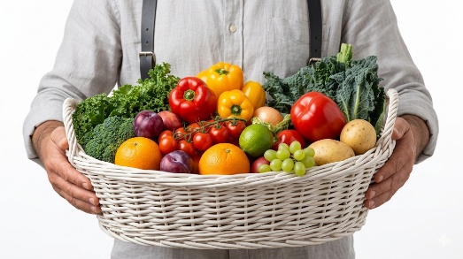
[Add additional rows as needed then delete this instruction]

Copyright and Acknowledgements
‘T-LEVELS’ is a registered trademark of the Department for Education.
‘T Level’ is a registered trademark of the Institute for Apprenticeships and Technical Education.
The T Level Technical Qualification is a qualification approved and managed by the Institute for Apprenticeships and Technical Education.
‘Institute for Apprenticeships & Technical Education’ and logo are registered trademarks of the Institute for Apprenticeships and Technical Education.
Pearson Education Limited is authorised by the Institute for Apprenticeships and Technical Education to develop and deliver this Technical Qualification.
Pearson and logo are registered trademarks of Pearson.
Copyright in this document belongs to, and is used under licence from, the Institute for Apprenticeships and Technical Education, © 2025

