**Домашнее задание 4, вар. 18 Лысенко Данила Сергеевич P3110**

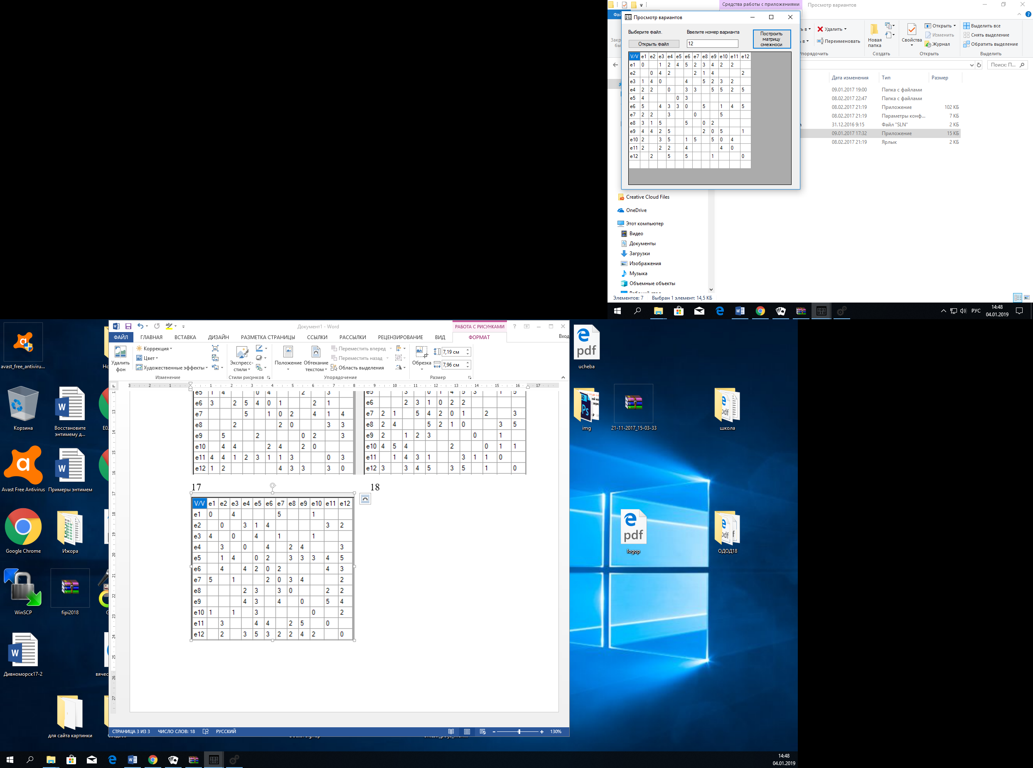

Рисунок 1 Граф, вариант 18

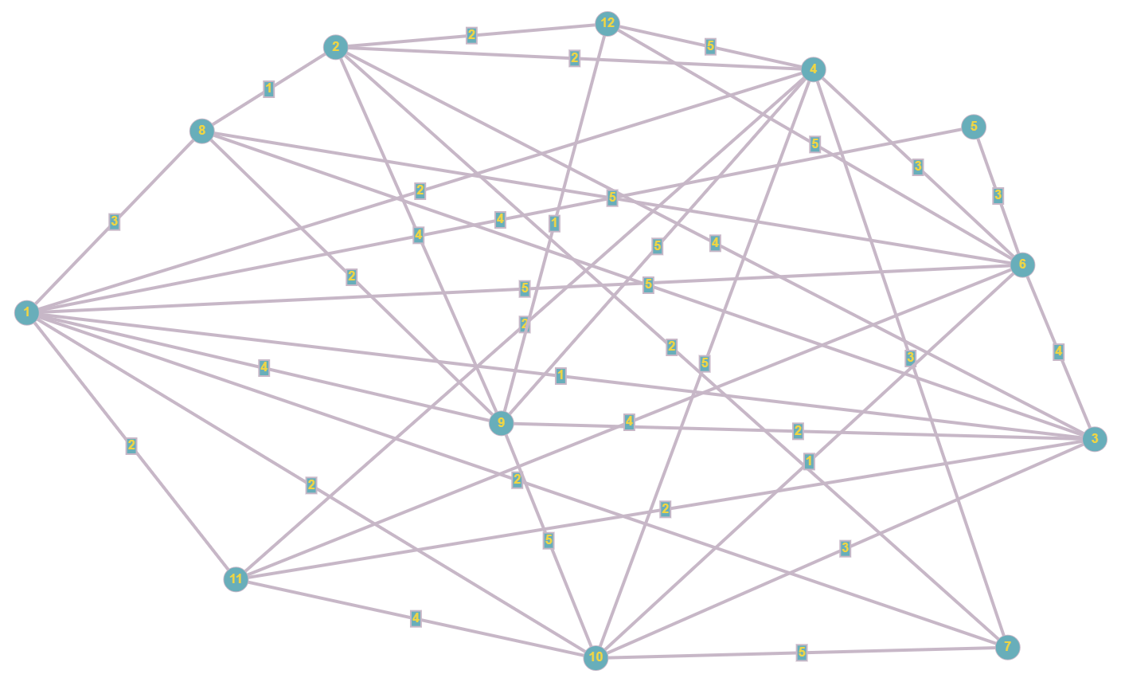

Нахождение гамильтонова цикла:

S = {e1}

S = {e1, e3}

S = {e1, e3, e2}

S = {e1, e3, e2, e7}

S = {e1, e3, e2, e7, e10}

S = {e1, e3, e2, e7, e10, e11}

S = {e1, e3, e2, e7, e10, e11}

S = {e1, e3, e2, e7, e10, e11, e4}

S = { e1, e3, e2, e7, e10, e11, e4, e12}

S = { e1, e3, e2, e7, e10, e11, e4, e12, e9}

S = { e1, e3, e2, e7, e10, e11, e4, e12, e9, e8}

S = { e1, e3, e2, e7, e10, e11, e4, e12, e9, e8, e6}

S = { e1, e3, e2, e7, e10, e11, e4, e12, e9, e8, e6, e5}

Ребро e5-e1 существует. Гамильтонов цикл найден.

Переименуем вершины графа:

|  |  |  |  |  |  |  |  |  |  |  |  |
| --- | --- | --- | --- | --- | --- | --- | --- | --- | --- | --- | --- |
| e1 | e3 | e2 | e7 | e10 | e11 | e4 | e12 | e9 | e8 | e6 | e5 |
| e1 | e2 | e3 | e4 | e5 | e6 | e7 | e8 | e9 | e10 | e11 | e12 |

Матрица соединений с перенумерованными вершинами:

|  |  |  |  |  |  |  |  |  |  |  |  |  |
| --- | --- | --- | --- | --- | --- | --- | --- | --- | --- | --- | --- | --- |
|  | e1 | e2 | e3 | e4 | e5 | e6 | e7 | e8 | e9 | e10 | e11 | e12 |
| e1 | 0 | X |  | 1 | 1 | 1 | 1 |  | 1 | 1 | 1 | 1 |
| e2 | X | 0 | X |  | 1 | 1 |  |  | 1 | 1 |  |  |
| e3 |  | X | 0 | X |  |  | 1 | 1 | 1 | 1 |  |  |
| e4 | 1 |  | X | 0 | X |  | 1 |  |  |  |  |  |
| e5 | 1 | 1 |  | X | 0 | X | 1 |  | 1 |  | 1 |  |
| e6 | 1 | 1 |  |  | X | 0 | X |  |  |  | 1 |  |
| e7 | 1 |  | 1 | 1 | 1 | X | 0 | X | 1 |  | 1 |  |
| e8 |  |  | 1 |  |  |  | X | 0 | X |  | 1 |  |
| e9 | 1 | 1 | 1 |  | 1 |  | 1 | X | 0 | X |  |  |
| e10 | 1 | 1 | 1 |  |  |  |  |  | X | 0 | X |  |
| e11 | 1 |  |  |  | 1 | 1 | 1 | 1 |  | X | 0 | X |
| e12 | 1 |  |  |  |  |  |  |  |  |  | X | 0 |

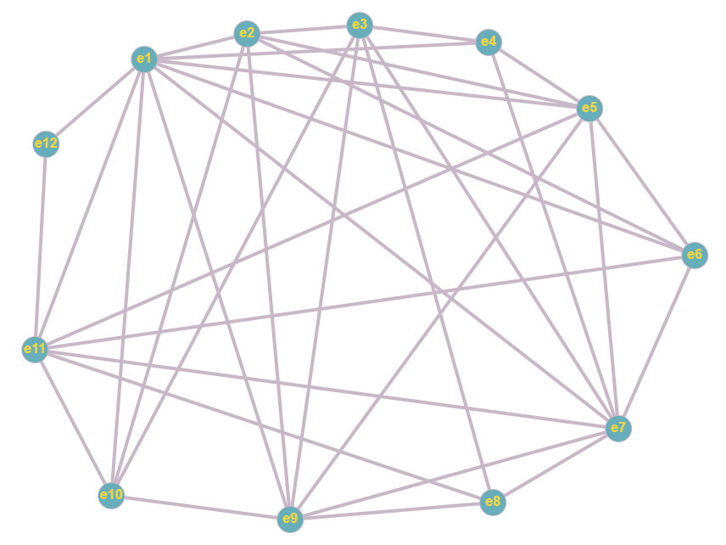

Построим граф пересечений:

|  |  |  |  |  |  |  |  |  |  |  |  |  |  |  |  |
| --- | --- | --- | --- | --- | --- | --- | --- | --- | --- | --- | --- | --- | --- | --- | --- |
|  | u3-9  (1) | U5-11  (2) | U1-10  (3) | U6-11  (4) | U1-9  (5) | U1-4  (6) | U4-7  (7) | U2-10  (8) | U3-10  (9) | U2-5  (10) | U1-5  (11) | U1-6  (12) | U5-7  (13) | U7-9  (14) | U7-11  (15) |
| u3-9 (1) | 1 | 1 |  | 1 |  | 1 |  |  |  | 1 | 1 | 1 |  |  | 1 |
| U5-11 (2) | 1 | 1 | 1 |  | 1 |  | 1 | 1 | 1 |  |  | 1 |  |  |  |
| U1-10 (3) |  | 1 | 1 | 1 |  |  |  |  |  |  |  |  |  |  | 1 |
| U6-11 (4) | 1 |  | 1 | 1 | 1 |  | 1 | 1 | 1 |  |  |  | 1 |  |  |
| U1-9 (5) |  | 1 |  | 1 | 1 |  |  | 1 | 1 |  |  |  |  |  | 1 |
| U1-4 (6) | 1 |  |  |  |  | 1 |  | 1 | 1 | 1 |  |  |  |  |  |
| U4-7 (7) |  | 1 |  | 1 |  |  | 1 |  |  | 1 | 1 | 1 |  |  |  |
| U2-10 (8) |  | 1 |  | 1 | 1 | 1 |  | 1 |  |  | 1 | 1 |  |  | 1 |
| U3-10 (9) |  | 1 |  | 1 | 1 | 1 |  |  | 1 | 1 | 1 | 1 |  |  | 1 |
| U2-5 (10) | 1 |  |  |  |  | 1 | 1 |  | 1 | 1 |  |  |  |  |  |
| U1-5 (11) | 1 |  |  |  |  |  | 1 | 1 | 1 |  | 1 |  |  |  |  |
| U1-6 (12) | 1 | 1 |  |  |  |  | 1 | 1 | 1 |  |  | 1 | 1 |  |  |
| U5-7 (13) |  |  |  | 1 |  |  |  |  |  |  |  | 1 | 1 |  |  |
| U7-9 (14) |  |  |  |  |  |  |  |  |  |  |  |  |  | 1 |  |
| U7-11 (15) | 1 |  | 1 |  | 1 | 1 |  | 1 | 1 |  |  |  |  |  | 1 |

Построение семейства Ψg.

J(i) = {3, 5, 7, 8, 9, 13, 14}

M1,3 = r1 v r3 = {111101000111001}

J(i) = {5, 7, 8, 9, 13, 14}

M1,3,5 = {111111011111001}

J(i) = {7, 13, 14}

M1,3,5,7 = {111111111111001}

J(i) = {13, 14}

M1,3,5,7,13 = {111111111111101}

J(i) = {14}

M1,3,5,7,13,14 = {111111111111111}

Ψ1 = {u3-9, u1-10, u1-9, u4-7, u5-7, u7-9}

Дальше покрыть невозможно, переходим к следующей строчке.

J(i) = {4, 6, 10, 11, 13, 14, 15}

M2,4 = r2 v r4 = {111110111001100}

J(i) = {6, 10, 11, 14, 15}