**Домашнее задание 4, вар. 18 Лысенко Данила Сергеевич P3110**

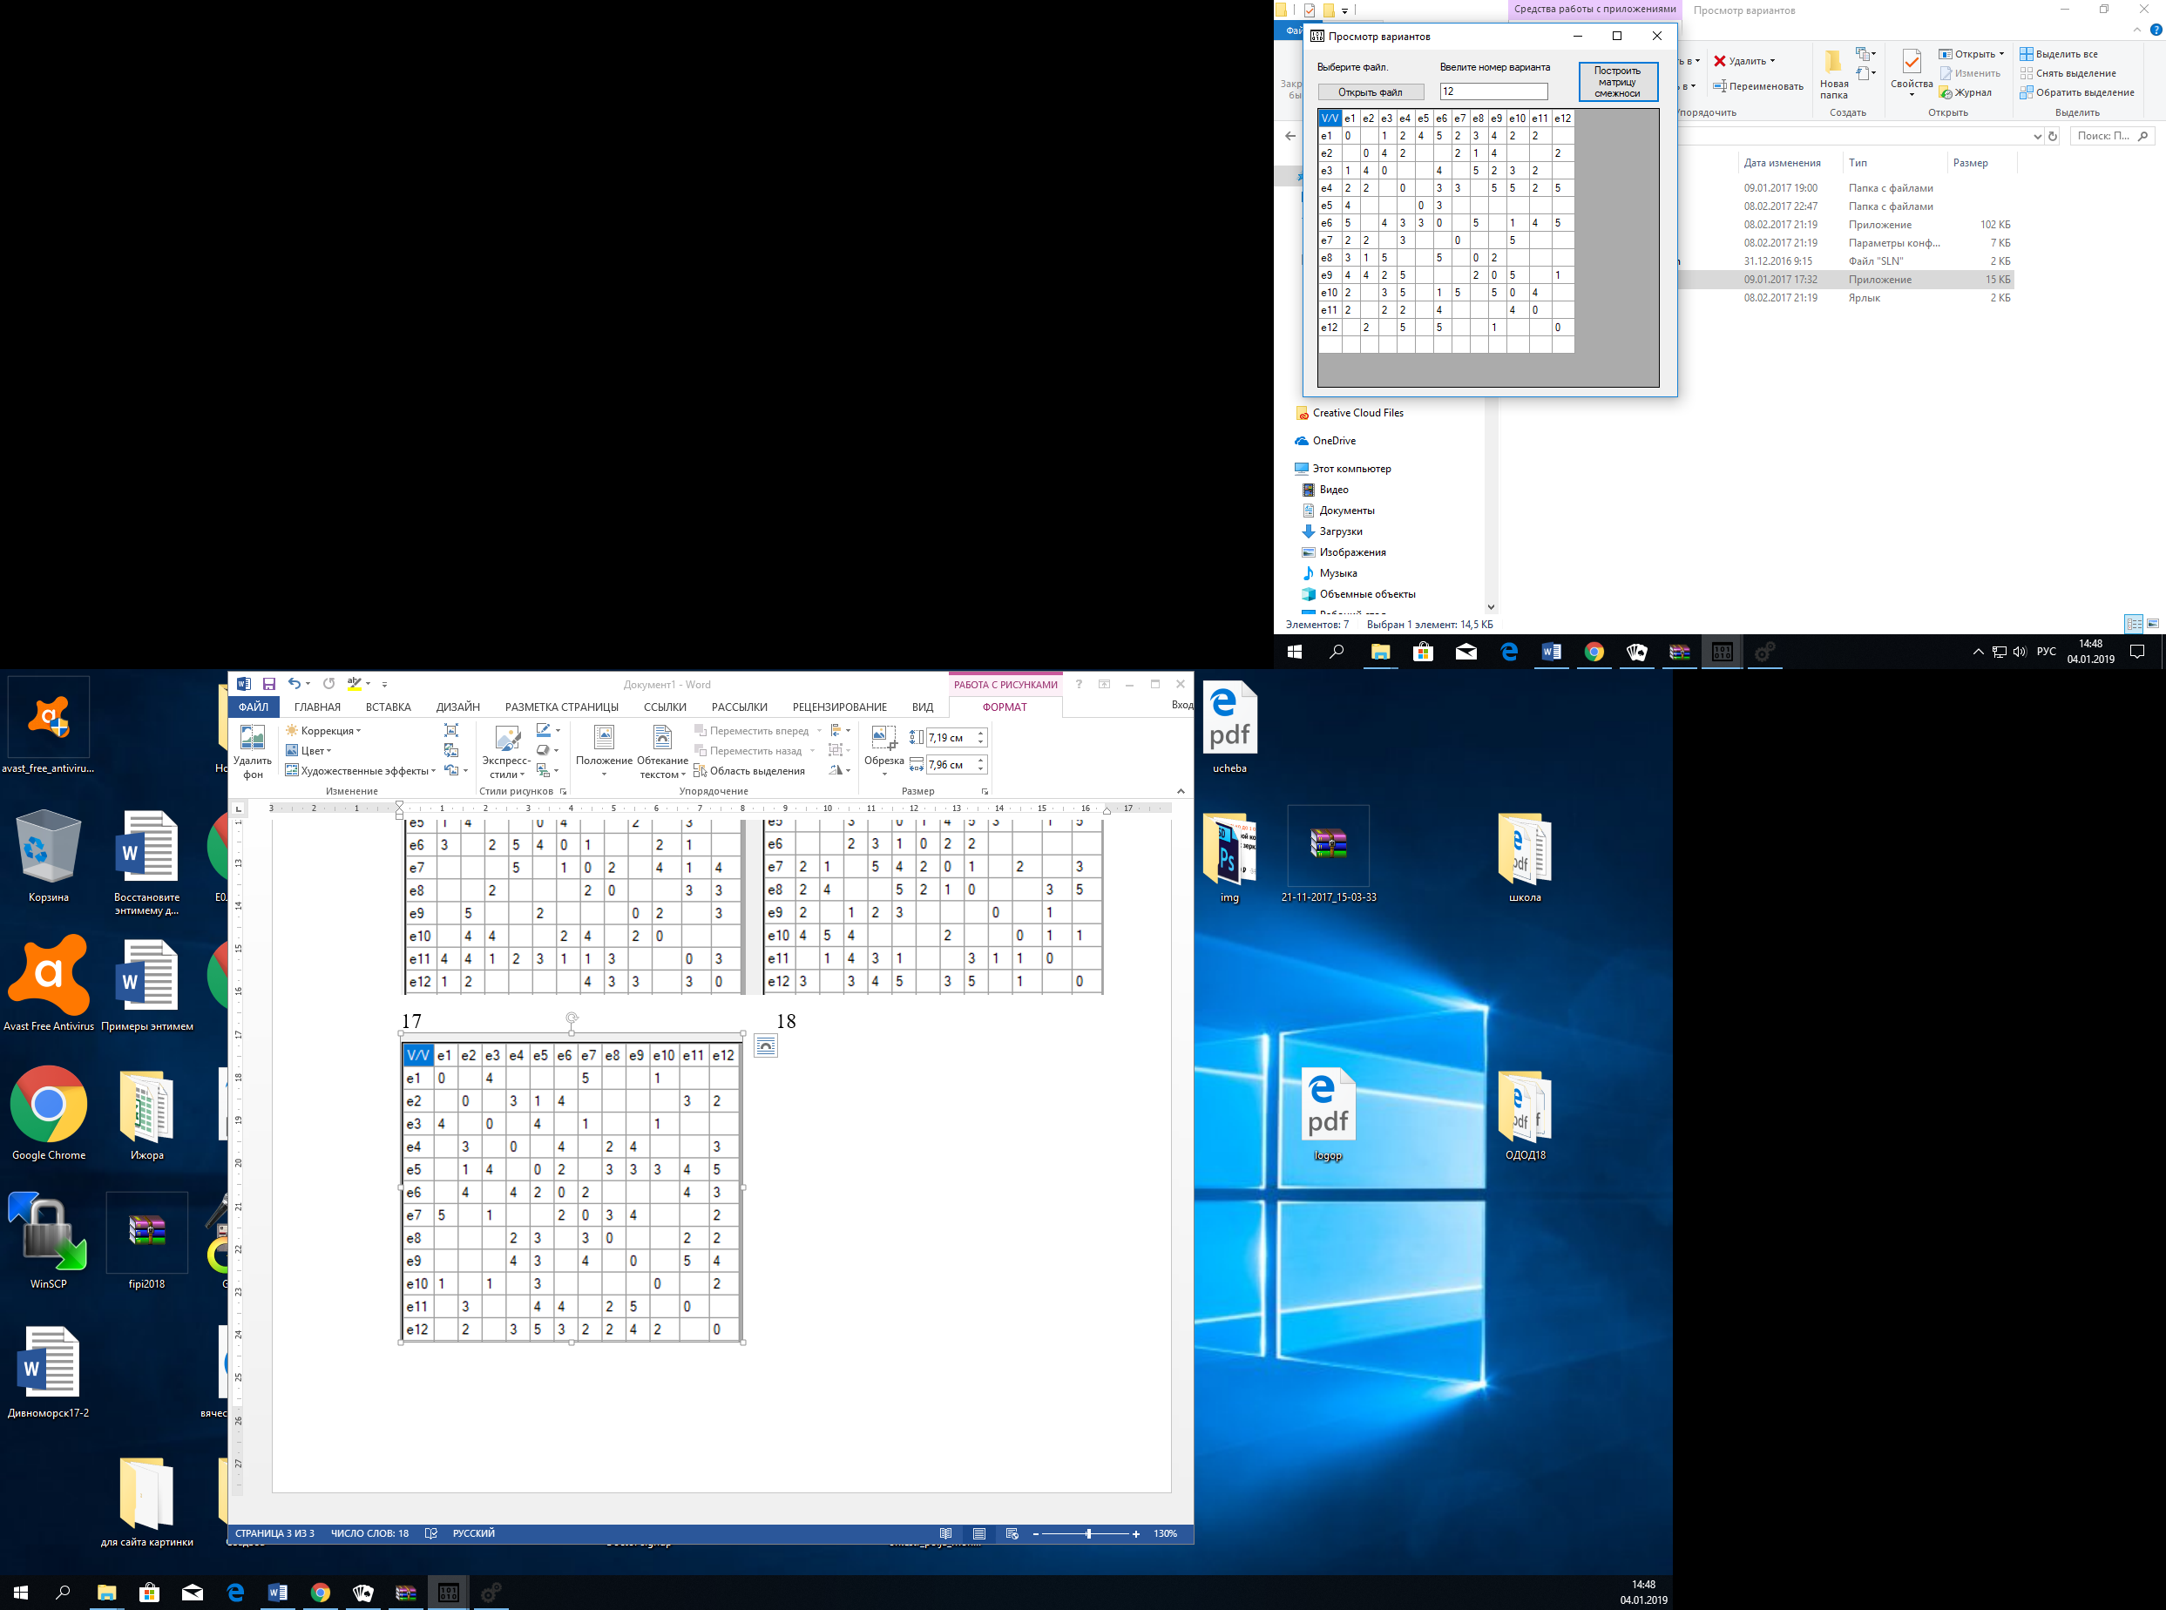

Рисунок 1 Граф, вариант 18

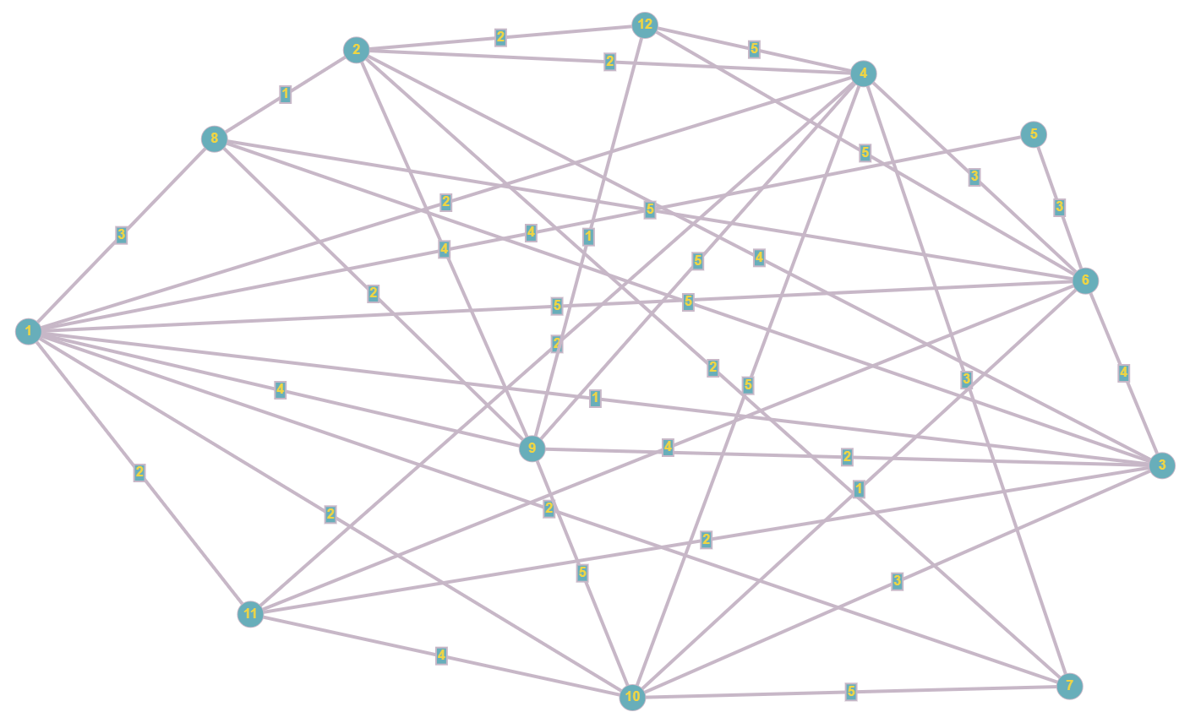

Нахождение гамильтонова цикла:

S = {e1}

S = {e1, e3}

S = {e1, e3, e2}

S = {e1, e3, e2, e7}

S = {e1, e3, e2, e7, e10}

S = {e1, e3, e2, e7, e10, e11}

S = {e1, e3, e2, e7, e10, e11}

S = {e1, e3, e2, e7, e10, e11, e4}

S = { e1, e3, e2, e7, e10, e11, e4, e12}

S = { e1, e3, e2, e7, e10, e11, e4, e12, e9}

S = { e1, e3, e2, e7, e10, e11, e4, e12, e9, e8}

S = { e1, e3, e2, e7, e10, e11, e4, e12, e9, e8, e6}

S = { e1, e3, e2, e7, e10, e11, e4, e12, e9, e8, e6, e5}

Ребро e5-e1 существует. Гамильтонов цикл найден.

Переименуем вершины графа:

|  |  |  |  |  |  |  |  |  |  |  |  |
| --- | --- | --- | --- | --- | --- | --- | --- | --- | --- | --- | --- |
| e1 | e3 | e2 | e7 | e10 | e11 | e4 | e12 | e9 | e8 | e6 | e5 |
| e1 | e2 | e3 | e4 | e5 | e6 | e7 | e8 | e9 | e10 | e11 | e12 |

Матрица соединений с перенумерованными вершинами:

|  |  |  |  |  |  |  |  |  |  |  |  |  |
| --- | --- | --- | --- | --- | --- | --- | --- | --- | --- | --- | --- | --- |
|  | e1 | e2 | e3 | e4 | e5 | e6 | e7 | e8 | e9 | e10 | e11 | e12 |
| e1 | 0 | X |  | 1 | 1 | 1 | 1 |  | 1 | 1 | 1 | 1 |
| e2 | X | 0 | X |  | 1 | 1 |  |  | 1 | 1 |  |  |
| e3 |  | X | 0 | X |  |  | 1 | 1 | 1 | 1 |  |  |
| e4 | 1 |  | X | 0 | X |  | 1 |  |  |  |  |  |
| e5 | 1 | 1 |  | X | 0 | X | 1 |  | 1 |  | 1 |  |
| e6 | 1 | 1 |  |  | X | 0 | X |  |  |  | 1 |  |
| e7 | 1 |  | 1 | 1 | 1 | X | 0 | X | 1 |  | 1 |  |
| e8 |  |  | 1 |  |  |  | X | 0 | X |  | 1 |  |
| e9 | 1 | 1 | 1 |  | 1 |  | 1 | X | 0 | X |  |  |
| e10 | 1 | 1 | 1 |  |  |  |  |  | X | 0 | X |  |
| e11 | 1 |  |  |  | 1 | 1 | 1 | 1 |  | X | 0 | X |
| e12 | 1 |  |  |  |  |  |  |  |  |  | X | 0 |

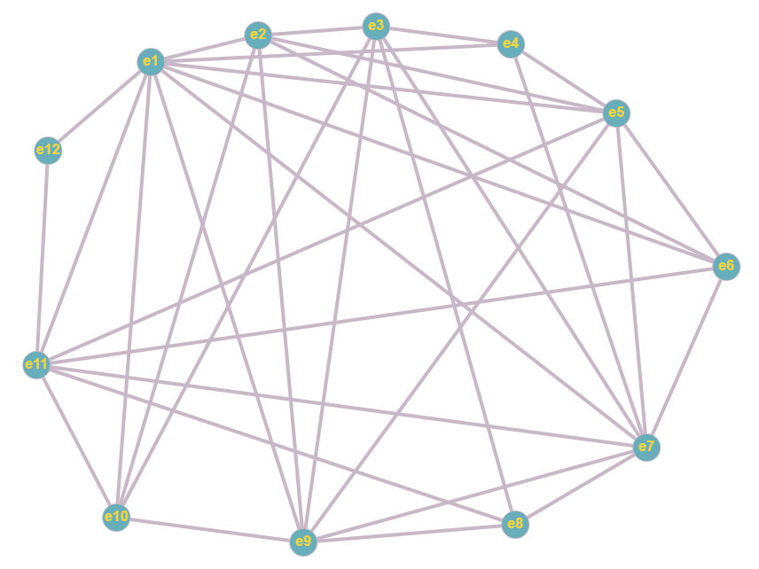

Построим граф пересечений:

|  |  |  |  |  |  |  |  |  |  |  |  |  |  |  |  |
| --- | --- | --- | --- | --- | --- | --- | --- | --- | --- | --- | --- | --- | --- | --- | --- |
|  | u3-9  (1) | U5-11  (2) | U1-10  (3) | U6-11  (4) | U1-9  (5) | U1-4  (6) | U4-7  (7) | U2-10  (8) | U3-10  (9) | U2-5  (10) | U1-5  (11) | U1-6  (12) | U5-7  (13) | U7-9  (14) | U7-11  (15) |
| u3-9 (1) | 1 | 1 |  | 1 |  | 1 |  |  |  | 1 | 1 | 1 |  |  | 1 |
| U5-11 (2) | 1 | 1 | 1 |  | 1 |  | 1 | 1 | 1 |  |  | 1 |  |  |  |
| U1-10 (3) |  | 1 | 1 | 1 |  |  |  |  |  |  |  |  |  |  | 1 |
| U6-11 (4) | 1 |  | 1 | 1 | 1 |  | 1 | 1 | 1 |  |  |  | 1 |  |  |
| U1-9 (5) |  | 1 |  | 1 | 1 |  |  | 1 | 1 |  |  |  |  |  | 1 |
| U1-4 (6) | 1 |  |  |  |  | 1 |  | 1 | 1 | 1 |  |  |  |  |  |
| U4-7 (7) |  | 1 |  | 1 |  |  | 1 |  |  | 1 | 1 | 1 |  |  |  |
| U2-10 (8) |  | 1 |  | 1 | 1 | 1 |  | 1 |  |  | 1 | 1 |  |  | 1 |
| U3-10 (9) |  | 1 |  | 1 | 1 | 1 |  |  | 1 | 1 | 1 | 1 |  |  | 1 |
| U2-5 (10) | 1 |  |  |  |  | 1 | 1 |  | 1 | 1 |  |  |  |  |  |
| U1-5 (11) | 1 |  |  |  |  |  | 1 | 1 | 1 |  | 1 |  |  |  |  |
| U1-6 (12) | 1 | 1 |  |  |  |  | 1 | 1 | 1 |  |  | 1 | 1 |  |  |
| U5-7 (13) |  |  |  | 1 |  |  |  |  |  |  |  | 1 | 1 |  |  |
| U7-9 (14) |  |  |  |  |  |  |  |  |  |  |  |  |  | 1 |  |
| U7-11 (15) | 1 |  | 1 |  | 1 | 1 |  | 1 | 1 |  |  |  |  |  | 1 |

Построение семейства Ψg.

J(i) = {3, 5, 7, 8, 9, 13, 14}

M1,3 = r1 v r3 = {111101000111001}

J(i) = {5, 7, 8, 9, 13, 14}

M1,3,5 = {111111011111001}

J(i) = {7, 13, 14}

M1,3,5,7 = {111111111111001}

J(i) = {13, 14}

M1,3,5,7,13 = {111111111111101}

J(i) = {14}

M1,3,5,7,13,14 = {111111111111111}

Ψ1 = {u3-9, u1-10, u1-9, u4-7, u5-7, u7-9}

M1,3,7 = {111101100111001}

J(i) = {5, 8, 9, 13, 14}

M1,3,7,8 = {111111110111001}

J(i) = {9, 13, 14}

M1,3,7,8,9,13,14 = {111111111111111}

Ψ2 = {u3-9, u1-10, u4-7, u2-10, u3-10, u5-7, u7-9}

Дальше покрыть невозможно, переходим к следующей строчке.

J(i) = {4, 6, 10, 11, 13, 14, 15}

M2,4 = r2 v r4 = {111110111001100}

J(i) = {6, 10, 11, 14, 15}

M2,4,6 = {111111111101100}

J(i) = {11, 14, 15}

M2,4,6,11 = {111111111111100}

J(i) = {14, 15}

M2,4,6,11,14 = {111111111111110}

J(i) = {15}

M2,4,6,11,14,15 = {111111111111111}

Ψ3 = {u5-11, u6-11, u1-4, u1-5, u7-9, u7-11}

M2,4,10 = {111111111101100}

J(i) = {11, 14, 15}

Ψ4 = {u5-11, u6-11, u2-5, u1-5, u7-9, u7-11}2,4,10,11,14,15

M2,6 = {111011111101000}

J(i) = {4, 11, 13, 14, 15}

M2,6,11 = {111011111111000}

J(i) = {4, 13, 14, 15}

M2,6,11,13 = {111111111111100}

J(i) = {14, 15}

M2,6,11,13,14,15 = {111111111111111}

Ψ5 = {u5-11, u1-4, u1-5, u5-7, u7-9, u7-11}

M2,10 = {111011111101000}

J(i) = {4, 11, 13, 14, 15}

M2,10,11 = {111011111111000}

J(i) = {4, 13, 14, 15}

M2,10,11,13 = {111111111111100}

J(i) = {14, 15}

M2,10,11,13,14,15 = {111111111111111}

Ψ6 = {u5-11, u2-5, u1-5, u5-7, u7-9, u7-11 }

Дальше покрыть невозможно, переходим к следующей строчке.

J(i) = {1, 5, 6, 7, 8, 9, 10, 11, 12, 13, 14}

M3,5 = {011110011000001}

J(i) = {1, 6, 7, 10, 11, 12, 13, 14}

M3,5,6 = {111111011100001}

J(i) = {7, 11, 12, 13, 14}

M3,5,6,7 = {111111111111001}

J(i) = {13, 14}

M3,5,6,7,13,14 = {111111111111111}

Ψ7 = {u5-11, u1-9, u1-4, u4-7, u5-7, u7-9}

M3,5,6,11 = {111111111110001}

J(i) = {12, 13, 14}

Ψ8 = {u5-11, u1-9, u1-4, u1-5, u1-6, u7-9}

Ψ9 = {u5-11, u1-9, u1-4, u1-5, u5-7, u7-9}

M3,5,10 = {111111111100001}

J(i) = {11, 12, 13, 14}

M3,5,10,11 = {111111111110001}

J(i) = {12, 13, 14}

M3,5,10,11,12 = {111111111111101}

J(i) = {14}

M3,5,10,11,12,14 = {111111111111111}

Ψ10 = {u1-10, u1-9, u2-5, u1-5, u1-6, u7-9}

J(i) = {12, 13, 14}

M3,5,10,11,13,14 = {111111111111101}

Ψ11 = {u1-10, u1-9, u2-5, u1-5, u5-7, u7-9}

Дальше покрыть невозможно, переходим к следующей строчке.

J(i) = {2, 6, 10, 11, 12, 14, 15}

M4 = {101110111000100}

M4,6 = {111111011100001}

J(i) = {7, 11, 12, 13, 14}

M4,6,7,13,14 = {111111111111111}

Ψ12 = {u6-11, u1-4, u4-7, u5-7, u7-9}

M4,6,11,12,14 = {111111111111111}

Ψ13 = {u6-11, u1-4, u1-5, u1-6, u7-9}

M4,6,11,13,14 = {111111111110001}

Ψ14 = {u6-11, u1-4, u1-5, u5-7, u7-9}

M4,10 = {101111111100100}

J(i) = {2, 11, 12, 14, 15}

M4,10,11 = {101111111110100}

J(i) = {2, 12, 14, 15}

M4,10,11,12 = {111111111111100}

J(i) = {14, 15}

M4,10,11,12,14,15 = {111111111111111}

Ψ15 = {u6-11, u2-5, u1-5, u1-6, u7-9, u7-11}

Дальше покрыть невозможно, переходим к следующей строчке. 5->6->7->8->9->10->11->12->13->14->15

Дальнейшее построение невозможно.

Ψ1 = {u3-9, u1-10, u1-9, u4-7, u5-7, u7-9}

Ψ2 = {u3-9, u1-10, u4-7, u2-10, u3-10, u5-7, u7-9}

Ψ3 = {u5-11, u6-11, u1-4, u1-5, u7-9, u7-11}

Ψ4 = {u5-11, u6-11, u2-5, u1-5, u7-9, u7-11}

Ψ5 = {u5-11, u1-4, u1-5, u5-7, u7-9, u7-11}

Ψ6 = {u5-11, u2-5, u1-5, u5-7, u7-9, u7-11}

Ψ7 = {u5-11, u1-9, u1-4, u4-7, u5-7, u7-9}

Ψ8 = {u5-11, u1-9, u1-4, u1-5, u1-6, u7-9}

Ψ9 = {u5-11, u1-9, u1-4, u1-5, u5-7, u7-9}

Ψ10 = {u1-10, u1-9, u2-5, u1-5, u1-6, u7-9}

Ψ11 = {u1-10, u1-9, u2-5, u1-5, u5-7, u7-9}

Ψ12 = {u6-11, u1-4, u4-7, u5-7, u7-9}

Ψ13 = {u6-11, u1-4, u1-5, u1-6, u7-9}

Ψ14 = {u6-11, u1-4, u1-5, u5-7, u7-9}

Ψ15 = {u6-11, u2-5, u1-5, u1-6, u7-9, u7-11}

Матрица значений критерия αγδ=׀ψγ׀ + ׀ψδ׀ - ׀ψγ∩ψδ׀

|  |  |  |  |  |  |  |  |  |  |  |  |  |  |  |  |
| --- | --- | --- | --- | --- | --- | --- | --- | --- | --- | --- | --- | --- | --- | --- | --- |
|  | 1 | 2 | 3 | 4 | 5 | 6 | 7 | 8 | 9 | 10 | 11 | 12 | 13 | 14 | 15 |
| 1 | 0 | 8 | 11 | 11 | 10 | 10 | 8 | 10 | 9 | 9 | 8 | 8 | 10 | 9 | 11 |
| 2 |  | 0 | **12** | **12** | 11 | 11 | 10 | **12** | 11 | 11 | 10 | 9 | 11 | 10 | **12** |
| 3 |  |  | 0 | 7 | 7 | 8 | 9 | 8 | 8 | 10 | 10 | 8 | 7 | 7 | 8 |
| 4 |  |  |  | 0 | 8 | 7 | 10 | 9 | 9 | 9 | 9 | 9 | 8 | 8 | 7 |
| 5 |  |  |  |  | 0 | 8 | 8 | 8 | 8 | 10 | 9 | 9 | 8 | 7 | 9 |
| 6 |  |  |  |  |  | 0 | 9 | 9 | 9 | 9 | 9 | 9 | 9 | 9 | 8 |
| 7 |  |  |  |  |  |  | 0 | 8 | 7 | 10 | 9 | 7 | 9 | 8 | 11 |
| 8 |  |  |  |  |  |  |  | 0 | 7 | 8 | 9 | 9 | 7 | 8 | 9 |
| 9 |  |  |  |  |  |  |  |  | 0 | 9 | 8 | 8 | 8 | 7 | 10 |
| 10 |  |  |  |  |  |  |  |  |  | 0 | 7 | 10 | 8 | 9 | 8 |
| 11 |  |  |  |  |  |  |  |  |  |  | 0 | 9 | 9 | 8 | 9 |
| 12 |  |  |  |  |  |  |  |  |  |  |  | 0 | 7 | 6 | 9 |
| 13 |  |  |  |  |  |  |  |  |  |  |  |  | 0 | 6 | 7 |
| 14 |  |  |  |  |  |  |  |  |  |  |  |  |  | 0 | 8 |
| 15 |  |  |  |  |  |  |  |  |  |  |  |  |  |  | 0 |

max αγδ = α2,3 = α2,4 = α2,8 = α2,5

Возьмем множества Ψ2 и Ψ3

Ψ2 = {u3-9, u1-10, u4-7, u2-10, u3-10, u5-7, u7-9}

Ψ3 = {u5-11, u6-11, u1-4, u1-5, u7-9, u7-11}

Ребра, вошедшие в Ψ2 – внутри гамильтонова цикла, а ребра, вошедшие в Ψ3 – снаружи.

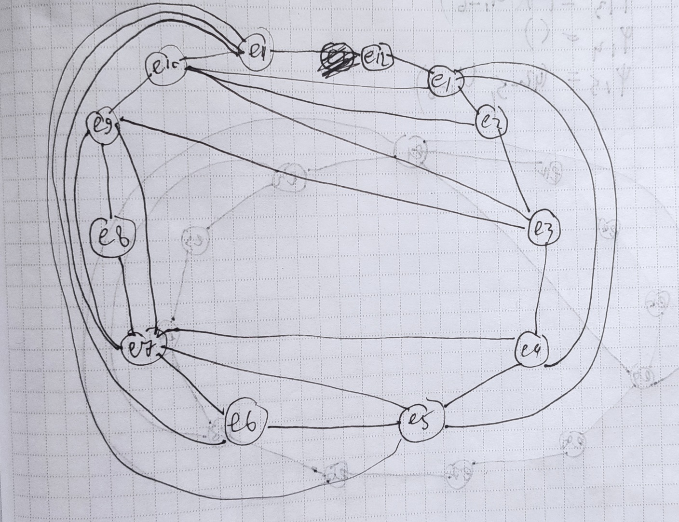

Удаление из Ψ реализованных ребер:

Ψ1 = {u1-9}

Ψ4 = {u2-5}

Ψ5 = {}

Ψ6 = {u2-5}

Ψ7 = {u1-9}

Ψ8 = {u1-9, u1-6}

Ψ9 = {u1-9}

Ψ10 = {u1-9, u2-5, u1-6}

Ψ11 = {u1-9, u2-5}

Ψ12 = {}

Ψ13 = {u1-6}

Ψ14 = {}

Ψ15 = {u2-5, u1-6}

Объединение множеств:

Ψ1 = {u1-9}

Ψ4 = {u2-5}

Ψ5 = {}

Множества:

Ψ1 = {u1-9}

Ψ4 = {u2-5}

Ψ5 = {}

Ψ8 = {u1-9, u1-6}

Ψ10 = {u1-9, u2-5, u1-6}

Ψ11 = {u1-9, u2-5}

Ψ13 = {u1-6}

Ψ15 = {u2-5, u1-6}

|  |  |  |  |  |  |  |  |  |
| --- | --- | --- | --- | --- | --- | --- | --- | --- |
|  | 1 | 4 | 5 | 8 | 10 | 11 | 13 | 15 |
| 1 | 0 | 2 | 1 | 2 | **3** | 2 | 2 | **3** |
| 4 |  | 0 | 1 | **3** | **3** | 2 | 2 | 2 |
| 5 |  |  | 0 | 2 | **3** | 2 | 1 | 2 |
| 8 |  |  |  | 0 | **3** | **3** | 2 | **3** |
| 10 |  |  |  |  | 0 | **3** | **3** | **3** |
| 11 |  |  |  |  |  | 0 | **3** | **3** |
| 13 |  |  |  |  |  |  | 0 | 2 |
| 15 |  |  |  |  |  |  |  | 0 |

max αγδ = α1,10 = α1,15 = α4,8 = α4,10 = α5,10 = α8,10 = α8,11 = α8,15 = α10,11 = α10,13 = α10,15 = α11,13 = α11,15

Возьмем множества Ψ1 и Ψ10

Ψ1 = {u1-9}

Ψ10 = {u1-9, u2-5, u1-6}

Ребра, вошедшие в Ψ1 – внутри гамильтонова цикла, а ребра, вошедшие в Ψ10 – снаружи.

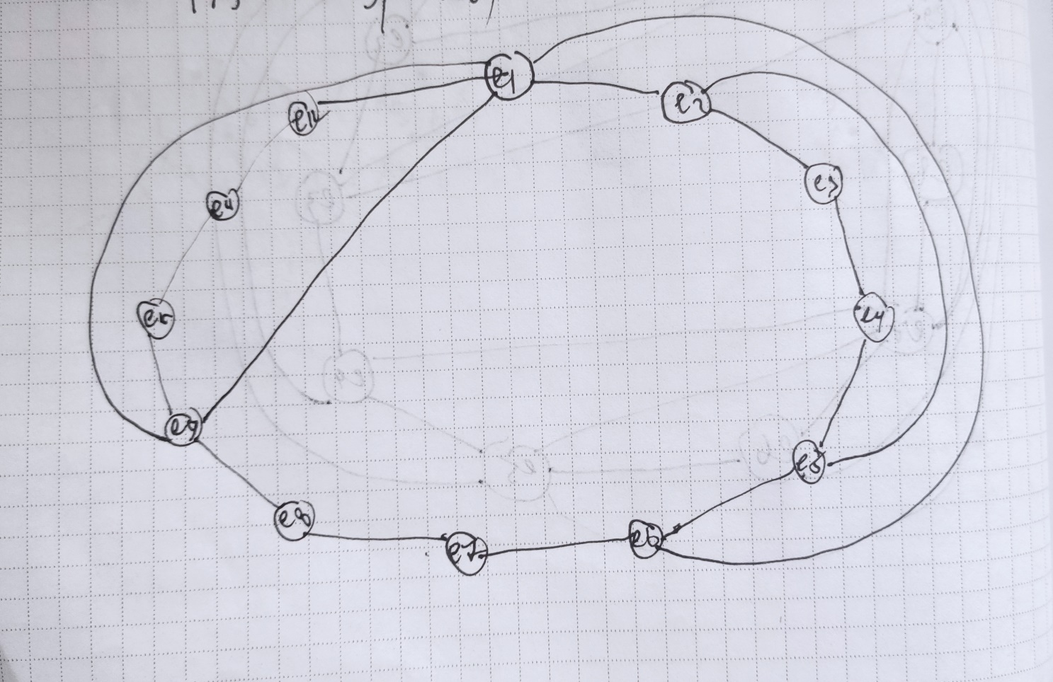

Удалив все реализованные ребра, получили пустое множество.

Все ребра графа реализованы. Толщина графа m = 3