Install Guide For pre-demo BAMER
You will need:
EXILED/LABAPI
MER
Local_Server

1. Install Blender
Download — blender.org

2. Install zip file for BAMER_ADDON
3. Open Blender and Drag and Drop the zip file and press OK to install Addon
4. Press Ctrl+A and delete to delete everything
5. Click on a side bar
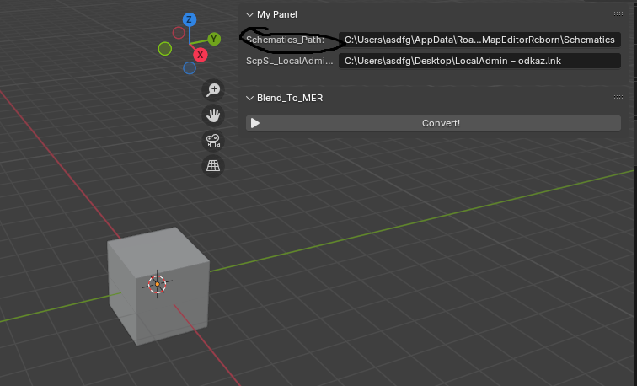
6. Find your Schematics path press Windows+R type %appdata% then open your EXILED file then to Configs – MapEditorReborn – Schematics and copy the path. It should look something like this:
C\Users\user_name\AppData\Roaming\EXILED\Configs\MapEditorReborn\Schematics
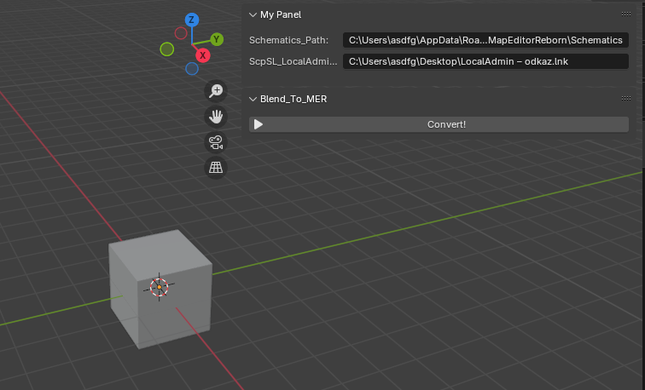
Then Copy it to Schematics_Path:

Then find your Local testing server folder ,right click Local Admin click more options.
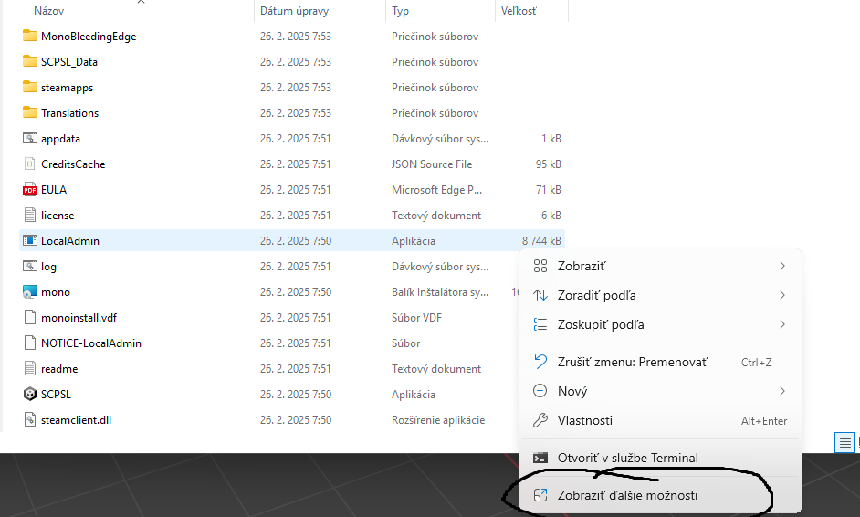
After that a new AdminLocal – link should be created. Drag and drop AdminLocal – link into any empty folder (Desktop,Recomended)
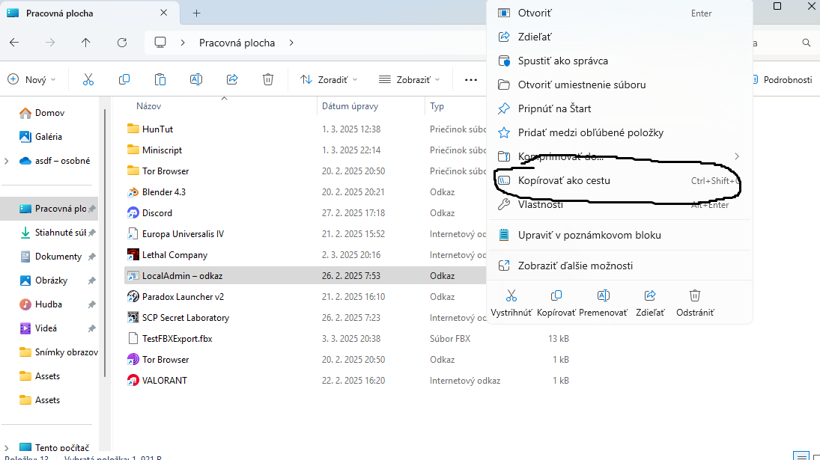
Then go to Desktop folder right click LocalAdmin – link and click Copy as Path
After that paste it into ScpSL_LocalAdmin - link

