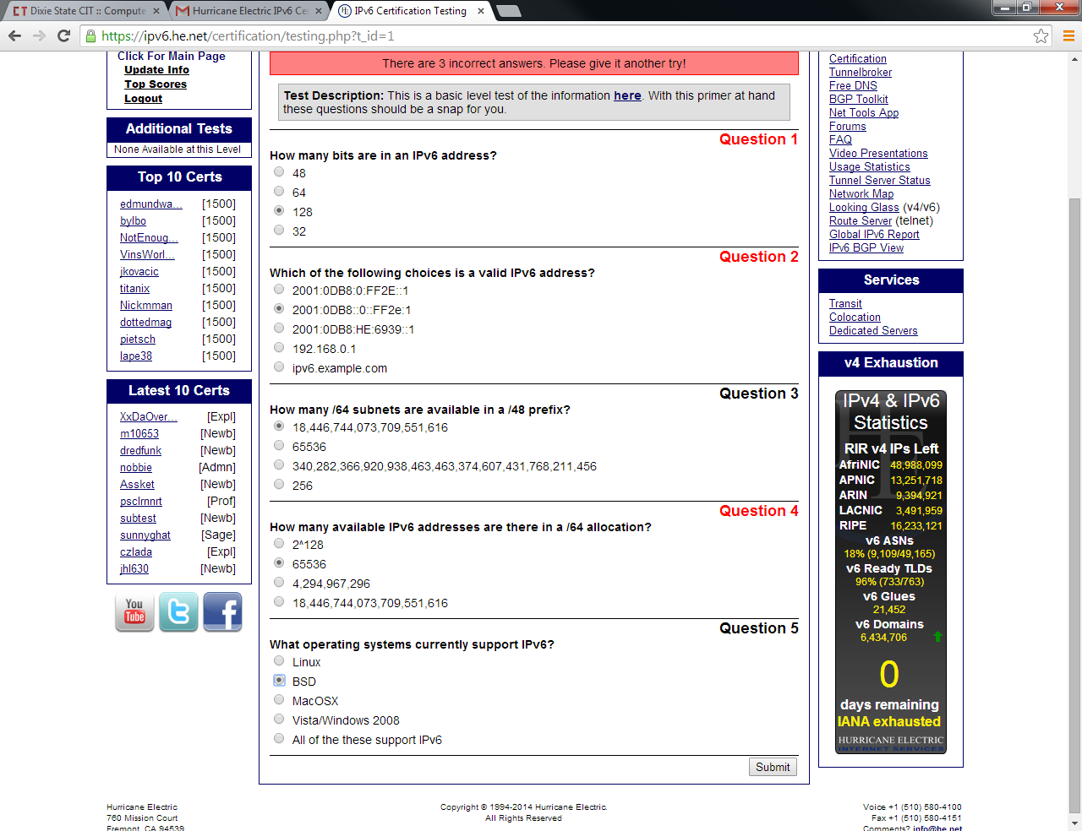

128

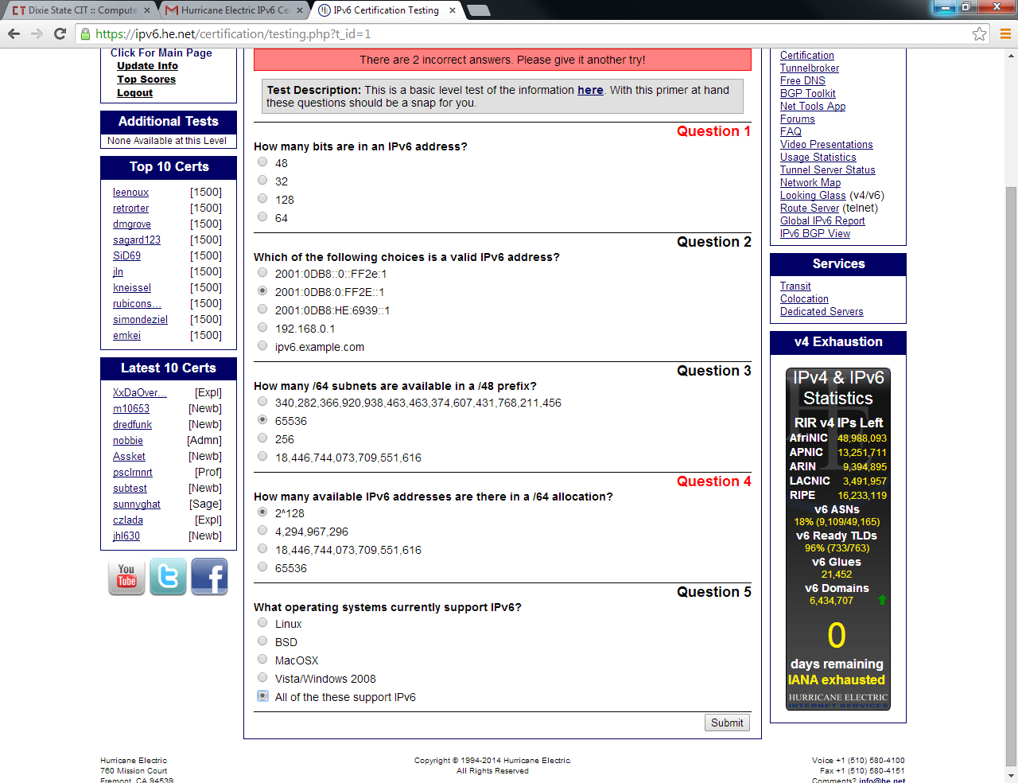

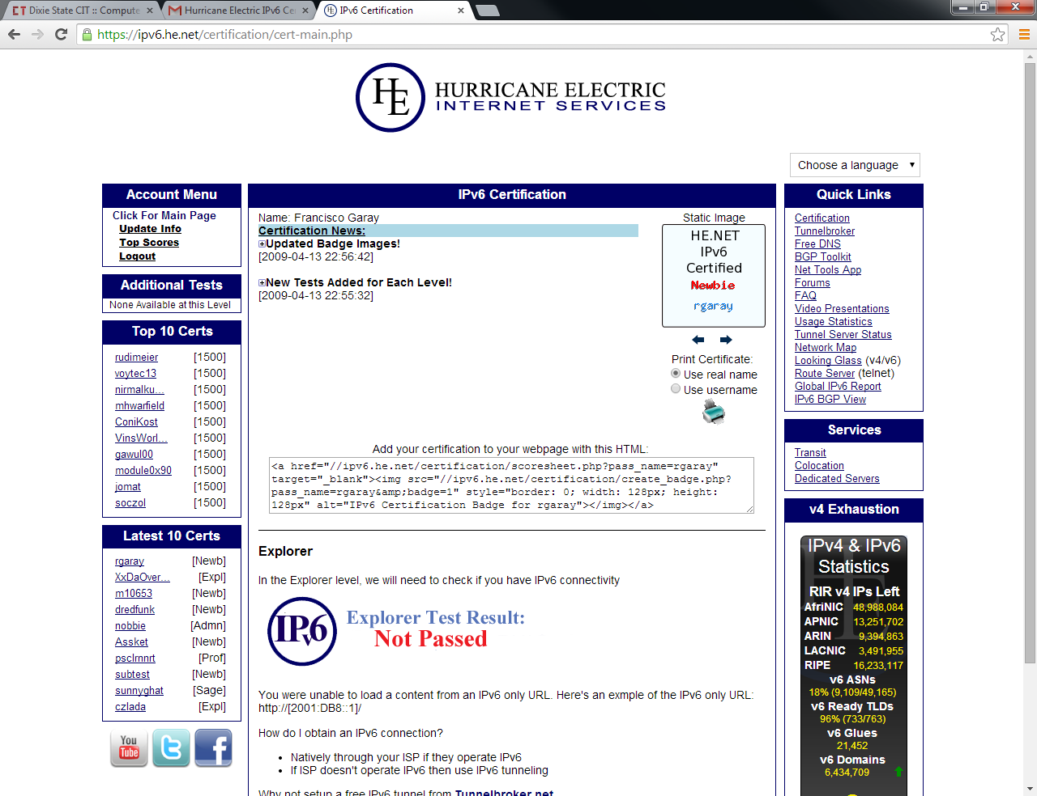

A9XBhN9Rt

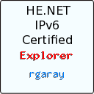

**What features of IPv6 do you see yourself using?**



**Question 2**

**If you were setting up a network of 12 million hosts that all needed their own unique globally routable addresses, which protocol would you use?**

 IPv4  
 IPng  
 IPv5  
 IPx  
 IPv6

**Question 3**

**Do you plan on making sure your workplace is IPv6 ready before IPv4 exhaustion?**

 Yes  
 No

**Question 4**

**Do you think that any of your co-workers or friends would find Hurricane Electric's IPv6 certification useful?**

 Very much  
 Somewhat  
 Not at all

**Question 5**

**Do you think you would benefit from using Hurricane Electric's free IPv6 certification process at work?**

 Very much  
 Somewhat  
 Not at all

**You request IPv6 glue for your nameservers through:**

 IETF  
 RIPE  
 ARIN  
 The registrar of the domain used by your name servers

**Pv6 glue for nameservers resides on which nameservers?**

 The ROOTs'  
 Your own  
 The TLDs'

**Question 3**

**Which of the following queries proves working IPv6 glue?**

 dig A ns1.exampledomain.tld @tld.server  
 dig AAAA ns1.exampledomain.tld @tld.server  
 dig -x 2001:db8::1 @tld.server  
 ping ns1.exampledomain.tld

**Question 4**

**Which TLD listed below is authoritative for .com & .net IPv6 Glue?**

 ipv6.arpa  
 a0.org.afilias-nst.info  
 GDNS1.ULTRADNS.NET  
 A.GTLD-SERVERS.net

**Question 5**

**What is another name sometimes used for A or AAAA nameserver glue records found in the top level domain zone files?**

 CNAME records  
 PTR records  
 GHOST records  
 host records

**Question 6**

**What is a registrar?**

 A nameserver  
 A glue record  
 An organization that is able to register domains  
 A notary

**Question 7**

**What is a registry?**

 A nameserver  
 A notary  
 An organization responsible for operating the authorative nameservers and database for a top level domain  
 A host record

**Question 8**

**Why does getting AAAA records for your nameservers in the corresponding TLD (top level domain) zone matter?**

 It enables entirely native IPv6 DNS queries and makes it possible for IPv6 only hosts to reach the nameservers for your domain, since they can't use glue that is just an A record.  
 It provides reverse DNS for your domain  
 It registers your domain  
 It doesn't. It's too hard, so you shouldn't bother.

**Question 9**

**IPv6 AAAA records have been added for several of the root nameservers.**

 True  
 False