L/M/S Segment – MEME
Result: Nothing for ANDVall, humanout, or stems at q-value of 0.1 (BH FDR) across tests

L Segment – FEL
ANDVall
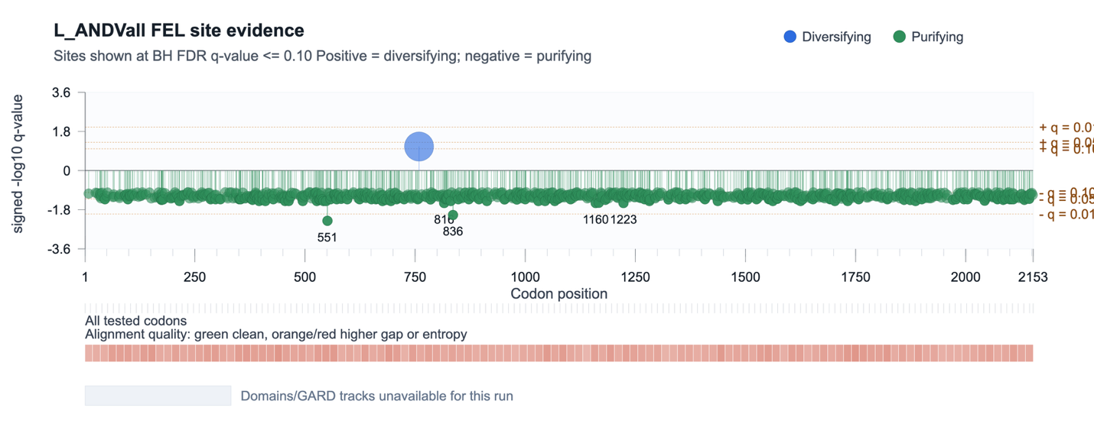
Stems
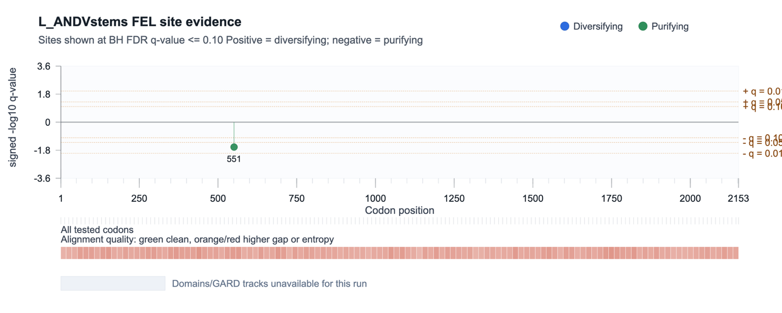
Humanout
Result: Nothing

M Segment – FEL
ANDVall
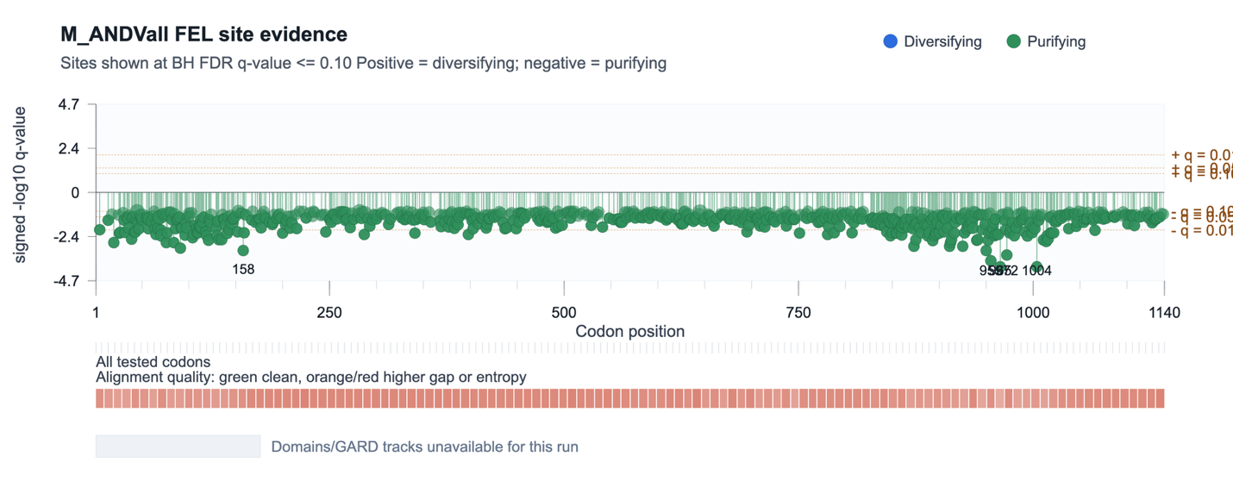
Stems
Result: Nothing

Humanout
Result: Nothing

S Segment – FEL
ANDVall
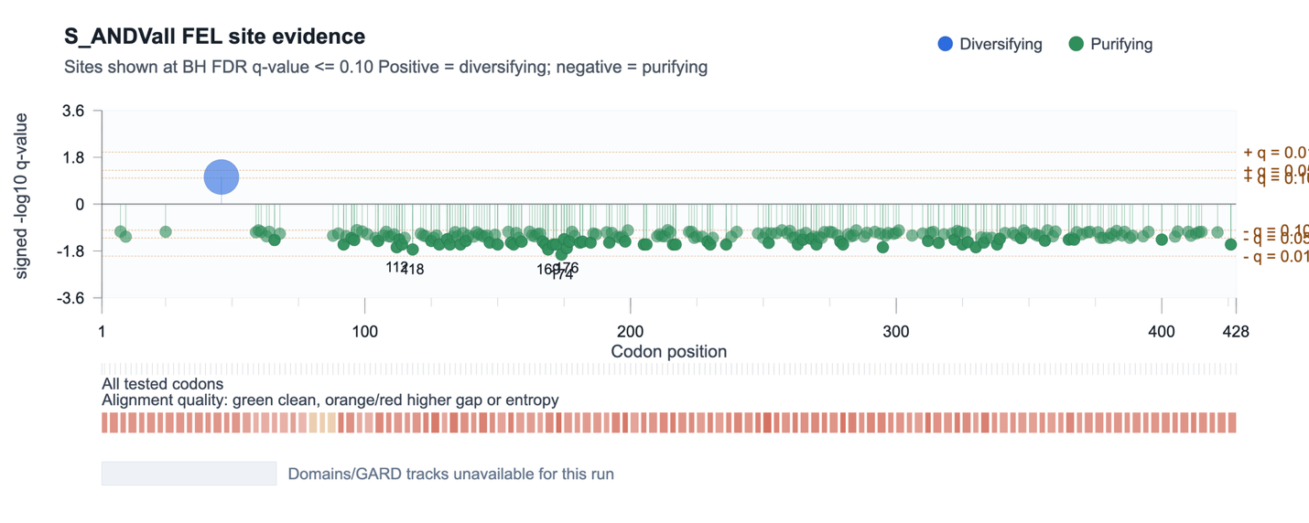
Stems
Result: Nothing

Humanout
Result: Nothing

L/M/S Segment – aBSREL & RELAX

