List of contents
1 Theoretical preparation 0
2 Work Course 0
3 Screenshots 0
4 Answers to the questions 0
4.1 Step 6 0
4.2 Step 7 0

Theoretical preparation

In the theoretical preparation of this exercise, we will primarily focus on the devices required to set up a network similar to the one in our assignment. There are four devices that we will encounter below:

Router
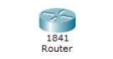

Switch
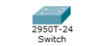

DHCP Server


Computer


Course of work

To begin with, we created the network by placing the devices in the emulator and connecting them using the cables suggested by the assignment. We then added modules to the router devices to be able to connect the two routers together. Immediately afterwards, we configured the WAN by assigning IP addresses and activating the clocking function on one router. The next step was to enable the connection between the routers and their respective switches. After successfully activating them, it was time to set IP addresses for our LANs. In LAN1, we had to assign static IPs manually as there is no DHCP server, unlike LAN2, where IP addresses are assigned dynamically. Finally, we enabled the WAN link, allowing the two routers to communicate with each other.
Screenshot

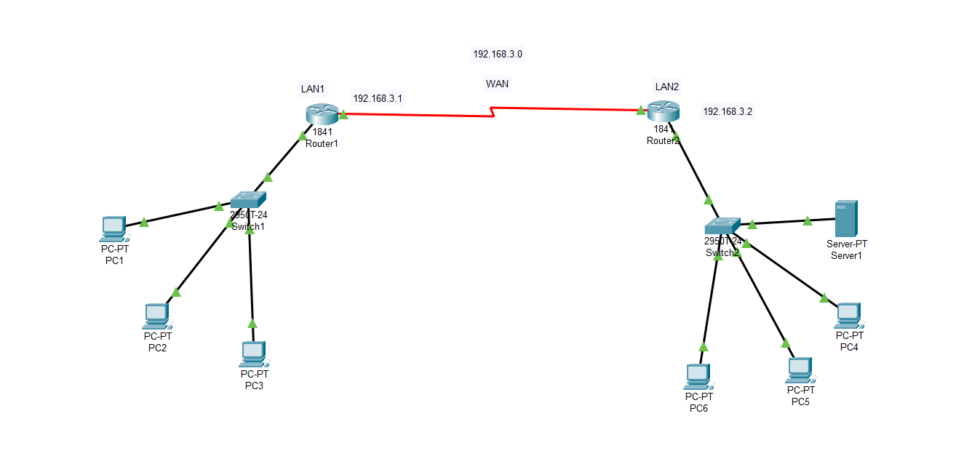

Answers to the questions

Step 6

In the Command Prompt on the PC1 Desktop with the command arp -a view the ARP table. What do you notice and why? (screenshot)
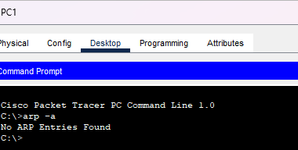
We notice that the ARP table is empty because PC1 has not communicated with any device so far.
----------------------------------------------------------------------------------------------------------

Perform a ping from PC1 to PC2, PC3, PC4, PC5, and PC6. Is there a difference in the responses? (screenshot)
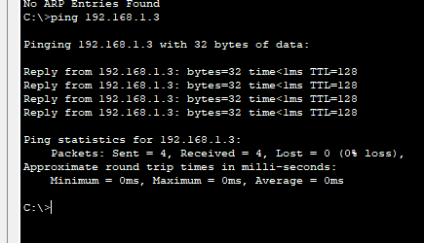
PC2 ping
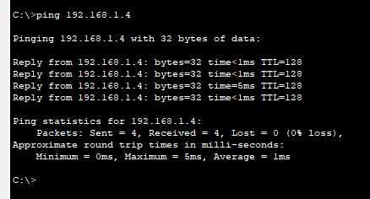
PC3 ping

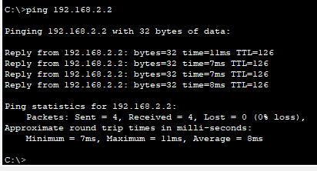
PC4 ping

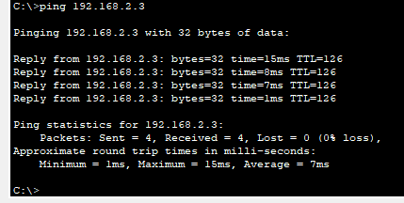
PC5 ping
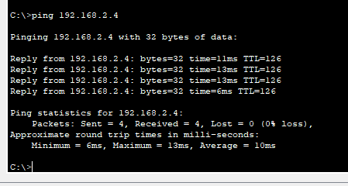
PC6 ping

As we can see, there is a difference in the time the packet travels when we ping a device from the other network (LAN2).

Look again at the ARP table on PC1. Is there a difference compared to Question 6? (screenshot)


Do any entries appear in the PC4 ARP table? Why?
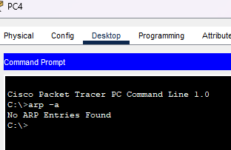
The reason nothing appears in either of the two tables is that Cisco Packet Tracer does not retain the ARP cache for devices that have communicated with each other in this simulation state.
Step 7

Using the command show ip route, confirm that the routers only "see" the LAN networks they are directly connected to(screenshot).
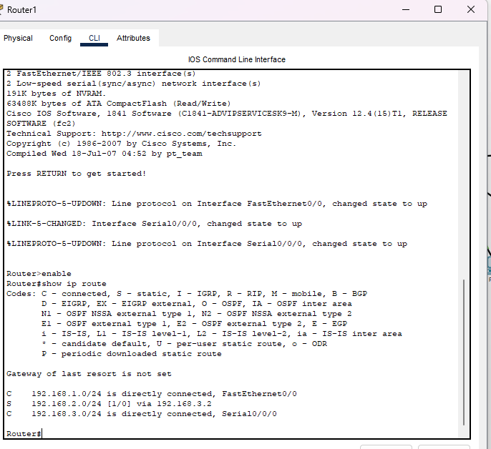
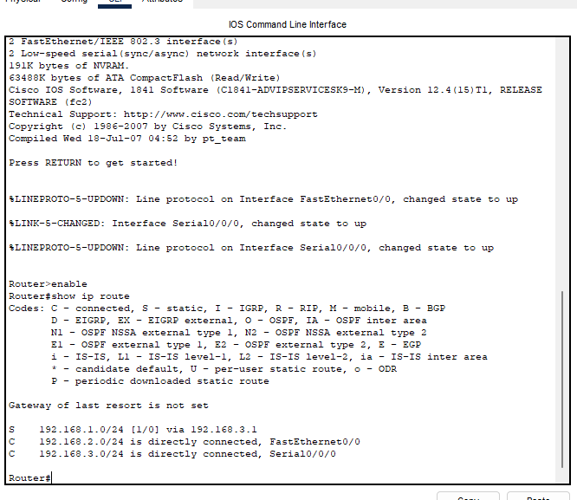
5. Ping from PC1 to PC2, PC3, PC4, PC5, and PC6. Do all PCs respond?
6. Ping from PC4 to PC1, PC2, PC3, PC5, and PC6. Do all PCs respond?
7. Export the ARP table from PC1 and PC4. Are the expected entries present?
As observed previously, all devices respond to the ping commands; however, the ARP tables remain empty for the reasons mentioned above.

