List of contents
1 Theoretical preparation 0
2 Work Course 0
3 Screenshots 0
4 Answers to the questions 0
4.1 Step 1 0
4.2 Step 2 0
4.3 Step 3 0
4.4 Step 4 0

Theoretical preparation

The Spanning Tree Protocol (STP) is a connection management protocol responsible for ensuring the elimination of loops at the local network level when multiple switches are connected to each other. The switches communicate with each other through Bridge Protocol Data Units (BPDUs). There are three kinds of messages: Configuration BPDU, Topology Change Notification BPDU, and Topology Notification Acknowledgement BPDU. STP elects a Root Switch based on the Bridge Priority parameter. Furthermore, ports are defined in four categories: Root Ports, Designated Ports, Alternative Ports, and Non-Designated Ports.

Course of work

The workflow began with creating an initial network to understand the fundamental operations of the STP protocol. Subsequently, we designed two larger network topologies, where we manually changed the Root Bridges and adjusted Bridge Priorities. Overall, the process was straightforward as the instructions were clear and concise.
Screenshots
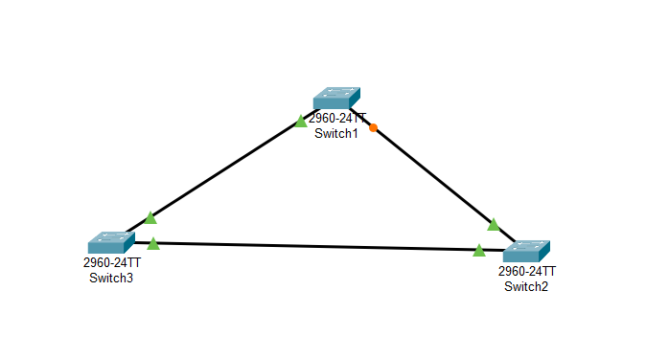
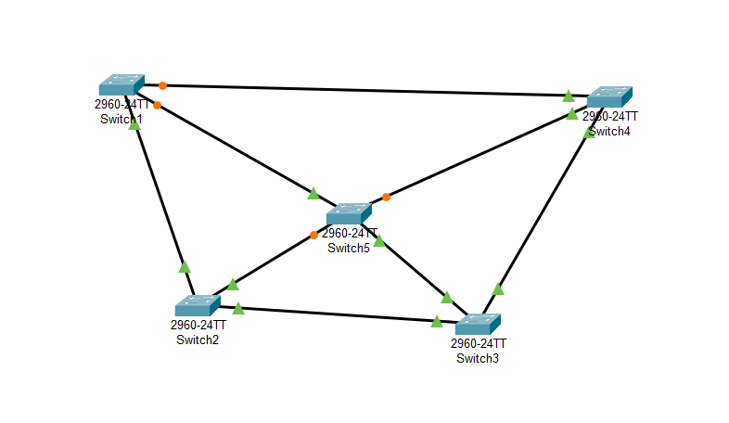

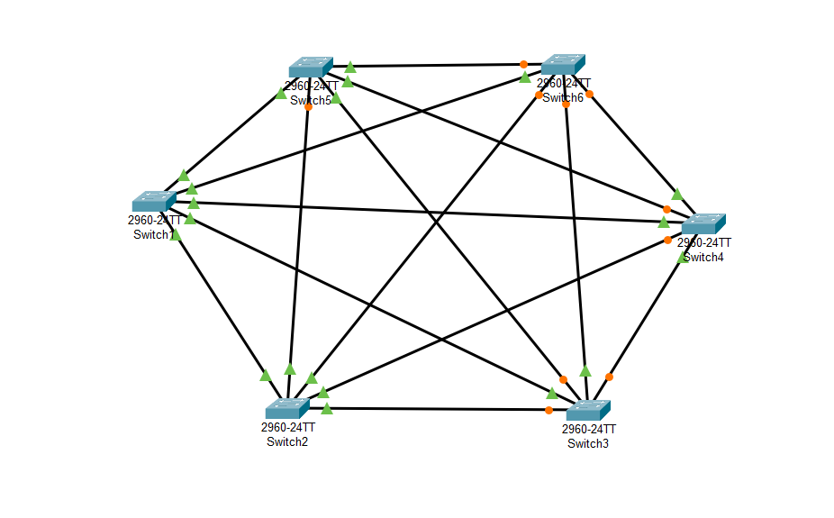

Answers to the questions

Step 1

Are all indications green now? If not, why?

As observed in the network diagram, not all indicators are green. The protocol has blocked the link between Switch 1 and Switch 3 to prevent a broadcast storm and maintain a loop-free topology.

In the CLI on each Switch, run the command show spanning-tree vlan 1
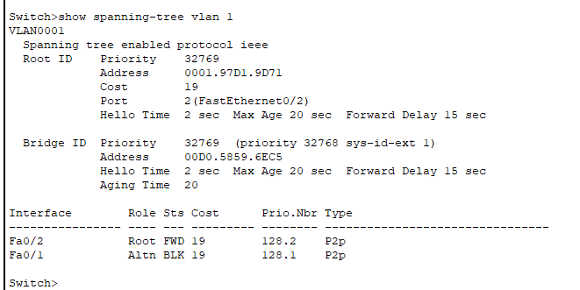
Switch 1
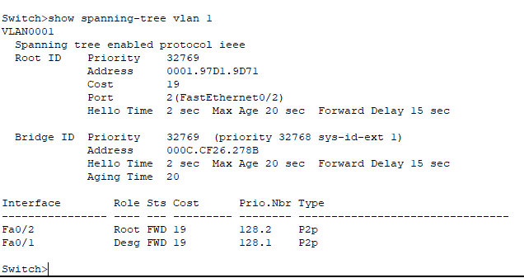
Switch 2

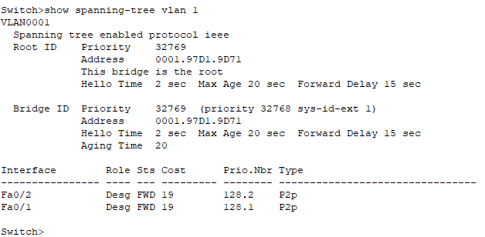
Switch 3

Which Switch is the Root, which port has been blocked, and why?

Switch 3 was elected as the Root Bridge, as indicated by the fact that the ports on the other two switches leading to it are designated as Root Ports. Port 1 on Switch 1 has been placed in a Blocking state to eliminate the loop.
Step 2&3

Check if there is a closed loop where all indicators are green. (screenshot)
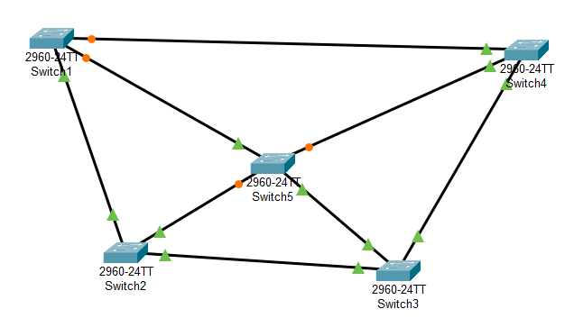
There is no loop where all indicators remain green. Opening a blocked port would immediately result in a network loop, which STP is designed to prevent.

Check if any port could be "green" without a loop
Ιt is not possible to transition a port to a forwarding state (green) without creating a loop.
In the CLI on each Switch, run the command (screenshot)
Switch>show spanning-tree vlan 1
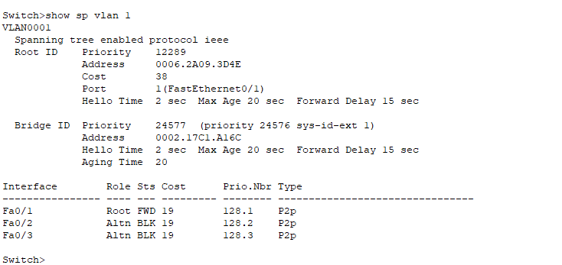
Switch 1
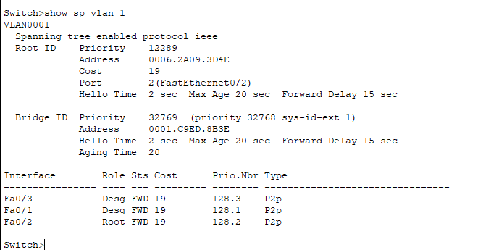
Switch 2
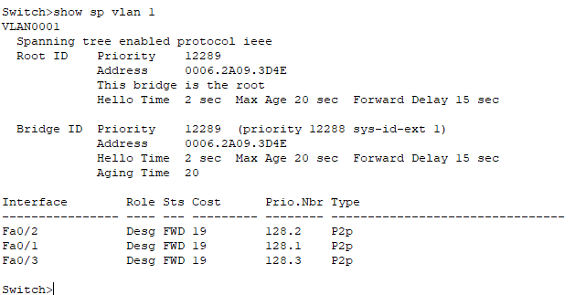
Switch 3
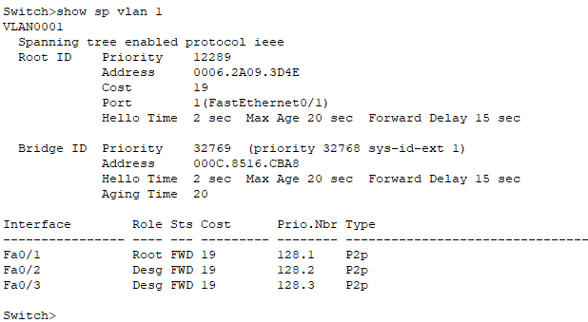
Switch 4
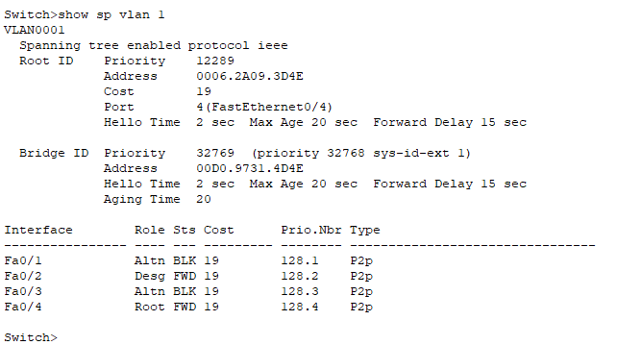
Switch 5

Which switch is elected as Root and which ports are blocked?
Switch 3 remains the root as all ports leading directly to it are active Root Ports. Redundant ports are set to Alternate (Blocking) status to ensure only one active path exists between any two segments.

What has changed in the network and why? (screenshot)
Which Switch is now the root? (screenshot)
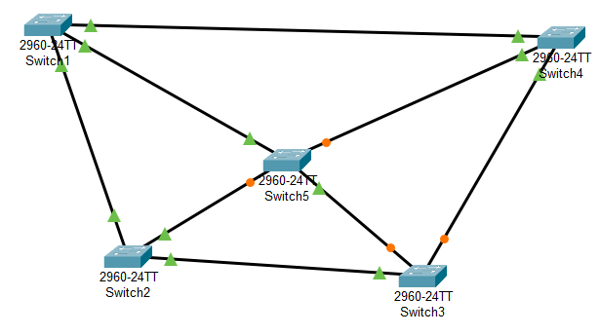
After manually configuring Switch 1 as the root, all of its ports transitioned to a Designated Forwarding (green) state. The other switches in the network re-calculated their path costs and blocked different ports to adapt to the new topology.

Step 4
Configure the STP protocol so that all ports of S2 and S4 are FWD (green forward). (screenshot)
