Game Design Document

Fill up the following document

1. Write the title of your project.

CyberShooter3D

1. What is the goal of the game?

You have to kill all cyber monsters and win the game by good scores

1. Write a brief story of your game.

So,a guy named jake is trapped in cyberMonsters city he is not able

to escape that city so he takes help of a friendly cyberMonster thats

It.

Thanks for reading the Design document of cyberShooter3D

1. Which are the playing characters of this game?

* Playing characters are the ones who respond to the user based on the input from the user.
* Cars, monkeys, dinos, wizards, etc., are the playing characters in the game.

|  |  |  |
| --- | --- | --- |
| Number | Character Name | What can this character do? |
| 1 | Jake | Main player |
| 2 |  |  |
| 3 |  |  |
| 4 |  |  |
| 5 |  |  |
| 6 |  |  |
| 7 |  |  |
| 8 |  |  |

1. Which are the Non-Playing Characters of this game?

* Non-Playing characters are the ones that don't have an action or behavior when the user interacts with the game.
* Hurdles, stones, bananas, coins, etc., are non-playing characters in the game.

|  |  |  |
| --- | --- | --- |
| Number | Character Name | What can this character do? |
| 1 | Friend cyberMonster | Help’s jake |
| 2 | Normal cyberMonsters | Civilions |
| 3 | Army cyberMonsters | Attack’s on jake |
| 4 | Boss cyberMonster | Rules on army |
| 5 |  |  |
| 6 |  |  |
| 7 |  |  |
| 8 |  |  |

Draw your imagination of this game. What does this game look like?

* Draw the game either on your computer or on paper.
* Add images of the game scenes to show each of the playing and non-playing characters at least once.

this is Jake.

this is friendly CyberMonster.

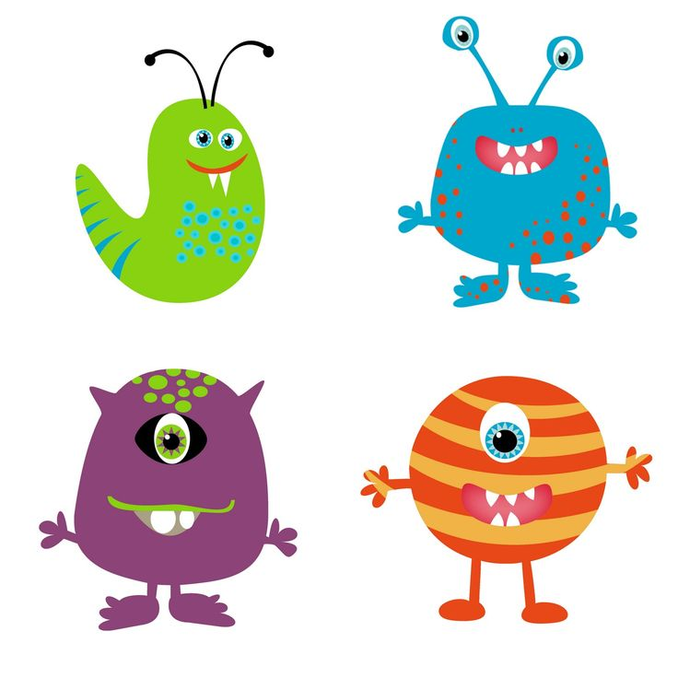Normal monsters.

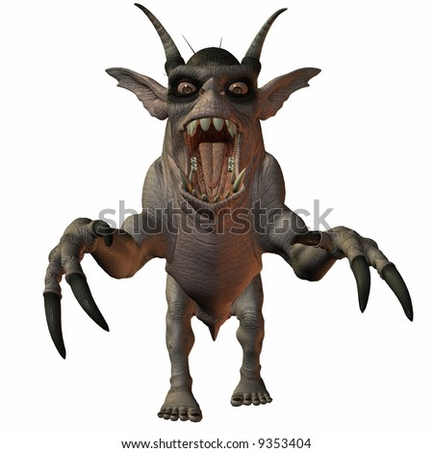Army monsters.

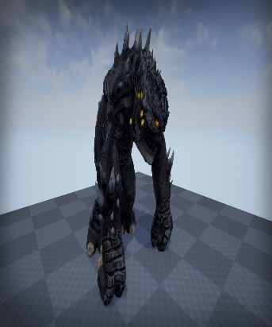 Monster boss.

How do you plan to make your game engaging?

So,the game will have many levels and ill try to make other monsters also

and many bosses etc.and ill make more updates inn the game this will help to make game engaging