CURRICULUM VITAE

Personal info:  MD. SABBIR AHAMMED  Date of birth: 09 October 1999  Blood Group: B+ (positive) Nationality : Bangladeshi Language: Bangla & English | 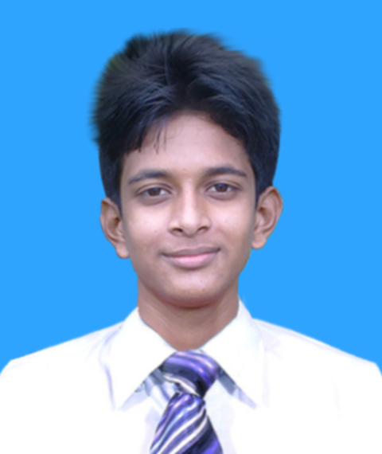 | Present Address:  Vill: Kadda, Nandun,  P.O: Ramkrishnopur,  P.S: Chowgacha,  Dist: Jessore.  Mobile : +8801953 32 14 02  Mail: @gmail.com

Career Objectives:

To face challenges for obtaining organizational vision. Where I can implement my conceptual, educational, skills and experiences.

Language Proficiency:

Bengali : Able to Read, Write, Speak and Understand.
English : Able to Read, Write.

Academic Career:

Higher Secondary Certificate:

Group : Humanities.
Name of the Institution : Chowgacha Degree College.
Board : Jessore Board.
Passing Year : 2016
Result : GPA- 3.67

Secondary School Certificate:

Group : Business Studies.
Name of the Institution : Shahpur Nagar Borni Secondary School.
Board : Jessore Board.
Passing Year : 2014
Result : GPA- 3.81

COMPUTER SKILL:

- Operating System : Microsoft Windows.
- Application : Microsoft Office, Adobe Photoshop, Oracle Database
- Internet : E-Mail And Internet Browsing
- Web Design : Static Web Page Design
- Graphics Design : Business Card, Banner, Book Cover Page, Flyer, Poster & Etc.

Training and Workshops:

- Computer Office Application (Trade of Six Month) From Bangladesh Technical Education Board.
- Graphics Design and Multimedia (Trade of Six Month) From Bangladesh Technical Education Board.
- E-Commerce & E-Marketing from Small & Medium Enterprise Foundation (SME).
- E-Commerce & E-Marketing from E-Commerce Association of Bangladesh (e-CAB).
- Mobile Servicing From Youth Development Directorate, Bangladesh.
- Web Design & Graphics Design (Trade of Six Month) From Skills for Employment Investment Program (SEIP).
- Responsive Web Design (Trade of Three Month) From Creative IT Institute.
- Professional Web Development (Trade of Six Month) From Creative IT Institute.

Experiences

Employer:
Institution: Chaklader Corp
Time: 6 Month
Designation: Digital Marketing Officer
Address: Level - 6, Sheikh Hasina Software Technology Park, Jessore-7400.

Employer:
Institution: Genesis Fashions Ltd.
Time: 3 Years 6 Month
Designation: Computer Operator
Address: 126/1 Kadda Nandun, Gazipur Sadar, Gazipur-1346.

PERSONAL PROFILE:

Name : Md. Sabbir Ahammed
Father’s Name : Md. Ahsan Ullah
Mother’s Name : Mist. Shamima Begum
Date of Birth : 9 Octember, 1999
Marital Status : Single.
Nationality : Bangladeshi.
Religion : Islam.
Sex : Male.
Height : 5.6
Weight : 54kg.
Blood Group : B (+)
Permanent Address : Vill: Nagar Borni, P.O: Ramkrishnopur,
P.S: Chowgacha, Dist: Jessore.

Declaration:

I do here by declare that the information furnished here are true to the best of my knowledge.


Date: 18-08-2021
Signature

