
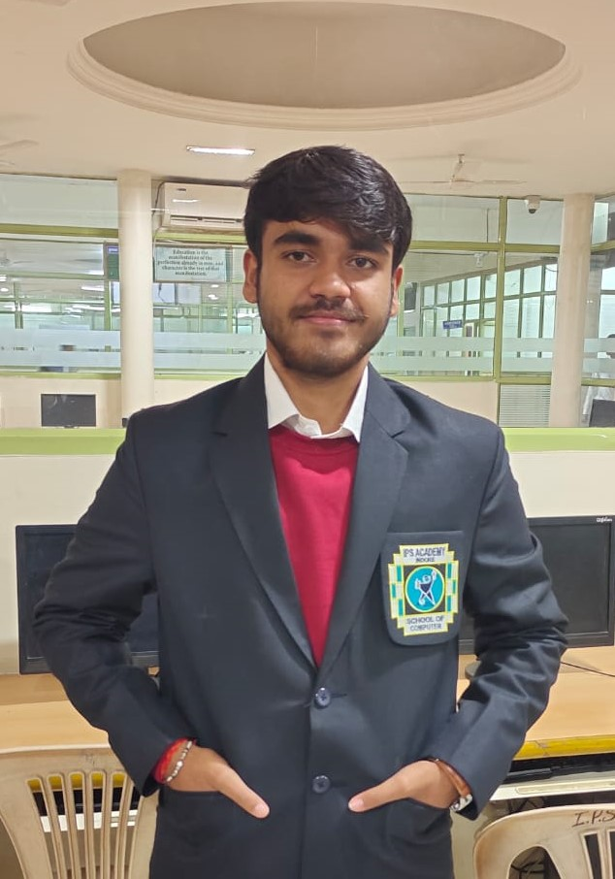

+
SANDEEPP
SHUKLA
CREATIVE DESIGNER
I am a professional creative designer
with 2 years of experience project
management, advertisement, and
computer aided design. Proven ability to
transform client ideas into beautiful,
functional design solutions.
EDUCATION
Master of Computer Architecture
Master of Front-End Design
I.P.S Academy, Indore

I.P.S Institute
WORK EXPERIENCE
Creative Designer
Incorporated integrated sustainable design
solutions into projects, preparing Web Design, Graphics Design, Website Design.
Senior Designer
Incorporated integrated sustainable design
solutions into projects, preparing 2D and
D design drawings
3
Think Unlimited / July 2021 – Mar 2024

CONTACT
SKILLS
+91 7007283116
spywithcode@gmail.com

spywithcodesite.com
Creativity
Leader
Computer
Communication
Unique
Drawing
COVER LETTER BY

MR. SANDEEP

CREATIVE DESIGNER

DEAR SIR…
I am writing a letter of interest in regards to the position in your company. Your company is known for its innovation, professionalism, and results-driven marketing strategy, which is why I am certain I would make a valuable addition to your team. I would be interested in learning more about the company and available opportunities, so I have enclosed my resume for your consideration.
I am confident that my experience in this field will be an asset to your company. As you will see on my resume, I have a proven record of achievements, which will allow me to make major contributions to your company.
I look forward to speaking with you to discuss how my experience and abilities match your needs. I will call you on the day of the week to see what day and time fit your busy schedule. Don’t hesitate to contact me at your phone number or contact me by email at your email address should you have any questions. I look forward to speaking with you.

MR. SANDEEP SHUKLA

