\
QO-100 transverter
TX 2.4G

max 5W
rev 0.2 SQ5NRY
S/N:

Made in Poland
rev 0.2 SQ5NRY
S/N:

Made in Poland
rev 0.2 SQ5NRY
S/N:

Made in Poland
rev 0.2 SQ5NRY
S/N:

Made in Poland
rev 0.2 SQ5NRY
S/N:

Made in Poland
rev 0.2 SQ5NRY
S/N:

Made in Poland
rev 0.2 SQ5NRY
S/N:

Made in Poland
rev 0.2 SQ5NRY
S/N:

Made in Poland
rev 0.2 SQ5NRY
S/N:

Made in Poland
rev 0.2 SQ5NRY
S/N:

Made in Poland
rev 0.2 SQ5NRY
S/N:

Made in Poland
rev 0.2 SQ5NRY
S/N:

Made in Poland
rev 0.2 SQ5NRY
S/N:

Made in Poland
rev 0.2 SQ5NRY
S/N:

Made in Poland
rev 0.2 SQ5NRY
S/N:

Made in Poland
rev 0.2 SQ5NRY
S/N:

Made in Poland
TRX
LNB
RX ext
ref out

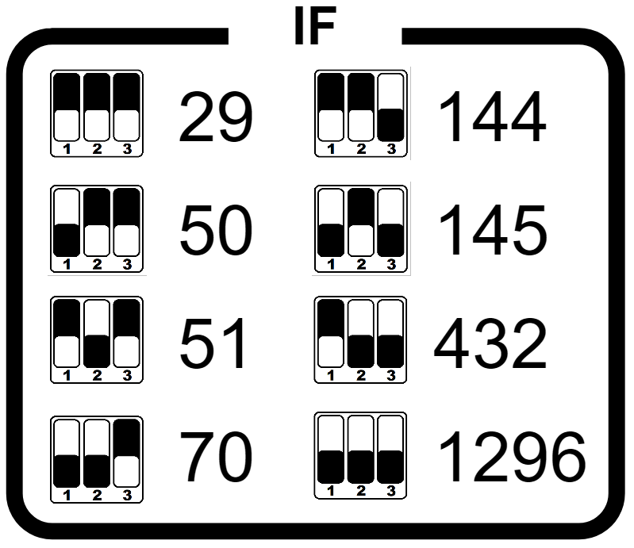
rev 0.2 SQ5NRY
S/N:

Made in Poland
rev 0.2 SQ5NRY
S/N:

Made in Poland
rev 0.2 SQ5NRY
S/N:

Made in Poland
rev 0.2 SQ5NRY
S/N:

Made in Poland
rev 0.2 SQ5NRY
S/N:

Made in Poland
rev 0.2 SQ5NRY
S/N:

Made in Poland
rev 0.2 SQ5NRY
S/N:

Made in Poland
rev 0.2 SQ5NRY
S/N:

Made in Poland
rev 0.2 SQ5NRY
S/N:

Made in Poland
rev 0.2 SQ5NRY
S/N:

Made in Poland
rev 0.2 SQ5NRY
S/N:

Made in Poland
rev 0.2 SQ5NRY
S/N:

Made in Poland
rev 0.2 SQ5NRY
S/N:

Made in Poland
rev 0.2 SQ5NRY
S/N:

Made in Poland
rev 0.2 SQ5NRY
S/N:

Made in Poland
rev 0.2 SQ5NRY
S/N:

Made in Poland
28V (13.8V)
1.1A

DC
PTT

