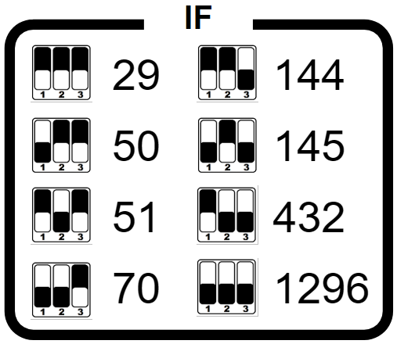

QO-100 transverter

28V (13.8V)
1.1A
max 5W
RX ext
ref out
TX
2.4G
DC
PTT
TRX
LNB

