\
28V (13.8V)
1.1A
DC+PTT
rev 0.2 SQ5NRY
S/N:

Made in Poland
rev 0.2 SQ5NRY
S/N:

Made in Poland
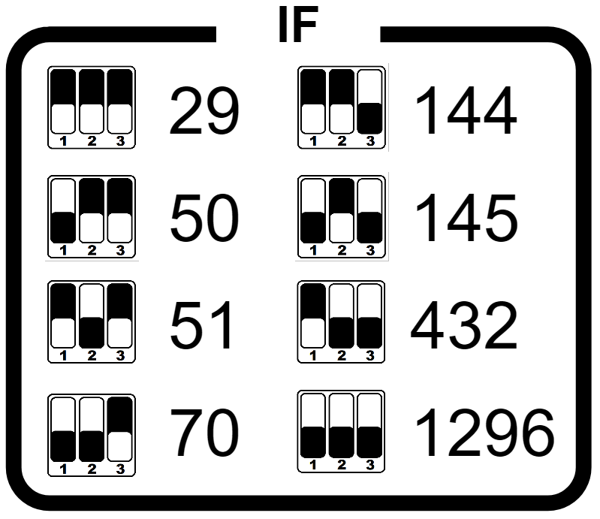
IF
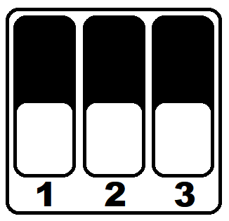
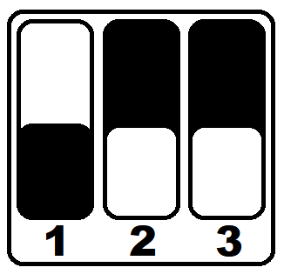
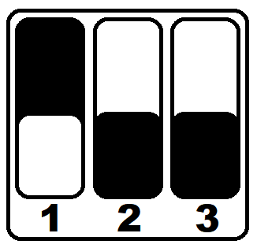
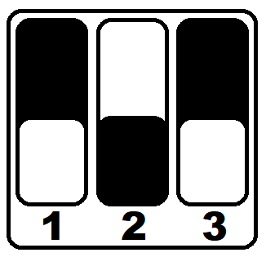
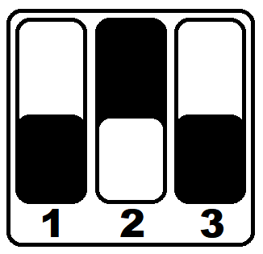
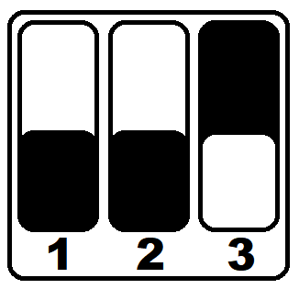
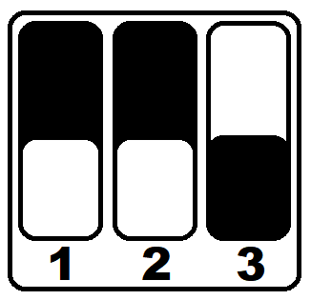
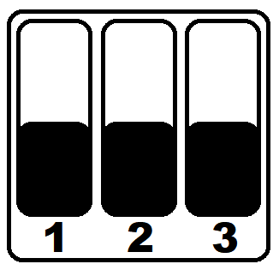
29
50
51
70
144
145
432
1296
S

S/N:
rev 0.2 SQ5NRY
S/N:

Made in Poland

rev 0.2 SQ5NRY
S/N:

Made in Poland

Made in Poland
rev 0.2 SQ5NRY

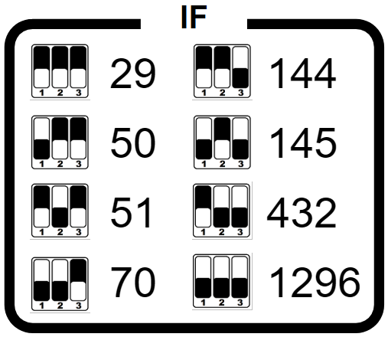

QO-100 transverter

28V (13.8V)
1.1A
max 5W
RX ext
ref out
TX
2.4G
DC
PTT
TRX
LNB

