**ERDs**

A description of the persistent data storage perspective of the Comestics Management System

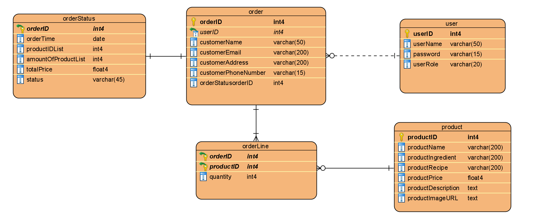

|  |  |  |  |  |  |  |  |
| --- | --- | --- | --- | --- | --- | --- | --- |
| **Table** | **Column** | **Type** | **Description** | **Length** | **Incl. in PK** | **Nullable** | **Unique** |
| ***product*** | productID | integer | Unique identifier for each product | N/A | True | False | True |
| productName | varchar | Name of product | 200 | False | False | False |
| productIngredient | varchar | Ingredient of product | 200 | False | False | False |
| productRecipe | varchar | Recipe of product | 200 | False | False | False |
| productPrice | double | Price of product | N/A | False | False | False |
| productDescription | text | Description of product | N/A | False | False | False |
| productImageURL | text | Image of product | N/A | False | False | False |
| ***order*** | orderID | integer | Unique identifier for each order | N/A | True | False | False |
| userID | integer | Unique identifier for each user | N/A | True | False | False |
| customerName | varchar | Name of customer | 50 | False | False | False |
| customerEmail | varchar | Email of customer | 200 | False | False | False |
| customerAddress | varchar | Address of customer | 200 | False | False | False |
| customerPhoneNumber | varchar | Phone number of customer | 15 | False | False | False |
| ***orderLine*** | orderID | integer | Reference to an order that this order line belong to | N/A | True | False | False |
| productID | integer | Reference to an product that this order line belong to | N/A | True | False | False |
| quantity | integer | Reference to product quantity that this order line belong to | N/A | False | False | False |
| ***orderStatus*** | orderID | integer | Reference to an order that this order status belong to | N/A | True | False | False |
| orderTime | Date | Order date time of user | N/A | False | False | False |
| productIDList | integer | Reference to list of products that this order status belong to | N/A | False | False | False |
| amountOfProductList | integer | the number of products | N/A | False | False | False |
| total | double | price total of products on order | N/A | False | False | False |
| status | varchar | Reference to status that this order belong to | 45 | False | False | False |
| ***user*** | userID | integer | Unique identifier for each user | N/A | True | False | False |
| userName | varchar | Name of user | 50 | False | False | False |
| password | varchar | Password for username | 15 | False | False | False |
| userRole | varchar | Role of user | 20 | False | False | False |