**CV Assignment-02**

**Name:-** K. Sai Prasanna Kumar

**Roll No:**- S20160010047

To Implement a simple window-based stereo matching algorithm for rectified stereo pairs.

**Main:**

Given images are parallel images,

* Initially we are taking a window of some fixed size around each pixel in reference image.
* Then we need to search for corresponding scanline in second image for a matching window.
* We need to find Depth map with respect to first view using Ground truth image.

**A screenshot of a cell phone

Description generated with very high confidence**

**Using Sum Squared Difference:**

**A screenshot of a computer

Description generated with very high confidence**

* While finding a map with window in second image we compute sum squared difference of window and template which we are taking in second image.
* Smaller the SSD, similar the patches are in two images.
* After Storing the depth level and save the image and check with ground truth.

**Using Normalized Correlation:**

**A screenshot of a cell phone

Description generated with very high confidence**

* In the same way we did in SSD we need to compute Correlation between image patches.
* But initially we need to normalize the left and right images and compare them based on correlation factor.
* Higher the correlation implies similar the corresponding patches and calculate depth level.
* Save the image and check with ground truth.

**Observations:-**

* Smaller the window size: more details it preserve but also has more noise.
* Larger the window size less details we get but disparity maps are smoother.
  + **Window size:** whenwindow size is increased time taken will also increases to search corresponding patch image. As pixel search range increased depth level decreases.
  + While decreasing search range takes disparity map towards white and time taken also increases as pixel range increased.

**SSD vs Normalized Correlation.**

**SSD:-**

**A picture containing nature, rain, outdoor

Description generated with very high confidenceA picture containing nature, rain

Description generated with very high confidence** 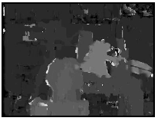

Window size:-5 Window size:-7 Window size:- 9

**Normalized Correlation:**

**A picture containing tree, outdoor, person, photo

Description generated with very high confidence**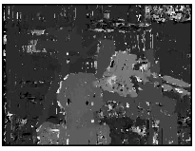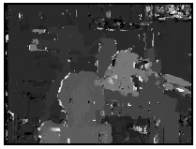

Window size:- 5 Window size:- 7 Window size:- 9

SSD gives better results and takes lesser time to execute than normalized.

A black sign with white text

Description generated with high confidence