**CV Assignment-03**

**Name**:-K. Sai Prasanna Kumar

**Roll** **No**:- S20160010047

**Image Categorization**

**Question 1:-**

In this task we have to implement image features, train a classifier using the training samples, and then evaluate the classifier on the test set.

We need to implement bag of visual words model and implement K-means cluster algorithm to compute visual word dictionary

**Implementation:**

1. Importing libraries:

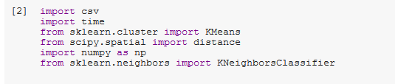

1. Loading labels of training and test data:

A screenshot of a cell phone

Description generated with very high confidence

1. Extracting Features and Regions of given data:

A screenshot of a social media post

Description generated with very high confidence

1. Computing Visual Bag Of -Words dictionary:

A screenshot of a social media post

Description generated with very high confidence

1. Implementing Kmeans clustering algorithm to features:

A screenshot of a cell phone

Description generated with very high confidence

1. Calculating Confusion Matrix and accuracy:

A screenshot of a social media post

Description generated with very high confidence

A screenshot of a cell phone

Description generated with high confidence