NetworkPort_Configuration

# ATAS

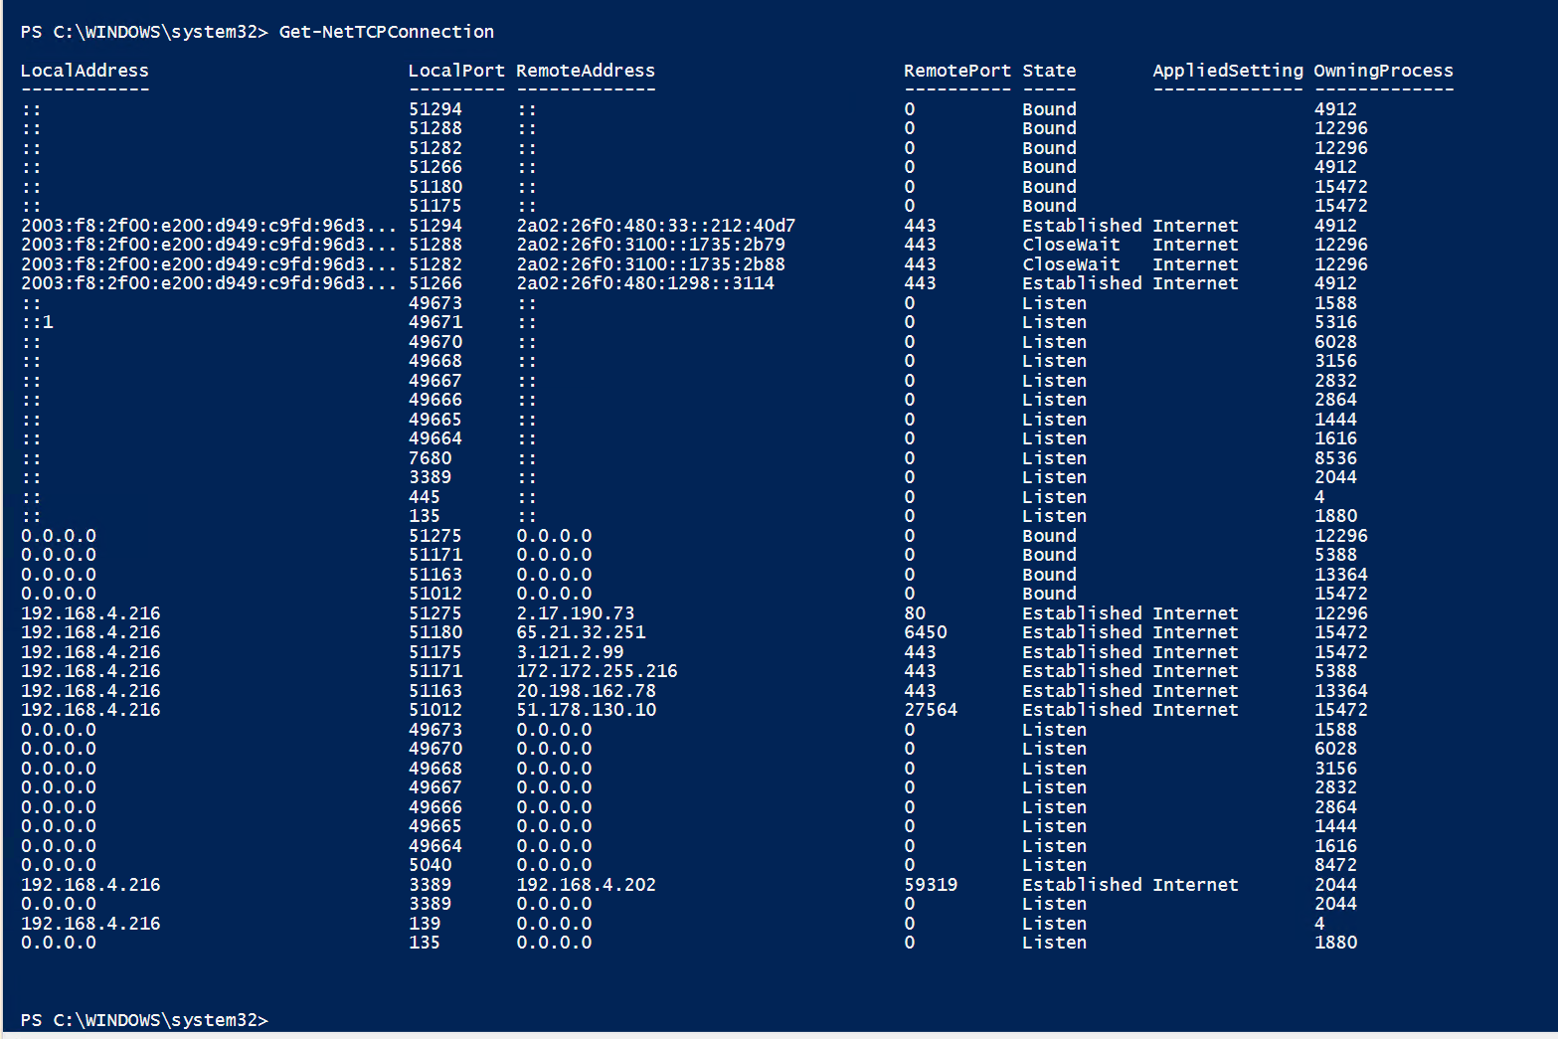

PowerShell commands

> Get-NetTCPConnection | Sort-Object RemoteAddress   
> Get-NetTCPConnection -State 'Established'

> Get-NetTCPConnection -State 'Established'   
 | Select-Object -Property *  
 ,@{Name = 'ProcessName'  
 ;Expression = {(Get-Process -Id $_.OwningProcess).Name}}

------

Dos-Cmd

> netstat  
> netstat -a  
> netstat -anb

# MT4

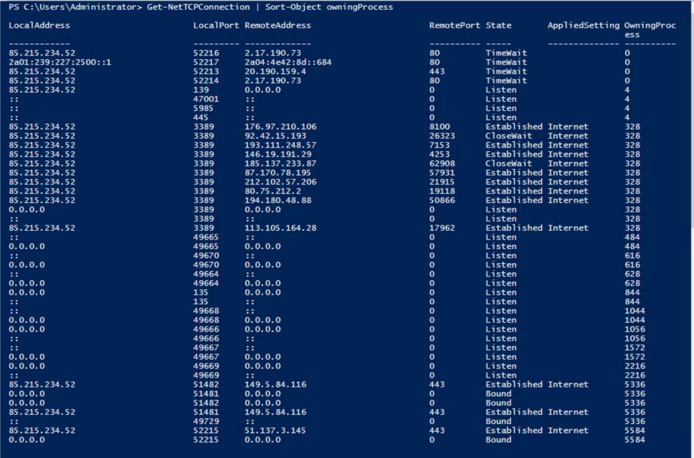

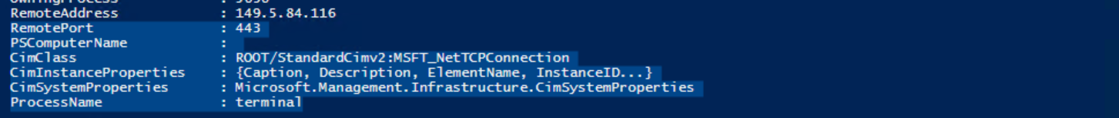  
fx flat

PowerShell commands

> Get-Process | Sort-Object ProcessName | Format-Table

> Get-Process | Sort-Object ProcessName   
 | Format-Table -Property Id, ProcessName

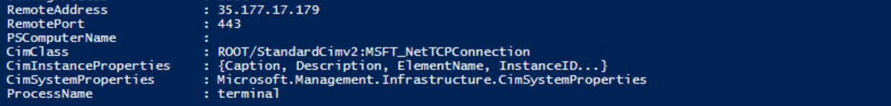  
Vantage Market

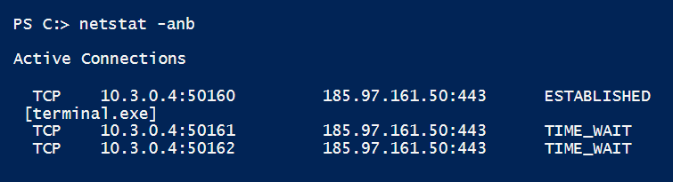  
GbeBrokers

----

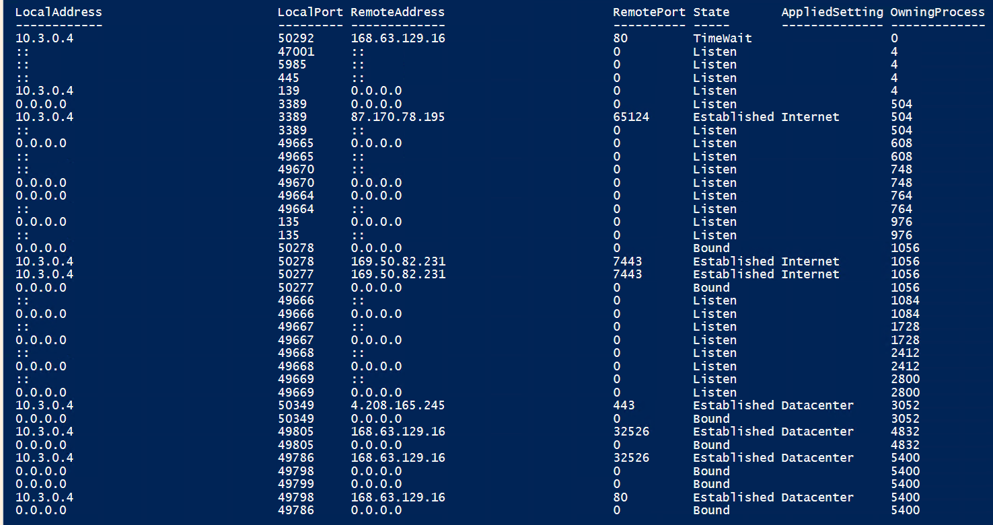  
**ActivTrades**

# NanoTrader

  
