The HTML DOM Tree of Objecs

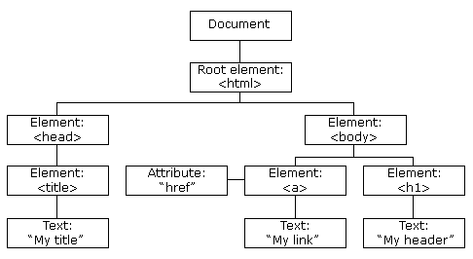

Finding HTML Elements
Method Description
document.getElementById(id) Find an element by element id
document.getElementsByTagName(name) Find elements by tag name
document.getElementsByClassName(name) Find elements by class name

