Starting SQL Server Management Studio (SSMS)

SSMS will be found in your start menu in the **Microsoft SQL Server 2016** folder. To start SSMS click **Microsoft SQL Server Management Studio**. When SSMS starts you will be presented with the following window. In the Object Explorer window click **Connect 🡪 Database Engine** from the drop down or click the Connect button. If the Object Explorer window is not present click **View 🡪 Object Explorer** or hit **F8**.

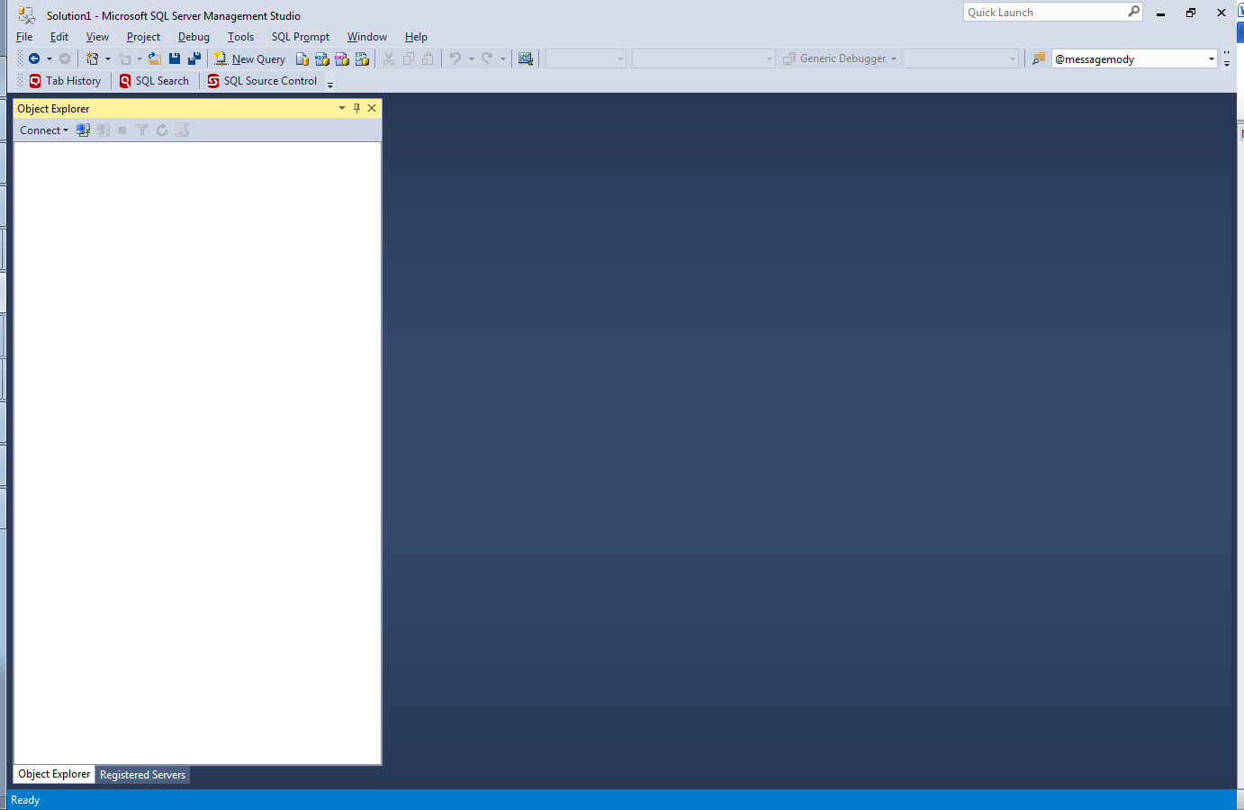

Connect Button

Connect Dropdown

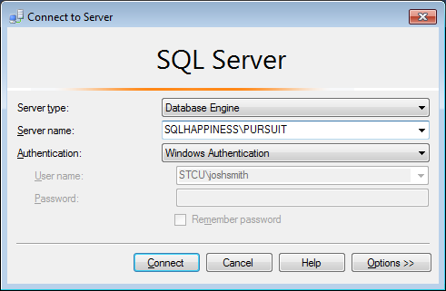In the **Connect to Server** dialogue window enter the SQL Server Instance name. Then click **Connect**.

Expand the **Databases** folder and either right-click the instance name or database and select **New Query**

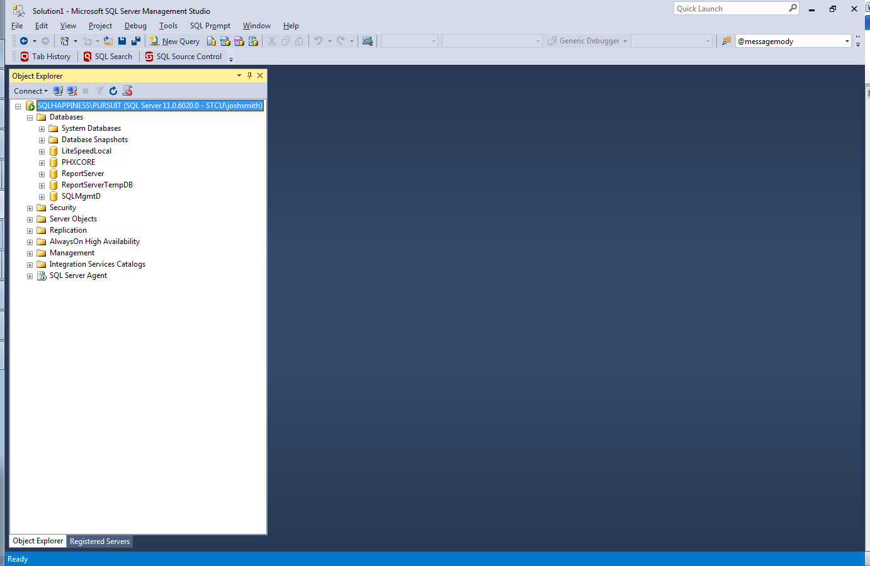

Instance name (top)

Database name (bottom)

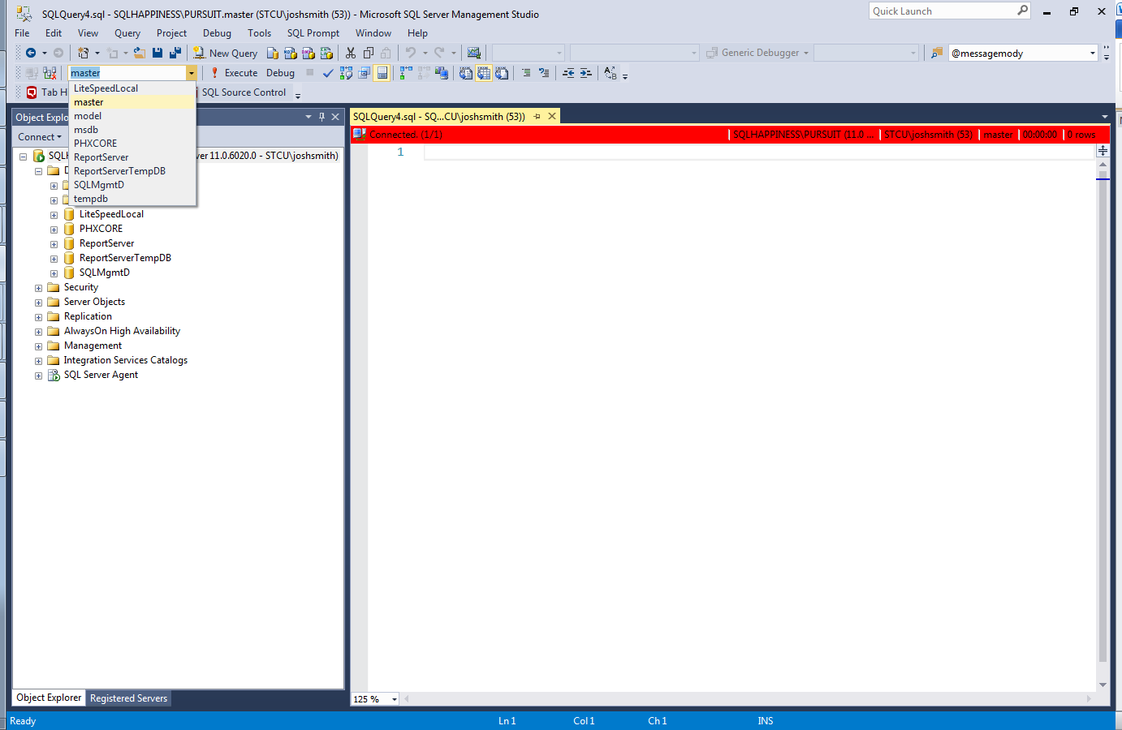

**Begin writing your query in this window.**

Ensure the database name in the dropdown is the database you intend to work with.