1 Select Help > Install New Software. The install dialog will appear.
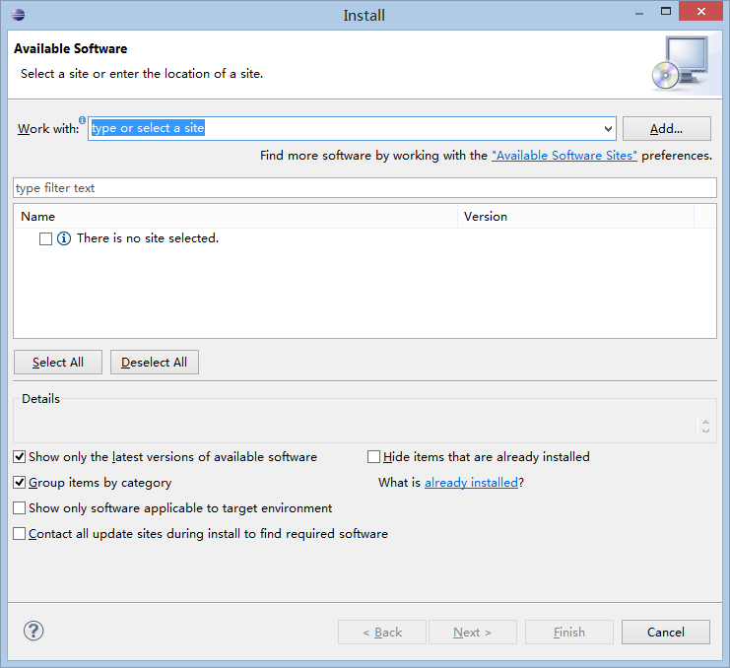
2 Click add and type in the name and update site for the plugin, as in the following figure. The SQL Format Plugin update URL is http://107.170.101.241/eclipse/.
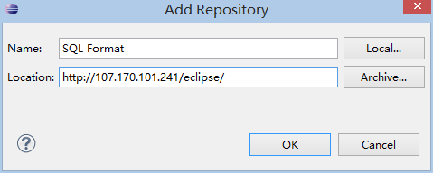

3 Click the checkbox next to the update site you just added. Click Next.
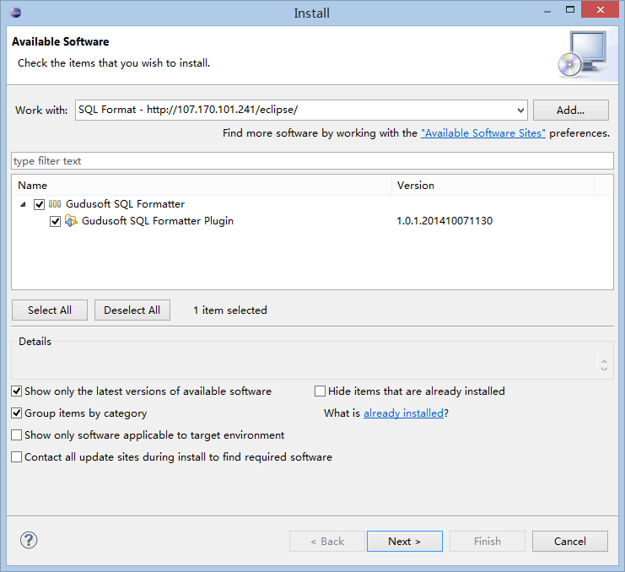
1.2.4 The following dialog box will appear. Click Next.
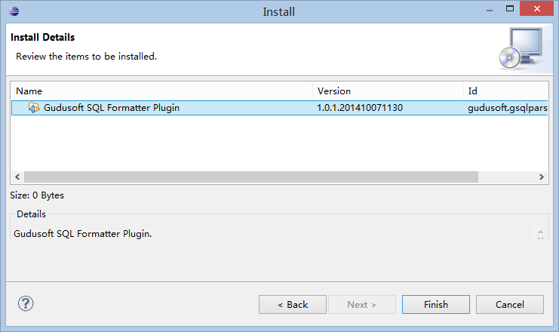
1.2.5 Click the radio button next to "I accept the terms of the license agreement". Click Finish.
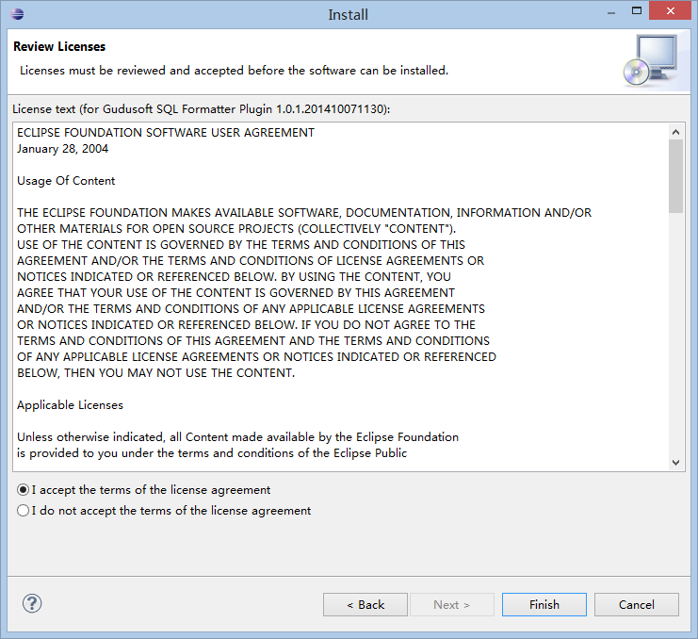
1.2.6 After Eclipse goes through the process of updating itself (which may take a few moments), you will see the following dialog. Click OK and Yes and wait for Eclipse to restart the workbench. Congratulations, now your new SQL Format plug-in is installed!
