Halaman login

**Module admin**

Halaman dashboard

Halaman verifikasi proposal

Halaman verifikasi perbaiki proposal

Halaman proposal diterima

Halaman seminar proposal

Halaman seminar hasil penelitian

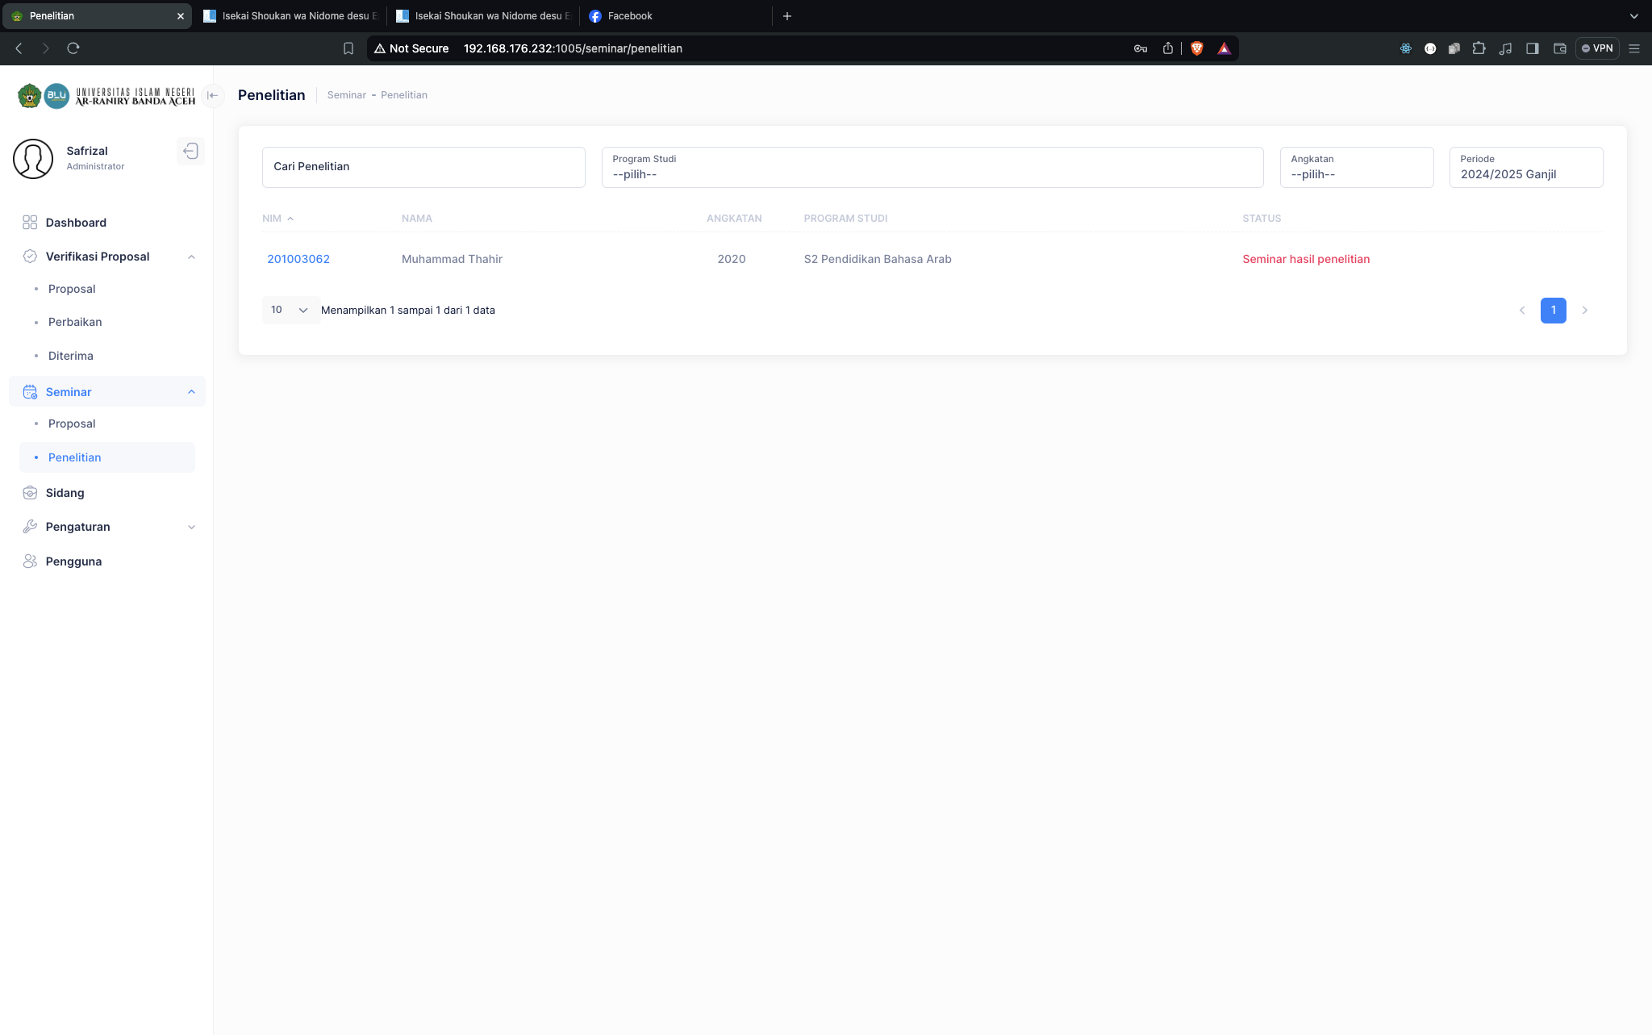

Halaman sidang munaqasyah

