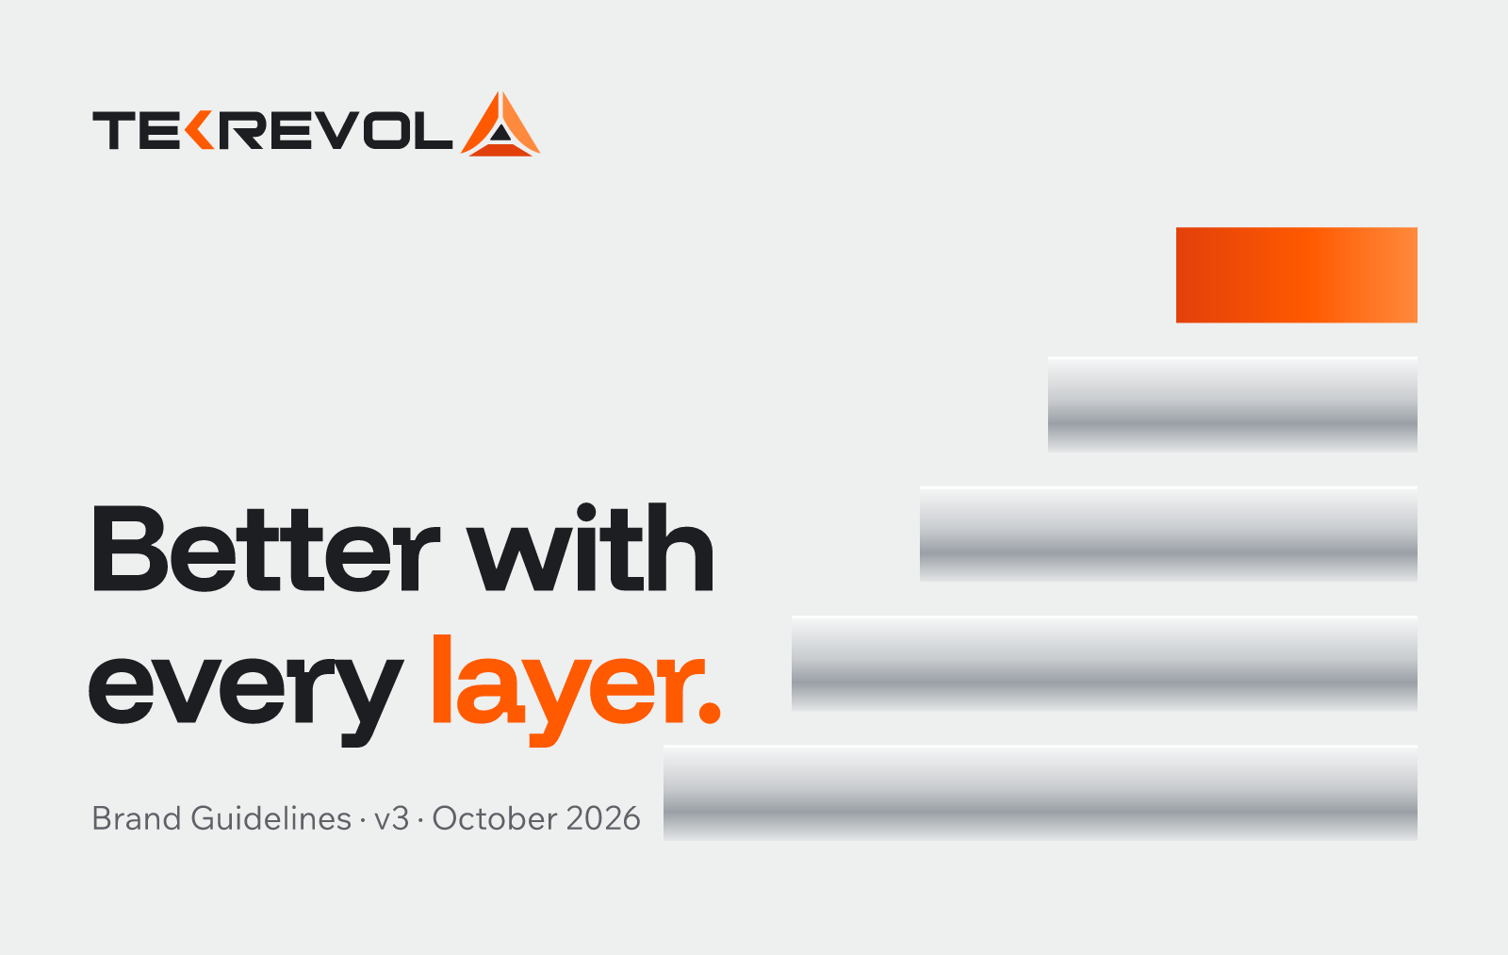
TekRevol Brand Guidelines
The visual and verbal identity for TekRevol as an AI-first software development company. For designers, developers, writers, and anyone using AI image or video tools on TekRevol work.
Status: proposed v3, October 2026. Colors, typography and the logo refresh need sign-off before the website build starts. The four service-pillar names are not final (Decision D01) and appear as examples only.

Contents
- Brand idea and positioning
- Logo
- Color
- Typography
- Layout, spacing and shape
- Graphic elements
- Imagery and AI image generation
- Motion and AI video generation
- Voice
- Applying it to the website
- Appendix: design tokens, files and fonts

01

Brand idea and positioning

What TekRevol is
One line: TekRevol builds the AI-native software other vendors, and other AI tools, couldn't finish.
Category: AI-first software development company. Software development stays the parent category, because that is where buyers search. AI moves from one service among many to the headline.

The brand idea: Better with every layer
Many software companies now call themselves AI companies. What sets TekRevol apart is how it got here:
- It adapted early. TekRevol took up AI tools and methods ahead of most of its market and folded them into how it builds.
- It scaled fast. It turned that early start into AI services, private-LLM work (RevAI) and AI-native delivery.
- It keeps evolving. Every project, every learning and every architecture becomes the base for the next one. The work gets better layer by layer.
The identity makes that growth visible: precise layers that build on each other, with the newest layer lit in TekRevol orange.

Look and feel
Clean, futuristic, modern, premium. Bright white and soft grey space, charcoal type, a touch of brushed metal, and one bright orange accent that always marks what matters most.
Word | Means | Looks like
Clean | Nothing extra; every element has a job | White and mist backgrounds, generous space, one idea per view
Precise | Engineered, specific, exact | Tight headline spacing, a strict grid, thin rules, mono labels
Metallic | Quality, permanence, enterprise-grade | Silver and steel surfaces, machined layers, satin finishes
Bright | Energy and speed of adoption | One TekRevol orange accent per view, orange light in imagery
Confident | Says what it does, plainly | Bold headlines with personality, short copy, clear calls to action

Personality
Trait | Means | Does not mean
Built | Engineered, precise, specific | Cold or robotic
Quick | Moves early, ships, communicates on schedule | Rushed or careless
Evolving | Always improving the next version | Restless or trend-chasing
Candid | Says what is true, including what went wrong before | Blunt or negative about others

Why orange
Four of the five named competitors lead with blue: LeewayHertz, Azumo, ScienceSoft and Cheesecake Labs. HatchWorks uses teal. The AI services category reads as one blue wall. A bright, disciplined orange on clean white and charcoal gives TekRevol instant recognition and keeps the equity the brand already has.

From the old brand to the new
Before | After
"Human Vision. Intelligent Technology. Exceptional Products." | A headline that names what TekRevol is and who it is for
Muted orange #F37A20 on dark stock photos | Bright TekRevol Orange #FF5A00 on white, mist and charcoal
Poppins everywhere | Funnel Display for headlines, Wix Madefor Text for everything else
Rounded pill buttons | Square buttons with the notch
Stock "AI" imagery: glowing brains, blue networks | Bright precise spaces, brushed metal, real builders, orange light

Proof the idea needs
The idea is about speed of adoption, so it needs evidence before it becomes a public claim. Collect:
- the year TekRevol started building with AI, and its first AI product or engagement
- how many AI or automation projects have shipped since
- RevAI milestones
- the Lovable partner listing, once it is live (not before)
Until these are confirmed, show the idea through design and real work, and avoid number claims about speed.

02

Logo

Anatomy
The logo is the TEKREVOL wordmark followed by the mark: three planes meeting in a peak (left plane, right plane, base bar) with a small charcoal triangle inside. The K carries an orange chevron. The geometry stays exactly as it is. The refresh only brightens the oranges and moves the ink to charcoal.
Part | Legacy | Refreshed
Left plane, K chevron | #EF5123 | TekRevol Orange #FF5A00
Right plane | #F37A20 | Flare #FF8A3D
Base bar | #EE3824 | Ember #E2400B
Wordmark, inner triangle | #282526 | Charcoal #1D1E21, or white on dark

Versions
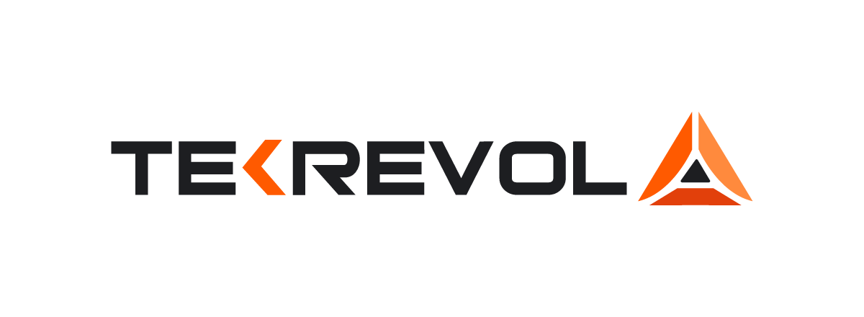
Full logo, charcoal ink: white and light backgrounds (primary).
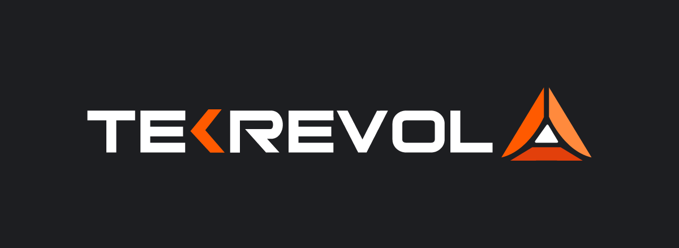
Full logo, white ink: charcoal, graphite and dark photography.
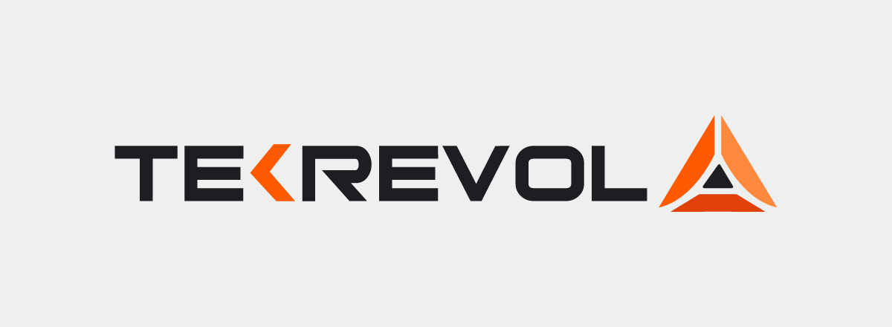
On mist grey and silver: charcoal ink.
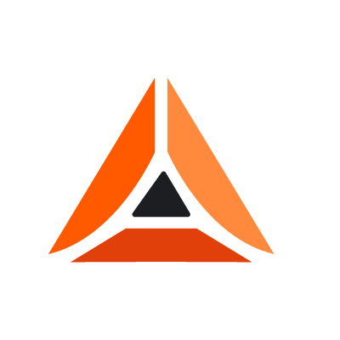
Mark only: favicons, app icons, social avatars, video watermarks, anywhere under 120 px wide.

Clear space and size
- Clear space on all sides equals the height of the letter T. Nothing enters it: no text, edges or other logos.
- Minimum size: full logo 120 px wide on screen, 30 mm in print. Mark only 20 px, 6 mm.

Do not
- Redraw, stretch, rotate or re-space the wordmark or the mark
- Recolor the planes or set the logo in one flat color (except all-white or all-charcoal for one-color printing)
- Place the full-color logo on orange or busy imagery. Use the white logo on charcoal, or a clean white panel behind it
- Add effects: glows, outlines, drop shadows, bevels, 3D
- Let AI image or video tools generate the logo. Always composite the real file afterwards

03

Color
A clean, light system: white and soft grey space, charcoal for type and contrast, a brushed-metal silver range for depth and quality, and one bright orange accent.

Neutrals
 | Name | HEX | RGB | CMYK* | Use
 | White | #FFFFFF | 255 255 255 | 0 0 0 0 | Primary background
 | Mist | #EEEFEF | 238 239 239 | 0 0 0 6 | Section backgrounds, cards on white
 | Silver | #C9CCCF | 201 204 207 | 3 1 0 19 | Metallic surfaces, dividers on charcoal, hover fills
 | Steel | #8A9097 | 138 144 151 | 9 5 0 41 | Metallic shading, icons on white (large), chart baseline
 | Muted | #5E6166 | 94 97 102 | 8 5 0 60 | Secondary text on white and mist
 | Graphite | #2E3034 | 46 48 52 | 12 8 0 80 | Raised surfaces on charcoal
 | Charcoal | #1D1E21 | 29 30 33 | 12 9 0 87 | Headlines, body text, dark sections, text on orange

Accent
 | Name | HEX | RGB | CMYK* | Use
 | TekRevol Orange | #FF5A00 | 255 90 0 | 0 65 100 0 | The brand accent: primary buttons, the highlighted word, key data, logo
 | Flare | #FF8A3D | 255 138 61 | 0 46 76 0 | Hover states, highlights on charcoal, logo right plane
 | Ember | #E2400B | 226 64 11 | 0 72 95 11 | Logo base plane, pressed states, deep end of the orange gradient
 | Orange Ink | #C23A00 | 194 58 0 | 0 70 100 24 | Orange as small text on white: links, labels, eyebrows
*CMYK values are direct conversions for reference. Confirm with the printer using a proof; bright orange needs a spot color or a press check for accuracy.

Proportion
Color | Share of a page or frame
White and mist | About 60%
Charcoal (type and dark sections) | About 20 to 25%
Silver and steel (metallic touches) | About 10%
TekRevol Orange | 5 to 10%: one focal point per view

Gradients
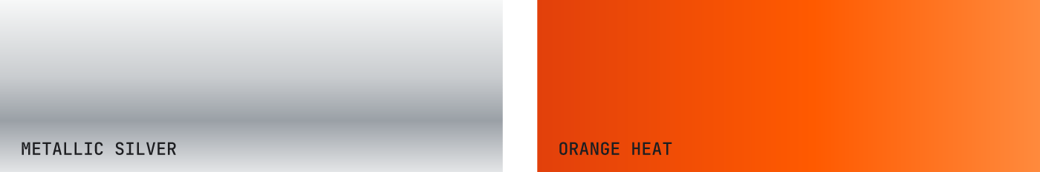
Metallic silver gives surfaces a brushed-metal finish: use it on graphic layers, cards in hero areas and illustrations. Orange heat runs from ember to flare: use it on the top layer of the Strata motif, progress bars and small highlights. Never set text in a gradient.
/* Metallic silver */
linear-gradient(180deg, #F7F8F8 0%, #C9CCCF 45%, #9AA0A6 70%, #E4E6E7 100%)
/* Orange heat */
linear-gradient(90deg, #E2400B 0%, #FF5A00 55%, #FF8A3D 100%)

Contrast
Text | On | Ratio | OK for
Charcoal | White / Mist | 16.7 / 14.5 | All text
Muted | White / Mist | 6.2 / 5.4 | All text
Charcoal | TekRevol Orange | 5.3 | All text, including buttons
White | Charcoal | 16.7 | All text
TekRevol Orange | Charcoal | 5.3 | All text
Orange Ink | White | 5.4 | All text
TekRevol Orange | White | 3.1 | Headlines 24 px and up only
White | TekRevol Orange | 3.1 | Avoid; use charcoal text on orange

Do not
- Use blue or purple as brand colors, or blue-purple gradients
- Set headlines or body text in grey gradients or metallic effects
- Use the legacy #F37A20 next to TekRevol Orange
- Put white text on orange buttons (use charcoal)
- Use more than one orange focal point per view

04

Typography
Headlines carry the personality; everything else stays simple and calm. Two free typefaces, plus a mono for small labels.
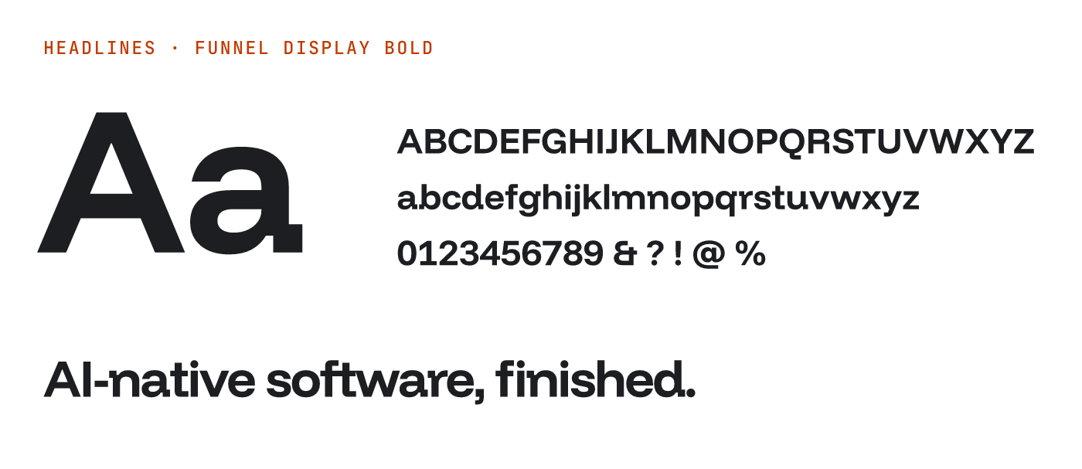
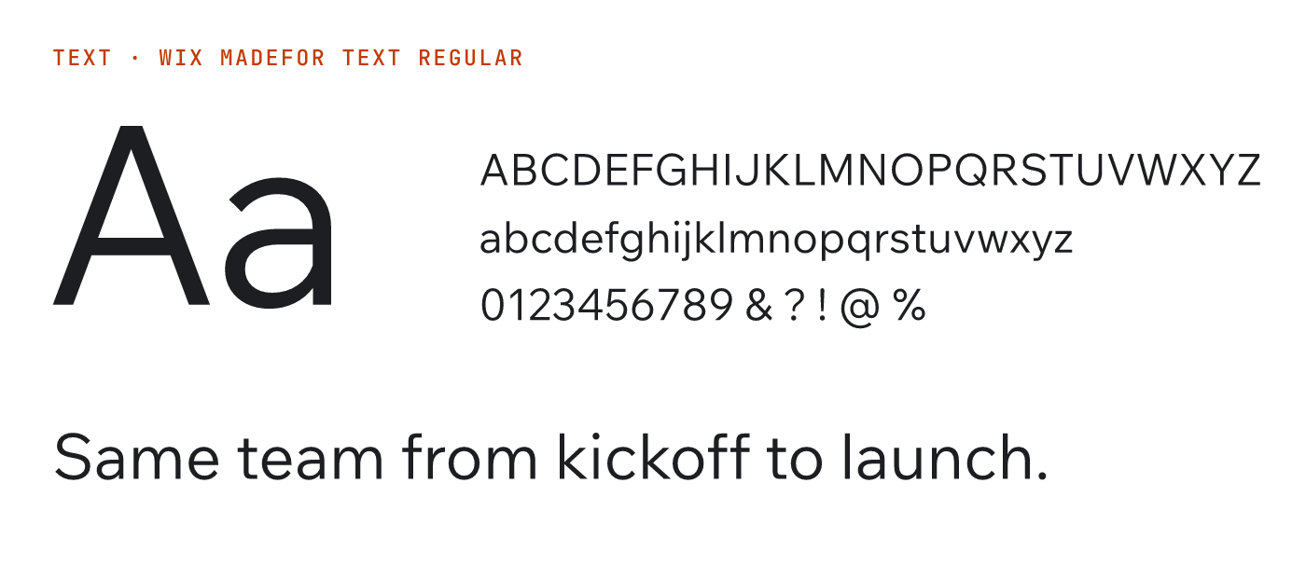
Role | Typeface | Weights | Why
Headlines | Funnel Display | SemiBold 600, Bold 700 | Modern and confident, with quietly unusual details that make headlines memorable without feeling tacky
Subheads, body, UI | Wix Madefor Text | Regular 400, Medium 500, SemiBold 600 | Refined and calm; very readable from captions to long articles
Labels, code, data | JetBrains Mono | Medium 500 | Small uppercase eyebrows and numbers that signal engineering
All three are free under the SIL Open Font License from Google Fonts. Font files are in the brand folder (see the appendix). Poppins and Inter are retired.

Type scale
Style | Typeface | Desktop | Mobile | Line height | Tracking
Display | Funnel Display Bold | 88 px | 44 px | 1.0 | -3%
H1 | Funnel Display Bold | 56 px | 34 px | 1.05 | -3%
H2 | Funnel Display SemiBold | 40 px | 28 px | 1.1 | -2%
H3 | Funnel Display SemiBold | 28 px | 22 px | 1.2 | -1%
H4 / subhead | Wix Madefor Text SemiBold | 20 px | 18 px | 1.35 | 0
Lead | Wix Madefor Text Regular | 20 px | 18 px | 1.55 | 0
Body | Wix Madefor Text Regular | 16 px | 16 px | 1.65 | 0
Small | Wix Madefor Text Regular | 14 px | 14 px | 1.5 | +0.5%
Button | Wix Madefor Text SemiBold | 15 px | 15 px | 1.2 | +1%
Label | JetBrains Mono Medium, UPPERCASE | 12 px | 12 px | 1.3 | +8%

Hierarchy
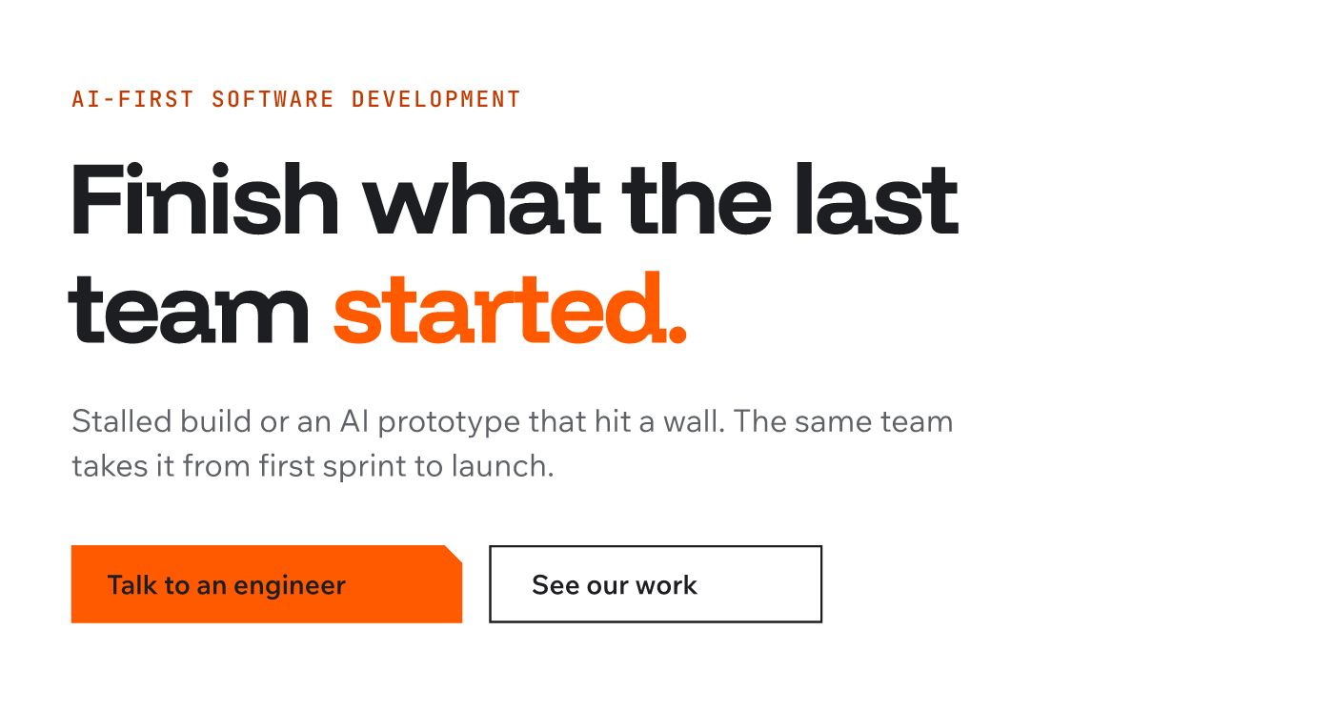
A block reads: label (eyebrow) › headline › lead › buttons. One headline style per section. The orange word is optional, and there is only ever one.

Kerning and tracking
- Keep kerning on everywhere (in CSS: `font-kerning: normal`). In design tools use Metrics or Optical kerning
- Headlines are tracked tighter as they grow: -1% at 28 px down to -3% at 56 px and above. Never track headlines positively
- Body text stays at 0. Labels are uppercase with +8%
- Hand-kern big headlines: check Te, Ta, Yo, AI, LT, "V," and pairs around periods and apostrophes
- Use tabular figures in tables and counters

Case and punctuation
- Sentence case for headlines and buttons: "Talk to an engineer"
- Write the name as TekRevol in text; all caps only in the logo
- No em dashes in copy. Use a period, comma or colon
- No headlines in all caps, no italics for emphasis, no fake bold or outlines

05

Layout, spacing and shape

Spacing
A 4 px base unit. Use only these steps: 4, 8, 12, 16, 24, 32, 48, 64, 96, 128, 160.
Context | Desktop | Tablet | Mobile
Hero padding (top and bottom) | 160 | 96 | 64
Section padding | 128 | 96 | 64
Between components in a section | 48 | 48 | 32
Headline to body | 24 | 24 | 16
Card padding | 32 | 32 | 16

Grid
Screen | Columns | Gutter | Side margin
1024 px and up | 12 | 24 px | Auto, content max 1280 px
640 to 1023 px | 8 | 24 px | 32 px
Below 640 px | 4 | 16 px | 16 px
Running text never exceeds about 68 characters per line. Headlines are left aligned and usually span 8 of 12 columns. Center alignment is for short statements and end cards only.

Shape
- Square by default. Sections, images and large cards have square corners
- Buttons, inputs and tags: 2 px corner radius, or the notch on primary buttons
- The notch is the signature corner: a 45° cut on the top-right, taken from the logo's diagonal planes. Sizes: 8 px (buttons, tags), 16 px (cards, image frames), 32 px (hero panels). Use it on the most important element in a view, not on everything
- Pills only for status dots and avatars
/* Notch, 16 px */
clip-path: polygon(0 0, calc(100% - 16px) 0, 100% 16px, 100% 100%, 0 100%);

Borders, depth and icons
- Thin 1 px rules in #D9DADB separate content on white. Controls use a 1.5 px charcoal or steel outline
- Depth comes from layering and metallic surfaces, not heavy shadows. Soft shadows only for menus and modals
- Icons: Lucide (open source), 1.5 px stroke at 24 px, in charcoal or muted; only an active icon is orange. Always pair icons with a label. No emoji as icons

06

Graphic elements

Strata: layers that build
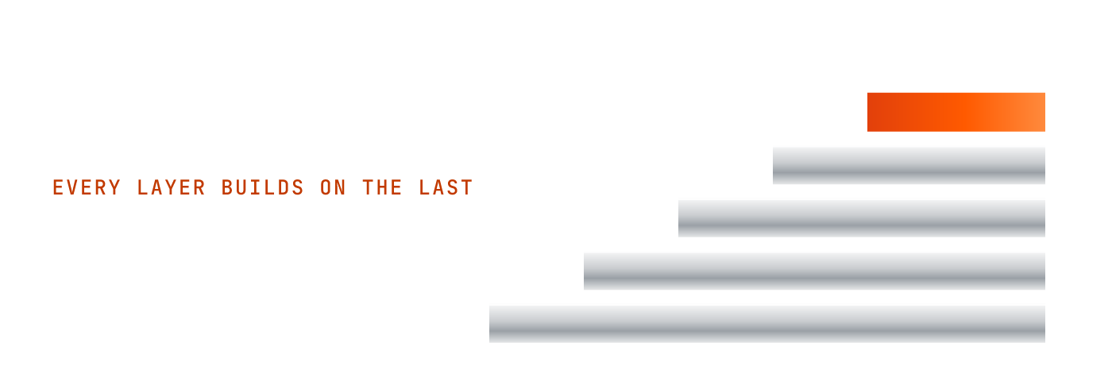
The brand's graphic signature: stacked, machined metal layers, widest at the base, with the newest layer on top in orange heat. It stands for the brand idea: every layer builds on the last, and the latest one is where the energy is.
- Use it as a hero graphic, a section divider, a process diagram (one layer per stage) or a frame for a key number
- Layers are square-cornered, evenly spaced, in metallic silver; only the top layer is orange
- One Strata per page or frame. Never reorder (orange is always on top), round the corners, or add other colors
- In motion, layers slide in from the bottom up, one after another

The notch
A 45° corner cut from the logo, used on primary buttons, featured cards and hero panels. It is the small detail that makes a TekRevol layout recognizable without the logo.

Orange light line
A single thin line or streak of orange light (2 to 4 px, or a soft motion streak in imagery) that suggests speed and momentum. Use it under a key headline, along a progress path, or crossing a hero image. One per view.

Metallic surfaces
Brushed silver and satin steel give depth and a premium, enterprise feel. Use them for graphic layers, device frames and abstract backgrounds, always on white, mist or charcoal, never as text.

07

Imagery and AI image generation
For photographers, 3D artists, designers and anyone prompting an AI image tool (Midjourney, GPT Image, Adobe Firefly, Gemini / Imagen, Stable Diffusion, Ideogram).

The look: bright precision
Clean, bright, futuristic spaces in white and soft grey. Brushed metal and precise forms. People doing real work. One bright orange element or light in every frame that pulls the eye. It should feel like a premium technology launch, calm and confident.

Five rules for every image
- Bright and clean. White, mist and pale grey dominate. Soft, even daylight or studio light. Lots of negative space.
- Metal for quality. Brushed aluminum, satin steel, silver surfaces and precise machined edges.
- One orange focal point. An orange object, light, line or motion streak. Never more than one, never orange everywhere.
- Layers you can see. Stacked plates, panels, shelves or screens, echoing "better with every layer".
- Real and specific. Real people, real interfaces, real devices. No fantasy tech.

Image families
Family | Use | Look
Machined layers | Hero, campaign key visuals | Stacked brushed-aluminum plates or panels in a white studio, the top layer glowing or finished in bright orange. Precise, minimal, product-shot quality
Kinetic orange | Section backgrounds, social, video | A clean grey or white scene crossed by a soft streak of orange light or motion blur: speed, momentum, fast adoption
Builders | About, careers, case studies | Documentary photos of the team in bright modern workspaces, natural light, laptops and whiteboards, one orange detail
Product in context | Service pages, case studies | Real TekRevol interfaces on devices on light grey or white surfaces, metal device frames, soft shadows
Industry scenes | Vertical pages (e.g. home-based care) | Real, calm, bright settings with the product in use; warm and respectful, never clinical blue

Avoid
Glass and liquid-glass effects, glowing brains, robots and humanoid AI faces, robot handshakes, blue holograms, binary rain, padlocks, circuit-board cities, dark neon scenes, purple-blue gradients, lens flares, fake UI with gibberish text, and any generated logo or lettering.

AI prompt kit

Master style block (paste at the end of every prompt)
Style: TekRevol brand. Clean, bright, futuristic and premium. White and soft light-grey environment (#FFFFFF, #EEEFEF) with brushed aluminum and satin steel surfaces (#C9CCCF, #8A9097) and charcoal details (#1D1E21). One single bright orange accent (#FF5A00), as an object, a light or a soft motion streak. Precise, minimal composition, stacked layers, generous negative space, soft even studio light, sharp focus, high-end product photography quality.
AI tools read hex codes loosely; the color words matter more.

Negative prompt
glass, liquid glass, blue light, purple, neon, dark moody, robots, humanoid faces, glowing brain, holograms, binary code, circuit board, padlock, lens flare, text, letters, logo, watermark, cartoon, clutter, multiple orange objects, oversaturated

Templates
Machined layers (hero): "Five stacked brushed-aluminum plates of decreasing size forming a stepped tower, the top plate finished in glossy bright orange, on a seamless white studio background, soft shadows, three-quarter view." + style block
Kinetic orange (background): "A minimal light-grey architectural space with a single soft streak of bright orange light sweeping diagonally across it, motion blur, lots of empty space on the left for text." + style block
Builders (team): "Documentary photo of a software engineer and a designer reviewing a product on a large monitor in a bright white modern office, natural daylight, one orange notebook on the desk, candid, 35 mm, shallow depth of field." + style block
Product in context: "A laptop and phone with silver aluminum frames on a pale grey desk, screens blank for compositing, soft daylight, one orange accent object nearby, top-down three-quarter view." + style block

Tool settings
Tool | Settings
Midjourney | --style raw --stylize 100 --ar 16:9 (web hero 21:9, LinkedIn 1:1 or 4:5, story 9:16) --no glass, blue, purple, text, logo
GPT Image | Write the style block as full sentences; ask for "no text or logos in the image"
Adobe Firefly | Style: Photo, visual intensity low to medium; use an approved key visual as the style reference
Stable Diffusion | Use the negative prompt as written; CFG 5 to 7

After generating
- Composite the real logo, UI and type afterwards. Never ship generated text or logos
- Grade to the palette: clean whites, neutral greys, no blue or green cast; check that only one orange element remains
- Check hands, faces, devices and reflections for AI artifacts
- Keep a board of approved images and reuse them as style references so everything belongs to the same world

08

Motion and AI video generation

Motion principle: build up
Things arrive the way the brand grows: from the bottom up, layer by layer, with the newest layer lighting orange. Motion is quick, smooth and exact. It never bounces.
Use | Duration | Easing
Hover, focus, color | 120 ms | ease-out
Menus, tabs, small reveals | 240 ms | cubic-bezier(0.2, 0.8, 0.2, 1)
Layers stacking into place | 640 ms, 80 ms stagger | cubic-bezier(0.2, 0.8, 0.2, 1)
Exits | 200 ms | cubic-bezier(0.4, 0, 1, 1)
- Elements rise 16 to 24 px and fade in, staggered bottom up
- Hover: buttons brighten to Flare; cards lift slightly. No scaling past 1.02
- One orchestrated moment per page (usually the hero Strata building)
- Respect reduced-motion settings: show the end state with no movement

Logo animation
The three planes slide in along their 45° angles (left, right, then the base bar), lock together, and a line of orange light runs up through them before settling. 1.2 seconds. Start or end of videos only.

Video language
Element | Rule
Look | Bright white and grey spaces, brushed metal, real people, one orange accent per shot
Camera | Slow push-ins, smooth lateral tracks, gentle orbits around objects. No handheld shake or whip pans
Pace | 25 to 30 seconds for social; 3 to 5 seconds per scene; one idea per scene
Type on screen | Funnel Display headlines, Wix Madefor Text captions, max 8 words at once
Captions | Burned in for social: Wix Madefor Text SemiBold, charcoal on white or white on charcoal
End card | White or mist background, Strata, logo, one line call to action
Sound | Clean electronic pulse, light and confident, building with the layers

AI video prompt kit
For Runway, Sora, Google Veo, Kling, Luma or Pika.
TekRevol brand film. Clean bright futuristic white and light-grey environment, brushed aluminum and satin steel surfaces, charcoal details, one bright orange accent (#FF5A00), soft even studio light, slow smooth camera, precise minimal composition, premium technology launch feel. No glass, no blue or purple light, no text, no logos.
Opener (5 to 8 s): "Brushed-aluminum plates slide in one by one from below and stack into a stepped tower in a white studio; the final top plate lands and glows bright orange; slow push-in." + style block
Kinetic reveal (4 s): "A soft streak of orange light sweeps across a minimal pale-grey space, leaving clean empty space for a headline; camera drifts slowly right." + style block
Builder scene (4 s): "Slow dolly past an engineer reviewing code in a bright white office, daylight, calm focus, one orange object on the desk." + style block
- Generate clean plates, then add type, the real logo and real UI in the edit
- Grade every clip to one look and check for flicker and AI artifacts
- Keep approved clips as references so the series stays consistent

09

Voice
Proposed, based on TekRevol's Messaging and Positioning (AI-First) document; needs sign-off from someone with brand authority.

The sound
Clear, direct and specific, like a sharp in-house engineer explaining the plan. Confident without showing off. A working example already on the site: "you want architectural truth, not a pitch."

Rules
- No em dashes, anywhere
- Active voice; short sentences of varied length
- Speak to one buyer's situation at a time; never "from startups to enterprises"
- Every claim traces to something real: a sourced number, a credential, a named case study
- No invented statistics; no speed or cost claims for AI-assisted delivery until a measured engagement backs them
- Name the situation, never the vendor: no rival agencies, platforms or AI tools in public copy
- Avoid stacked rule-of-three phrasing, "whether X, Y, or Z" constructions and false "from X to Y" ranges
- Define jargon the first time it appears

Headline directions by audience
Audience | Lead with | Direction
Founders | Trust | "Built by people who finish what the last team, or the last AI tool, started."
SMB owners | Speed | "Your business is already running. Your software should be too."
Mid-market champions | Something to take upstairs | "A proposal your leadership will actually approve."
Mid-market approvers | Compliance | "Built to the standard your industry already requires."

Words to avoid
Revolutionary, cutting-edge, next-gen, unleash, supercharge, seamless, game-changing, "harness the power of AI".

Approved proof (public)
800+ apps and digital products delivered · 98% client satisfaction · 10 years of experience · 4.8/5 on Clutch · Clutch Top 1000, Inc. 5000 and other listed awards · HIPAA, SOC 2, GDPR and PCI DSS experience · named case studies: Kinder Morgan, Rehkempers, Pure Plank, Rise Up Kings.
Not yet public: the Lovable partner listing (until live), home-based care product names (until naming is confirmed), final pillar names (until D01 closes).

10

Applying it to the website
The website rebrand is the first and largest use of this system. Goal: show at first glance that TekRevol is an AI company with deep engineering underneath.

Homepage structure
Section | Background | Pattern
Hero | White | Label › display headline naming what TekRevol is and who it is for › lead › primary + secondary button. Strata (metal layers, orange top) builds on the right
Proof band | Mist | Award logos in charcoal at 60% opacity plus 2 to 3 proof numbers (800+, 4.8/5 Clutch, 10 years) in mono
Pillars | White | Four cards on the 12-column grid, each with a label, H3, one line and a link; the featured card takes the notch
Finish what was started | Charcoal | The rescue story for stalled builds and AI prototypes; white headline, one orange word, real product imagery
Case studies | White | Cards leading with the client's result; filterable by industry
Compliance | Mist | HIPAA, SOC 2, GDPR and PCI DSS named plainly, as a block a champion can forward
Closing call to action | White | Strata, H1 line, one primary button

Components
- Primary button: orange fill, charcoal text, notch. One per view
- Secondary button: white with a charcoal outline
- Links: Orange Ink, underline on hover
- Cards: white on mist or mist on white, square corners, 32 px padding, a 1 px rule; the featured card gets the notch
- Labels: mono uppercase eyebrows above section headings
- Navigation: white bar, charcoal logo and links, one orange "Talk to an engineer" button

Page templates to design
Homepage · service pillar page · individual service page · case study · blog article · industry hub (home-based care) · about and careers · contact.

Build notes for developers
- Load Funnel Display and Wix Madefor Text from Google Fonts with display=swap; preload Funnel Display 700 and Wix Madefor Text 400
- Expose the tokens in the appendix as CSS custom properties
- Respect prefers-reduced-motion for the Strata build and reveals
- Real HTML text everywhere, never text in images, so search engines and AI assistants can read and cite it
- Check every text and background pair against the contrast table before shipping

A

Appendix: design tokens, files and fonts

CSS tokens
:root {
--white: #FFFFFF; --mist: #EEEFEF; --silver: #C9CCCF; --steel: #8A9097;
--muted: #5E6166; --graphite: #2E3034; --charcoal: #1D1E21;
--orange: #FF5A00; --flare: #FF8A3D; --ember: #E2400B; --orange-ink: #C23A00;
--line: #D9DADB;
--font-head: "Funnel Display", "Helvetica Neue", Arial, sans-serif;
--font-text: "Wix Madefor Text", system-ui, sans-serif;
--font-mono: "JetBrains Mono", ui-monospace, monospace;
--space: 4px 8px 12px 16px 24px 32px 48px 64px 96px 128px 160px;
--radius-sm: 2px; --notch-sm: 8px; --notch-md: 16px; --notch-lg: 32px;
}

Files
Everything is in Projects\TekRevol\01-brand-system\:
- TekRevol-Brand-Guidelines-v3.docx: this document
- logos\: tekrevol-logo-v3.svg (charcoal), tekrevol-logo-v3-white.svg, tekrevol-mark-v3.svg; legacy files for comparison
- images\: the PNG visuals used in this document
- fonts\: TTF files of Funnel Display, Wix Madefor Text and JetBrains Mono

Fonts
Download the full families (all weights) from Google Fonts: fonts.google.com/specimen/Funnel+Display, fonts.google.com/specimen/Wix+Madefor+Text, fonts.google.com/specimen/JetBrains+Mono. Install them before editing this document so headings display correctly; the main faces are also embedded in this file.

