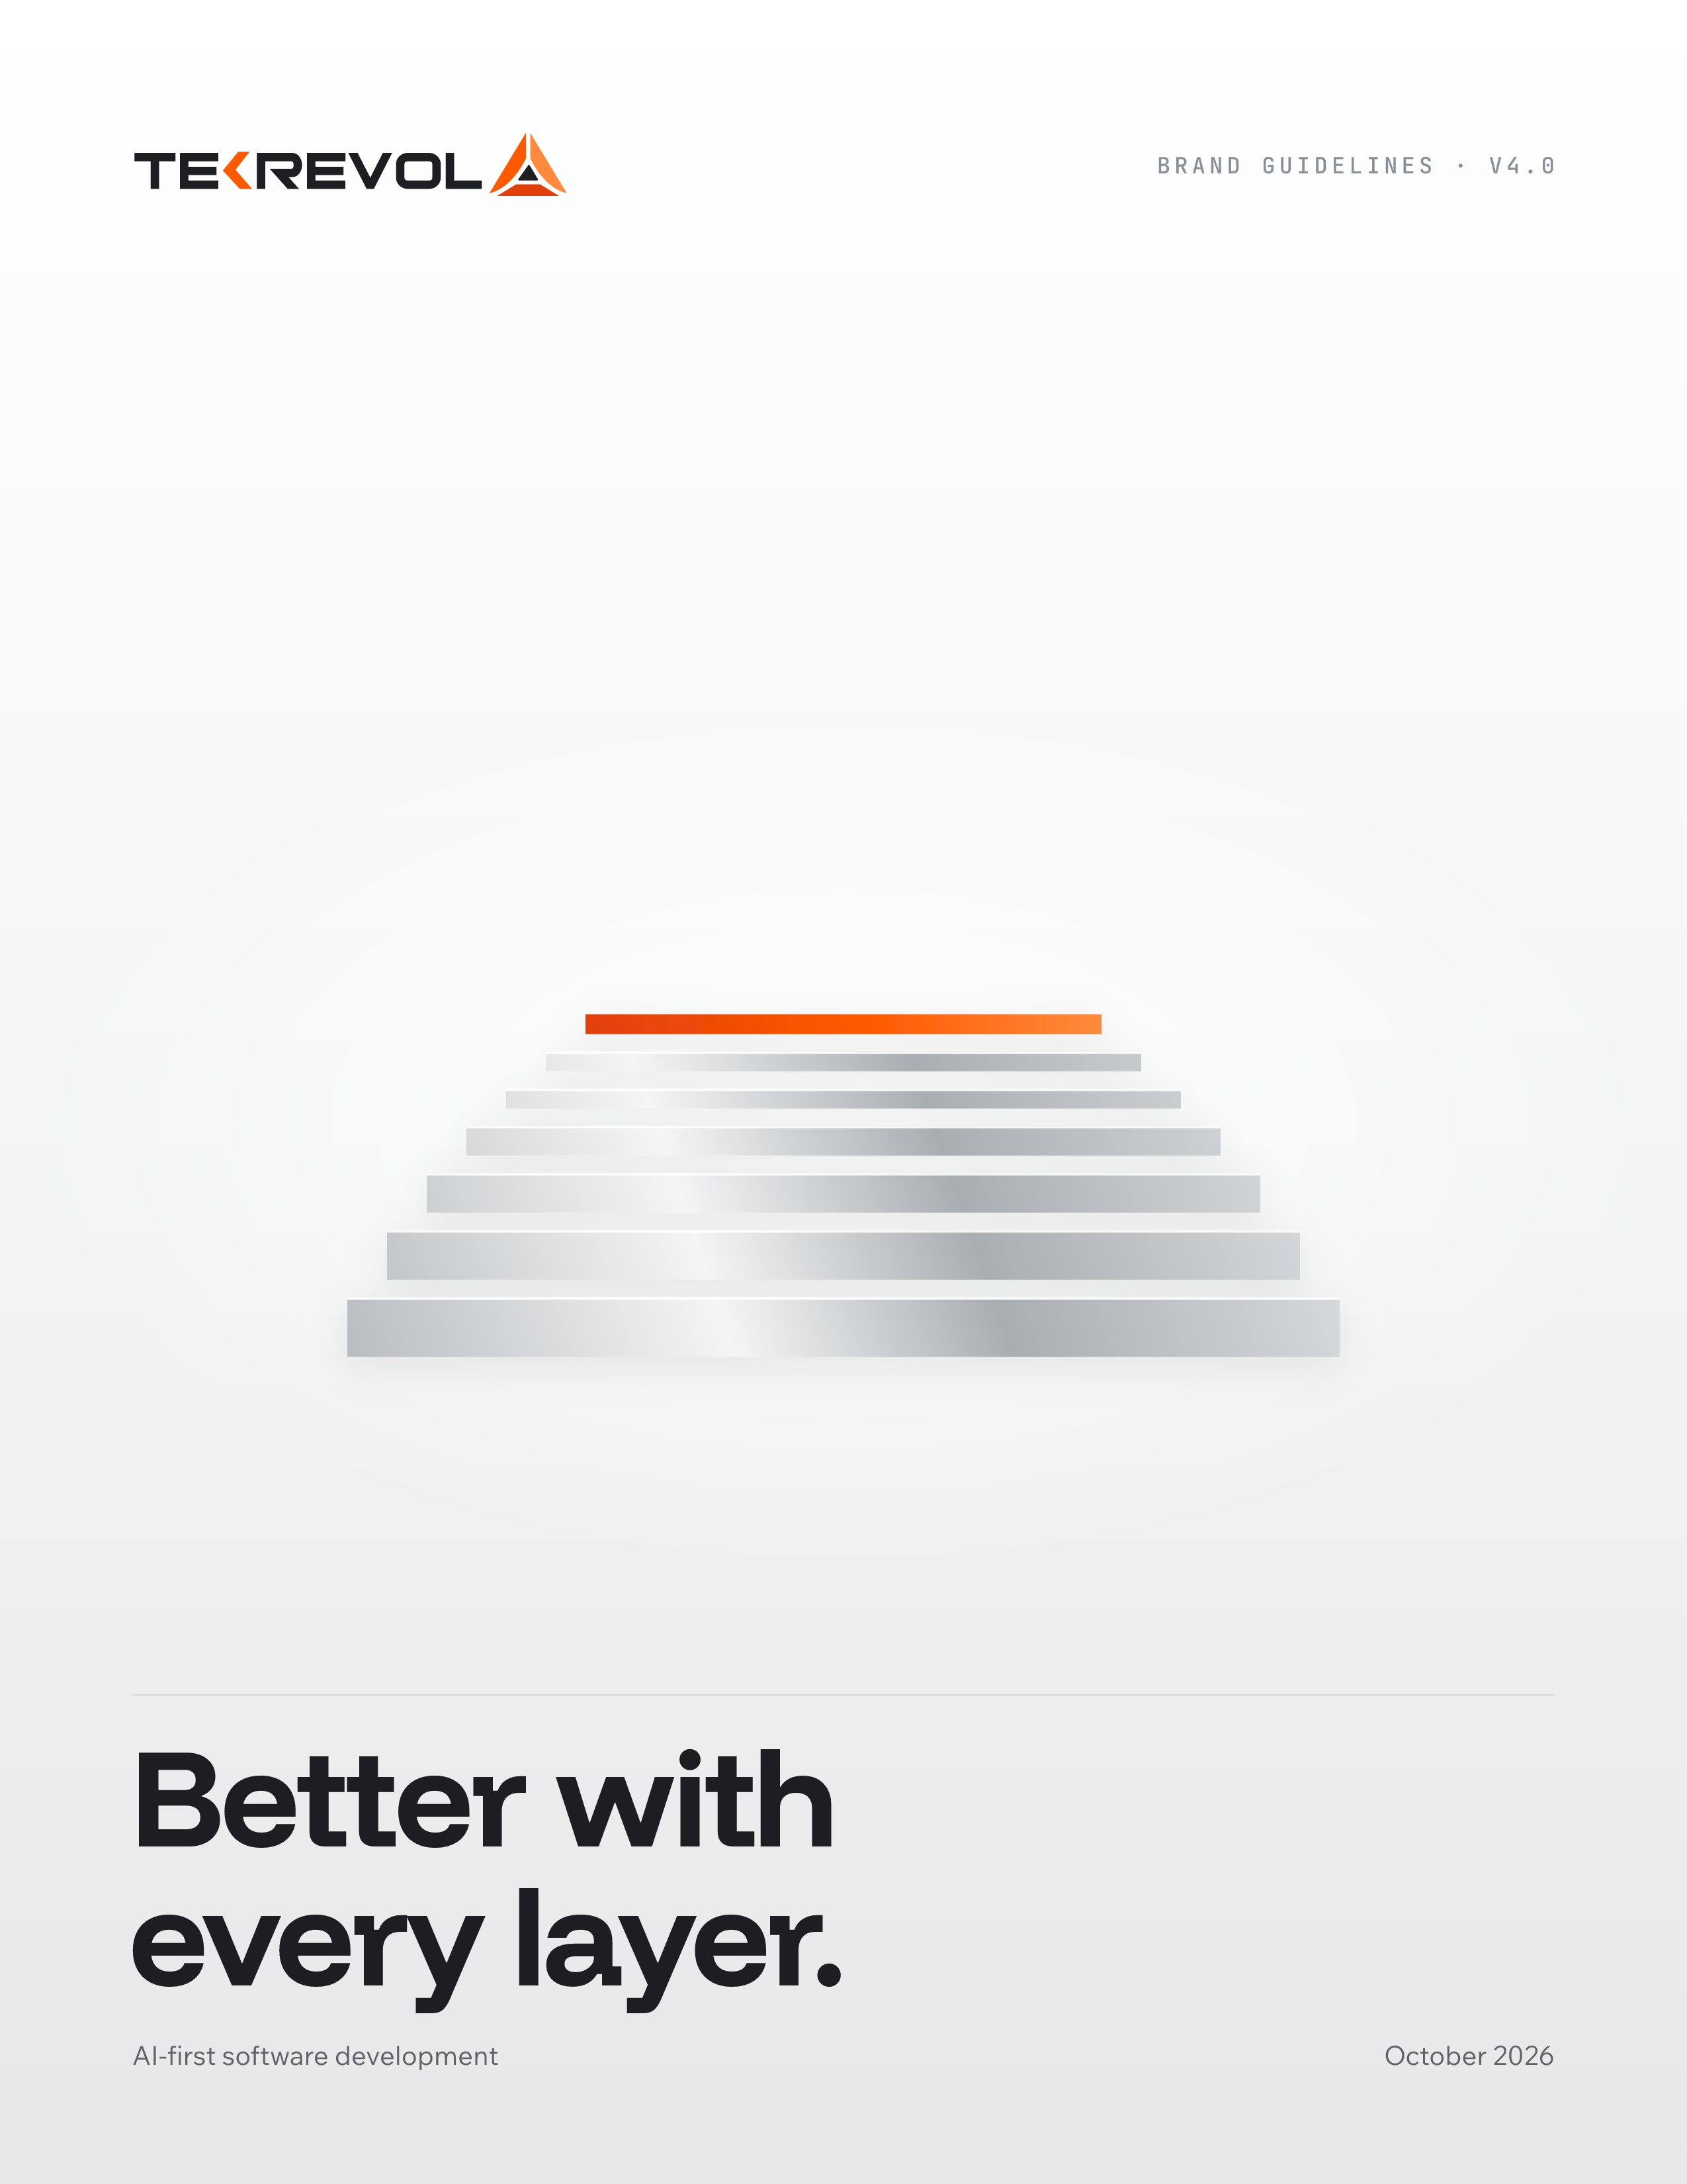

BRAND GUIDELINES · V4.0 · OCTOBER 2026
Contents
01 Brand foundation

02 Logo

03 Color

04 Typography

05 Layout, spacing and shape

06 Components

07 Graphic elements

08 Imagery and AI image generation

09 Motion and AI video generation

10 Voice

11 Applying it to the website

12 Brand in use

13 Appendix

01 / BRAND FOUNDATION

Brand foundation
TekRevol builds the AI-native software other vendors, and other AI tools, couldn't finish.

Status: proposed v4.0 for the AI-first rebrand. Colors, typography and the logo refresh need sign-off before the website build starts. The four service-pillar names are not final (Decision D01) and appear as examples only.

What TekRevol is
Category: AI-first software development company. Software development stays the parent category because that is where buyers search. AI moves from one service among many to the headline.
What this means in practice: TekRevol is not an "AI agency" that bolted AI onto a services menu. AI runs through the whole delivery lifecycle: strategy, architecture, build, deployment and operations. The company adapted early, scaled fast and keeps evolving. Every project becomes the base for the next.

The brand idea: Better with every layer
The identity makes that growth visible: precise layers that build on each other, with the newest layer lit in TekRevol orange.
- It adapted early. TekRevol took up AI tools and methods ahead of most of its market and folded them into how it builds.
- It scaled fast. It turned that early start into AI services, private-LLM work (RevAI) and AI-native delivery.
- It keeps evolving. Every project, every learning and every architecture becomes the base for the next one.
Why this matters for trust. AI buyers are tired of hype. "AI-powered" is now a baseline expectation, not a differentiator. The brands that earn trust show their work: the architecture, the process, the layers that got them here. "Better with every layer" promises compounding improvement, not magic.

Look and feel
Clean, futuristic, modern and premium. Bright white and soft grey space, charcoal type, brushed-metal silver, and one bright orange accent that always marks what matters most.
In one sentence: it should feel like a premium technology launch from a company that ships, not a pitch deck from a company that talks.

Personality
TRAIT | MEANS | DOES NOT MEAN
Built | Engineered, precise, specific | Cold or robotic
Quick | Moves early, ships, communicates on schedule | Rushed or careless
Evolving | Always improving the next version | Restless or trend-chasing
Candid | Says what is true, including what went wrong before | Blunt or negative about others
Warm | Human-centered, approachable, real | Soft or unserious

Why orange
Four of the five named competitors lead with blue: LeewayHertz, Azumo, ScienceSoft and Cheesecake Labs. HatchWorks uses teal. The AI services category reads as one blue wall. A bright, disciplined orange on clean white and charcoal gives TekRevol instant recognition and keeps the equity the brand already has.

Proof the idea needs
The idea is about speed of adoption, so it needs evidence before it becomes a public claim:
- the year TekRevol started building with AI, and its first AI product or engagement
- how many AI or automation projects have shipped since
- RevAI milestones
- the Lovable partner listing, once it is live (not before)

02 / LOGO

Logo
The geometry stays exactly as it is. The refresh brightens the oranges and moves the ink to charcoal.

Anatomy
The TEKREVOL wordmark followed by the mark: three planes meeting in a peak (left plane, right plane, base bar) with a small charcoal triangle inside. The K carries an orange chevron.
PART | LEGACY | REFRESHED
Left plane, K chevron | #EF5123 | TekRevol Orange #FF5A00
Right plane | #F37A20 | Flare #FF8A3D
Base bar | #EE3824 | Ember #E2400B
Wordmark, inner triangle | #282526 | Charcoal #1D1E21, or white on dark

Versions
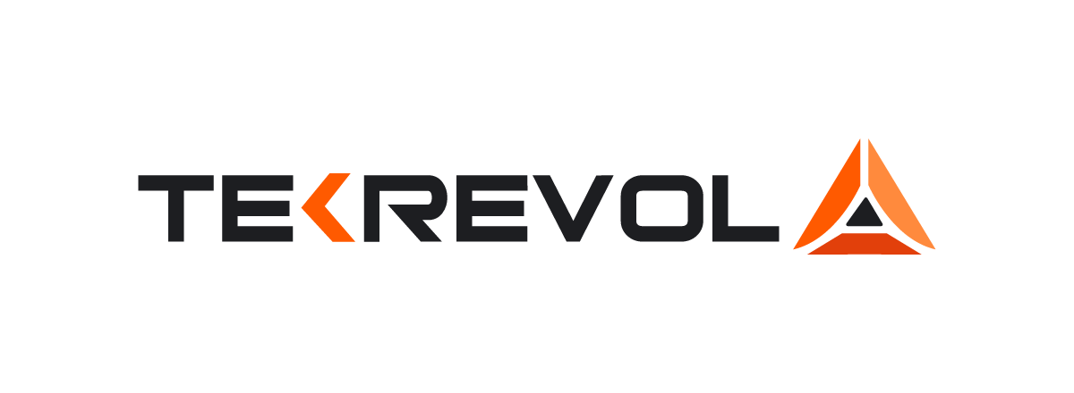
Charcoal ink on white and light backgrounds (primary).
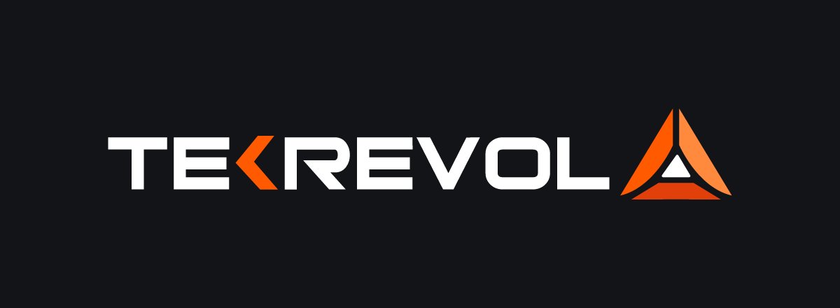
White ink on Deep Charcoal, charcoal and dark photography.
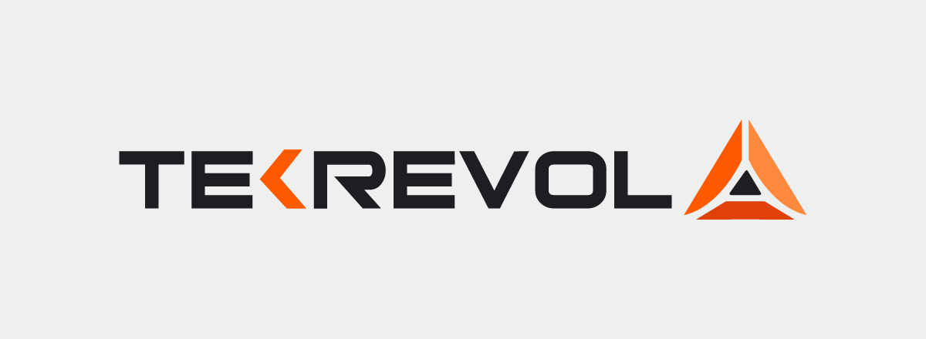
Charcoal ink on mist and silver.
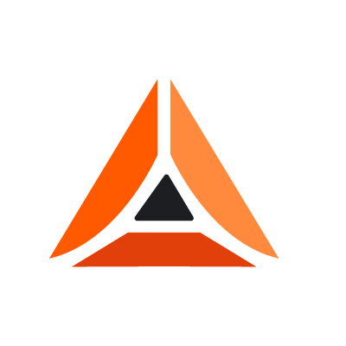
Mark only: favicons, app icons, avatars and watermarks under 120 px wide.

Clear space and size
- Clear space on all sides equals the height of the letter T
- Minimum size: full logo 120 px on screen, 30 mm in print. Mark only 20 px, 6 mm

Do not
- Redraw, stretch, rotate or re-space the wordmark or the mark
- Recolor the planes or set the logo in one flat color (except all-white or all-charcoal for one-color printing)
- Place the full-color logo on orange or busy imagery
- Add glows, outlines, drop shadows, bevels or 3D
- Let AI tools generate the logo. Always composite the real file afterwards

Logo animation
The planes slide in along their 45° angles, lock together, and a line of orange light runs up through the mark before it settles. Total 1.2 seconds. Use at the start or end of videos only; on the web, use the static SVG.
STEP | MOVEMENT | TIMING
Left plane | Enters from 40 px left and 40 px down | 0 to 400 ms, cubic-bezier(0.2, 0.8, 0.2, 1)
Right plane | Enters from 40 px right and 40 px down | 120 to 520 ms
Base bar | Fades in, slides up 16 px | 240 to 540 ms
Light line | 2 px orange line from base to peak | 600 to 1100 ms
Settle | Mark at final position | By 1200 ms
A Lottie version for presentations is still to be produced (see the appendix).

03 / COLOR

Color
A clean, light system with a first-class dark mode. White and grey space, charcoal type, brushed-metal silver and one bright orange accent.

Light palette
 | NAME | HEX | RGB | CMYK* | USE
 | White | #FFFFFF | 255 255 255 | 0 0 0 0 | Primary background
 | Mist | #EEEFEF | 238 239 239 | 0 0 0 6 | Section backgrounds, cards on white
 | Silver | #C9CCCF | 201 204 207 | 3 1 0 19 | Metallic surfaces, dividers on charcoal, hover fills
 | Steel | #8A9097 | 138 144 151 | 9 5 0 41 | Metallic shading, large icons, chart baseline
 | Muted | #5E6166 | 94 97 102 | 8 5 0 60 | Secondary text on white and mist
 | Graphite | #2E3034 | 46 48 52 | 12 8 0 80 | Raised surfaces on charcoal
 | Charcoal | #1D1E21 | 29 30 33 | 12 9 0 87 | Headlines, body text, dark sections, text on orange

Accent
 | NAME | HEX | RGB | CMYK* | USE
 | TekRevol Orange | #FF5A00 | 255 90 0 | 0 65 100 0 | Primary accent: buttons, the highlighted word, key data, logo
 | Flare | #FF8A3D | 255 138 61 | 0 46 76 0 | Hover states, accent on dark backgrounds, logo right plane
 | Ember | #E2400B | 226 64 11 | 0 72 95 11 | Logo base plane, pressed states, deep end of the orange gradient
 | Orange Ink | #C23A00 | 194 58 0 | 0 70 100 24 | Orange as small text on white: links, labels, eyebrows

Dark mode palette
 | NAME | HEX | RGB | CMYK* | USE
 | Deep Charcoal | #131417 | 19 20 23 | 17 13 0 91 | Dark mode page background, cinematic sections
 | Dark Surface | #1A1B1E | 26 27 30 | 13 10 0 88 | Dark mode cards, elevated surfaces
 | Dark Border | #2A2C30 | 42 44 48 | 13 8 0 81 | Decorative dividers only
 | Dark Control | #6E727A | 110 114 122 | 10 7 0 52 | Input and button outlines on dark (3:1 or more)
 | Dark Muted Text | #8B8E94 | 139 142 148 | 6 4 0 42 | Secondary text on dark backgrounds
Dark mode is not an inversion. Deep Charcoal is the base, Dark Surface lifts cards, and Flare becomes the accent for text and links because it reads better on deep neutrals. Headlines are white; secondary copy uses Dark Muted Text. Dark mode is for screens only, never print or static PDFs.
*CMYK values are direct conversions for reference. Confirm with a printer's proof; bright orange needs a spot color or press check.

Proportion
COLOR | SHARE OF A PAGE OR FRAME
White and mist (light mode) or Deep Charcoal (dark mode) | About 55%
Charcoal (type and dark sections) | About 20 to 25%
Silver and steel (metallic touches) | About 10%
TekRevol Orange | 5 to 10%: one focal point per view. The primary button does not count; it is functional

Gradients
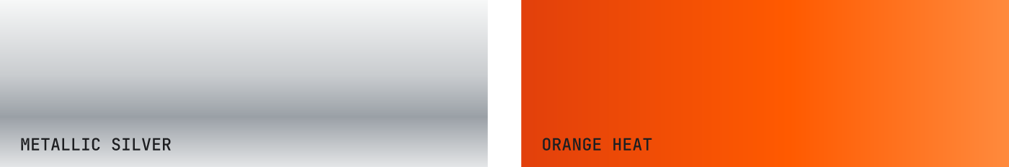
/* Metallic silver: graphic layers, hero cards, illustrations. Never text. */
linear-gradient(180deg, #F7F8F8 0%, #C9CCCF 45%, #9AA0A6 70%, #E4E6E7 100%)
/* Orange heat: Strata top layer, progress bars, small highlights. Never text. */
linear-gradient(90deg, #E2400B 0%, #FF5A00 55%, #FF8A3D 100%)

Contrast
TEXT | ON | RATIO | OK FOR
Charcoal | White / Mist | 16.7 / 14.5 | All text
Muted | White / Mist | 6.2 / 5.4 | All text
Charcoal | TekRevol Orange | 5.3 | All text, including buttons
Orange Ink | White | 5.4 | All text
TekRevol Orange | White | 3.1 | Headlines 24 px and up only
White | TekRevol Orange | 3.1 | Avoid; use charcoal text on orange
White | Deep Charcoal | 18.4 | All text
Flare | Deep Charcoal | 7.9 | All text on dark
Dark Muted Text | Deep Charcoal / Dark Surface | 5.6 / 5.2 | All text on dark
Ember | Deep Charcoal | 4.4 | Not for text on dark

Do not
- Use blue or purple as brand colors, or blue-purple gradients
- Set text in grey gradients or metallic effects
- Use the legacy #F37A20 next to TekRevol Orange
- Put white text on orange buttons
- Use more than one orange focal point per view
- Use Ember as a text color on dark backgrounds (the logo is the exception)
- Use Dark Border as the only outline of an input; use Dark Control

04 / TYPOGRAPHY

Typography
Headlines carry the personality. Everything else stays simple and calm.

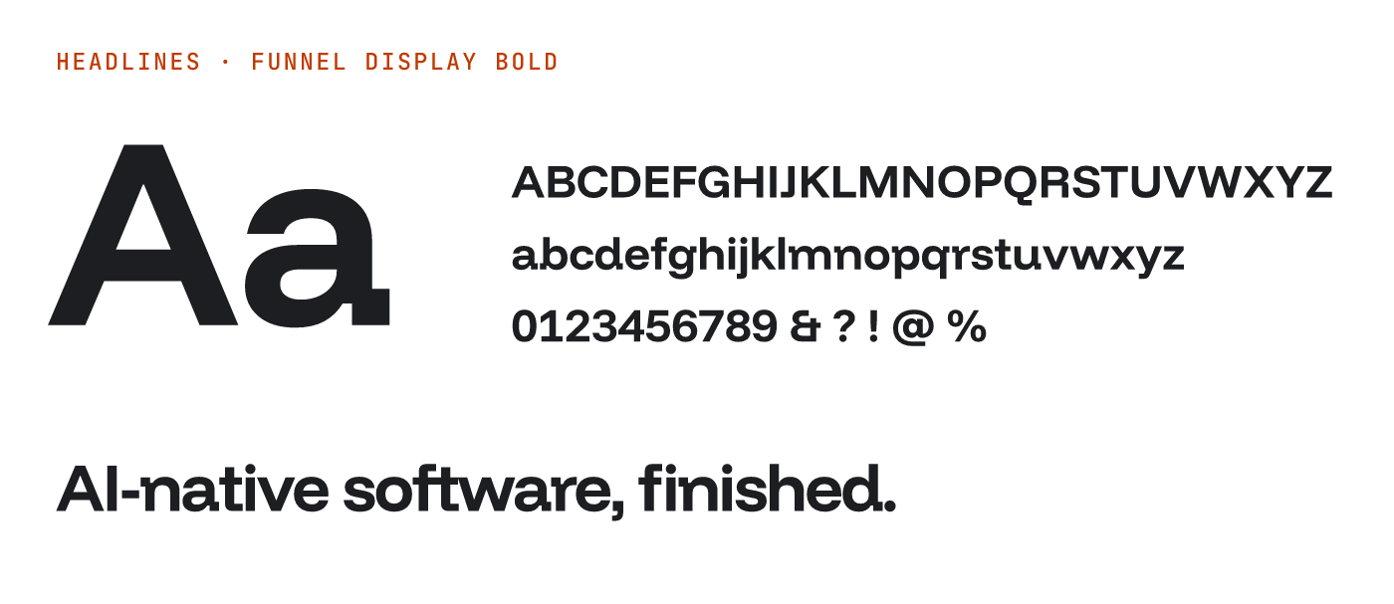
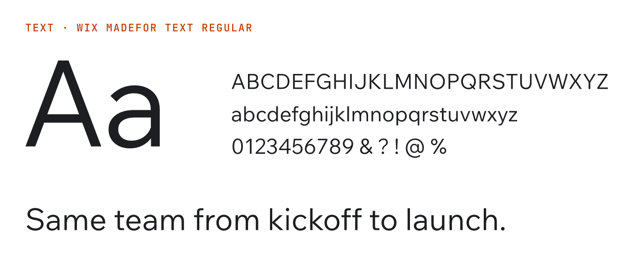
ROLE | TYPEFACE | WEIGHTS
Headlines, pull quotes | Funnel Display | SemiBold 600, Bold 700
Subheads, body, UI | Wix Madefor Text | Regular 400, Medium 500, SemiBold 600
Labels, code, proof numbers | JetBrains Mono | Medium 500
All three are free under the SIL Open Font License from Google Fonts.

Type scale
STYLE | TYPEFACE | DESKTOP | MOBILE | LINE HEIGHT | TRACKING
Display | Funnel Display Bold | 88 | 44 | 1.0 | -3%
H1 | Funnel Display Bold | 56 | 34 | 1.05 | -3%
H2 | Funnel Display SemiBold | 40 | 28 | 1.1 | -2%
Pull quote | Funnel Display SemiBold | 32 | 24 | 1.25 | -1%
H3 | Funnel Display SemiBold | 28 | 22 | 1.2 | -1%
H4 | Wix Madefor Text SemiBold | 20 | 18 | 1.35 | 0
Lead | Wix Madefor Text Regular | 20 | 18 | 1.55 | 0
Body | Wix Madefor Text Regular | 16 | 16 | 1.65 | 0
Small | Wix Madefor Text Regular | 14 | 14 | 1.5 | +0.5%
Button | Wix Madefor Text SemiBold | 15 | 15 | 1.2 | +1%
Label | JetBrains Mono Medium, caps | 12 | 12 | 1.3 | +8%
Data large | JetBrains Mono Medium | 48 | 32 | 1.1 | 0
Sizes in px. Pull quote: a line from a case study, a founder quote or a key insight. Data large: proof numbers (800+, 4.8/5, 10+), with a Label above in Orange Ink on light or Flare on dark.

Kerning, tracking and case
- Kerning on everywhere (`font-kerning: normal`); Metrics or Optical kerning in design tools
- Headlines tighten as they grow: -1% at 28 px to -3% at 56 px and above. Never track headlines positively
- Body at 0; labels uppercase at +8%
- Hand-kern big headlines: Te, Ta, Yo, AI, LT, "V," and pairs around periods and apostrophes
- Tabular figures in tables and counters
- Sentence case for headlines and buttons. Write TekRevol in text; all caps only in the logo
- No em dashes, no all-caps headlines, no italics for emphasis, no fake bold

Font loading
Use one method, not both. Option A (simplest): Google Fonts with preconnect and display=swap. Option B (fastest, no third-party request): self-host WOFF2 files and preload Funnel Display 700 and Wix Madefor Text 400.
<!-- Option A -->
<link rel="preconnect" href="https://fonts.gstatic.com" crossorigin>
<link href="https://fonts.googleapis.com/css2?family=Funnel+Display:wght@600;700
&family=Wix+Madefor+Text:wght@400;500;600&family=JetBrains+Mono:wght@500&display=swap" rel="stylesheet">
<!-- Option B -->
<link rel="preload" href="/fonts/FunnelDisplay-Bold.woff2" as="font" type="font/woff2" crossorigin>

05 / LAYOUT, SPACING AND SHAPE

Layout, spacing and shape
A 4 px grid, generous space and square corners with one signature notch.

Spacing
Use only these steps: 4, 8, 12, 16, 24, 32, 48, 64, 96, 128, 160.
CONTEXT | DESKTOP | TABLET | MOBILE
Hero padding | 160 | 96 | 64
Section padding | 128 | 96 | 64
Between components | 48 | 48 | 32
Headline to body | 24 | 24 | 16
Card padding | 32 | 32 | 16

Grid
SCREEN | COLUMNS | GUTTER | SIDE MARGIN
1024 px and up | 12 | 24 px | Auto, content max 1280 px
640 to 1023 px | 8 | 24 px | 32 px
Below 640 px | 4 | 16 px | 16 px
Running text stays under about 68 characters a line. Headlines are left aligned and usually span 8 of 12 columns. Center alignment is for short statements and end cards.

Shape
- Square by default: sections, images and large cards
- Buttons, inputs and tags: 2 px radius, or the notch on primary buttons
- The notch: a 45° cut on the top-right corner, from the logo's diagonal planes. 8 px (buttons, tags), 16 px (cards, frames), 32 px (hero panels). Use it on the most important element in a view
- Pills only for status dots and avatars
/* Notch, 16 px */
clip-path: polygon(0 0, calc(100% - 16px) 0, 100% 16px, 100% 100%, 0 100%);

Borders, depth and icons
- 1 px #D9DADB rules separate content on white; controls use a 1.5 px charcoal or steel outline
- Depth comes from layering and metallic surfaces. Soft shadows only for menus and modals
- Icons: Lucide, 1.5 px stroke at 24 px, charcoal or muted; only an active icon is orange; always with a label; no emoji

06 / COMPONENTS

Components
Build and document these before the website rebrand goes live.

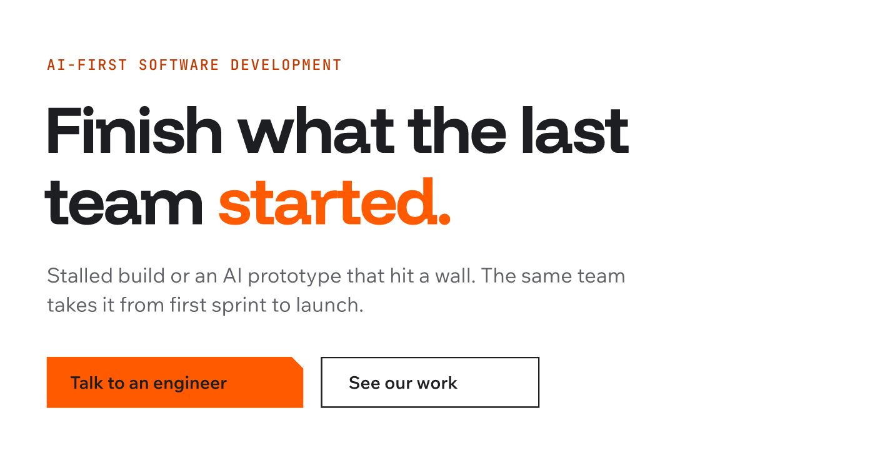
COMPONENT | SPECIFICATION
Primary button | Orange fill, charcoal text, 8 px notch top-right, 12 px vertical and 24 px horizontal padding (on the 4 px grid). Hover Flare, active Ember, disabled 40% opacity with no hover
Secondary button | White fill, 1.5 px charcoal outline, charcoal text, 2 px radius. Hover Mist, active Silver. On dark: transparent with a Dark Control outline and white text
Card | White, 1 px #D9DADB border, 32 px padding, square corners. Featured: 16 px notch. Dark: Dark Surface with Dark Border
Label | JetBrains Mono Medium 12 px, uppercase, +8%. Orange Ink on light, Flare on dark
Proof number | Data large (JetBrains Mono 48 px) with a Label above. Charcoal on light, white on dark
Navigation | White (light) or Deep Charcoal (dark). Charcoal or white logo, Wix Madefor Text Medium 15 px links, one orange "Talk to an engineer" button

07 / GRAPHIC ELEMENTS

Graphic elements
Stacked metal layers, a 45° notch and a single line of orange light.

Strata: layers that build
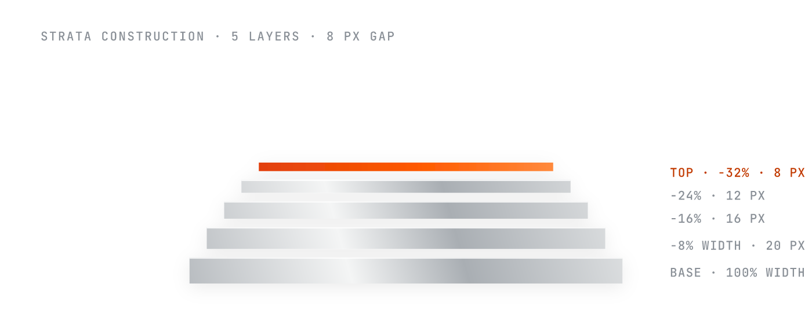
The brand's graphic signature: machined metal layers stacked into a centered peak that echoes the logo, with the newest layer on top in orange heat.
RULE | SPECIFICATION
Layers | 3 to 7. Five is the standard
Height | Base layer 24 px; each layer above 4 px shorter, never below 8 px (layers 6 and 7 stay at 8 px). Measured at a 400 px base width; scale proportionally
Width | Base 100%; each layer above 8% of the base narrower, centered (five layers: 100, 92, 84, 76, 68%)
Gap | 8 px desktop, 4 px mobile
Fill | Metallic silver across the whole shape, bottom-left to top-right; top layer in orange heat, left to right
Corners and shadow | Square corners. One soft shadow on the group: 0 4px 16px rgba(0,0,0,0.08)
Mobile | Below 640 px: 80% width and five layers maximum
- One Strata per page or frame. Orange is always on top
- Uses: hero graphic, section divider, process diagram (one layer per stage), frame for a key number
- Motion: layers slide in bottom up, 640 ms, 80 ms stagger, cubic-bezier(0.2, 0.8, 0.2, 1)

The notch
A 45° corner cut from the logo on primary buttons, featured cards and hero panels. The detail that makes a TekRevol layout recognizable without the logo.

Orange light line
One thin line or streak of orange light that suggests speed: under a key headline, along a progress path or across a hero image. Static: a 2 px TekRevol Orange line. Motion: a 4 px Ember-to-Flare line sweeping across in 600 ms. One per view.

Metallic surfaces
Brushed silver and satin steel give depth and an enterprise feel: graphic layers, device frames and abstract backgrounds on white, mist or charcoal, never text. Device frames get a subtle machined edge (inset 0 1px 2px rgba(255,255,255,0.4)). One metallic surface per view: a highlight, not a texture.

08 / IMAGERY AND AI IMAGE GENERATION

Imagery and AI image generation
Documentary, not abstract. TekRevol shows the work, the people and the process.

The look: bright precision
Clean, bright, futuristic spaces in white and soft grey. Brushed metal and precise forms. Real people doing real work. One bright orange element or light in every frame. It should feel like a premium technology launch, calm and confident.
This is a deliberate counter-position to the category standard of glowing brains, orbital shapes and abstract data visualizations. Brand graphics are the exception: the Strata, the notch and the light line may be rendered or animated as clean graphics. Photography and AI imagery stay documentary.

Five rules for every image
- Bright and clean. White, mist and pale grey dominate. Soft daylight or studio light. Lots of negative space.
- Metal for quality. Brushed aluminum, satin steel, silver surfaces. Metal is a texture, not a subject.
- One orange focal point. An orange object, light, line or motion streak. Never more than one.
- Layers you can see. Stacked plates, panels, shelves or screens, physically plausible.
- Real and specific. Real people, interfaces and devices. No fantasy tech, robots or humanoid AI faces.

Image families
FAMILY | USE | LOOK
Process layers | Hero, key visuals | Real physical layers (stacked laptops on a desk, studio shelving, architectural models), shallow depth of field, one orange element. The layer idea is physical, not CGI
Kinetic orange | Backgrounds, social, video | A clean grey or white scene crossed by a soft streak of orange light. The orange is motion, not an object
Builders | About, careers, case studies | Documentary photos of the team in bright workspaces, one orange detail (a notebook, a mug, a cable). Candid, 35 mm
Product in context | Service pages, case studies | Real TekRevol interfaces on devices on light surfaces. Screens are composited from real UI, never generated
Industry scenes | Vertical pages | Real, calm, bright settings with the product in use; warm, never clinical blue

Avoid
Glass and liquid-glass effects, glowing brains, robots, humanoid AI faces, robot handshakes, holograms, binary rain, padlocks, circuit-board cities, dark neon scenes, purple-blue gradients, lens flares, fake UI, generated logos or lettering, abstract 3D with no physical plausibility, floating shapes, glowing particles and "data streams".

AI prompt kit

Master style block
Style: TekRevol brand. Clean, bright, futuristic and premium. White and soft light-grey environment (#FFFFFF, #EEEFEF) with brushed aluminum and satin steel surfaces (#C9CCCF, #8A9097) and charcoal details (#1D1E21). One single bright orange accent (#FF5A00), as a real object, a light or a soft motion streak. Documentary photography style, real people, real devices, real spaces. Precise, minimal composition, generous negative space, soft even studio light, sharp focus, high-end editorial quality.

Negative prompt
glass, liquid glass, blue light, purple, neon, dark moody, robots, humanoid faces, glowing brain, holograms, binary code, circuit board, padlock, lens flare, text, letters, logo, watermark, cartoon, clutter, multiple orange objects, oversaturated, abstract 3D, floating shapes, data streams, glowing particles

Templates (each + style block)
- Process layers: "A neat stack of five closed silver laptops on a white studio desk, the top one open with its screen glowing bright orange, soft shadows, three-quarter view."
- Kinetic orange: "A minimal light-grey architectural space with one soft streak of bright orange light sweeping diagonally across it, motion blur, empty space on the left for text."
- Builders: "Documentary photo of a software engineer and a designer reviewing a product on a large monitor in a bright white office, natural daylight, one orange notebook on the desk, candid, 35 mm, shallow depth of field."
- Product in context: "A laptop and phone with silver aluminum frames on a pale grey desk, screens blank for compositing, soft daylight, one orange accent object nearby, top-down three-quarter view."

Tool settings
TOOL | SETTINGS
Midjourney | --style raw --stylize 100 --ar 16:9 (hero 21:9, LinkedIn 1:1 or 4:5, story 9:16) --no glass, blue, purple, text, logo, abstract
GPT Image (ChatGPT) | Write the style block as full sentences; ask for "no text or logos in the image"
Adobe Firefly | Style: Photo, visual intensity low to medium; an approved key visual as style reference
Stable Diffusion | Negative prompt as written; CFG 5 to 7

After generating
- Composite the real logo, UI and type afterwards
- Grade to the palette: clean whites, neutral greys, no blue or green cast, one orange element
- Check hands, faces, devices and reflections for artifacts
- Keep a board of approved images as style references

09 / MOTION AND AI VIDEO GENERATION

Motion and AI video generation
Things arrive the way the brand grows: from the bottom up, layer by layer.

Principles
USE | DURATION | EASING
Hover, focus, color | 120 ms | ease-out
Menus, tabs, small reveals | 240 ms | cubic-bezier(0.2, 0.8, 0.2, 1)
Layers stacking into place | 640 ms, 80 ms stagger | cubic-bezier(0.2, 0.8, 0.2, 1)
Exits | 200 ms | cubic-bezier(0.4, 0, 1, 1)
- Elements rise 16 to 24 px and fade in, staggered bottom up. Nothing bounces
- Hover: buttons brighten to Flare; cards lift slightly; no scaling past 1.02
- One orchestrated moment per page; respect reduced-motion settings

Signature moment: the hero build
TIME | WHAT HAPPENS
0 ms | Label fades in over 200 ms
200 ms | Headline fades in and rises 16 px over 400 ms
400 ms | Lead fades in and rises 12 px over 400 ms
600 ms | Buttons fade in and rise 8 px over 300 ms
800 ms | Strata layers slide up 24 px and fade in, 400 ms each, 80 ms apart; the orange top layer brightens (opacity 0.8 to 1) for 200 ms after landing
About 2 s | Hero fully composed (five layers)
Text is readable from the first frame; only the Strata waits. Build in CSS with IntersectionObserver for scroll-triggered versions, and in After Effects for video.

Video language
ELEMENT | RULE
Look | Bright white and grey spaces, brushed metal, real people, one orange accent per shot
Camera | Slow push-ins, smooth lateral tracks, gentle orbits. No handheld shake or whip pans
Pace | 25 to 30 s for social; 3 to 5 s per scene; one idea per scene
Type | Funnel Display headlines, Wix Madefor Text captions, max 8 words on screen
End card | White or mist, Strata, logo, one-line call to action
Sound | Clean electronic pulse, light and confident

AI video prompt kit
TekRevol brand film. Clean bright futuristic white and light-grey environment, brushed aluminum and satin steel surfaces, charcoal details, one bright orange accent (#FF5A00), soft even studio light, slow smooth camera, precise minimal composition, premium technology launch feel. Real people, real spaces, documentary style. No glass, no blue or purple light, no text, no logos, no abstract 3D.
- Builder scene (4 s): "Slow dolly past an engineer reviewing code in a bright white office, daylight, calm focus, one orange object on the desk."
- Kinetic reveal (4 s): "A soft streak of orange light sweeps across a minimal pale-grey space, leaving empty space for a headline; camera drifts slowly right."
- Strata opener: build it as a motion graphic from the Strata SVG, not with an AI video tool, so the geometry stays exact

10 / VOICE

Voice
Write like the smartest person in the room who has nothing to prove.

Proposed, based on TekRevol's Messaging and Positioning (AI-First) document; needs sign-off from someone with brand authority.

The sound
Clear, direct and specific, like a sharp in-house engineer explaining the plan. A working example already on the site: "you want architectural truth, not a pitch."

Rules
- No em dashes, anywhere
- Active voice; short sentences of varied length
- One buyer's situation at a time; never "from startups to enterprises"
- Every claim traces to something real: a sourced number, a credential, a named case study
- No invented statistics; no speed or cost claims for AI-assisted delivery until a measured engagement backs them
- Name the situation, never the vendor
- Avoid stacked rule-of-three phrasing, "whether X, Y, or Z" and false "from X to Y" ranges
- Define jargon the first time it appears

Voice spectrum
CONTEXT | TONE | EXAMPLE
Homepage hero | Confident, direct | "Finish what the last team started."
Case study | Factual, understated | "Rehkempers replaced a 50-year manual pricing process with automated truss pricing across four plants."
Technical blog | Precise, no fluff | "How we take an AI-built prototype to production: what we keep and what we rebuild."
Sales email | Helpful, no pressure | "I looked at your current setup. Here are the two things I'd fix before you scale. Want to talk them through?"
Social | Human, quick | "Your AI prototype got you 80% of the way. Here's what the last 20% actually involves."

Headline directions by audience
AUDIENCE | LEAD WITH | DIRECTION
Founders | Trust | "Built by people who finish what the last team, or the last AI tool, started."
SMB owners | Speed | "Your business is already running. Your software should be too."
Mid-market champions | Something to take upstairs | "A proposal your leadership will actually approve."
Mid-market approvers | Compliance | "Built to the standard your industry already requires."
Technical evaluators | Architecture | "The architecture decisions that make AI systems production-ready."
Enterprise procurement | Risk | "AI delivery with the security and audit trail your legal team needs."

Words to avoid
Revolutionary, cutting-edge, next-gen, unleash, supercharge, seamless, game-changing, "harness the power of AI". Also: "AI-powered" on its own, "digital transformation", "leverage" and "utilize" (say "use"), "robust" (show what makes it robust).

Approved proof (public)
800+ apps and digital products delivered · 98% client satisfaction · 10 years of experience · 4.8/5 on Clutch · Clutch Top 1000, Inc. 5000 and other listed awards · HIPAA, SOC 2, GDPR and PCI DSS experience · named case studies: Kinder Morgan, Rehkempers, Pure Plank, Rise Up Kings.
Not yet public: the Lovable partner listing (until live), home-based care product names (until confirmed), final pillar names (until D01 closes).

11 / APPLYING IT TO THE WEBSITE

Applying it to the website
Show at first glance that TekRevol is an AI company with deep engineering underneath.

Homepage structure
SECTION | LIGHT / DARK | PATTERN AND COMPONENTS
Hero | White / Deep Charcoal | Label, display headline naming what TekRevol is and who it is for, lead, primary and secondary button; Strata builds on the right
Proof band | Mist / Dark Surface | Award logos at 60% opacity plus two or three Data large proof numbers
Pillars | White / Deep Charcoal | Four cards on the 12-column grid; the featured card takes the notch
Finish what was started | Charcoal / Deep Charcoal | The rescue story; white H2, one orange word, real product imagery
Case studies | White / Deep Charcoal | Cards leading with the client's result; filterable by industry
Compliance | Mist / Dark Surface | HIPAA, SOC 2, GDPR and PCI DSS named plainly, as a block a champion can forward
Closing call to action | White / Deep Charcoal | Static Strata, H1 line, one primary button
Responsive: on mobile the hero Strata moves below the buttons, the proof band wraps to two rows, pillars stack, compliance becomes an accordion and the closing Strata scales to 60%.

Templates to design
Homepage · service pillar · service · case study · blog article · industry hub (home-based care) · about and careers · contact. For each: a labeled wireframe, the three breakpoints, the dark variant and the motion choreography.

Build notes
- Choose one font-loading method (see Typography)
- Expose the appendix tokens as CSS custom properties; build dark mode as a first-class theme and test every component in both
- Hero build in CSS plus IntersectionObserver; respect prefers-reduced-motion
- Real HTML text everywhere so search engines and AI assistants can read and cite it
- Check every text and background pair against the contrast table
- Keep components in a shared Figma and code library

12 / BRAND IN USE

Brand in use
Sample applications of the system. Illustrative layouts, not final designs.

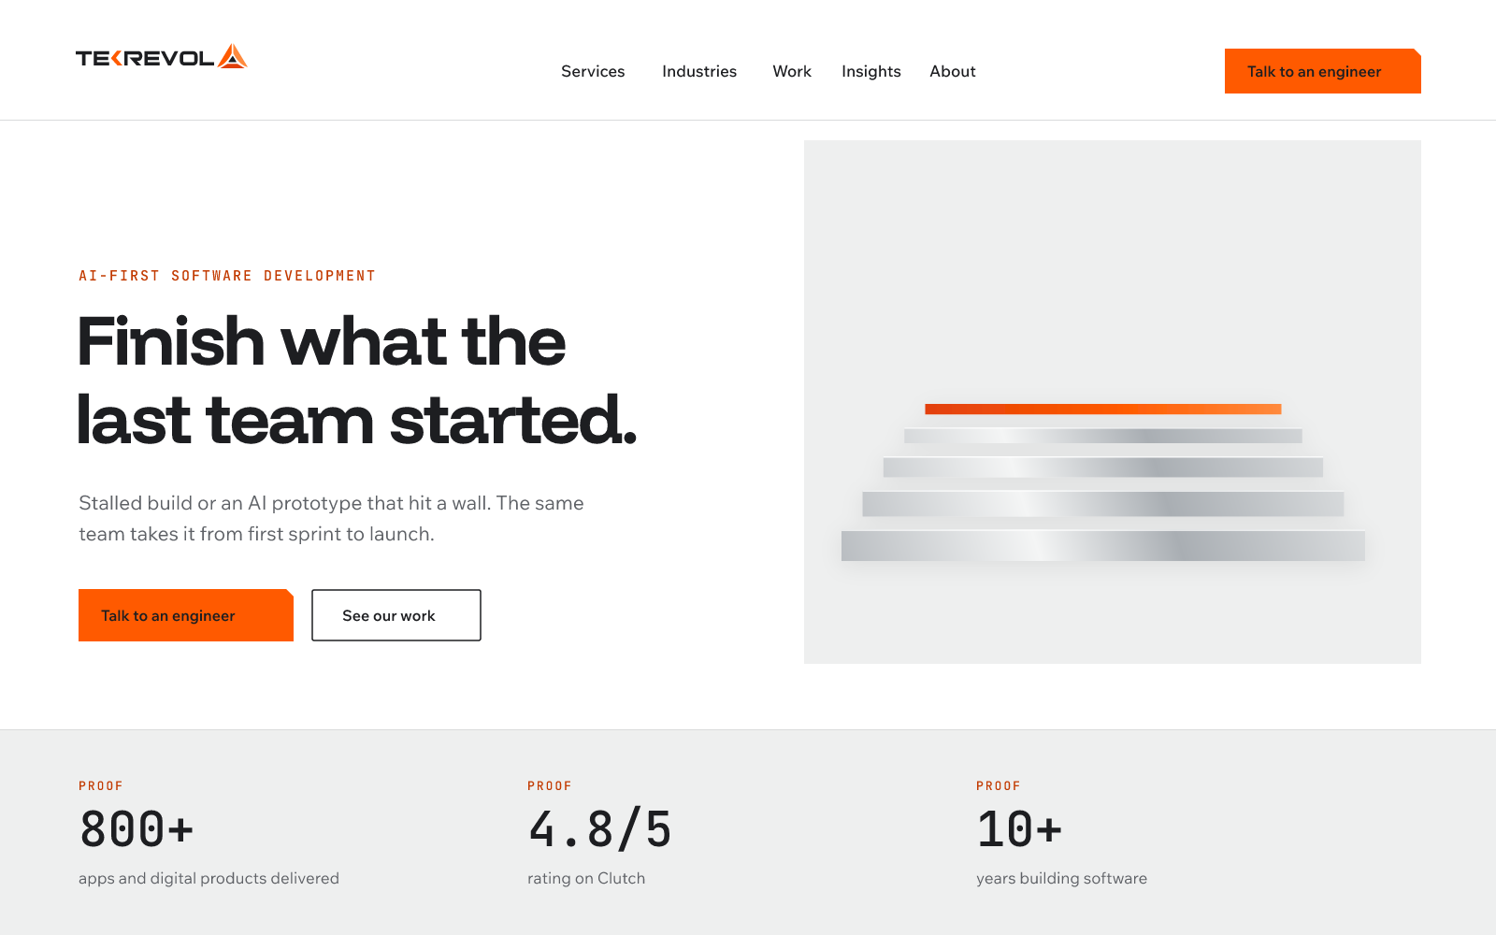
Homepage hero, desktop, light mode.
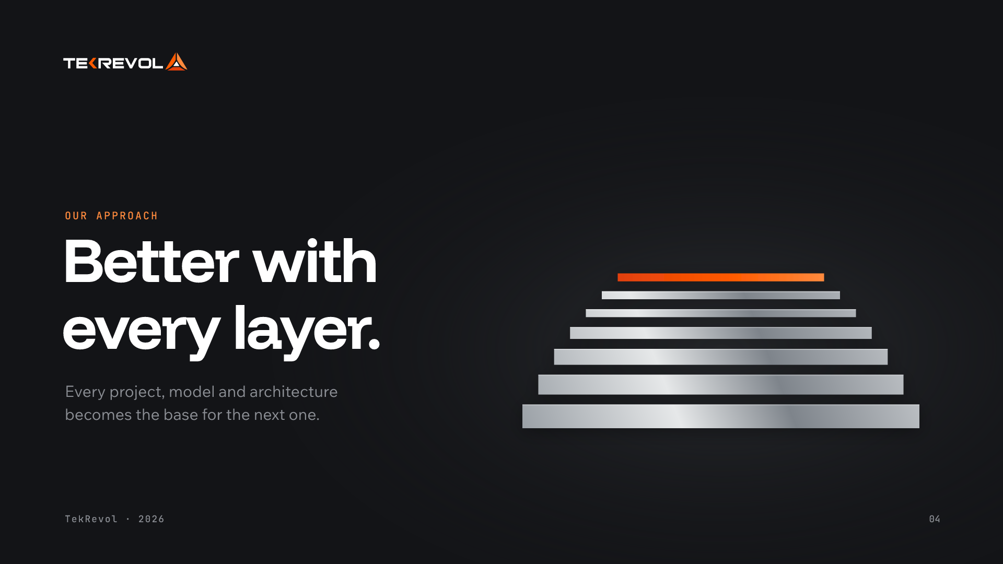
Presentation slide, dark mode.
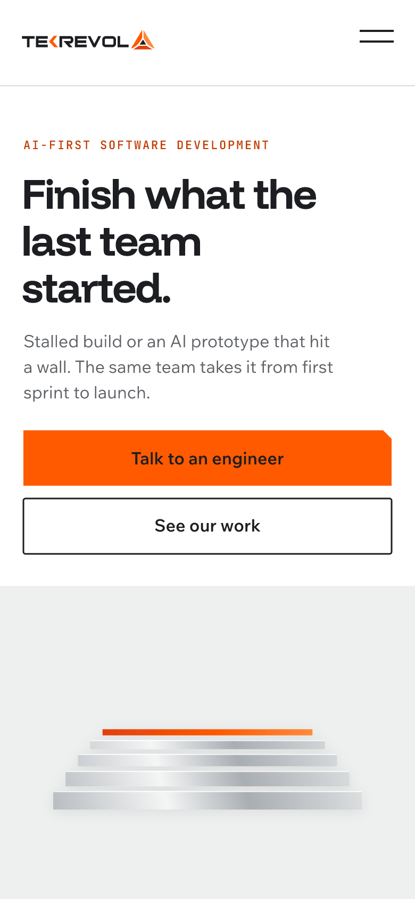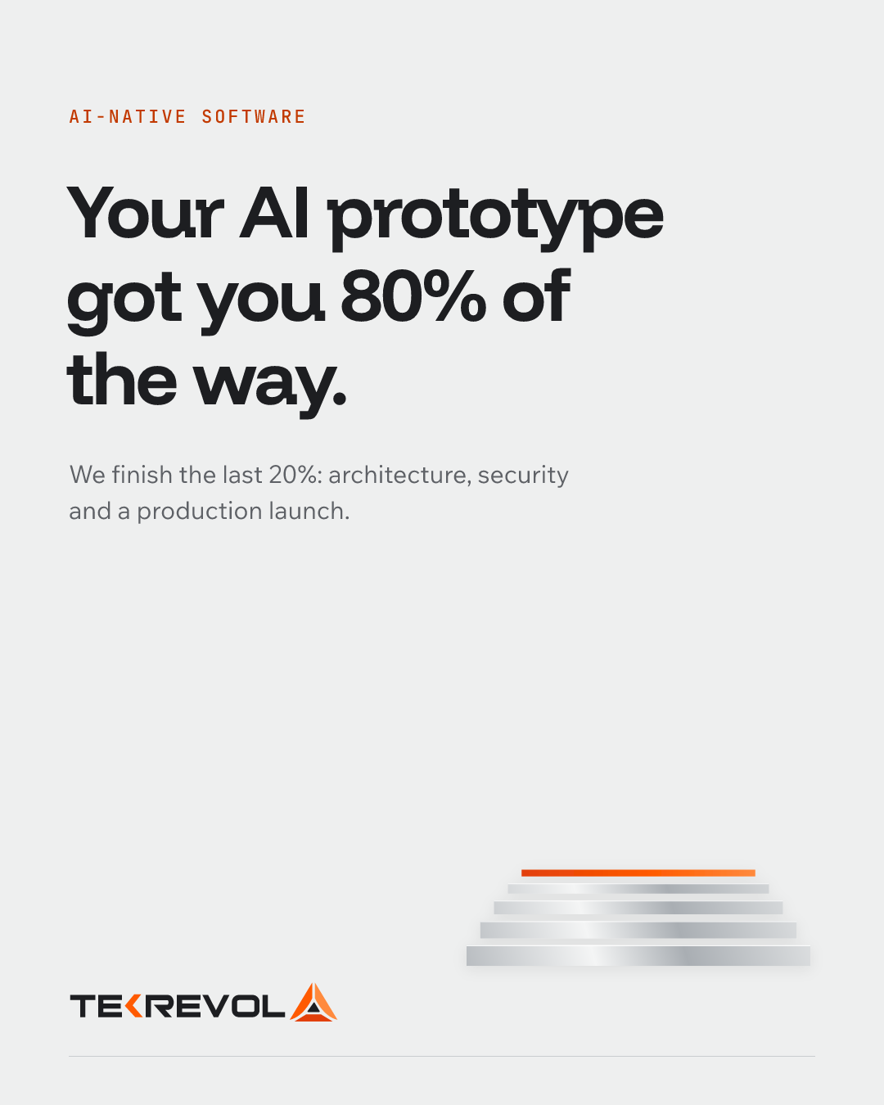
Mobile hero and a LinkedIn post (4:5).
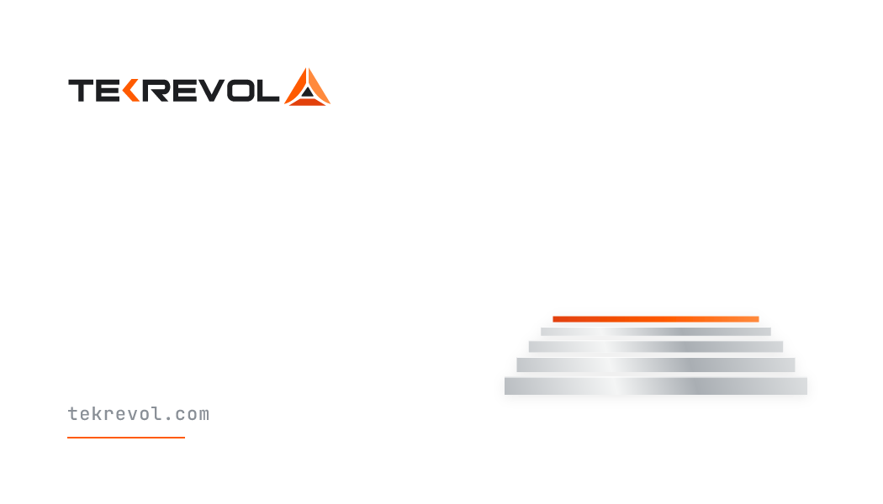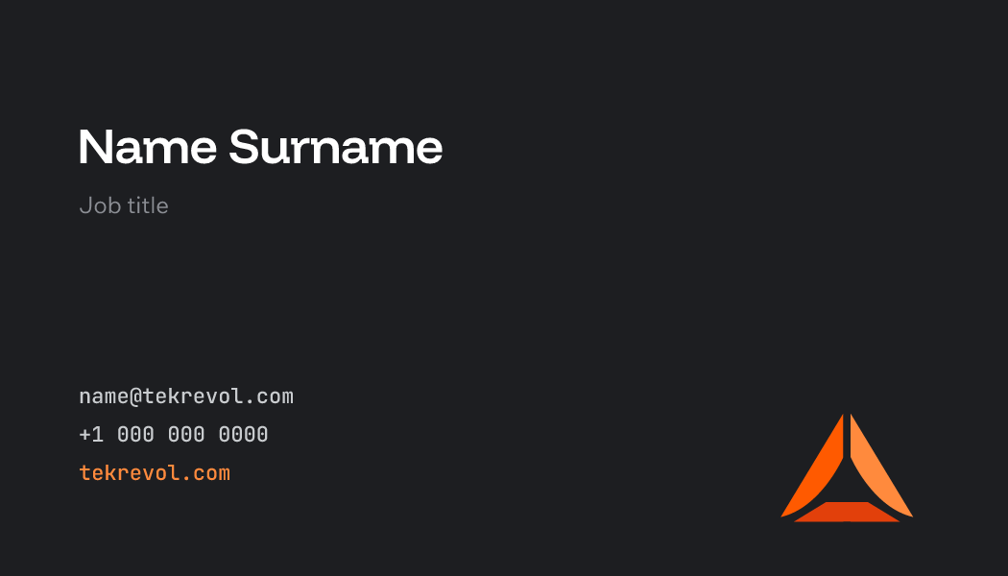
Business card, front and back (3.5 × 2 in).

13 / APPENDIX

Appendix
Design tokens, files and fonts.

CSS custom properties
:root {
--color-white: #FFFFFF;
--color-mist: #EEEFEF;
--color-silver: #C9CCCF;
--color-steel: #8A9097;
--color-muted: #5E6166;
--color-graphite: #2E3034;
--color-charcoal: #1D1E21;
--color-deep-charcoal: #131417;
--color-dark-surface: #1A1B1E;
--color-dark-border: #2A2C30;
--color-dark-control: #6E727A;
--color-dark-muted-text: #8B8E94;
--color-orange: #FF5A00;
--color-flare: #FF8A3D;
--color-ember: #E2400B;
--color-orange-ink: #C23A00;
--color-bg-primary: var(--color-white);
--color-bg-secondary: var(--color-mist);
--color-text-primary: var(--color-charcoal);
--color-text-secondary: var(--color-muted);
--color-border: #D9DADB;
--color-accent: var(--color-orange);
--color-accent-text: var(--color-orange-ink);
--space-1: 4px;
--space-2: 8px;
--space-3: 12px;
--space-4: 16px;
--space-6: 24px;
--space-8: 32px;
--space-12: 48px;
--space-16: 64px;
--space-24: 96px;
--space-32: 128px;
--space-40: 160px;
--font-headline: "Funnel Display", sans-serif;
--font-text: "Wix Madefor Text", sans-serif;
--font-mono: "JetBrains Mono", monospace;
--ease-standard: cubic-bezier(0.2, 0.8, 0.2, 1);
--ease-exit: cubic-bezier(0.4, 0, 1, 1);
--duration-hover: 120ms;
--duration-menu: 240ms;
--duration-stack: 640ms;
--duration-exit: 200ms;
}
[data-theme="dark"] {
--color-bg-primary: var(--color-deep-charcoal);
--color-bg-secondary: var(--color-dark-surface);
--color-text-primary: var(--color-white);
--color-text-secondary: var(--color-dark-muted-text);
--color-border: var(--color-dark-border);
--color-accent-text: var(--color-flare);
}
In dark mode the orange button fill stays TekRevol Orange; Flare becomes the color for accent text and links.

Files
ASSET | STATUS | LOCATION
Logo SVG (color, white, mark) | Ready | logos\
Logo and favicon PNGs | Ready | logos\png\
Strata SVG and PNG (3, 5, 7 layers) | Ready | strata\
Fonts (TTF) | Ready | fonts\
Design tokens JSON | Ready | tokens\tekrevol-tokens.json
Brand sample visuals | Ready | samples\
PDF of this guide | Ready | TekRevol-Brand-Guidelines-v4.pdf
WOFF2 web fonts | To produce (developer) | Google Fonts download
Lottie logo and Strata animations | To produce (motion designer) | -
Figma component library | To produce (design) | -
Presentation and social templates | To produce (design) | -
Curated Lucide icon set | To produce (design) | -
All paths are inside Projects\TekRevol\01-brand-system\.

Font licenses
Funnel Display, Wix Madefor Text and JetBrains Mono are free under the SIL Open Font License. No commercial license is needed.

