Poland Pitch Deck
Slide plan and copy for Omais
Source file: Decks.pptx on SharePoint, version of 16 October 2026 (104 slides). Slide numbers below match that version.
Length: 11 slides. Six case studies, with credentials and story around them.
Look: modern and premium, few words per slide.

Rules for the whole deck
- No client names or client logos anywhere. Use the descriptors in this document, for example â€œa leading South African retailerâ€. This includes names inside screenshots and app mockups.
- Use the copy in this document as written. Do not add numbers or results that are not here.
- US spelling. No dashes inside sentences.
- Where a value is in [square brackets], leave the space and mark it. Sana will send the final figure.

The 11 slides at a glance
# | Slide | Source in Decks.pptx | Action
1 | Cover | Slide 19 | Edit subtitle
2 | xLoop at a Glance | Slide 3 | Edit numbers, map, industries
3 | AI First Engineering | New (use slide 20 and 24 visuals) | New slide
4 | Industries We Serve | Slide 17 layout | Rebuild: replace logos with sector tiles
5 | Case: Banking | Slide 27 | Rebuild on the slide 36 layout
6 | Case: Retail | Slide 25 | Rebuild on the slide 36 layout
7 | Case: Healthcare | Slide 28 | Rebuild on the slide 36 layout
8 | Case: Middle East cloud migration | Slide 36 | Keep layout, new text
9 | Case: Gulf data platforms | New, on the slide 36 layout | New slide
10 | Case: Poland fintech | Slide 62 | Rebuild on the slide 36 layout
11 | Why xLoop for Poland and contact | Slide 104 | Rewrite text

Not used: slides 54 and 55 (wrong headcount and office count), slide 74 (â€œISO 27001 Alignedâ€ tag), slide 75 and 51 (named logo walls).

Slide 1: Cover

Source: slide 19
ACTION
Keep the design. Change the text.
Title AI Consulting and Data Engineering
Subtitle for Polish Enterprises
Tagline Where Impactful AI Begins

Slide 2: xLoop at a Glance
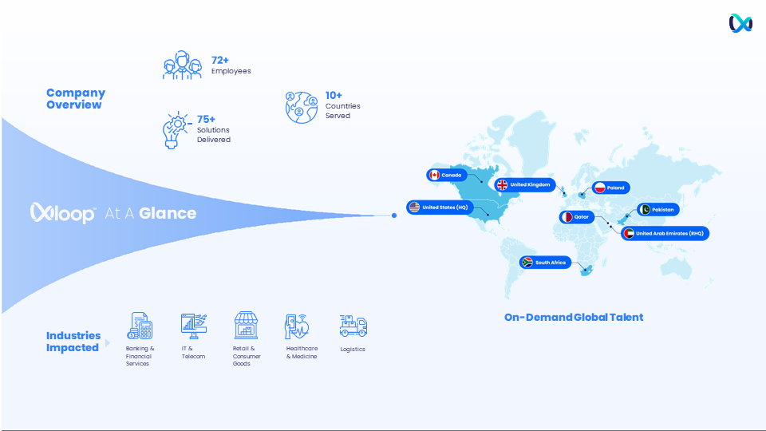
Source: slide 3
ACTION
- Keep the layout and the map.
- Replace the three numbers (72+ Employees, 75+ Solutions Delivered, 10+ Countries Served) with the four stats below.
- Map: keep the current pins and add Hungary.
- Industries row: replace with the six industries below, same icon style.
Title xLoop at a Glance
Stat 1 90 People, engineers and consultants
Stat 2 $5M+ Annual revenue run rate (as of 2026)
Stat 3 4 Offices: San Mateo, Dubai, Doha, Karachi
Stat 4 8 Countries served
Small line Founded in 2022
Industries Banking and Financial Services · Retail · Real Estate · Healthcare · Logistics · Travel
Partners strip AWS Â· Microsoft Â· Snowflake Â· Databricks Â· Salesforce (partner logos are fine)
Footer line Certified ISO 42001 and ISO 27001 Lead Auditors on our team

Slide 3: AI First (new slide)
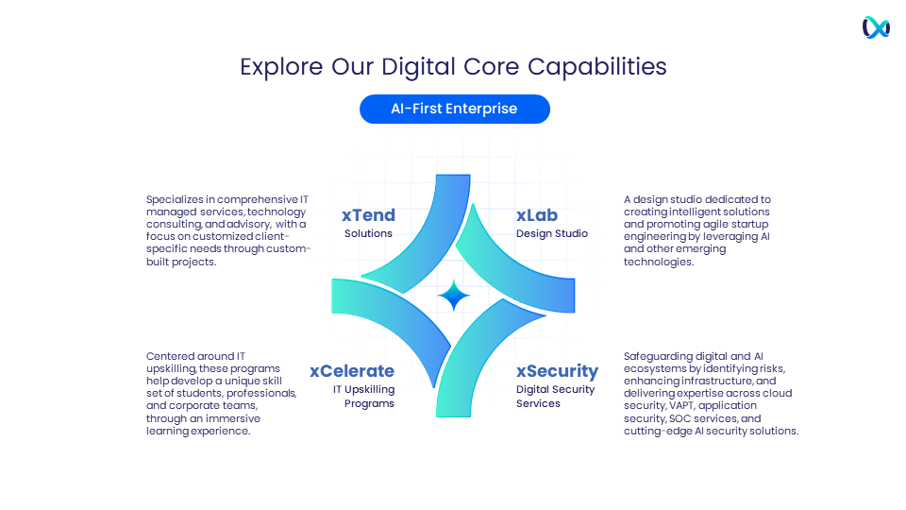
Visual reference: slide 20 (the four business lines graphic can sit small at the bottom)
LAYOUT
Two columns, Then on the left, Now on the right, with an arrow or the loop motif between them. The Now column is the visual focus. A bottom band carries the closing line. If five rows feel crowded, lay it out as a four step path instead: Understand our data, Fix the gaps, Automate with agentic workflows, AI native organization.
Title AI First Engineering
Subtitle We changed how we work before we asked clients to change theirs

Then | Now
Data spread across systems, with gaps nobody could see | We mapped our data and fixed the gaps, so every decision runs on numbers we trust
Manual, repetitive processes | Automation and agentic workflows handle routine work, and people approve what matters
Software and data engineering services | AI native delivery: engineers work with AI coding assistants, and an engineer reviews and tests every change
AI projects as pilots | AI agents built for production on an 11 stage reference architecture, from input guardrails to observability
Security as a separate service | AI security built in: red teaming, AI security audits, certified ISO 42001 and ISO 27001 Lead Auditors

Bottom band Where we are going: an AI native organization that is agile, dependable and data backed.

Slide 4: Industries We Serve
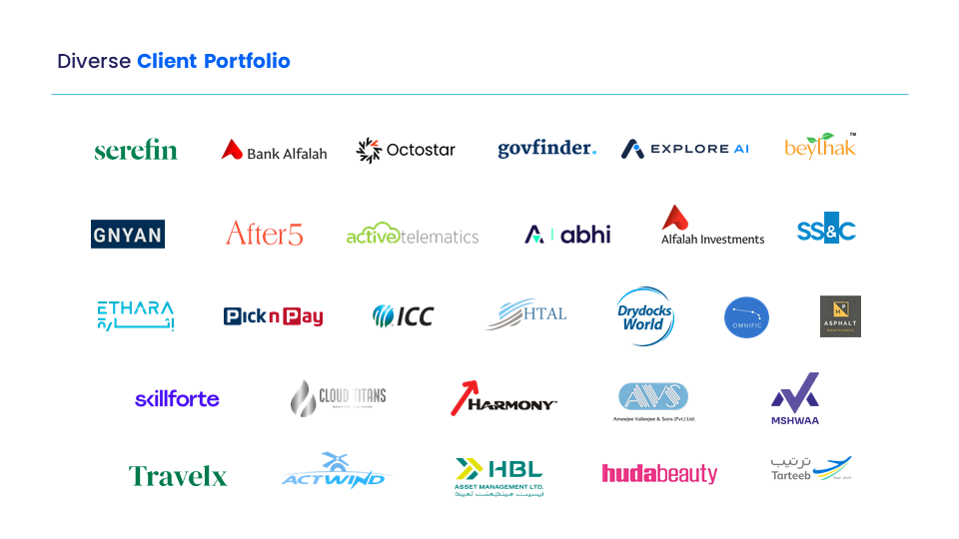
Source: slide 17. Keep the title style only. The logos must go.
ACTION
Replace the logo wall with six sector tiles. Each tile has the sector name, who we worked with (descriptors, no names) and what we did. Use an icon per sector.
Title Industries We Serve
Subtitle Who we have worked with, and what we built for them

Sector | Who | What we did
Banking and Financial Services | A leading asset management firm  A UAE commercial bank  A financial services firm | AI investment assistant  Migration to Microsoft Azure  COBOL to Java modernization with AI
Retail | A leading South African retailer  A fast food chain in Saudi Arabia  A large retail and real estate group in the Middle East | Single source of truth on Snowflake  AI ordering with xServe  AWS to Azure migration assessment
Real Estate | A leading UAE real estate group | Data platform on Databricks
Healthcare | A Canadian healthcare platform  One of Pakistan's leading NGOs | AI search over video recordings and security testing  National immunization platform
Logistics | A global maritime services company  A container depot | Data platform on Databricks  Operations modernization
Travel | A travel insurance provider | AI claims and policy app

Slides 5 to 10: Case studies
All six cases use one layout, so the deck reads as one set. Use the slide 36 layout for every case. Rebuild slides 27, 25, 28 and 62 on it, build the Gulf case new on it, and reuse their existing images.
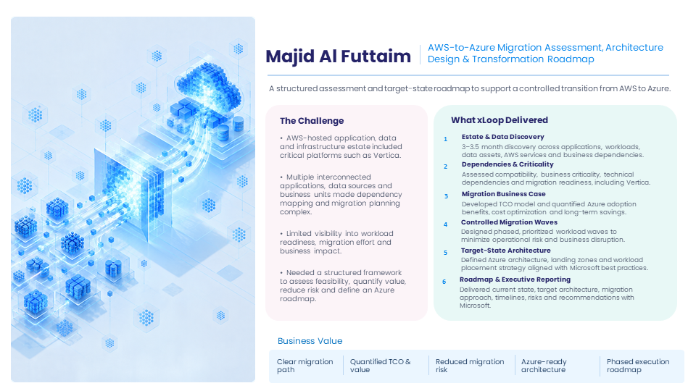
Layout for all six cases: slide 36
THE FORMAT, IN THIS ORDER
Element | What goes in it | Length
Client | Anonymous descriptor, no name or logo | One line
Headline | What we built, in plain words | Up to 8 words
Summary | One sentence under the headline | Up to 25 words
Tags | Sector, service, technology | Exactly 3
The Challenge | Left box, bullet points | Exactly 3 bullets
What xLoop Delivered | Right box, numbered steps, each with a bold name and one line | Exactly 4 steps
Business Value | Bottom strip of short labels | Exactly 4 labels
Image | Left panel, reuse the slide's current image | No client logos in it

No percentages or result numbers in any case. The only numbers allowed are the ones already in the text below.

Slide 5: Banking, AI investment assistant
Source: slide 27. Rebuild on the slide 36 layout with the copy below. Reuse the current image.
Client A leading asset management firm
Headline AI Powered Funds Information Discovery
Summary An LLM investment assistant that turns long fund reports into plain language answers for investors.
Tags Financial Services Â· AI and LLM Â· Conversational AI
The Challenge
â€¢ Investors faced 40+ page fund reports and slow, manual research.
â€¢ Risk profiling was unclear, which led to poor fund selection.
â€¢ Basic fund details were hard to find, and support was delayed by manual processes.
What xLoop Delivered
1 Risk Profiling: Investors describe their goals in plain language and get a risk profile.
2 Fund Suggestions: Personalized fund suggestions matched to each investor's profile.
3 Fund Comparison: Side by side comparison of fund performance, returns and risk.
4 Always On Assistant: A conversational interface available 24/7, with no complex navigation.
Business Value Faster investor research Â· Clearer risk profiling Â· 24/7 investor support Â· Less manual support work

Slide 6: Retail, single source of truth
Source: slide 25. Rebuild on the slide 36 layout with the copy below. Reuse the current image.
Client A leading South African retailer
Headline Data Strategy and Migration to Snowflake
Summary One trusted source of truth for reporting, data analysis, data science and AI.
Tags Retail Â· Data Platform Â· Snowflake on AWS
The Challenge
â€¢ Data was spread across SAP ERP, SAP BW and application databases.
â€¢ Several competing sources of truth, and no unified view.
â€¢ Reporting and analysis could not rely on one consistent set of numbers.
What xLoop Delivered
1 Data Strategy: Defined the migration and analytics strategy.
2 Central Data Warehouse: Built on Snowflake with a medallion architecture.
3 Lakehouse Migration: Moved data from traditional databases to a cloud lakehouse on Snowflake and AWS.
4 Pipeline Optimization: Optimized the pipelines end to end, from data creation to use.
Business Value Single source of truth Â· Consistent reporting Â· Ready for data science and AI Â· Scalable cloud platform

Slide 7: Healthcare, AI search over recordings
Source: slide 28. Rebuild on the slide 36 layout with the copy below. Reuse the current image.
Client A Canadian healthcare platform
Headline AI Search Across Thousands of Recordings
Summary Staff ask a question in plain language and get answers from the full recordings archive.
Tags Healthcare Â· AI and RAG Â· Conversational AI
The Challenge
â€¢ Thousands of video recordings sat unprocessed in the cloud.
â€¢ Key insights were buried in hours of conversations, with no way to retrieve them.
â€¢ Staff had no practical way to find relevant information on demand.
What xLoop Delivered
1 Transcription Engine: Converted historical recordings into searchable text, stored securely in Amazon S3.
2 Retrieval Augmented Generation: An LLM finds and puts into context the relevant parts of the transcripts.
3 Natural Language Chatbot: Staff ask questions and get contextual answers instantly.
4 React Dashboard: A simple front end for staff to search and review.
Business Value Archive fully searchable Â· Answers on demand Â· Less manual searching Â· Insights put to use

Slide 8: Middle East, AWS to Azure migration assessment
Source: slide 36. Keep the layout. Replace the text with the copy below.
Client A large retail and real estate group in the Middle East
Headline AWS to Azure Migration Assessment and Roadmap
Summary A structured assessment and target state roadmap for a controlled move from AWS to Azure, delivered with Microsoft.
Tags Retail and Real Estate Â· Cloud Migration Â· Microsoft Azure
The Challenge
â€¢ An AWS estate of applications, data and infrastructure, including critical platforms such as Vertica.
â€¢ Many interconnected applications, data sources and business units made dependency mapping complex.
â€¢ Limited visibility into workload readiness, migration effort and business impact.
What xLoop Delivered
1 Estate and Data Discovery: A 3 to 3.5 month discovery across applications, workloads, data, AWS services and business dependencies.
2 Migration Business Case: A TCO model quantifying Azure adoption benefits, cost optimization and long term savings.
3 Waves and Target Architecture: Phased workload waves and an Azure architecture with landing zones, aligned with Microsoft best practices.
4 Roadmap and Executive Reporting: Current state, target architecture, timelines, risks and recommendations, delivered with Microsoft.
Business Value Clear migration path Â· Quantified TCO and value Â· Reduced migration risk Â· Azure ready architecture

Slide 9: Gulf, data platforms
Source: new slide on the slide 36 layout. Use the image from slide 38. No client names or logos.
Client Three Gulf enterprises: a UAE commercial bank, a leading UAE real estate group and a global maritime services company
Headline One Source of Truth for Gulf Enterprises
Summary One trusted data platform for each of three Gulf enterprises, so leadership decides from the same numbers.
Tags Gulf Enterprises Â· Data Platforms Â· Databricks and Azure
The Challenge
â€¢ Analytics teams could not get full value from their data.
â€¢ Data sat across many systems, without a single source of truth.
â€¢ Leadership needed one trusted view to make better decisions.
What xLoop Delivered
1 UAE Commercial Bank: Migration to Microsoft Azure.
2 UAE Real Estate Group: A single source of truth built on Databricks.
3 Global Maritime Services Company: A single source of truth built on Databricks.
4 One Approach: We build one governed data platform, so teams work from one set of numbers.
Business Value One trusted source of data Â· Decisions from the same numbers Â· Analytics on a modern cloud platform Â· 331% ROI reported for Azure Databricks (Forrester TEI, commissioned by Microsoft) [Sana to confirm the figure]

Slide 10: Poland, fintech platform
Source: slide 62. Rebuild on the slide 36 layout with the copy below. Reuse the current image.
Client A Polish fintech company
Headline Secure Real Time Transactions and Faster Onboarding
Summary A secure, scalable fintech platform with real time transaction monitoring and simple onboarding.
Tags Fintech Â· Web and Mobile Platform Â· Django and Stripe
The Challenge
â€¢ The platform had to handle real time transactions securely.
â€¢ New users needed a frictionless onboarding experience.
â€¢ The platform had to scale as transaction volume grew.
What xLoop Delivered
1 Transaction Insights: Real time monitoring for immediate financial clarity and control.
2 Simple Onboarding: A streamlined process that makes joining quick and easy.
3 Mobile Experience: Built with React Native for a responsive interface on any device.
4 Security and Scale: Security built in, and a platform that grows with transaction volume.
Business Value Real time monitoring Â· Simpler onboarding Â· Security built in Â· Scales on demand

Slide 8 was an assessment and roadmap. Do not change any wording to say the migration itself was completed.

Slide 11: Why xLoop for Poland, and contact
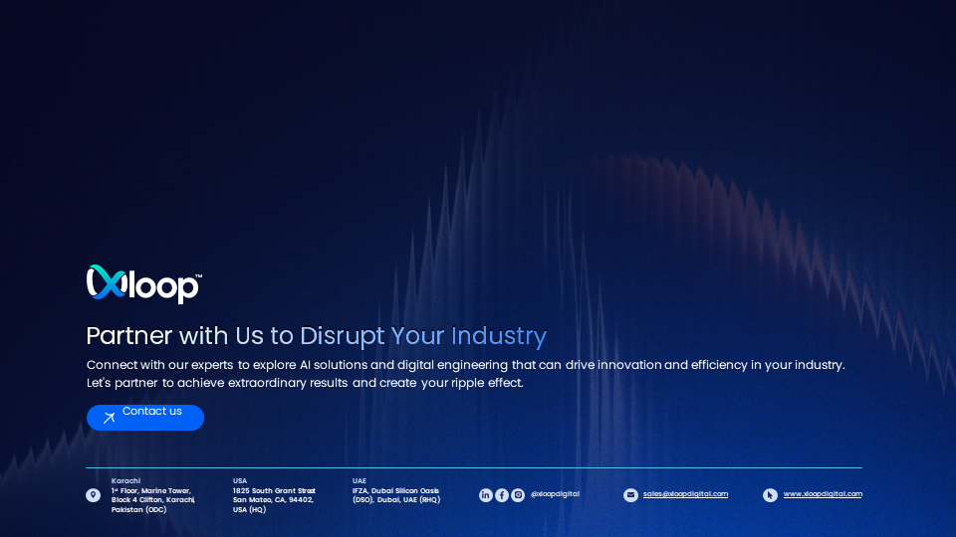
Source: slide 104
ACTION
- Keep the dark design, logo and footer.
- Replace the headline, body text and button with the copy below.
- Footer: add the Doha office so it matches the four offices on slide 2.
Headline Why xLoop for Poland
Point 1 We already deliver for Polish companies: a fintech platform, plus application modernization and a SIEM migration for a Polish cloud company.
Point 2 People in your time zone: team members based in Hungary.
Point 3 AI first, with security built in: certified ISO 42001 and ISO 27001 Lead Auditors on our team.
Quote â€œxLoop architects meticulously planned and executed the migration, ensuring minimal disruption to our operations.â€
Attribution John Waterhouse, Founder and CEO, Cloud Titans Ltd
Button Start with one use case
Doha footer QFC Tower 1, West Bay, Doha, Qatar (RHQ)

The quote must stay word for word. It is from a signed testimonial and is the only client name allowed in the deck.

