xLoop LinkedIn: Data & AI posts for the sales trip

Post 1 · AI Agents (video or gif)
Slide | On-visual text
1 | Before an AI agent goes live, we check five things.
2 | 1. A clear job. With a person who owns the outcome.
3 | 2. Data the agent can trust.
4 | 3. Permissions limited to the task.
5 | 4. A human checkpoint for actions that matter.
6 | 5. Logs that show why it did what it did.
7 | Miss one, and the agent becomes something your team has to babysit instead of something that saves them time. · We design, build and secure AI agents for production.

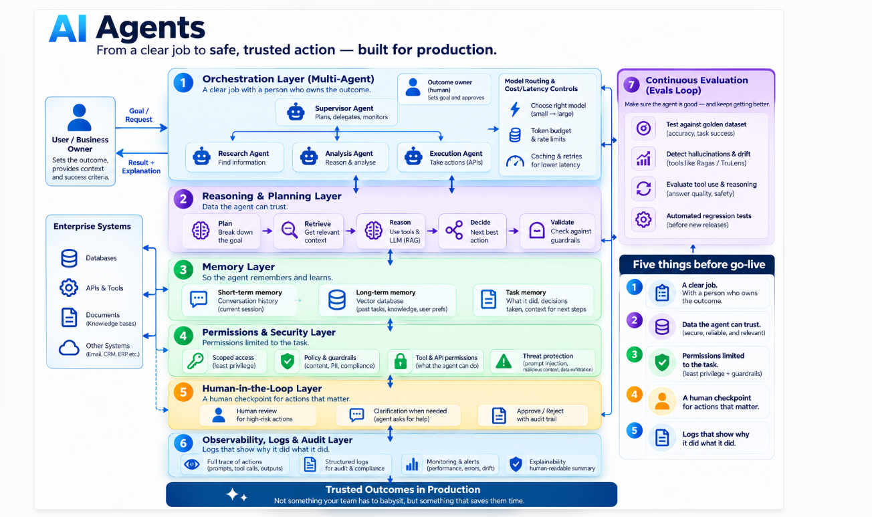

Caption
Which of these five is hardest in your organization? We see #2 most often.

First comment: "How we build AI agents for production: https://xloopdigital.com/services/ai-agents-and-autonomous-systems"
Hashtags: #AIAgents #AgenticAI #EnterpriseAI #AIGovernance

Post 2 · Case: HBL Asset Management · Video (~30s)
One of Pakistan’s largest asset managers.
Over PKR 340 Billion under management.
Yet, operations still ran on spreadsheets.
Manual reconciliation.
Manual NAV tagging.
A massive compliance risk.
We automated it.
Ingestion and matching—
reconciled in seconds.
Rule-based NAV tagging.
Exceptions flagged instantly.
No more guesswork.
RPA pushes matched data.
Strict role-based access
for Ops, Audit, and Admin.
Faster processing.
Less manual effort.
Audit-ready compliance.
(Your Logo)
Caption
HBL Asset Management's transaction processing depended on spreadsheets and people double-checking each other. We built a secure, automated workflow: file matching, rule-based NAV tagging, exception reporting and RPA into their desktop portal.

If your operations team still reconciles by hand, this is where we'd start.

Visual brief: use the real dashboard screens from the HBL case study slide. Calm finance palette, no stock "robot" imagery.
First comment: "Automation and AI for banking and asset management: https://xloopdigital.com/industries/banking-and-finance"
Hashtags: #AssetManagement #IntelligentAutomation #RPA #FinancialServices

Post 3 · AI security · Video (~30s)
Scene | On-screen text | Visual
1 | Can your AI agent be misused? | Agent icon connected to email, files, APIs
2 | Once AI can read files, send emails or call other systems, security isn't only about the model. | Connections light up one by one
3 | Can a hidden instruction in a document redirect it? | Document with a hidden line glowing
4 | Can it reach data the user shouldn't see? Can someone talk it out of its rules? | Locked folder, chat bubble
5 | Test it before launch, like any new application. AI red teaming · AI security audit · AI governance | Three service tiles
6 | Start with an AI Security Assessment. Certified ISO 27001 and ISO 42001 Lead Auditors. | Logo + CTA

Caption
None of this is a reason to slow down AI adoption. It's a reason to test before you launch. We attack your AI system the way a real adversary would, so you find the gaps first.

Visual brief: calm and technical, not alarmist. No hoodies, no red alert screens.
First comment: "Book an AI Security Assessment: https://xloopdigital.com/services/ai-security-service"
Hashtags: #AISecurity #AIRedTeaming #PromptInjection #ISO42001

Post 4 · Data foundation · Carousel
Slide | On-visual text
1 | If you asked a team why their AI pilot stalled, here’s what they’d tell you…
2 | - Two reports showing different revenue numbers.
3 | - Customer data spread across systems that don't talk to each other.
4 | - Nobody sure which table is the right one.
5 | That's a data problem. AI just makes it visible faster.
6 | To solve that, we fix the foundation first.
7 | Clear ownership, pipelines you can monitor. Then your AI use cases have something solid to stand on.

Caption
Our checklist shows how to tell if your data is ready for AI. Link in the first comment.

Visual brief: slides 2 to 4 as three "symptoms", each with a simple icon. Slide 5 is the turn, bold type.
First comment: "Is your data ready for AI? The checklist: [blog link]. And how we fix the foundation: https://xloopdigital.com/services/data-analytics"
Hashtags: #DataStrategy #DataEngineering #AIReadiness #DataQuality

Post 5 · Case: AWS to Azure migration plan · Carousel
Slide | On-visual text
1 | Moving a group-wide estate from AWS to Azure. Where do you start?
2 | The client: a large retail and real estate group in the Gulf.
3 | Estate and data discovery. We mapped every application, workload and data store, including Vertica.
4 | Dependencies and criticality. Feasibility assessed workload by workload.
5 | Business case. A total cost of ownership model leadership could decide on.
6 | Controlled migration waves. A sequenced plan, starting with a pilot wave.
7 | Delivered jointly with Microsoft. Planning a cloud move? We start with the estate, not the tools.

Caption
A cloud migration fails in planning long before it fails in cutover. For this group, we covered the Assess and Design phases of our migration framework: what exists, what depends on what, what it costs, and in what order it moves.

Visual brief: slides 3 to 6 follow a left-to-right path (Assess → Design). Show AWS → Azure on slide 1 only. No client logo.
First comment: "How we plan and run cloud migrations: https://xloopdigital.com/services/cloud-and-hyperscaling"
Hashtags: #CloudMigration #Azure #AWS #CloudStrategy

Post 6 · AI agents · Carousel
Slide | On-visual text
1 | What's inside a multi-agent system that runs in production?
2 | Orchestration. LangGraph, LangChain, AutoGen or CrewAI decide which agent does what, and in what order.
3 | Models. OpenAI and Anthropic models, picked per task.
4 | Memory and retrieval. Pinecone or Chroma give agents the right context from your own data.
5 | Services. FastAPI connects agents to your apps and workflows.
6 | Runtime. Kubernetes keeps it running, scaling and observable.
7 | Our multi-agent reference architecture covers 11 stages. Ask us for the walkthrough.

Caption
The tools matter less than the discipline around them: which agent owns which step, what context it gets, and how you watch it once it's live.

Visual brief: layered stack that builds up one layer per slide. Tool logos small; no implied partnership.
First comment: "Building agents? See how we work: https://xloopdigital.com/services/ai-agents-and-autonomous-systems"
Hashtags: #AgenticAI #MultiAgentSystems #LangGraph #AIEngineering

Post 7 · Case: Azure + Databricks across the Gulf · Carousel
Slide | On-visual text
1 | Three Gulf enterprises. Three different starting points.
2 | A UAE bank · Azure migration. Moving core analytics workloads to Azure with a controlled, wave-by-wave plan.
3 | A real estate group · Databricks. One lakehouse for data from across the business.
4 | A global maritime services company · Databricks. Operational data turned into analytics teams can use.
5 | How we build on Databricks: raw, cleaned and business-ready layers, governance built in, pipelines you can monitor.
6 | Same goal for all three: leadership makes decisions from numbers everyone trusts. Working on Azure or Databricks?

Caption
Different industries, different platforms, same problem: getting more out of the data they already have. Here's what we're building with three Gulf enterprises.

Visual brief: one slide per client with a sector icon (bank, building, ship) and the platform logo. Slide 5 is a three-layer diagram. No client names or logos.
First comment: "Our data and analytics work: https://xloopdigital.com/services/data-analytics"
Hashtags: #Databricks #Azure #DataAnalytics #UAE
⚠️ Confirm with delivery (Irfan) before scheduling: the scope line on slides 2 to 4 (sales only gave "Azure migration" and "Databricks"), whether the work is finished or still in progress, and that it's not a problem to describe these clients anonymously. If there's a measurable result (sources connected, data volume, teams using it, report time), put it on that client's slide.

Post 9 · Data platforms · Video (~25s)
Scene | On-screen text
1 | Snowflake or Databricks? Start with your data, not the logo.
2 | The fundamentals are the same: layered data, governance, well-designed pipelines.
3 | What should decide it: where your data has to live.
4 | The licenses you already have. The skills your team has today.
5 | Get those right and your architecture carries over. Send us your shortlist and your constraints.

Caption
We've delivered on both Snowflake and Databricks. Our architects will tell you which fits your situation and why.

Visual brief: fast cuts, one idea per scene. Same three-layer block as post 8 for consistency.
First comment: "We partner with AWS, Microsoft, Snowflake, Databricks and Salesforce. Our data work: https://xloopdigital.com/services/data-analytics"
Hashtags: #Snowflake #Databricks #DataArchitecture #Lakehouse

Checks done
- HBL Asset Management named (approved, A16). Content from the HBL case study slide, which gives no figures, so none are used
- MAF and Wefi Tech anonymized: our files say internal only, no client permission on record. Swap in names only once permission is confirmed
- MAF post says "plan", never "migrated to Azure" (A26 is discovery + plan)
- Gulf post: no results claimed (none on file), no "single source of truth"
- No headcount, country count or ISO company certification. US spelling, no em dashes in post copy

