Rasa 6 DO / Rasa 6 AO / Rasa 6 DUO

Parts list:

1x 220k resistor
1x 150k resistor
3x audio jack
2x B50k potentiometers
1x Arduino Beetle
8x pins
1x 16-pin female adaptor
1x 16-pin cable
1x MCP4822 integrated circuit chip (AO / DUO only)
2x 1 ohm bypass resistors (DUO only)
1x PCB board
1x faceplate
3x nuts
2x M3 screws

Assembly:

Background: I have designed multiple Rasa 6 PCB boards. They all have the same input configuration, but have different output configurations. The Rasa6-DO is the simplest board that writes Digital Out (DO) to two headphone jacks. The Rasa6-AO writes Analog Out (AO) via a Digital-to-Analog Converter (DAC) that in turn outputs analog signal to two headphone jacks. The Rasa6-DUO can be used for digital out or analog out. If assembling Rasa6-AO or Rasa6-DUO in AO mode, the first step is to install the DAC chip on the front of the PCB board.

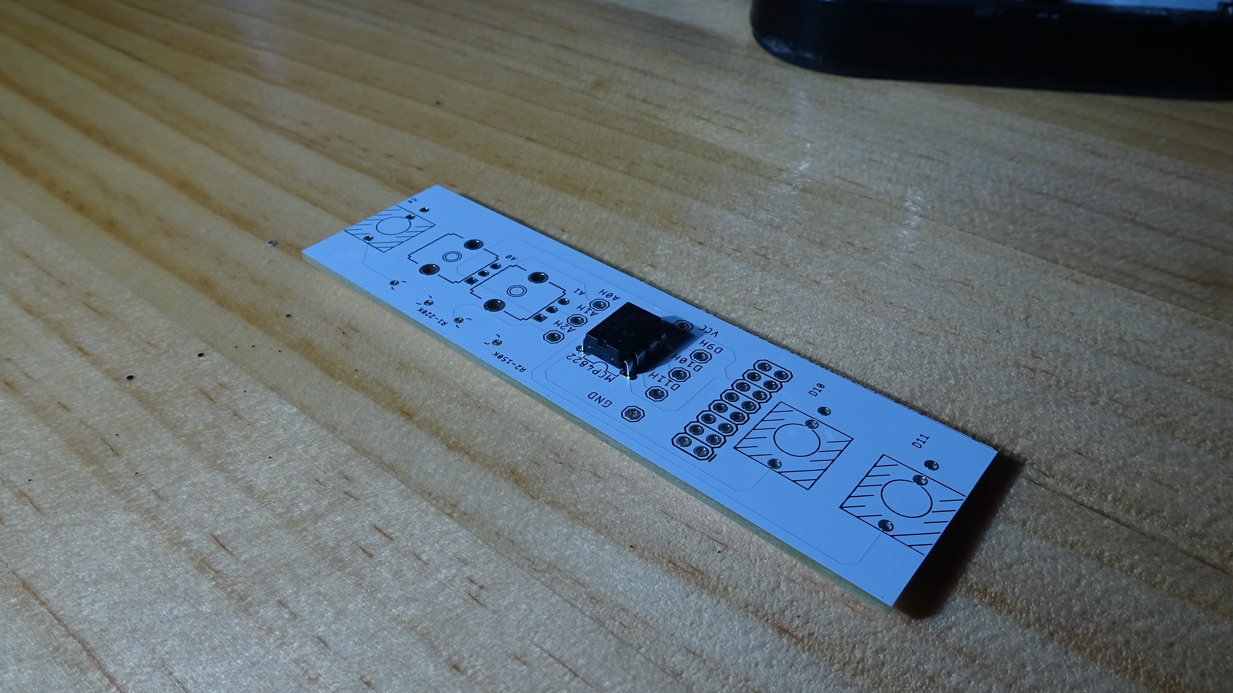
If assembling Rasa6-AO or Rasa6-DUO in DO mode, the first step is to install the 1 ohm DAC bypass resistors.

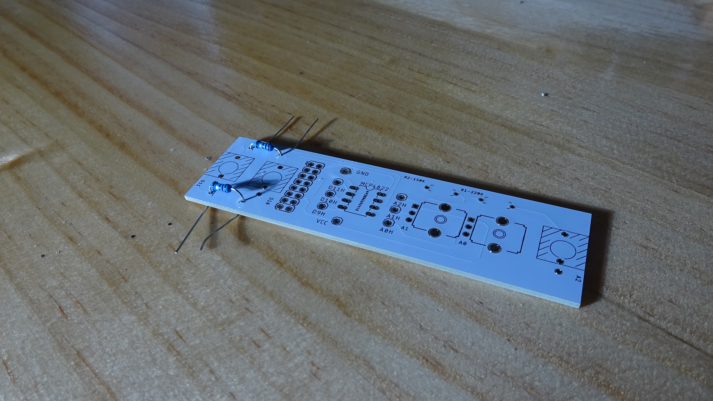
Step 1: You can start by soldering the 16-pin DC power adaptor. The adaptor faces backwards. It must have the correct orientation: the gap in the adaptor should face the top of the PCB. Flip the module over and solder the adaptor from the front. You may use a headphone jack to prop up the other side of the module so that the adaptor sits comfortably in the PCB holes.

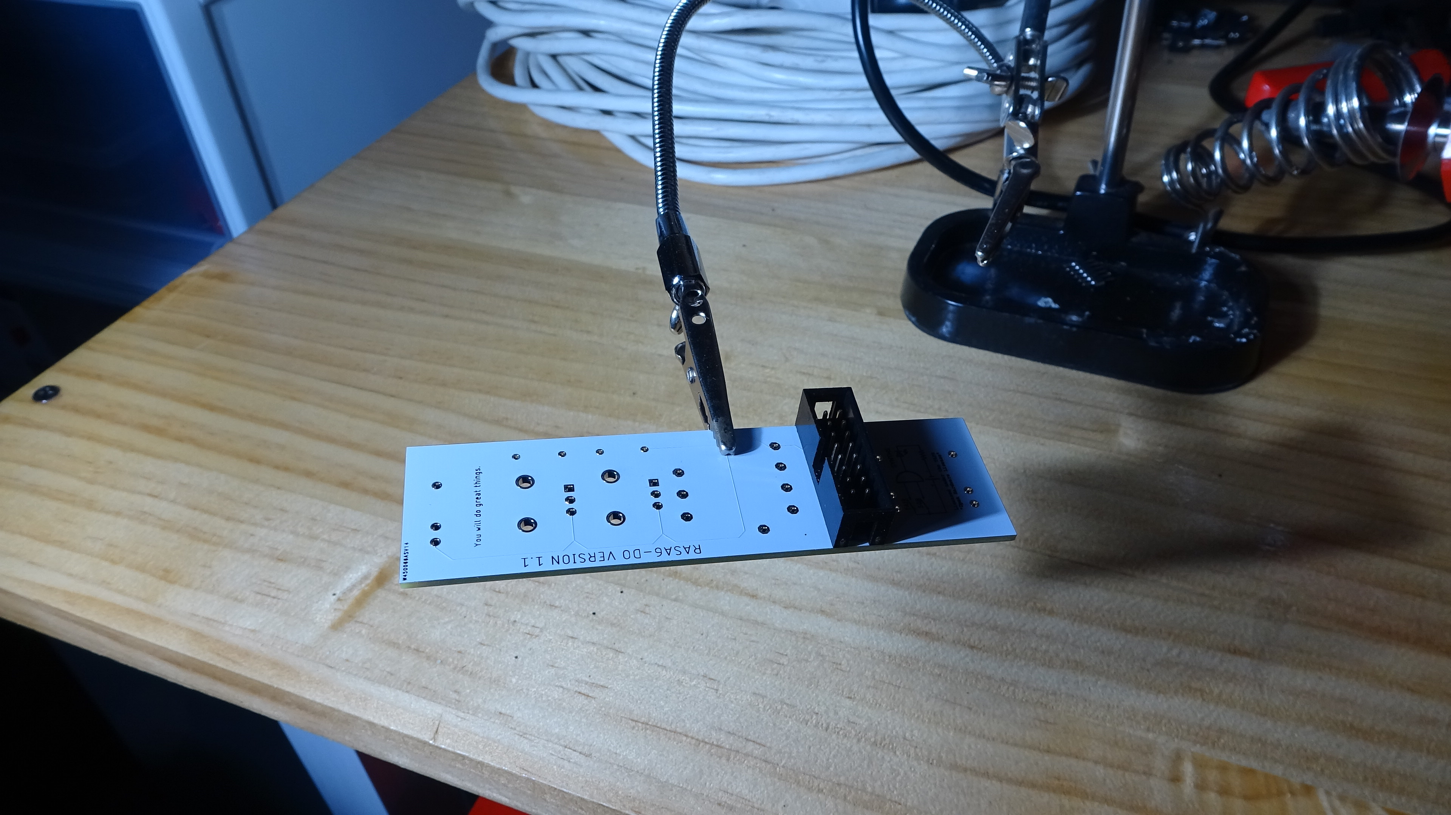
Step 2: Now is a good time to add the headphone jacks. You can insert all 3 headphone jacks then flip over the PCB. Once flipped over, the headphone jacks should sit comfortably in the PCB holes while you solder them in place.

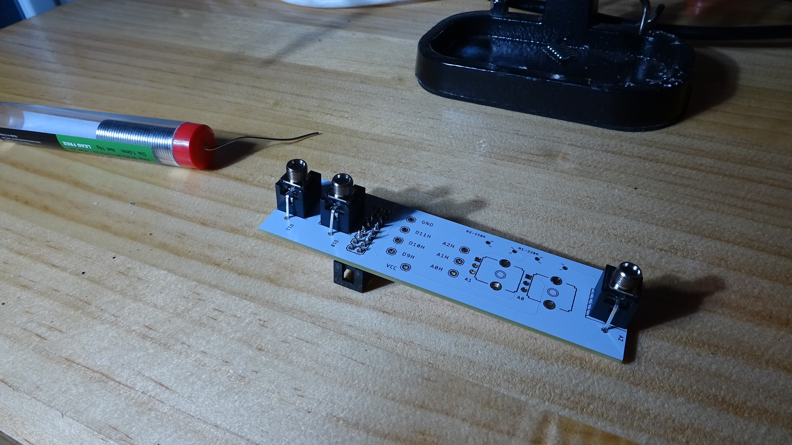
Step 3: I tend to install the potentiometers now. However, if you do not have a soldering station with clamps that hold the PCB, you may find it easier to install the Arduino now. Installing the Arduino is the trickiest part of the assembly. First, you need to rest the breakout pins into the 8 holes on the back of the PCB. Do not solder these in yet.

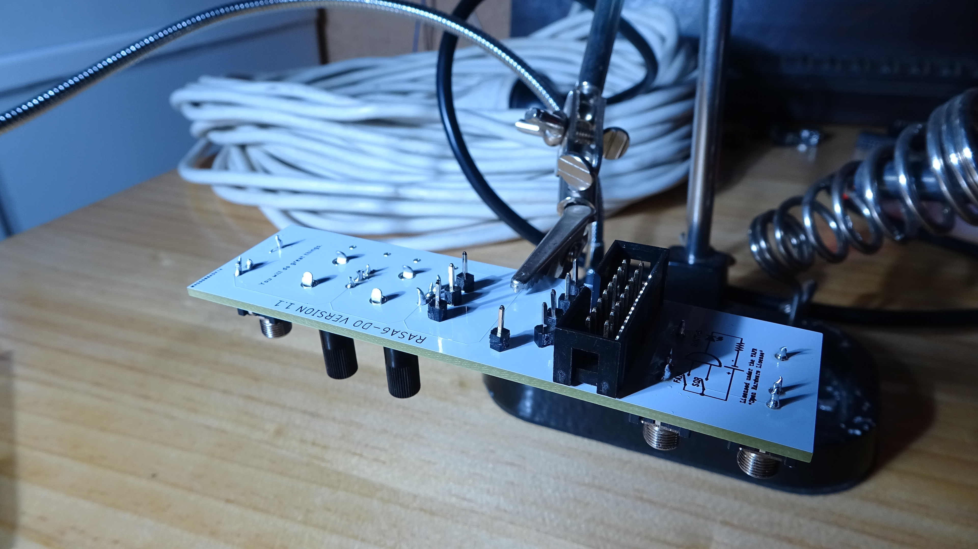
Next, line up the Arduino and place it on top of the breakout pins so that all pins line up with the appropriate Arduino holes. The Arduino will fit snugly on top of the pins, but this requires some pins to bend in toward the centre. It is easiest if you start from the 4 pins toward the bottom of the PCB and use a pencil or other tool to move each remaining pin into its respective hole. Once all pins are in, solder the pins to the Arduino then flip the board and solder the pins to the PCB.

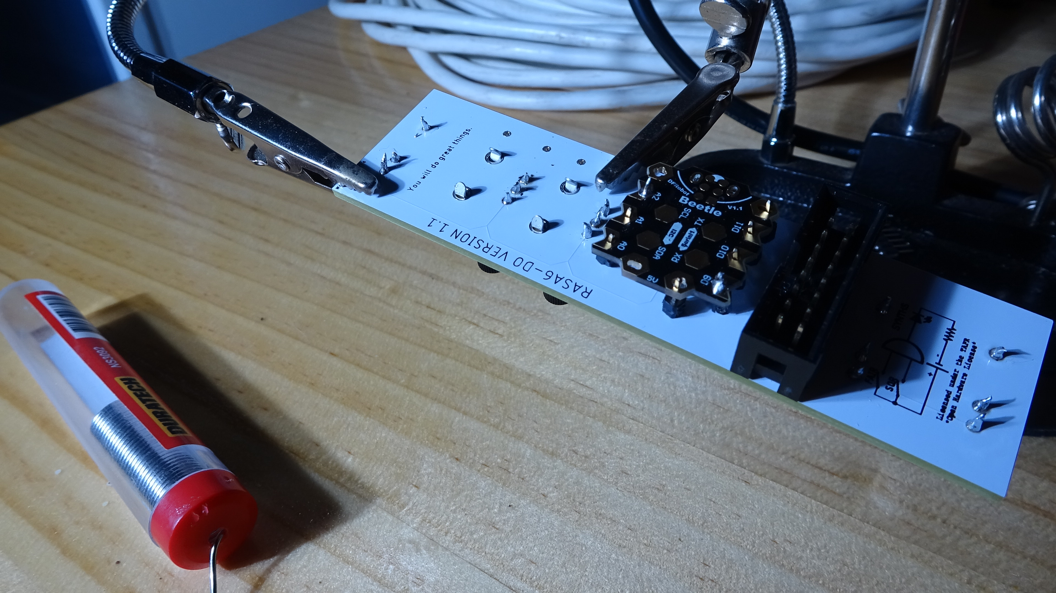
Step 4: Install the potentiometers (if you haven’t already) and the resistors. When I install the resistors, I like to pull the wire through the back of the PCB board with pliers to help the resistor sit flat against the PCB. You can trim excess resistor wire before or after soldering.

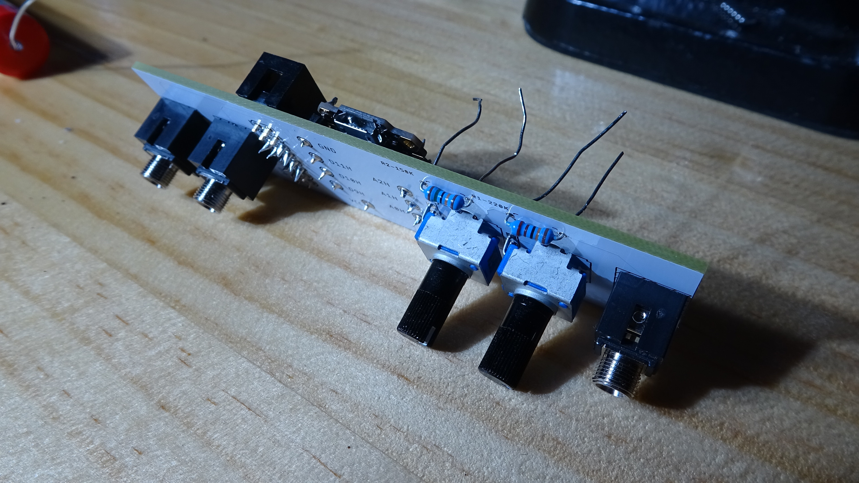

Step 5: Place the faceplate over the audio jacks and potentiometers, then tighten the audio jack nuts by hand.

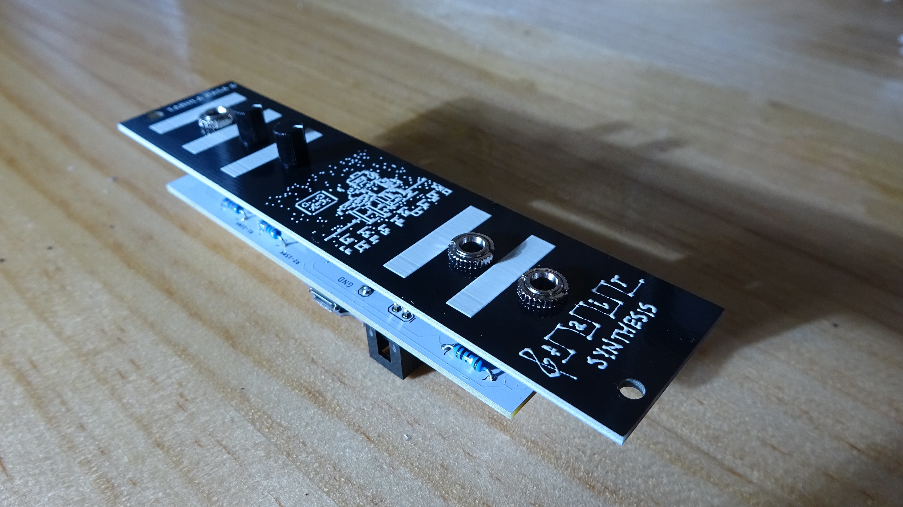
Now the module is complete. You can start to develop your own music programs! For sample code and reference documentation, check out the Fair & Square GitHub page.

