Software Requirements Specification
for
application for keeping track of watering plants

Version 4.0
Prepared by Wiktor Mandra
Lodz University of Technology
12.06.2026

Table of Contents
1. Introduction 4
1.1. Purpose 4
1.2. Document Conventions 4
1.2.1. Terminology: 4
1.2.2. Formatting: 4
1.3. Intended Audience and Reading Suggestions 4
1.4. Product Scope 4
1.5. References 5
2. Overall Description 5
2.1. Product Perspective 5
2.2. Product Features 5
2.2.1 Main Features 5
2.2.2. Use Case Diagram 6
2.3. User Classes and Characteristics 7
2.3.1 Class Diagram 7
2.4. Operating Environment 8
2.6. Assumptions and Dependencies 8
3. System Features 8
3.1. Manage Plant 8
3.2. Action Schedule 8
3.3. Logging action history 8
3.4 Multi-user collaboration 8
3.5 Notifications 9
4. Requirements 9
4.1. Functional Requirements 9
4.2. Nonfunctional Requirements 9
4.2.1. Performance 9
4.2.2. Security 9
4.2.3. Usability 9

Revision History
Name | Date | Reason for Changes | Version
Wiktor Mandra | 01.05.2026 | Functional and non-functional requirements definition | 1.0
Wiktor Mandra | 09.05.2026 | Use case diagram | 2.0
Wiktor Mandra | 22.05.2026 | Class diagram | 3.0
Wiktor Mandra | 12.06.2026 | Updated class diagram; system features | 4.0

1. Introduction

1.1. Purpose
This document specifies software requirements for “GreeLendar”, a mobile application designed to help users track the watering, fertillization and genereal care of their plants. This app aims to simplify plant maintenance by providing reminders, logs and care recommendations based on plant species, environment, and user input.

1.2. Document Conventions

1.2.1. Terminology:
Plant Profile: A digital record of a user’s plant including species, age and care history.
Care Log: A timeline of actions (watering, fertillization, etc.) performed on a plant.

1.2.2. Formatting:
Requirements are labeled as REQ-xx (functional) or NF-xx (non-functional).
Priorities: High (H), Medium (M), Low (L).

1.3. Intended Audience and Reading Suggestions
Developers: Focus on technical constriants and interfaces, scetions ….
Project Managers: Review scope, dependencies, and timelines, sections ….
Users: Understand features and user interactions, sections ….
Testers: Verify functional and non-functional requirements, senctions ….

1.4. Product Scope
GreeLendar is a cross-platform app (Android/iOS/Web) that:
Tracks watering, fertilization and repotting schedules.
Provides care reminders based on plants species and evironmental conditions (e.g., humidity, sunlight, temperature).
Logs historical data (e.g., growth photos, soil moisture).
Offers a database of plant care guides (e.g., water frequency, ideal light).
Supports multi-user households (shared plant care).

1.5. References
(1998). IEEE Recommended Practice for Software Requirements Specifications (IEEE Std 830-1998) [Review of IEEE Recommended Practice for Software Requirements Specifications]. IEEE. https://ieeexplore.ieee.org/stamp/stamp.jsp?tp=&arnumber=720574

Trefle | The plants API. (2024). Trefle.io. https://trefle.io/
‌Google. (2023). Material Design. Material Design. https://m3.material.io/

2. Overall Description

2.1. Product Perspective
The GreeLendar is a standalone app which utilizes third party Trefle API and PostrgreSQL for data backup and between user synchornization.

2.2. Product Features

2.2.1 Main Features
Plant profile: Add or edit plants with species name, photo, care guidelines, log information
Care scheduling: Set cyclical reminders for action such as watering, repoting, etc.
Log actions: Save histiorical action taken to specific plant
Plants Database: Browse list of all plats list provided by Trefle
Take picture: Take picture when adding new plant or to confirm action taken

2.2.2. Use Case Diagram
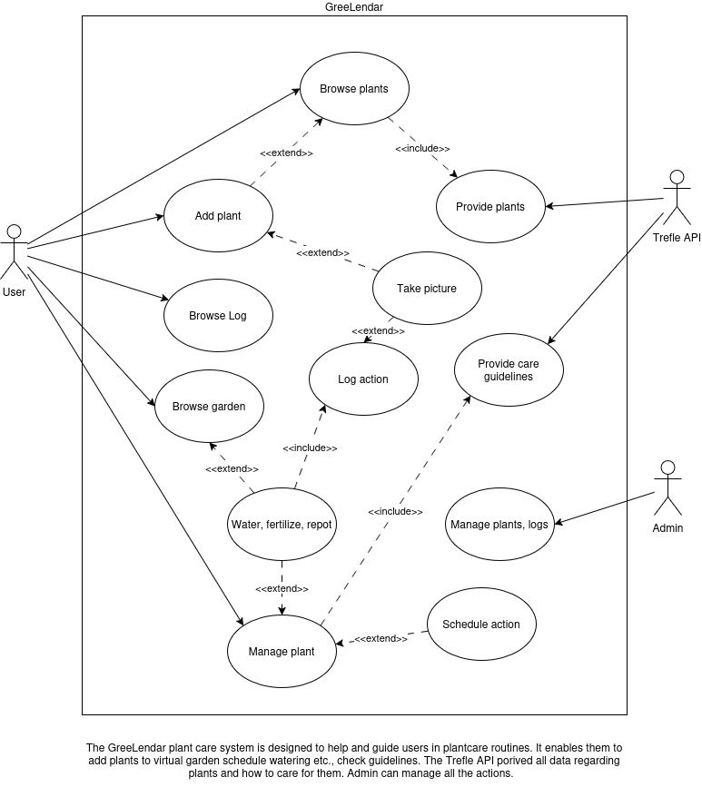

2.3. User Classes and Characteristics

2.3.1 Class Diagram

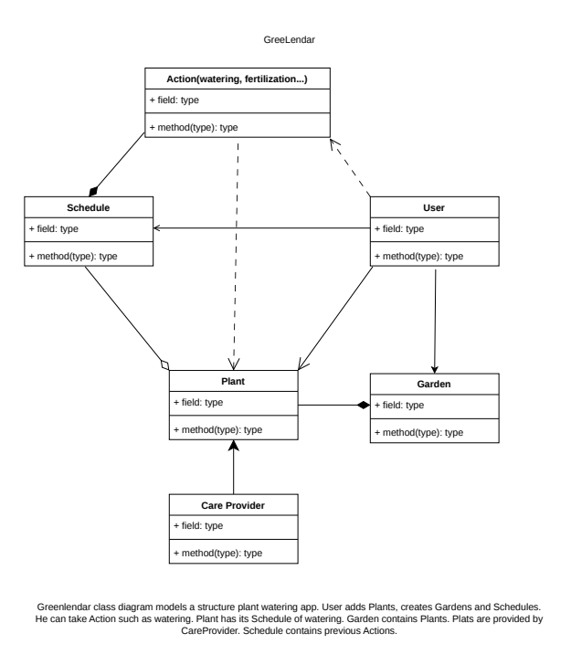

2.4. Operating Environment
Mobile: iOS15+, Adnroid 10+
Web: Chrome, Firefox, Safari (latest 2 versions)
Backend: Node.js + SQLite
API: Trefle 1.6.0

2.6. Assumptions and Dependencies
Assumptions:
Users have basic plant knowledge: name and watering frequency
App has access to internet connection at least when adding new plant
Dependencies:
Trefle.io API to retrieve plant list when adding new plant to garden

3. System Features
Short overview of features in GreeLendar

3.1. Manage Plant
Add, edit, delete plant. Group them into gardens

3.2. Action Schedule
Schedule when to water, fertailize or sprinkle plants.

3.3. Logging action history
Every action taken upon plant is stored in database and user can view hitorical actions

3.4 Multi-user collaboration
Allows users to share their plants or gardens and assign care to another user

3.5 Notifications
When scheduled action time comes app sends push notificaton to alert user

4. Requirements

4.1. Functional Requirements
REQ-1.1: The app shall allow users to add plant by providing at least species name
REQ-1.2: The app shall support uploading (JPEG/PNG) images for plant profiles
REQ-2.1: The app shall allow users to set custom intervals for each care task
REQ-2.2: The app shall send notification 1 hour before the scheduled task
REQ-3.1: The app shall log date, time, and user for each care action
REQ-3.2: The app shall display timeline of past actions for each plant.

4.2. Nonfunctional Requirements

4.2.1. Performance
NF-1.1: The app shall load dashboard in <2 seconds
NF-1.2: The app shall support up to 100 plants per user without performance issues

4.2.2. Security
NF-2.1: The app shall require authentication for all sensitive acions (e.g., deleting plants)

4.2.3. Usability
NF-3.1 The app shall support dark mode

