**Deanship of Postgraduate Studies**

**Drop with ‘W’**

**Help / User Manual**

January 2019  
Version 0.01

**DISCLAIMER**

The University represented by the Deanship of Postgraduate Studies offers a range of postgraduate programs at the diploma, masters and doctoral levels through advanced course work and research in various combinations.

Copyright © 2019 by Sultan Qaboos University

All rights reserved. No part of this publication may be reproduced, distributed, or transmitted in any form or by any means, including photocopying, recording, or other electronic or mechanical methods, without the prior written permission of the publisher. For permission requests, write to the publisher, addressed “Attention: Coordinator,” at the address below.

Sultan Qaboos University   
Center for Information System | Al-Khod | Muscat | Oman  
Phone : +968-24141500 Web : www.squ.edu.om

**Document Revisions**

|  |  |  |
| --- | --- | --- |
| Date | Version Number | Document Changes |
| 13-Jan-2018 | 0.01 | Initial draft |
|  |  |  |
|  |  |  |
|  |  |  |

**Approvals**

This document requires following approvals:

|  |  |
| --- | --- |
| Name | Title |
|  |  |
|  |  |
|  |  |
|  |  |

**Distribution**

This document has been distributed to:

|  |  |
| --- | --- |
| Name | Title |
| DPS |  |
| Online Distribution to concerned users through related services at SQU portal |  |
|  |  |
|  |  |

**Contents**

1 PREFACE 5

1.1 Description of the User 5

1.2 Obtaining Documentation and Information 5

2 Description of the product 6

2.1 Purpose of the Product 6

2.2 Process Overview 6

2.3 [Sub-process/Workflow Student] 7

2.3.1 [Procedures for Students] 7

2.4 [Sub-process/Workflow Approvers] 10

2.4.1 [Procedures for Approvers] 10

# PREFACE

## Description of the User

User is defined as stakeholder candidates from Deanship of Postgraduate Studies, system analyst, administrators and developers from Center for Information Systems along with related students and approvers from concerned colleges/departments at Sultan Qaboos University. Any users who are not defined considered as restricted users and having limited ability to proceed with this documents.

## Obtaining Documentation and Information

**Internet**

The latest version of the documentation is available at the following address:   
Help link/section of DPS E-Services | Drop with ‘W’ at Portal

**Ordering Documentation**

Documentation, user instructions and technical information can be ordered by calling   
Deanship of Postgraduate Studies.

**Documentation Feedback**

If you are reading Deanship of Postgraduate Studies product documentation on the internet, any comments can be submitted on the support website. Comments can also be sent dps_eservices@squ.edu.om.

We appreciate your comments.

# Description of the product

## Purpose of the Product

Drop with ‘W’ performed in special circumstances and must be approved by the multiple approvers with help of Deanship of Studies. Electronic services are available in portal for paper free green environment to make the process simple and efficient.

## Process Overview

**Form Number**: DPS7

**Form Name :** Drop with ‘W’

**Rules:** • Students with FULL time, should have minimum 9 (nine) credit balance after the drop operation

• Students with PART time, should have minimum 3 (three) credit balance after the drop operation

• Drop with ‘W’ will held within predefined period only

Users :

* Student

• Advisor[PROCESS/WORKFLOW]

## [Sub-process/Workflow Student]

Student need to initiate first.

1. Student need to follow the set of rules (mentioned in 2.2) to find eligibility
2. Student need to be in **specific predefined period for Drop the courses**
3. *Full Time Students should maintain minimum 9 credits after drop any course*
4. *Part Time Students should maintain minimum 3 credits after drop any course*

### [Procedures for Students]

**To apply for Drop with ‘W’:**

1. Login to portal.
2. Click Academic /DPS Tab (In Manual it is DPS tab).
3. Select Drop with W from left menu.
4. Click  button on right from **Action** column.

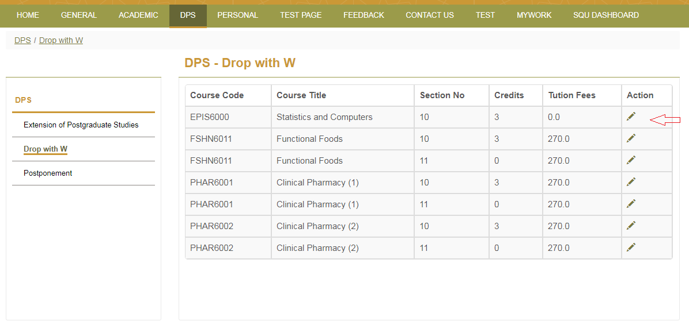

1. Select Submit button to confirm drop of a particular course.
2. Click **X** (close) or press **Esc** key to exit if do not want to drop the specific course.

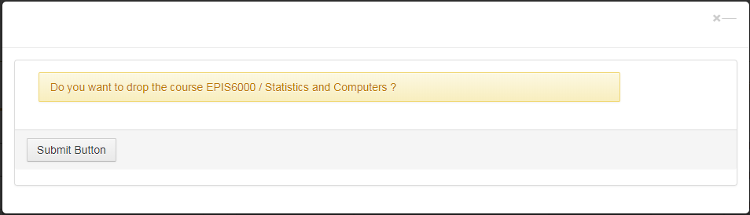

1. Work flow will start. Student and approvers will be notified.

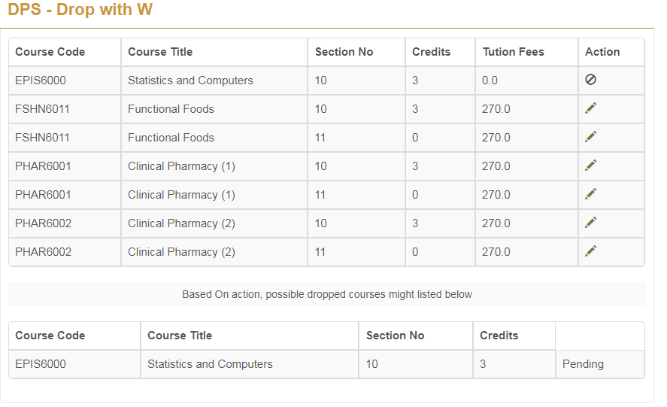

1. Approver level is one. And only one approver is there.
2. Advisor
3. Drop request will be accepted when the approver accept the request. Process can be rejected for approvers’ rejection and no further progress in same channel will entertain. Student need to start fresh again with all the applicable rules.

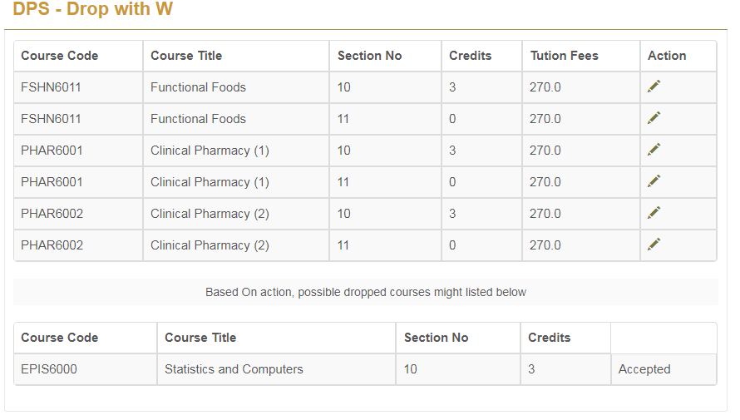

## [Sub-process/Workflow Approvers]

Approval process starts after student’s initiation.

List of Approvers :

1. Advisor (Program Coordinator)

### [Procedures for Approvers]

**To approve Student drop courses:**

1. Get notification
2. Login Portal.
3. Select **DPS** tab from top menu
4. Select **Drop with W** from left menu
5. Approver will see approval screen with appropriate role/s
6. Select appropriate role
7. Able to find list of students who applied for **Drop with ‘W’**

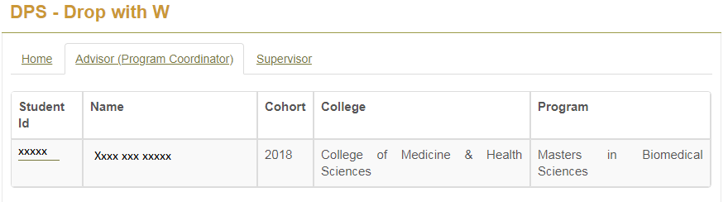

1. Select appropriate student

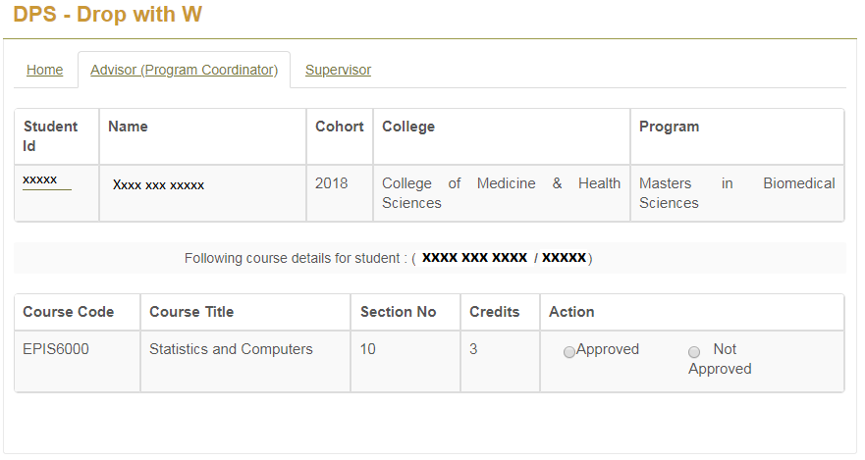

1. Take action (Approve/Reject) by selecting appropriate radio button
2. For Approve need to select approve radio button and **Yes** button at the next dialogue box. If not sure then **No** and exit.

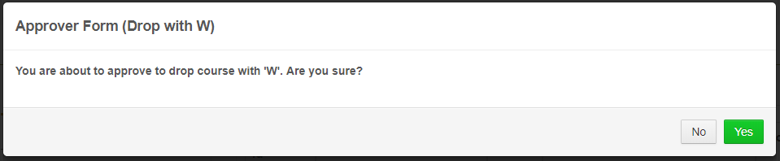

1. For reject , approver need to provide reason or rejection

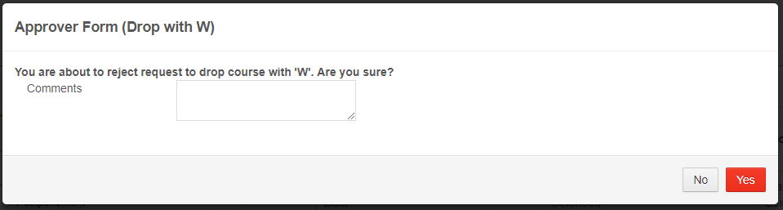

1. In case of reject, approver and requester both will find **Rejected** action for their respective approver

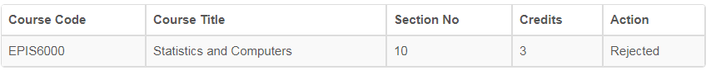

1. In case of approve the approver and requester both will find **Accepted** as an action by respective approver.

