**Deanship of Post Graduate Studies**

**Postponement of Studies**

**Help / User Manual**

March 2019  
Version 0.03

**DISCLAIMER**

The University represented by the Deanship of Postgraduate Studies offers a range of postgraduate programs at the diploma, masters and doctoral levels through advanced course work and research in various combinations.

Copyright © 2018 by Sultan Qaboos University

All rights reserved. No part of this publication may be reproduced, distributed, or transmitted in any form or by any means, including photocopying, recording, or other electronic or mechanical methods, without the prior written permission of the publisher. For permission requests, write to the publisher, addressed “Attention: Coordinator,” at the address below.

Sultan Qaboos University   
Center for Information System | Al-Khod | Muscat | Oman  
Phone : +968-24141500 Web : www.squ.edu.om

# Document Revisions

|  |  |  |
| --- | --- | --- |
| Date | Version Number | Document Changes |
| 04-03-2019 | 0.01 | Initial draft |
| 05-03-2019 | 0.02 | Images changes containing link name |
| 06-03-2019 | 0.03 | Spelling issue addressed |
|  |  |  |

# Approvals

This document requires following approvals:

|  |  |
| --- | --- |
| Name | Title |
|  |  |
|  |  |
|  |  |
|  |  |

# Distribution

This document has been distributed to:

|  |  |
| --- | --- |
| Name | Title |
|  |  |
|  |  |
|  |  |
|  |  |

Contents

1 PREFACE 5

1.1 Description of the User 5

1.2 Obtaining Documentation and Information 5

2 Description of the product 6

2.1 Purpose of the Product 6

2.2 Process Overview 6

3 [PROCESS/WORKFLOW] 7

3.1 [Sub-process/Workflow Student] 7

3.1.1 [Procedures for Students] 7

3.2 [Sub-process/Workflow Approvers] 9

3.2.1 [Procedures for Approvers] 9

3.2.2 [Final approval] 12

# PREFACE

## Description of the User

User is defined as stakeholder candidates from Deanship of Post Graduate Studies, system analyst, administrators and developers from Center for Information Systems along with related students and approvers from concerned colleges/departments at Sultan Qaboos University. Any users who are not defined considered as restricted users and having limited ability to proceed with this documents.

## Obtaining Documentation and Information

**Internet**

The latest version of the documentation is available at the following address:   
Help link/section of DPS E-Services | Postponement of studies at Portal

**Ordering Documentation**

Documentation, user instructions and technical information can be ordered by calling   
Deanship of Post Graduate Studies.

**Documentation Feedback**

If you are reading Deanship of Post Graduate Studies product documentation on the internet, any comments can be submitted on the support website. Comments can also be sent dps_eservices@squ.edu.om.

We appreciate your comments.

# Description of the product

## Purpose of the Product

Postponement of study granted in special circumstances and must be approved by the multiple approvers with help of Deanship of Studies. Electronic services are available in portal for paper free green environment to make the process simple and efficient.

## Process Overview

**Form Number**: DPS13

**Form Name :** Postponement of Studies

**Rules:** • Maximum postpone allowed for two ( 2) semesters only

• Students are not allowed to postpone extended semester

• Apply for postponement period is at the Drop with ‘W’ period

Users :

* Student

• Supervisor / Advisor

• College Dean

• DPS (Scholarship, Academic) Dean

# [PROCESS/WORKFLOW]

## [Sub-process/Workflow Student]

Student need to initiate first.

1. Student need to follow the set of rules to find eligibility
2. Student need to be in **drop with ‘W’ period**
3. *Student can apply for maximum* ***two 2 semesters*** *postpone****.***
4. Any **extended** semester cannot **postpone**.

### [Procedures for Students]

**To apply for postponement of studies:**

1. Login to portal.
2. Click DPS tab.
3. Select Postponement of studies from left menu.
4. Click ‘Apply for Postpone’ button on right.

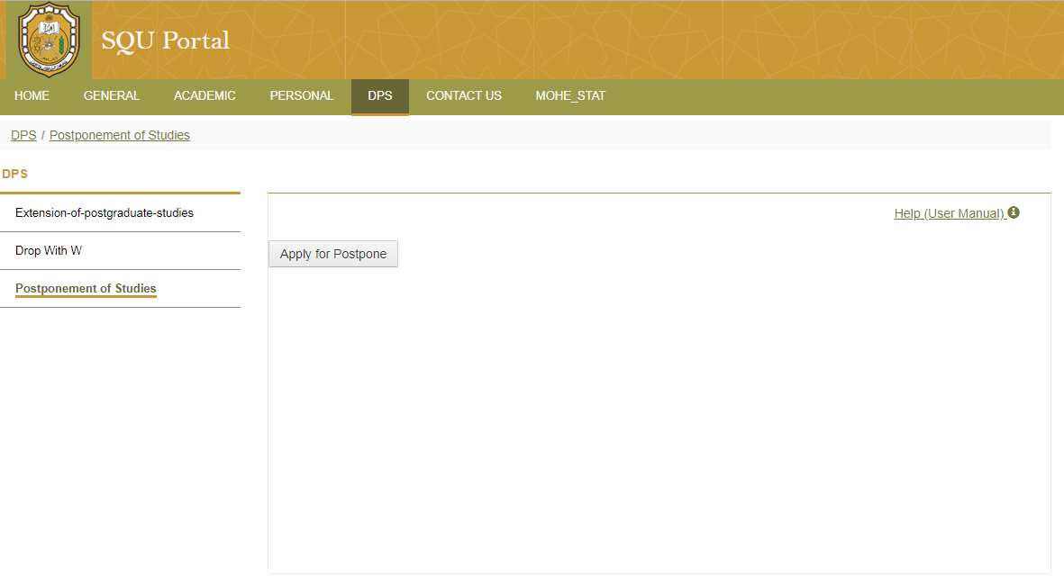

1. Select year/semester radio button .
2. Select reason for not completing

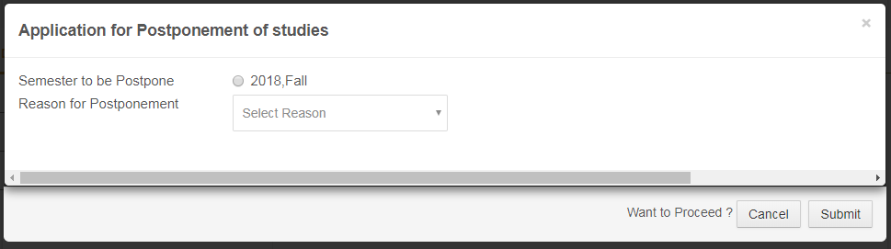

1. Click Submit
2. Work flow will start. Student and approvers will be notified.

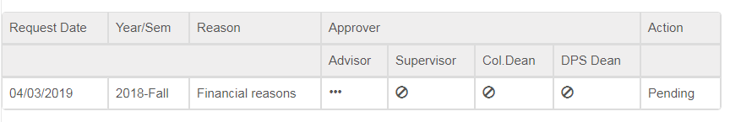

1. There are three type of approvers
2. Supervisor / Advisor
3. College Dean
4. DPS Dean
5. Postponement of studies will be accepted when all three approvers accept the request. Process can be rejected for any of the approvers’ rejection and no further progress in same channel will entertain. Student need to start fresh again with all the applicable rules.

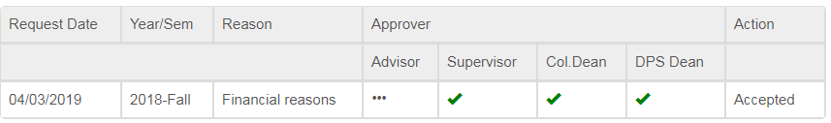

## [Sub-process/Workflow Approvers]

Approval process starts after student’s initiation.

List of Approvers :

1. Supervisor / Advisor (Program Coordinator)
2. College Dean
3. DPS Dean

### [Procedures for Approvers]

**To approve Student postponement of studies:**

1. Get notification
2. Login Portal.
3. Select **DPS** tab from top menu
4. Select **Postponement**  from left menu
5. Approver will see approval screen with appropriate role/s
6. Select appropriate role
7. Able to find list of students who applied for **Postponement of Studies**

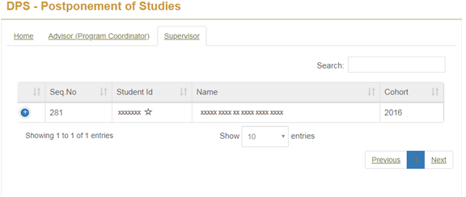

1. Select appropriate student

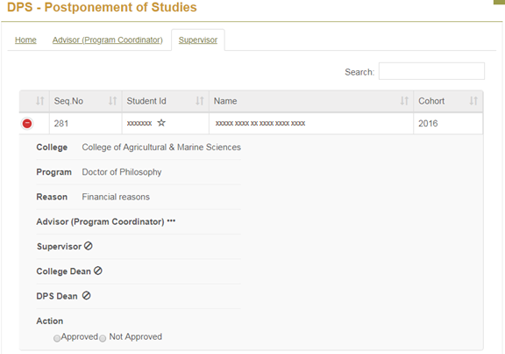

1. Take action (Approve/Reject) by selecting appropriate radio button
2. To Approve the action, it’s required to select approve radio button and **Yes** button at the next dialogue box. If not sure then **No** and exit.

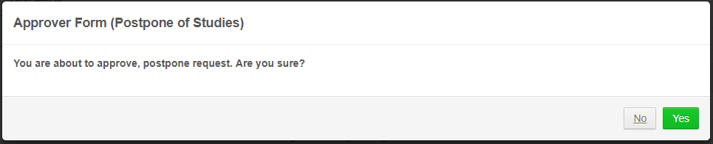

1. For reject , approver need to provide reason or rejection

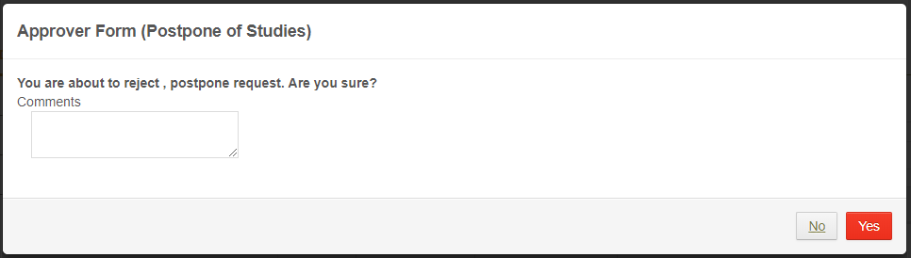

1. In case of reject, approver and requester both will find red color cross sign for their respective approver

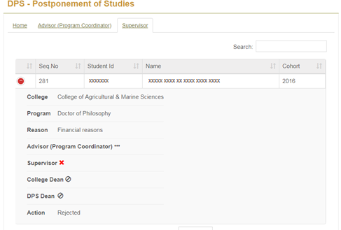

1. In case of approve the approver and requester both will find **green** color right (check) mark on their respective approver.

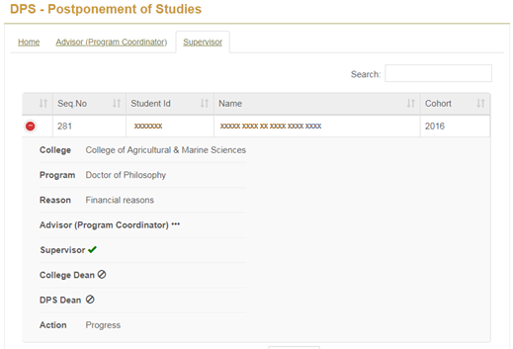

### [Final approval]

Normally final approval done by DPS Dean .

