planning & development division, c is, squ.
Portlet Development Documentation
Draft Version
Bhabesh Bhabani Mukhopadhyay
20-April-2013

This template contains documentation of portlet development starting from requirements, analysis & design to testing
[Leave Application]
[prjLeaveApp]

1. Introduction 2
1.1. Purpose of the portlet 2
1.2. Portlet Scope 2
1.3. Definition, acronym, and abbreviation 2
2. User Group & Characteristics 2
3. Analysis & Design 2
3.1. Use Cases 2
3.2. Functional Requirements 2
3.3. Non Functional Requirements 3
3.4. Activity Diagrams 3
3.5. Business Rules & Validations 3
3.6. ER or Class Diagram 3
3.7. Database stored procedures / functions 3
3.8. Sequence Diagram 4
4. Implementation 4
4.1. Portlet Information 4
4.2. Spring MVC Portlet Details 4
4.3. Packages & Classes 4
4.4. Form & Validations 5
4.5. Project Details 5
4.6. Repository Details (CVS/SVN) 5
5. Styling 6
6. Deployment 6
6.1. Test Environment 6
6.2. Production Environment 6
7. Test Scenarios & Result 6
8. Authorization Group 6
9. Revision History 7

- Introduction
The first section of the document is an Introduction. Its purpose is to provide a brief overview of the function of the system and the reasons for its development, its scope, and references to the development context (e.g., reference to the problem statement written by the client, references to existing systems, feasibility studies). The introduction also includes the objectives and success criteria of the project.

  - Purpose of the portlet
This Portlet facilitates SQU Academic/Non academic staff to apply Leave through centralized portal. Based upon predefined criteria an employee is eligible to select different type of leave/s. An HOD can delegate other employees at the time of applying for leave. There are more than one approver for sabbatical leave. Requester and Approver can access and perform in a single window. Requester, approver and delegated person will receive e-mail for any activity relates with leave application portlet.
  - Portlet Scope
The scope of this portlet is to provide the following feature:
- By default leave application portlet having following feature
  - Apply for a leave application
  - List of own leaves as a requester
    - View the leave application
    - Update the leave application
    - Cancel the leave application
    - Update (Further Clarification)
  - List of Leaves of others to approve
    - View the leave application
    - Actions
      - Action link at table grid
        - Approve
        - Return
        - Reject
      - Action at action form
        - Approve
        - Return
        - Reject
- Leave Application Form
  - Leave Type
      - Research Id
  - Leave Start Date
  - Leave End Date
  - Remarks
  - Approver Selection
  - Delegation details
    - From Date
    - To Date
    - Branch
    - Employee Name
- Email Notification

  - Definition, acronym, and abbreviation
Sabbatical : extended period of leave from one's customary work, especially for rest, to acquire new skills or training, etc
Delegate : A person authorized to act as representative for another
Default Approver : Default designated leave approver at the same branch, department, and section as of leave applicant
Chosen Approver : Selected approver from different area (normally different department/section within same branch)
Waiting for Approval : Leave Applied but no action taken by approver
Further Clarification : Approver return the leave application to requester for more explanation.
Return : An action for approver to return the application to applicant for more explanation
Approve : Approved the leave
Reject : Reject the leave application

- User Group & Characteristics
The purpose of this section is to describe the target audience/users including information about their groups & characteristics based on the organization where the portlet is deployed.

S.No. | College/Center | Department/Division | Group/Designation | Access Level
1 | All Employee |  | Requester | User Access
2 | HOD,Director,Dean |  | Approver | Admin Access

- Analysis & Design
The purpose of this section is to describe analysis and design details of the portlet in question. The information includes use cases, functional and non-functional requirements, UML diagrams related to design etc.
  - Use Cases
This sub-section will show high level UML business use case diagram for the portlet.

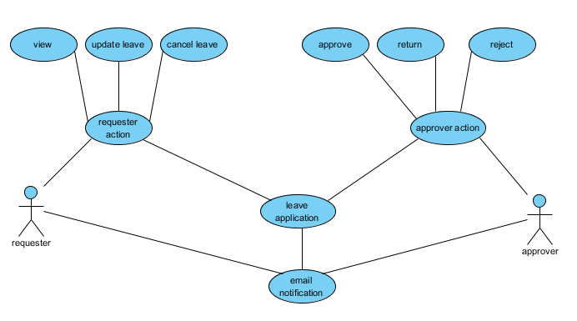

  - Functional Requirements
This sub-section is used to described the functional requirements of portlet which are related with direct interaction with the users.

Requirement ID: | LA01
Title: | My Leave Applications
Description: | List of own leaves as a requester
Priority: | 3 (high)
Comments:
Sketch:
Reference (req.):

Requirement ID: | LA02
Title: | Leave applications to be approved
Description: | List of Leaves of others to approve
Priority: | 3 (high)
Comments:
Sketch:
Reference (req.):

Requirement ID: | LA03
Title: | Leave Application Form
Description: | Leave Application Form
Priority: | 3 (high)
Comments:
Sketch:
Reference (req.):

Requirement ID: | LA04
Title: | Leave Application view
Description: | View the leave Application
Priority: | 3 (high)
Comments:
Sketch:
Reference (req.):

Requirement ID: | LA05
Title: | Leave Application Update
Description: | Update the leave Application before any further action
Priority: | 3 (high)
Comments:
Sketch:
Reference (req.):

Requirement ID: | LA06
Title: | Leave Application Cancel
Description: | Cancel the leave application when no action taken or returned by approver
Priority: | 3 (high)
Comments:
Sketch:
Reference (req.):

Requirement ID: | LA07
Title: | Leave Application Approve
Description: | Approving Leave Application
Priority: | 3 (high)
Comments:
Sketch:
Reference (req.):

Requirement ID: | LA08
Title: | Leave Application Return
Description: | Return the leave application
Priority: | 3 (high)
Comments:
Sketch:
Reference (req.):

Requirement ID: | LA09
Title: | Leave Application Reject
Description: | Reject the leave application
Priority: | 3 (high)
Comments:
Sketch:
Reference (req.):

  - Non Functional Requirements
This sub-section is used to described non-functional requirements of portlets which are not directly related to the users.
    - Performance Requirement
    - Security Requirement
No Special security requirements

    - Other Requirements
No Special other requirements

  - Activity Diagrams
This sub-section is used to present high level control flow of the portlet in question. If possible lower level control flow for each use case can also be presented.
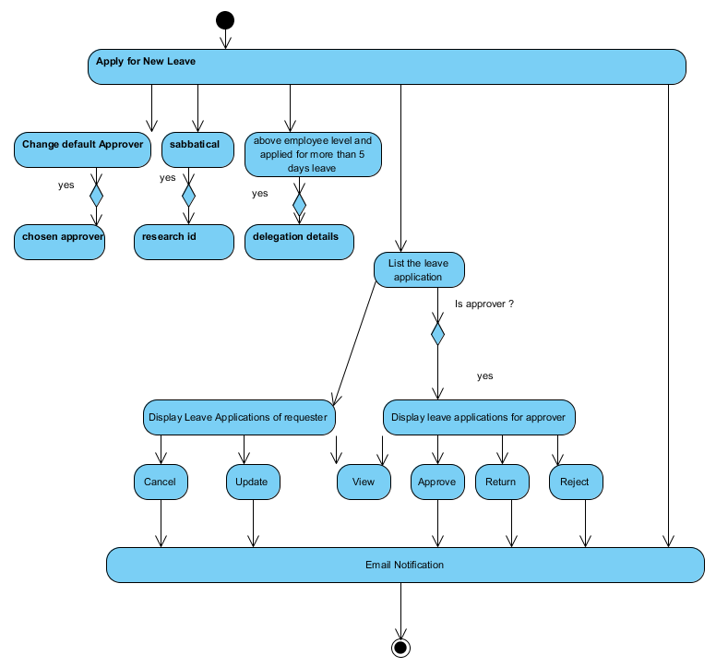

  - Business Rules & Validations
The purpose of this sub-section is to describe all the business rules and validation that are applied on this portlet.
    - Leave Application Form
      - Leave type should be empty
      - Start Date Should not be empty
      - End Date Should not be empty
      - If not normal employee and leave period beyond 5 days delegation details is/are must
      - Total delegation time should be equal to Total leave time
      - Delegation start date should not be empty
      - Delegation end date should not be empty
      - Before applying leave he should not have any pending leave request to approve
      - For backdated leave application there is a predefined days. Any leave beyond that timeframe can not be accepted. At present the time frame duration is 5 days.
      - No leave application should overlap with past and future leaves.
    - Updating Leave Application
      - Update is only possible by requester before action taken by approver.
    - Further Clarification
      - If any request returned by approver the leave status changed to Further Clarification.
      - Requester need to view and update/submit the further clarified leave to returned back to approver for actions.
    - Cancel Leave Application
      - Leave application can be cancelled by requester either it is a fresh (before action taken by approver) or it is returned by approver for any reason.
    - Approving Leave Request
      - Approver can not approve a leave if he return or reject
      - After approve he can not take any further action except view the leave application.
    - Return Leave Request
      - After returning the leave request to requester; unless until requester update the status approver cannot take any further action except view
      - Approver can not return any leave request without specifying reason.
      - Any approved or rejected leave request can not be returned.
    - Reject Leave request
      - Any rejected leave requested neither be approved nor returned except view.
      - Approver can not reject any leave request without specifying reason.
    - Sabbatical Leave
      - There are four approvers against each sabbatical leave. Every one’s hierarchy level is different from others. Unless until the immediate approves the immediate next can not take any action(s).
      - If the concerned approver is engaged with the leave application other approvers just wait and can only view the leave application.
      - If the concerned approver reject the leave application all other can not initiate any further action except view.
      - After successful approval from immediate approver, next approver notified (email) and can take action but not vice versa.
    - Delegation
      - If delegation is there, then requested leave will handled and directed to delegated employee.

  - ER or Class Diagram
The purpose of this sub-section is to describe the persistent data layer of the portlet. All the tables with their relationships should be described in this subsection.
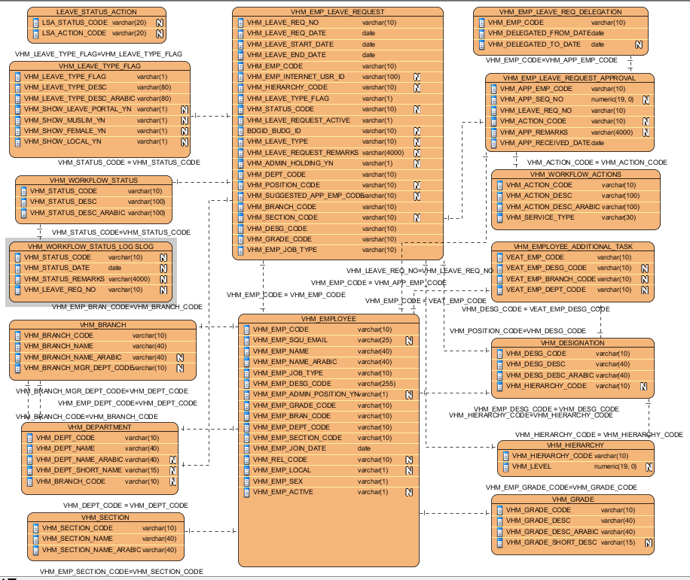

Entity Description
Entity | Description
VHM_EMP_LEAVE_REQUEST | This table provides information about leave request
VHM_EMP_LEAVE_REQUEST_APPROVAL | This table provide details of leave request approver
VHM_WORKFLOW_ACTIONS | This is a master table for approver actions (e.g. approve/return/reject)
VHM_WORKFLOW_STATUS | This is a master table for request status (e.g. waiting for approval/ approve / further clarification / reject / cancel
VHM_WORKFLOW_STATUS_LOG SLOG | This is a log table maintained for request history details
VHM_EMP_LEAVE_REQ_DELEGATION | This is a delegation table for leave request
VHM_LEAVE_TYPE_FLAG | Table for leave type
LEAVE_STATUS_ACTION | This table used for mapping for table VHM_WORKFLOW_STATUS & VHM_WORKFLOW_ACTIONS
VHM_EMPLOYEE | This is table with employee details
VHM_BRANCH | Table branch details
VHM_DEPARTMENT | Table for Department details
VHM_SECTION | Table for Section Details
VHM_DESIGNATION | Table for designation of an employee
VHM_HIERARCHY | Table for Hierarchy/Level of employees
VHM_GRADE | Table for grade ( admin/academic/technical etc) for employee

  - Database stored procedures / functions
All the stored procedures and/or functions used in this portlets are described in this sub section.
Procedure name / function name | allow_eleave_request
Description | Check eligibility of leave request
Parameters
  Name | Type | IN/OUT | Description
  P_EMP_CODE | VARCHAR2 | IN
  P_LEAVE_FLAG | VARCHAR2 | IN
  P_LEAVE_START | DATE | IN
  P_LEAVE_END | DATE | IN
  P_LEAVE_REQ_NO | VARCHAR2 | IN
  P_SUGGESTED_APP_EMP_CODE | VARCHAR2 | IN
  P_ACCEPT_LEAVE_YN | VARCHAR2 | OUT
  P_LEAVE_CODE | VARCHAR2 | OUT
  P_MSG_ENG | VARCHAR2 | OUT
  P_MSG_ARB | VARCHAR2 | OUT
  P_CHECKED_APP_EMP_CODE | VARCHAR2 | OUT
Return value
Comments | It provide arabic and english message , eligible or not as well valid approver code

Procedure name / function name | get_higher_mgr_process
Description | To get the default manager (leave approver)
Parameters
  Name | Type | IN/OUT | Description
  P_EMP_CODE | VARCHAR2 | IN
  V_MGR_EMP | VARCHAR2 | OUT
  V_HINT | VARCHAR2 | OUT
Return value
Comments | It gives default approver id

Procedure name / function name | check_eleave_delegation
Description | Find out the validity of the delegation data
Parameters
  Name | Type | IN/OUT | Description
  P_DLG_EMP_CODE | VARCHAR2 | IN
  P_DLG_START | DATE | IN
  P_DLG_END | DATE | IN
  P_LEAVE_REQ_NO | VARCHAR2 | IN
  P_LEAVE_EMP_CODE | VARCHAR2 | IN
  P_ACCEPT_DLG_YN | VARCHAR2 | OUT
  P_MSG_ENG | VARCHAR2 | OUT
  P_MSG_ARB | VARCHAR2 | OUT
Return value
Comments | It gives English and Arabic message as well flag for delegation accepted or not
Return value
Comments

Procedure name / function name | check_eleave_Research
Description | Check for valid research id
Parameters
  Name | Type | IN/OUT | Description
  P_RESEARCH_CODE | VARCHAR2 | IN
  P_LEAVE_EMP_CODE | VARCHAR2 | IN
  P_ACCEPT_YN | VARCHAR2 | OUT
  P_MSG_ENG | VARCHAR2 | OUT
  P_MSG_ARB | VARCHAR2 | OUT
Return value | VARCHAR2
Comments | Output Bilingual message and flag for acceptance

Procedure name / function name | get_leave_status_by_action
Description | Get appropriate leave status against leave action
Parameters
  Name | Type | IN/OUT | Description
  PARAM_ACTION_CODE | VARCHAR2 | IN
  PARAM_LANG | VARCHAR2 | IN
Return value | VARCHAR2
Comments

Procedure name / function name | get_last_approval_action
Description | Action of last approver (for sabbatical)
Parameters
  Name | Type | IN/OUT | Description
  PARAM_EMP_CODE | VARCHAR2 | IN
  PARAM_REQ_NO | VARCHAR2 | IN
Return value | VARCHAR2
Comments | Valid for Sabbatical

Procedure name / function name | is_valid_leave_app_approver
Description | Find out the valid leave app approver (sabbatical)
Parameters
  Name | Type | IN/OUT | Description
  PARAM_SEQUENCE | VARCHAR2 | IN
  PARAM_REQ_NUM | VARCHAR2 | IN
Return value | VARCHAR2
Comments | Valid for Sabbatical

  - Sequence Diagram
Any important or critical feature/process/code should be explained in more details with an interaction diagram.

- Implementation
The purpose of this section is to describe implementation details like package & classes information, project details, spring framework related details, repository details etc.
  - Portlet Information
This sub-section is used to describe portlet related information.
    - Portlet Details
Title | Leave Application
Short Title | Leave Application
Abbreviated Title | LA
Keywords | Leave Application

    - Modes & Action
Portlet Mode | Action | Func. Req. | Description
View | Default, welcome | LA01 | Show list of leave applications for requester
View |  | LA02 | Show list of leave applications for approver
View | newApply | LA03 | New leave application form
View | leaveView | LA04 | Display leave application
View | updateLeaveApply | LA05 | Leave application form for update
View | leaveCancel | LA06 | Cancel the leave application
View | leaveApprove | LA07 | Approve the leave application
View | leaveApprove | LA08 | Return the leave application
View | leaveApprove | LA09 | Reject the leave application

  - Spring MVC Portlet Details
The purpose of this sub-section is to provide information related to spring frame like controller, action mapping, model(s), view (JSP) etc.
Portlet Mode | Request Mapping | Func. Req. | Controller | Method Name | Model(s) | View
View | default | LA01 | LeaveAppControllerMain | welcome | LeaveAppModel | welcome.jsp
View | default | LA02 |  | welcome |  | welcome.jsp
View | newApply | LA03 |  | newApply |  | leaveApplicationForm.jsp
View | leaveView | LA04 |  | leaveApplicationView |  | leaveApplicationView.jsp
View | updateLeaveApply | LA05 |  | updateLeaveApply |  | leaveApplicationForm.jsp
View | leaveCancel | LA06 |  | leaveApplicationCancel
View | leaveApprove | LA07/ 08/ 09 |  | leaveApplicationApprove |  | leaveApplicationApproveForm.jsp

  - Packages & Classes
This sub-section is used to describe java packages and classes used in this portlet project. ‘om.edu.squ.squportal.portlet’ is used as base package followed by portlet name and then sub packages.
Ex: om.edu.squ.squportal.vehiclebooking
Sub-Package | Class | Description
leaveapp.controller | LeaveAppControllerMain | Main spring controller class which handles all the request in VIEW mode.
leaveapp.model | LeaveAppModel | Model bean for class list portlet. This bean property attached with the form field of jsp page/s
leaveapp.bo | AdminAction | Business object to held Approver Action data
 | AllowEleaveRequestProc | Object for oracle stored procedure "allow_eleave_request"
 | Branch | Object for SQU Branch
 | Budget | Budget object
 | CheckLeaveDelegation | e-leave delegation data object
 | CheckLeaveResearch | business object for stored procedure check_eleave_Research
 | DelegatedEmp | Delegated employee object
 | Department | Department object
 | Designation | Designation object
 | EmailData | E-mail data object
 | Employee | Employee object
 | HoD | HOD Object
 | LeaveApprove | Leave Approve object
 | LeaveRequest | Leave Request object
 | LeaveStatus | Leave Status object
 | LeaveType | Leave Type object
 | Sabbatical | Sabbatical object
 | Section | Section object
leaveapp.dao.db | LeaveDbDao | Dao Interface for LeaveApp db activity
 | LeaveDbDaoImpl | DataBase activity to get leave records (requester/approver/delegation/email)- Involve portal (hrmscl) database
leaveapp.dao.service | LeaveAppServiceDao | Service layer dao interface
 | LeaveAppServiceDaoImpl | Service layer activity to for leave records/process and communicate view and data layer
leaveapp.dao.ldap | LdapDao | Interface for LDAP operation
 | LdapDaoImpl | Implementation of SQU - Portal OID (Oracle Internet Directory) LDAP operation
leaveapp.servlet | LeaveAppBranchServlet | Servlet for get branch records for ajax
 | LeaveAppEmpServlet | Servlet for get employee objects of a particular branch for ajax
 | LeaveAppHodServlet | Servlet for find approver based on branch/department/section for ajax
 | LeaveAppResearchServlet | Servlet for find budget data relates with research for sabbatical leave and used for ajax
leaveapp.utility | Constants | Constants
 | UtilProperty | Property file handler
leaveapp.utility.email | EmailApprove | E-mail system for approved leave request
 | EmailCancel | Email system for Canceled leave request
 | EmailDataAbstract | Super class for Email system
 | EmailGeneral | Email system for general condition including delegation and notification next immediate sabbatical approver
 | EmailLeave | Interface for email system
 | EmailReject | Email system for Rejected leave request
 | EmailReturn | Email system for returned leave request
 | EmailService | Interface for Email sending process
leaveapp.utility.email.process | MailProcess | Email sending process
leaveapp.utility.email.template | tmplateLeaveAppEmail.st | General Email template
 | tmplateLeaveAppEmailApprover.st | Email template for approver
 | tmplateLeaveAppEmailReqester.st | Email template for requester
leaveapp.validator | LeaveAppValidator | leave application validation

  - Form & Validations
This sub-section is used to provide details of form(s) (if any) used in the portlet. Information like field names, type of field (text, select etc.), validation applied etc.
S.No. | Field | FieldName | FieldType | Data Type | Validations | Comments
1 | Dropdown for leave type | leaveTypeFlag | select | text | Required
2 | Text box for leave start date | leaveStartDate | text box | text | Required
3 | Text box for leave end date | leaveEndDate | text box | text | Required
4 | Text box for leave remark | leaveRemarks | text area | text | Not Required
5 | Redio button for selection of hod | Hod | Radio button | Text | Not Required
6 | Delegation from date | delegatedEmps[n].fromDate | Text box | Text | Required | Applicable for delegation
7 | Delegation to date | delegatedEmps[n].toDate | Text box | Text | Required | Applicable for delegation

  - Project Details
The purpose of this sub-section is to provide project details for the portlet
Project Name | prjLeaveApp
Project file name | prjLeaveApp
Version | V1
IDE + version | Eclipse Helios – service release 2
Java version | 1.6
J2EE version
Spring version | 3.1.0
Other Details

  - Repository Details (CVS/SVN)
This sub-section describes the repository details where the project and its source are stored. The should include the final locked versions and the working copy version details.
Repository Server Host | svnsrv.squ.edu.om
Repository Server URL | http://svnsrv.squ.edu.om:9880
Trunk folder | http://svnsrv.squ.edu.om:9880/portal_dev/trunk/prjLeaveApp
Last released branch
Last released date

- Styling
This sub-section will include styling & UI theme (CSS), client side scripting related information. Any information apart from the one followed by all portlets will be mentioned in this sub-section
- Deployment
This section is used to describe deployment related details like application server + version, portlet container + version, operating system, machine hardware details etc.
  - Test Environment
Platform (OS) | Windows Server 2003
Application Server | Tomcat 6
Portlet Container | Java Open Portlet Container 2.0
Machine Details | Processor: intel i-7 pc 64 bit  RAM: 16 GB
Other Details

  - Production Environment
Platform (OS) | Linux (RHEL)
Application Server | Tomcat 6.0.33
Portlet Container | Java Open Portlet Container 2.0
Machine Details | Processor:  RAM:GB
Other Details

- Test Scenarios & Result
This section will describe various test scenarios with criticality factor which should be used for testing. Each scenario will refer to a functional and/or non-functional requirement. Test results can be attached as a separate form/document to this document.
- Check leave start date
- Check leave end date
- Check delegation start date
- Check delegation end date
- Check requester list
- Check approver list
- Check email sending
- Authorization Group
This section will contain authorization details like list of employees/developers/group with access permission (read/write) to this portlet and its source.
- Revision History
This section will describe the revision history for this document.
S.No. | Author | Version | Date | Comments
1 | Bhabesh Bhabani Mukhopadhyay | 1.0 | 28-April-2013 | First Draft version

