WEB & E-SERVICE division, cis, squ.
Portlet Development Documentation
Bhabesh Bhabani Mukhopadhyay
22-Sept-2019

This template contains documentation of portlet development starting from requirements, analysis & design to testing
[Transcript]
[prjTranscript]

1. Introduction 2
1.1. Purpose of the portlet 2
1.2. Portlet Scope 2
2. Definition, acronym, and abbreviation 2
3. Functional Requirements 3
4. Non Functional Requirements 4
4.2. Activity Diagrams 4
4.3. Business Rules & Validations 4
4.4. ER or Class Diagram 5
4.5. Database stored procedures / functions 6
4.6. Sequence Diagram 9
5. Implementation 9
5.1. Portlet Information 9
5.2. Spring MVC Portlet Details 10
5.3. Packages & Classes 11
5.4. Form & Validations 12
5.5. Project Details 12
5.6. Repository Details (CVS/SVN) 12
6. Styling 13
7. Deployment 13
7.1. Test Environment 13
7.2. Production Environment 13
8. Test Scenarios & Result 13
9. Authorization Group 13
10. Revision History 13

- Introduction
The first section of the document is an Introduction. Its purpose is to provide a brief overview of the function of the system and the reasons for its development, its scope, and references to the development context (e.g., reference to the problem statement written by the client, references to existing systems, feasibility studies). The introduction also includes the objectives and success criteria of the project.

  - Purpose of the portlet
This Portlet facilitates SQU Academic and students to view transcript through centralized portal. Based upon predefined criteria privileged academics is eligible to select different students to see their transcript. A valid student is eligible to view his/her transcript. This portlet connected with SIS Common Control, through which eligible academics can request to view particular students transcript.
  - Portlet Scope
The scope of this portlet is to provide the following feature:
- By default Transcript portlet having following feature
  - Search for Student details
  - View student’s details
    - View list of courses
- View particular transcript

- Definition, acronym, and abbreviation

- Functional Requirements
This sub-section is used to described the functional requirements of portlet which are related with direct interaction with the users.

Requirement ID: | TR01
Title: | Transcripts Search
Description: | Search for Academic transcript
Priority: | 3 (high)
Comments:
Sketch:
Reference (req.):

Requirement ID: | TR02
Title: | List of Courses
Description: | Student details along with list of courses
Priority: | 3 (high)
Comments:
Sketch:
Reference (req.):

Requirement ID: | TR03
Title: | Transcript Details
Description: | Transcript Details
Priority: | 3 (high)
Comments:
Sketch:
Reference (req.):

- Non Functional Requirements
This sub-section is used to described non-functional requirements of portlets which are not directly related to the users.
    - Performance Requirement
    - Security Requirement
No Special security requirements

    - Other Requirements
No Special other requirements
  - Activity Diagrams
This sub-section is used to present high level control flow of the portlet in question. If possible lower level control flow for each use case can also be presented.
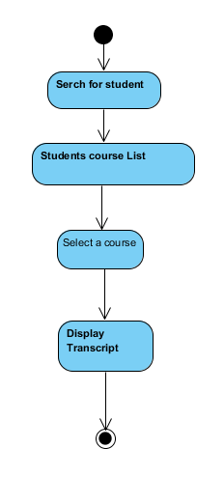

  - Business Rules & Validations
The purpose of this sub-section is to describe all the business rules and validation that are applied on this portlet.
4.3.1 Transcript Form
4.3.1.1 Only authenticated user can search related students
  - ER or Class Diagram
The purpose of this sub-section is to describe the persistent data layer of the portlet. All the tables with their relationships should be described in this subsection.
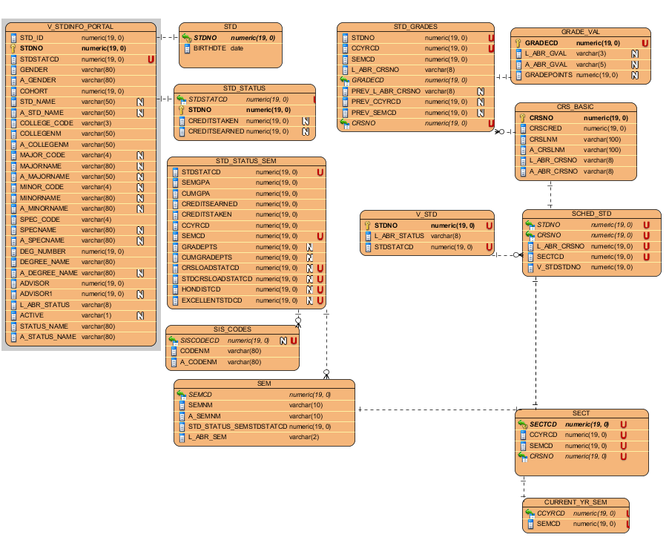
Entity Description
Entity | Description
V_STDINFO_PORTAL | Student data pull for portal
STD | Student table
STD_STATUS | Student status
STD_STATUS_SEM | Students Cumulative grade points, grade points, Semester GPA, Cumulative GPA etc
SIS_CODES | Code table
SEM | Semester description
STD_GRADES | Grade table
V_STD | View of the student table
GRADE_VAL | Grade values (A,A+ etc..)
CRS_BASIC | Courses in effect at from/to time frame
SCHED_STD | Registration data
SECT | Details of courses with first and second withdraw dates
CURRENT_YR_SEM | Current Year Semester

  - Database stored procedures / functions
All the stored procedures and/or functions used in this portlets are described in this sub section.
Procedure name / function name | MISC_PKG.FAC_NAMES
Description | Get Faculty name
Parameters
  IN/OUT | Description
  IN | EmpNo
  IN | ‘EMPNO’
  IN | Language
Return value
Comments | It provide arabic and english name of faculty

Procedure name / function name | MISC_PKG.FIRST_ADMITTED
Description | First college
Parameters
  IN/OUT | Description
  IN | Student StatCode
  IN | ‘COL’
  IN | Language
Return value
Comments | First college

Procedure name / function name | MISC_PKG.CERT_INFO
Description | School Certificate type
Parameters
  IN/OUT | Description
  IN | Student no
  IN | CERTTYPE/ STREAM
  IN | Language
Return value
Comments | It gives English and Arabic School certificate type
Return value
Comments

Procedure name / function name | STD_SCH_PERCENT
Description | Check for valid research id
Parameters
  IN/OUT | Description
  IN | Student No
  IN | ‘PERC’
Return value | VARCHAR2
Comments | School Percentage

Procedure name / function name | MISC_PKG.STD_DEGREE_HISTORY
Description | Degree History
Parameters
  IN/OUT | Description
  IN | Student StatCode
  IN | Course Year
  IN | Sem code
  IN | College Name
  IN | Language
Return value | VARCHAR2
Comments | Degree History

Procedure name / function name | REG_PKG.WAS_FSP
Description | Course Credit Value
Parameters
  IN/OUT | Description
  IN | Student No
  IN | Course Year
  IN | Sem Code
  IN | Course Abbreviation No
  IN | Grade Code
  IN | Grade value
Return value | VARCHAR2
Comments | Course credit value

Procedure name / function name | WEB_PKG.SIS_Web_access
Description | Control the access
Parameters
  IN/OUT | Description
  IN | Student No
  IN | Student Stat code
  IN | College Code
  IN | Employee Number
  IN | Access Domain
  IN | Degree Number
  IN | Advisor 1 Number
  IN | Advisor 2 Number
Return value | VARCHAR2
Comments | Control the access

  - Sequence Diagram
Any important or critical feature/process/code should be explained in more details with an interaction diagram.

- Implementation
The purpose of this section is to describe implementation details like package & classes information, project details, spring framework related details, repository details etc.
  - Portlet Information
This sub-section is used to describe portlet related information.
    - Portlet Details
Title | Transcript
Short Title | Transcript
Abbreviated Title | TR
Keywords | Transcript
    - Modes & Action
Portlet Mode | Action | Func. Req. | Description
View | Default, welcome | TR01 | Show list of Transcripts for requester
View | resAccessPermissionForStudent | TR02 | Find eligibility of an academics to view transcript
View | submitStudentInfo | TR03 | Submit Student Id by Academics
View | studentDetails | TR04 | Render to student details
View | resSummary | TR05 | Student Summary List
View | pdfTranscript | TR06 | PDF Generation of transcript
View | back2main | TR07 | Back button
View | eventStudentDetails | TR08 | Render back to student details

  - Spring MVC Portlet Details
The purpose of this sub-section is to provide information related to spring frame like controller, action mapping, model(s), view (JSP) etc.
Portlet Mode | Request / Resource/Mapping | Func. Req. | Controller | Method Name | Model(s) | View
View | default | TR01 | TranscriptController | welcome | TranscriptModel | welcome.jsp
View | resAccessPermissionForStudent | TR02 |  | getAccessPermission
View | submitStudentInfo | TR03 |  | submitStudentId
View | studentDetails | TR04 |  | studentDetails |  | studentInfo.jsp
View | resSummary | TR05 |  | getSummary
View | pdfTranscript | TR06 |  | pdfTranscript
View | back2main | TR07 |  | back2main
View | eventStudentDetails | TR08 |  | eventStudentDetails

  - Packages & Classes
This sub-section is used to describe java packages and classes used in this portlet project. ‘om.edu.squ.squportal.portlet’ is used as base package followed by portlet name and then sub packages.
Ex: om.edu.squ.squportal.vehiclebooking
Sub-Package | Class | Description
transcript.controller | TranscriptController | Main spring controller class which handles all the request in VIEW mode.
transcript.model | TranscriptModel | Model bean for class list portlet. This bean property attached with the form field of jsp page/s
transcript.dao.bo | AccessDTO | Business object to held Approver Access data
 | GradeSemester | Grade semester object
 | Postpone | Postpone object
 | Budget | Budget object
 | RegistrationBO | Student registration status object
 | Student | Student object
 | StudentStatus | StudentStatus object
 | User | User object
transcript.dao.db | TranscriptDbDao | Dao Interface for transcript db activity
 | TranscriptDbImpl | DataBase activity to get transcript records
transcript.dao.service | TranscriptServiceDao | Service layer dao interface
 | TranscriptServiceImpl | Service layer activity to for transcript and communicate view and data layer
transcript.dao.pdf | TranscriptPdfDao | Interface for Implementation class to generate pdf
 | TranscriptPdfImpl | Generating PDF
transcript.utility | Constants | Constants
 | UtilProperty | Property file handler
 | UtilService | Get user Student/Staff (Academic)
transcript.security | Crypto | Interface for Encryption
 | CryptoAES | Encrypt and Decrypt using Base64

  - Form & Validations
This sub-section is used to provide details of form(s) (if any) used in the portlet. Information like field names, type of field (text, select etc.), validation applied etc.
S.No. | Field | FieldName | FieldType | Data Type | Validations | Comments
1 | TextBox for Student Id | stdId | Text box | text | Required

  - Project Details
The purpose of this sub-section is to provide project details for the portlet
Project Name | prjTranscript
Project file name | prjTranscript
Version | V1
IDE + version | Eclipse Luna – Release (4.4.0)
Java version | 1.7
J2EE version
Spring version | 3.2.3
Other Details

  - Repository Details (CVS/SVN)
This sub-section describes the repository details where the project and its source are stored. The should include the final locked versions and the working copy version details.
Repository Server Host | gitlab.squ.edu.om
Repository Server URL | http://gitlab.squ.edu.om
Trunk folder | http://gitlab.squ.edu.om/portal-team/transcript/tree/master
Last released branch
Last released date

- Styling
This sub-section will include styling & UI theme (CSS), client side scripting related information. Any information apart from the one followed by all portlets will be mentioned in this sub-section
- Deployment
This section is used to describe deployment related details like application server + version, portlet container + version, operating system, machine hardware details etc.
  - Test Environment
Platform (OS) | Red Hat 7
Application Server | Liferay 6.2
Portlet Container | Liferay 6.2
Machine Details
Other Details

  - Production Environment
Platform (OS) | Linux (RHEL)
Application Server | Liferay 6.2
Portlet Container | Liferay 6.2
Machine Details | Processor:  RAM:GB
Other Details

- Test Scenarios & Result
This section will describe various test scenarios with criticality factor which should be used for testing. Each scenario will refer to a functional and/or non-functional requirement. Test results can be attached as a separate form/document to this document.
- Check valid student id
- Authorization Group
This section will contain authorization details like list of employees/developers/group with access permission (read/write) to this portlet and its source.
- Revision History
This section will describe the revision history for this document.
S.No. | Author | Version | Date | Comments
1 | Bhabesh Bhabani Mukhopadhyay | 1.0 | 24-Sept-2019 | First version

