5471 WORK PAPER
User Guide
Populating the master template from client documents
The one rule that explains everything
You enter local currency. The template calculates US dollars.
The tool writes only the local-currency figures and three exchange rates. Every USD column, subtotal and cross-schedule link is your template's own formula. This is why a missing rate stops generation: =ROUND(D10/$G$6,0) with a blank G6 returns #DIV/0! in every USD cell.

Contents

1. The five-minute path
Everything else in the tool is review. This is the whole job:
- Entities & documents — name the stakeholder and the entity.
- Drag the trial balance onto the entity.
- Press Process entity.
- Check the functional currency filled in (it usually auto-detects).
- Generate.
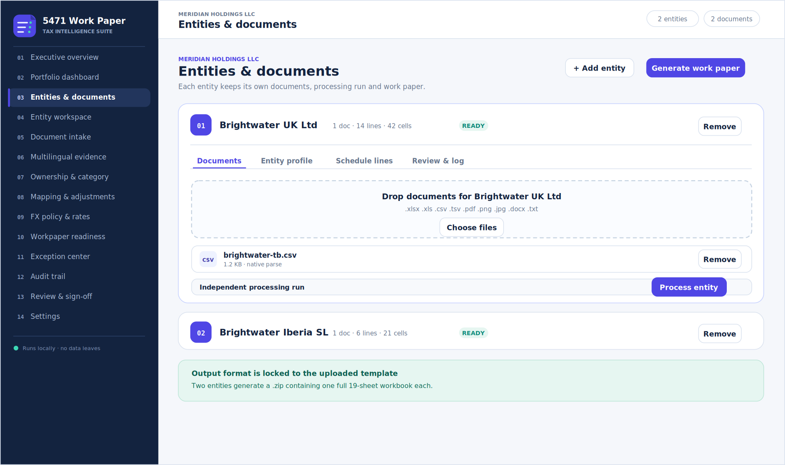
Figure 1 — Entities & documents. The working tab: add entities, upload, and process.

2. The 14 tabs

Tabs you act in
Tab | What you do here
03 Entities & documents | The working tab. Add, rename and remove entities; upload documents; process; edit the profile, schedule lines and unmatched captions.
09 FX policy & rates | Apply published rates, check a live rate, override a rate.
07 Ownership & category | Ownership facts and filing categories, laid out for review.
11 Exception center | Fix everything outstanding across all entities in one place.
14 Settings | Mapping rules, Groq key, free service providers, quota dashboard.

Tabs you read
Tab | What it shows
01 Executive overview | Engagement totals, the nine-stage flow, output status.
02 Portfolio dashboard | All entities side by side. Open switches the active entity.
04 Entity workspace | Everything known about the active entity, plus its open issues.
05 Document intake | Every file loaded, which entity holds it, and how it was read.
06 Multilingual evidence | Each caption, its detected language, translation, and the line it fed.
08 Mapping & adjustments | Which document caption produced each populated line.
10 Workpaper readiness | Blocking versus advisory findings. You can generate from here.
12 Audit trail | Every action with a timestamp. Exports as JSON.
13 Review & sign-off | Final summary before approval.

Inside an entity: four sub-tabs
Expand an entity in Entities & documents and you get:
Sub-tab | Contents
Documents | Drop zone, file list, Process entity, and the five processing stages.
Entity profile | Identity, period ends, currency, ownership, categories and FX rates.
Schedule lines | Every Schedule C and Schedule F line, editable, with its target cell.
Review & log | Unmatched captions to assign, and the processing log.

3. One stakeholder, one entity
The normal case. One entity produces one .xlsx file.
- Entities & documents — replace “New stakeholder” with the client name.
- Rename “Entity 1” to the foreign corporation.
- Drop the trial balance or financial statements onto the drop zone.
- Press Process entity. Captions map to Schedule C and F lines, and entity details fill themselves.
- Open Entity profile, confirm the fields marked auto, and fill any blanks. Setting the functional currency auto-fills all three exchange rates.
- Open Review & log and assign anything unmatched.
- Generate. You get 5471_Workpaper_<Stakeholder>_<Entity>.xlsx.

Which files can be read
Handling | Formats
Parsed locally | .xlsx .xlsm .csv .tsv .txt
Accepted, needs AI extraction | .pdf .png .jpg .docx
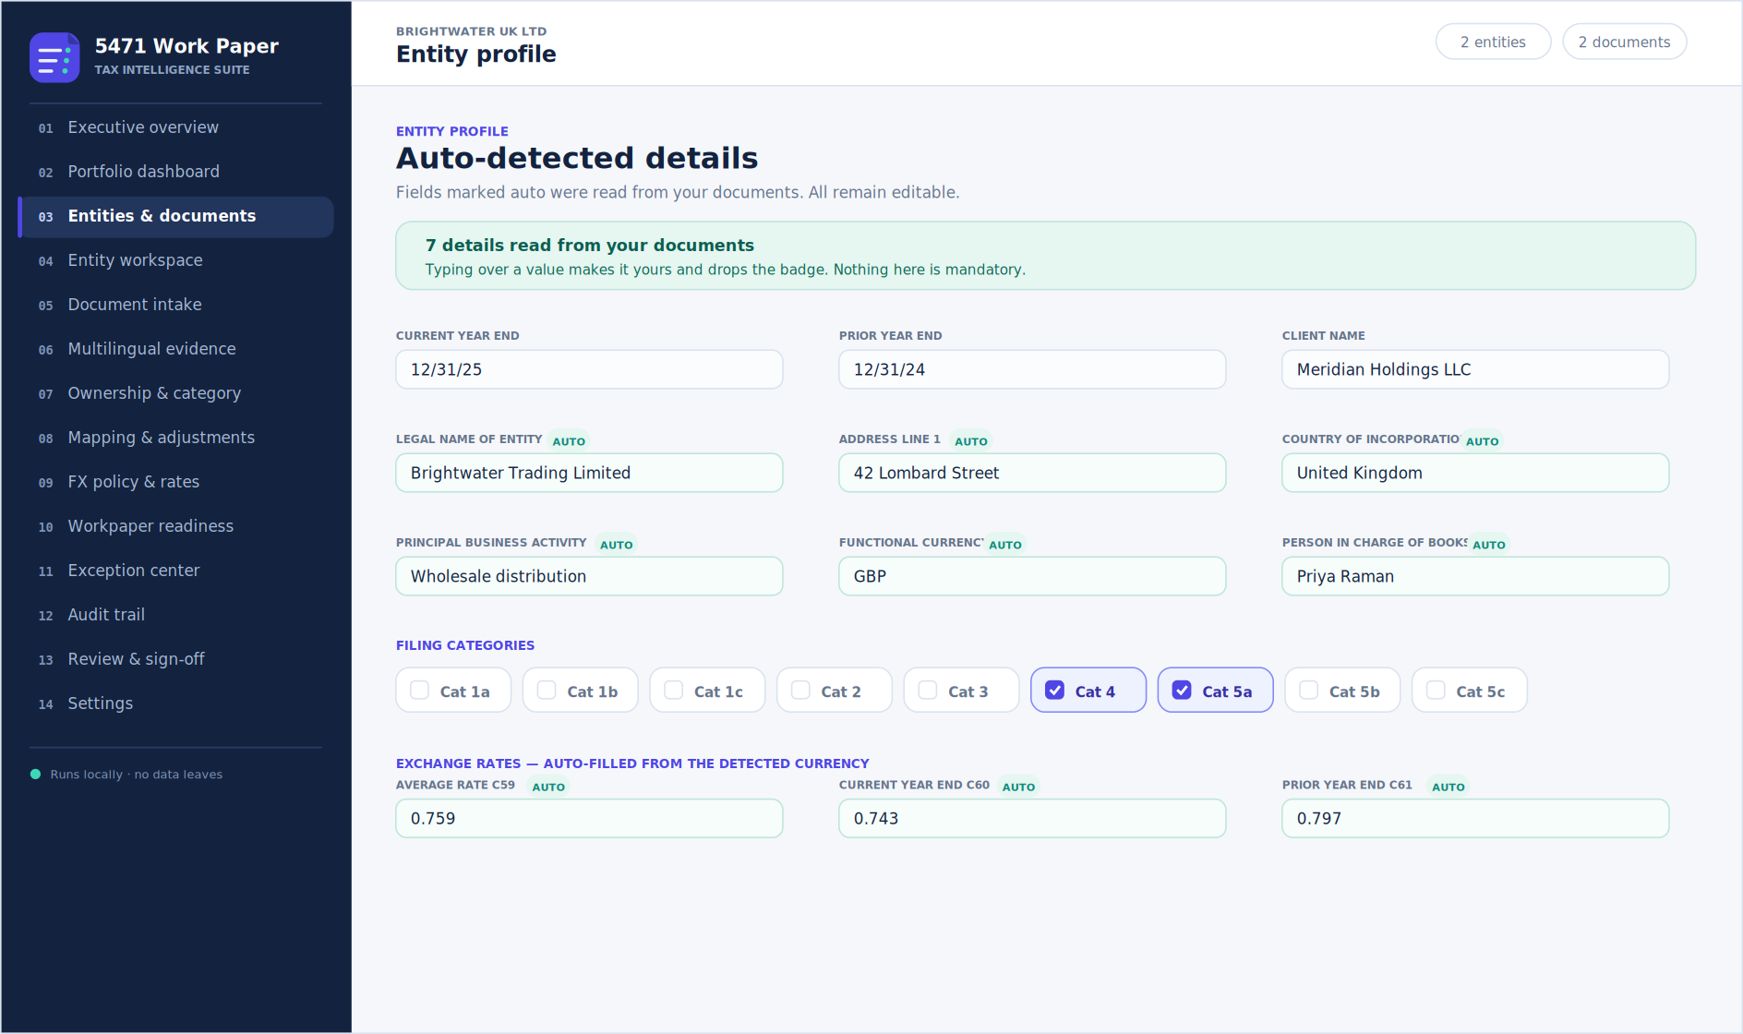
Figure 2 — Entity profile. Fields marked auto were read from the uploaded documents and stay editable.

4. One stakeholder, multiple entities
Entities never combine
Each entity is calculated completely separately. Form 5471 is filed per foreign corporation, so n entities produce n workbooks. There is no consolidation, by design.

- Set the stakeholder name once. It applies to every entity and writes to cell B3.
- Press + Add entity for each foreign corporation, and rename each one.
- Upload each entity's documents onto that entity's own drop zone. Documents never mix.
- Press Process entity on each one separately.
- Set each entity's own currency. They can differ, and each gets its own three rates.
- Clear each entity's unmatched captions.
- Generate all for a .zip containing one full 19-sheet workbook per entity, or Generate on a single entity for just that one.

Switching between entities
Entity-scoped tabs always show the active entity. Change it with the entity chips at the top of the FX, evidence, mapping, ownership, readiness and sign-off tabs, or with Open on the Portfolio dashboard.

Side by side
 | Single entity | Multiple entities
Documents | One pool | One pool each, isolated
Processing | One run | One run each, independent
Currency and rates | One set | One set each, can differ
Validation | One checklist | One checklist each
Output | Single .xlsx | .zip, one workbook per entity
Consolidation | n/a | None — by design

5. What blocks generation
Only the three exchange rates. Everything else is advisory and lets you proceed.
Finding | Level | Blocks generation?
Average rate C59 missing, with income statement lines | block | Yes
Current year end rate C60 missing, with balance sheet lines | block | Yes
Prior year end rate C61 missing, with balance sheet lines | block | Yes
No filing category selected | advisory | No
Functional currency not set | advisory | No
Current year end not set | advisory | No
Unassigned captions remain | advisory | No
Setting the functional currency normally clears all three blocks at once.
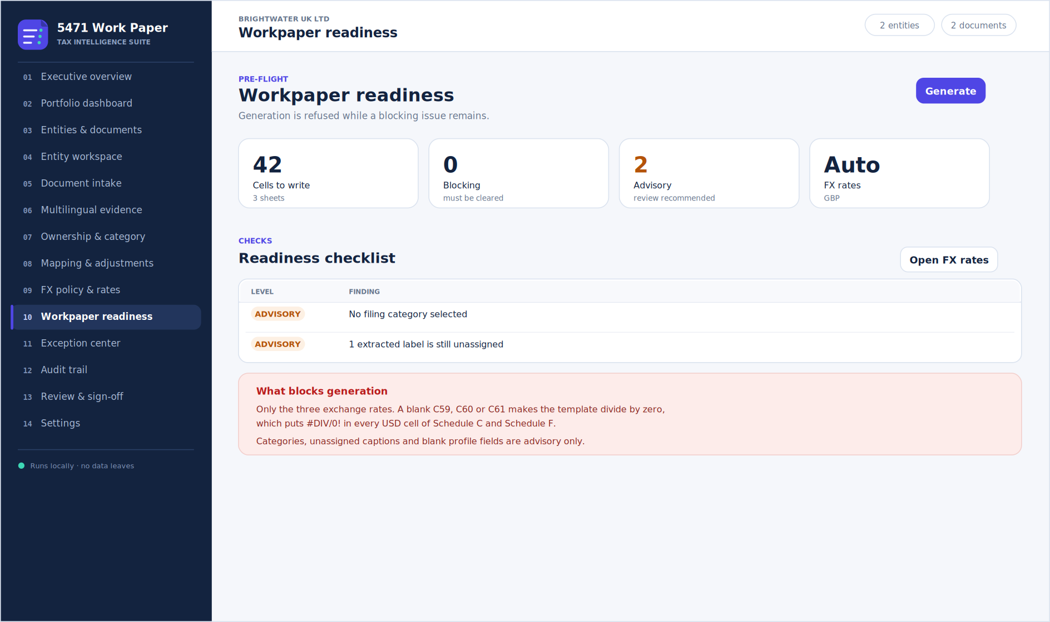
Figure 3 — Workpaper readiness. Blocking findings are always exchange rates.

6. What this tool calculates
The tool has a deliberately narrow arithmetic remit. It reads, maps, looks up and writes. Everything it does falls into these five jobs.
Job | What happens | Why it is safe to automate
Reading documents | Extracts label and value rows from .xlsx, .xlsm, .csv, .tsv, .txt and text-layer PDFs. | Mechanical. The values are transcribed, never derived.
Mapping captions | Binds each caption to a template line using deterministic keyword rules; the longest matching keyword wins. | Rules are visible and editable in Settings, and every binding is shown with its source caption.
Combining duplicates | Two captions bound to the same line are summed. | Addition only. No reclassification.
Normalising formats | Dates to the template's m/d/yy form; ownership 0.65 to 65; “Euro” to EUR. | Format conversion, not judgment. Values that cannot be trusted are rejected.
Rate lookup | Fetches the published IRS yearly average and US Treasury 12/31 spot rate for the currency and year. | A table lookup against published data, shown beside the value in use.
Writing cells | Writes the values into the template's designated input cells and flags the workbook to recalculate. | The workbook's own formulas then produce every derived figure.
Notice what is absent from that list: no US-dollar figure, no subtotal, no tax computation. The tool populates inputs. The template computes.

7. What it does not calculate, and why
Each exclusion below is deliberate. They fall into three groups: arithmetic that belongs to your template, computations that require professional judgment, and data the documents simply do not contain.

7.1 Arithmetic that belongs to the template
Not calculated | Who does it | Reason
US dollar amounts on Schedules C and F | Template formulas dividing by C59, C60, C61 | One source of truth. If the tool also computed USD, two answers would exist for the same cell and could disagree after any edit.
Gross profit, total income, total deductions, total assets | Template SUM formulas | These are your reviewed formulas. Overwriting them with static numbers would break the workbook for anyone who later changes an input.
Cross-schedule links (C to H, H to J, E to E-1) | Template formulas | The linkage encodes your firm's method. The tool must not silently restate it.
Rounding | Template ROUND(x,0) | Rounding at the wrong point changes totals. The template decides where it happens.
The practical consequence
Values are entered in local currency, exactly as reported, and are never pre-converted. If a USD column looks wrong, the cause is a rate in C59–C61, not the figure the tool wrote.

7.2 Computations requiring professional judgment
Not calculated | Reason
Filer category (1a–5c) | Category depends on ownership attribution, not arithmetic. A filer can hold 50% of the shares directly and still report 100% voting power through constructive ownership from a spouse. No parser can infer that from a share register, so the tool leaves the category boxes to you and only warns when none is ticked.
Book-to-tax adjustments (Schedule C column H) | Deciding that entertaining is disallowed, or that a provision is not yet deductible, is a judgment about tax law applied to a specific fact pattern. The tool writes book figures into column F and leaves column H for the preparer.
Earnings and profits (Schedule H) | E&P is not book profit. It requires US-basis adjustments — depreciation method differences, disallowed items, prior-year balances — that are not present in a set of local statutory accounts.
Subpart F and GILTI (Schedules I, I-1, Q) | These require income to be characterised by category and tested against exceptions. Characterisation is a legal conclusion, not a lookup.
Foreign tax credit (Schedule E, E-1) | Creditability, splitter rules and high-tax kickout all turn on analysis of the foreign tax, not on the amount alone.
Previously taxed E&P (Schedules J, P) | Requires opening balances by PTEP group from the prior year's workpaper, which the current-year documents do not contain.
Functional currency determination | Whether the currency is the functional currency, and whether DASTM applies, is a determination about the entity's economic environment.
Which schedules are required | This follows from the filer category, which is your determination.

7.3 Data the documents do not contain
Not calculated | Reason
Prior-year carryovers | Schedule J opening balances and foreign tax credit carryforwards come from last year's filed workpaper. Enter them by hand; the tool will not invent them.
Rates for non-calendar year ends | The bundled tables hold IRS yearly averages by calendar year and Treasury spot rates at 12/31. An entity with, say, a 30 April year end needs a rate at 30 April, which is in neither table. Auto-fill is skipped and you enter the rate you have determined.
Text in scanned PDFs | A scanned filing is an image. The tool reports that there is no text layer rather than guessing, because a silently empty extraction is worse than a clear refusal.
Consolidated figures across entities | Form 5471 is filed per foreign corporation. Combining entities would produce a workbook that matches no filing obligation.

7.4 Things it is not
- It is not a tax return and does not file anything. The deliverable is a work paper.
- It does not audit or verify your source documents. If the trial balance is wrong, the work paper is wrong.
- It does not decide materiality, or whether a figure deserves investigation.
- It does not replace review. Stage 08 of the flow is a human gate by design.

7.5 Where each schedule's numbers come from
Schedule | Populated by | Note
Basic Information | Tool | Profile, ownership facts, categories you tick, exchange rates.
Schedule C — income statement | Tool (column F) | Local currency only. USD column L is a template formula.
Schedule F — balance sheet | Tool (columns D, F) | Local currency only. USD columns G and H are template formulas.
Schedules E, E-1 | Preparer | Foreign taxes paid and their creditability.
Schedules H, J, P | Preparer | E&P and previously taxed E&P, including prior-year balances.
Schedules I, I-1, Q | Preparer | Subpart F, GILTI and income grouping.
Schedules G, M, R | Preparer | Other information, related-party transactions, distributions.

7.6 Known limits you will meet in practice
What you will see | Explanation
#DIV/0! on Schedule E and Entity Structure | Eleven such cells exist in the master template before the tool touches it. They divide by inputs a preparer supplies. The tool does not write to those cells and does not cause the errors.
A caption bound to the wrong line | Keyword rules are heuristics. Mapping & adjustments shows the source caption behind every populated line so a wrong binding is visible in seconds, and the rule can be corrected in Settings.
More expense lines than the template has slots | The template exposes a fixed number of “other deduction” rows. Combine immaterial items, or map them to the nearest named line.
Ownership stated two ways | Item C voting percentage and the Schedule B pro rata share can legitimately differ where stock is attributed. Both come from you; the tool reconciles neither.

8. Exchange rates
Three divide rates: functional currency units per 1 USD.
Rate | Cell | Used by | Default source
Average | C59 | Schedule C | IRS yearly average
Current year end | C60 | Schedule F, end of year | US Treasury 12/31 spot
Prior year end | C61 | Schedule F, beginning of year | US Treasury 12/31 spot
151 currencies ship offline: averages 2017–2025 and spot rates 2016–2025. Apply published rates refills them. Check live rate fetches an indicative quote from OFX, then Frankfurter, then ExchangeRate-API; Override C60 applies it and records the change in the audit trail.
Published rates govern the work paper
Live quotes are indicative mid-market rates. Schedule C expects the IRS yearly average and Schedule F the US Treasury 12/31 spot rate. Live rates are supplemental, not a replacement.
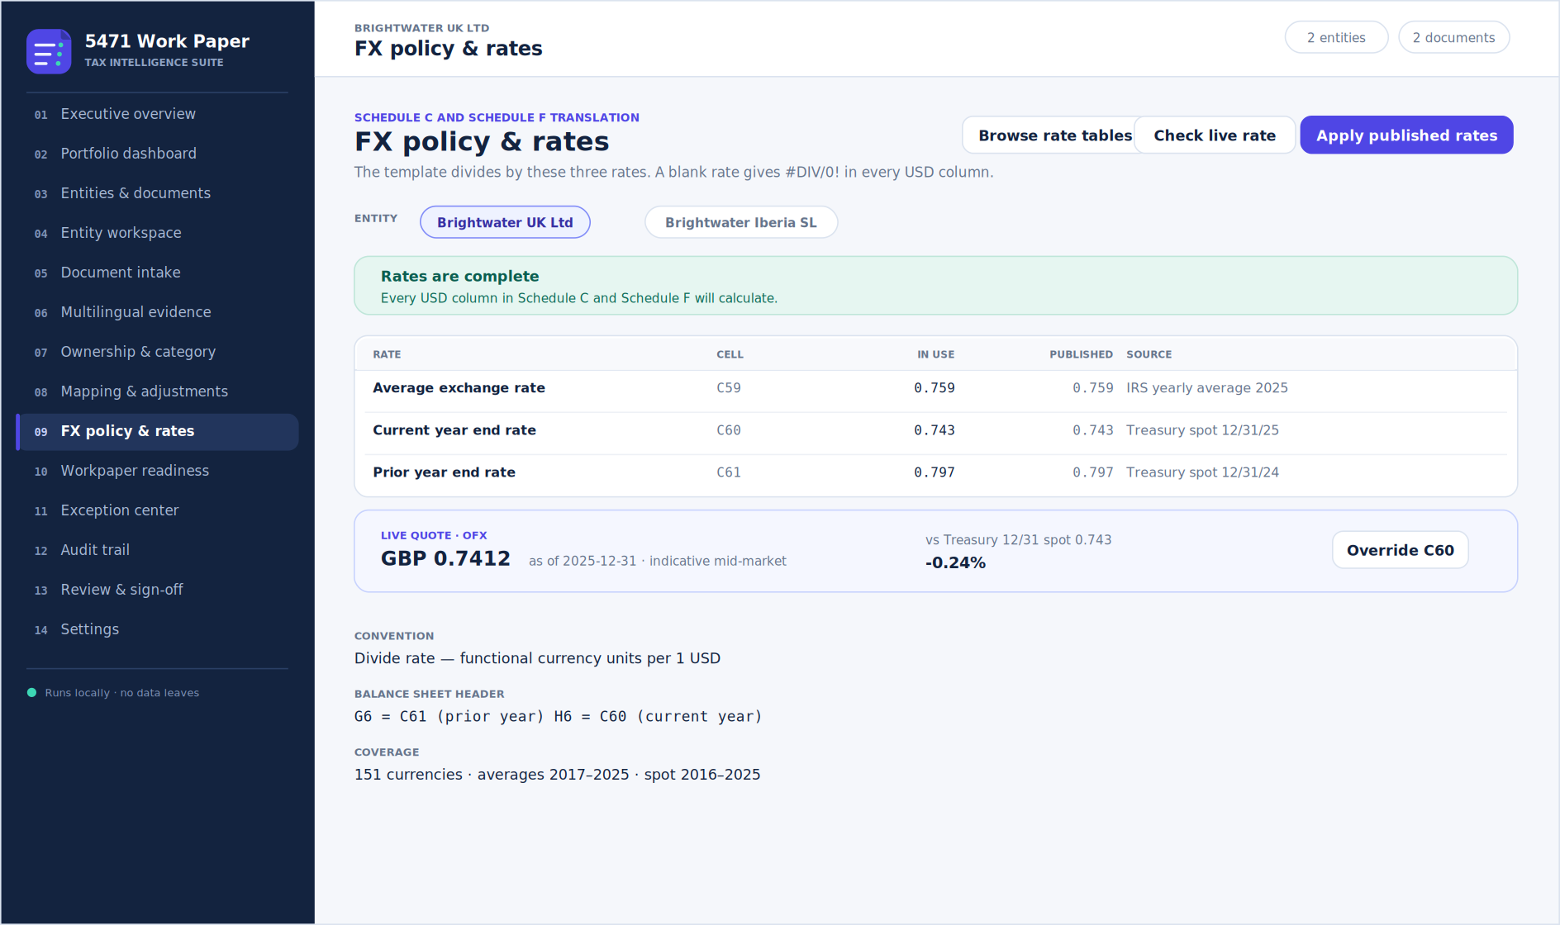
Figure 4 — FX policy & rates. Rates in use beside published values, with an optional live quote.

9. Where your data lands
Content | Template cells
Client, entity, addresses, activity, currency | Basic Information B1:B4, B11:B27
Ownership facts | Basic Information C33:C40
Filing categories 1a–5c | Basic Information B42:B50
Exchange rates | Basic Information C59:C61
Income statement, local currency | Income Statement F7:F59
Balance sheet, local currency | Balance Sheet D10:D62 and F10:F62
Nothing else is touched. All 19 sheets, formulas, styling, merged ranges and hidden sheets survive intact.
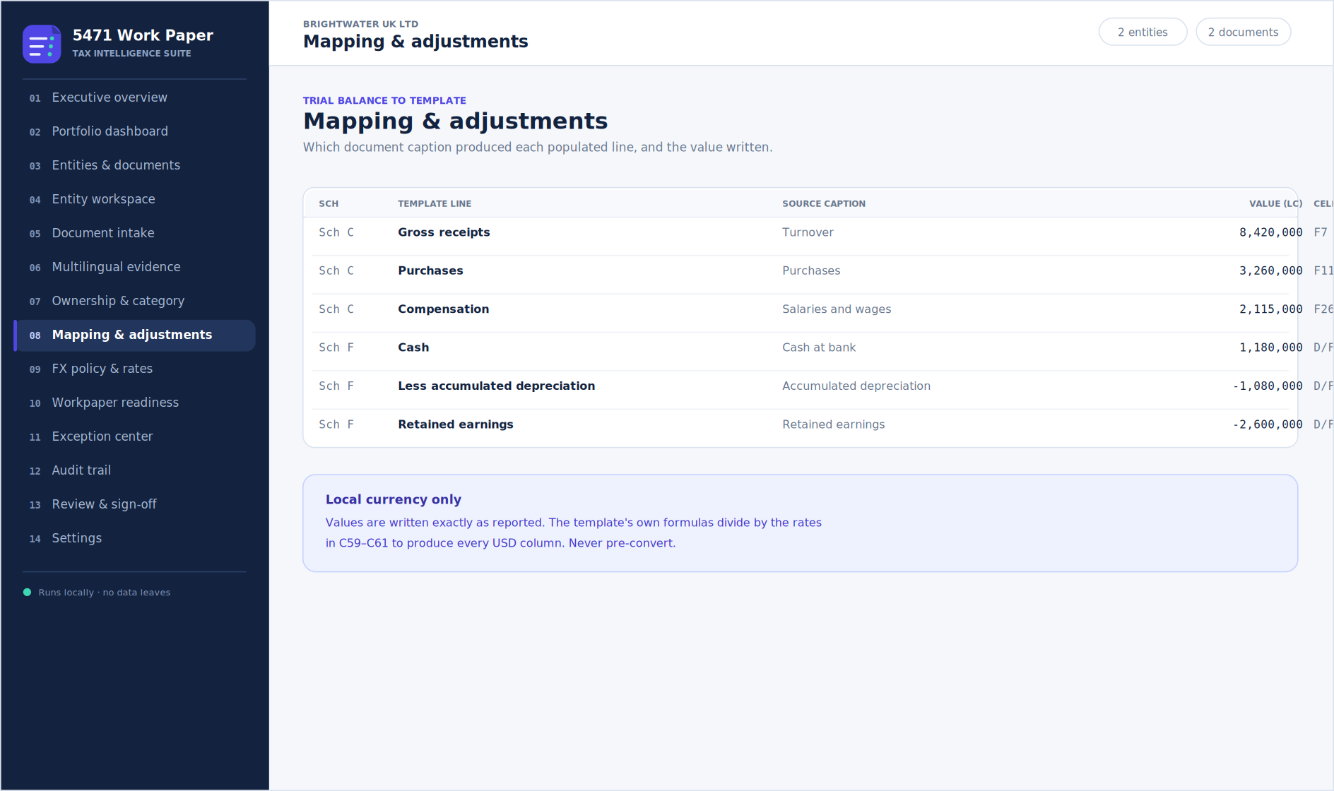
Figure 5 — Mapping & adjustments. Every populated line traced back to its source caption.

10. Auto-detection of entity details
Processing reads entity particulars from label and value pairs in your documents: legal name, addresses, country, formation date, business activity, books custodian, currency, period ends, ownership percentages, CFC facts and ticked categories.
- Fills only blank fields — it never overwrites what you typed.
- Each detected value carries an auto badge showing the caption it came from.
- Type over it and the badge drops; the value becomes yours.
- Untrustworthy values are rejected: non-numeric percentages, day counts over 366, unknown currency codes.
- Works on .xlsx, .csv, .tsv and .txt only.

Trigger it with a header block above the trial balance
Legal Name of Entity,Brightwater Trading Limited
Country of Incorporation,United Kingdom
Functional currency,GBP
Ownership % at end of year,82.5

11. Free services
No account is required for translation or live rates. Providers fall through on failure, and usage meters reset daily.
Provider | Use | Free allowance
MyMemory | Translation | 5,000 characters per day
Lingva | Translation fallback | None published
OFX | Live FX, tried first | None published
Frankfurter (ECB) | Live FX and historical | None published
ExchangeRate-API | Live FX, latest only | None published
Groq | Translation and mapping | Needs your own API key
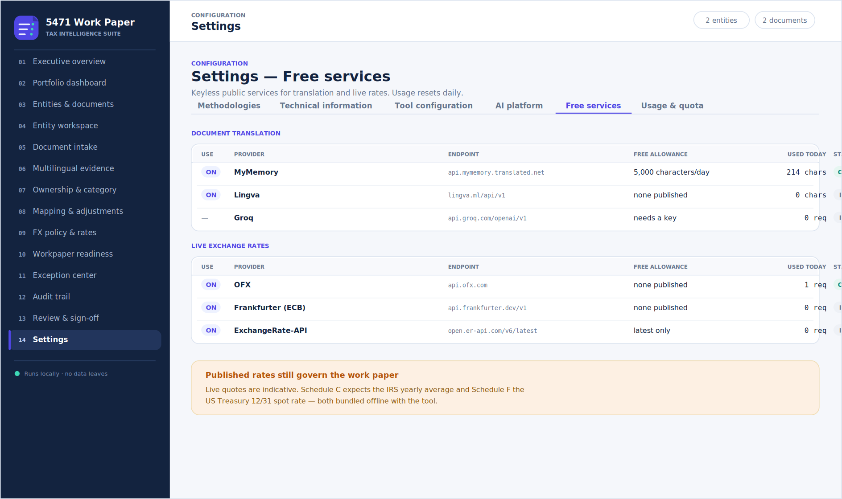
Figure 6 — Settings, Free services. Provider status and daily quota.

12. Troubleshooting
Symptom | Cause and fix
#DIV/0! in USD columns | A rate is blank. Set the functional currency, or use Apply published rates on the FX tab.
Generate is disabled or reads “Blocked” | A rate is missing. Workpaper readiness shows which one.
#DIV/0! on Schedule E or Entity Structure | Pre-existing in your template — those formulas divide by cells a preparer fills in. Not caused by the tool.
Numbers landed on the wrong line | Mapping & adjustments shows the source caption. Adjust keywords in Settings, Tool configuration, or reassign in Review & log.
Nothing extracted from a PDF | PDFs are not parsed locally. Enter the values by hand, or use Groq.
Live rate or translation fails | The page must be served over HTTPS, not file://. Check Settings, Free services for the error text.
Entity details did not auto-fill | Detection needs label and value pairs in a parseable file. Add a header block above the trial balance.

13. Worth knowing
- Nothing leaves your browser unless you click Translate or Check live rate. Documents are parsed locally and never uploaded.
- Local currency only. Never pre-convert figures to US dollars.
- The audit trail records every action and exports as JSON for the engagement file.
- Work is held in the browser session — generate before closing the tab.
- Deep links work: ?view=fx and ?view=entities open straight to a tab.
- A Groq API key is optional, entered by each user, and never bundled into the file.
Figures in this guide are rendered illustrations of the interface, drawn from the application's own layout and colour values.

