ABC-Conditioned Score Correction for Dermoscopic Melanoma Classification under External Dataset Shift

Abstract
We present a reproducible evaluation and score-correction framework for dermoscopic melanoma classification under external dataset shift. The framework combines segmentation-derived ABC descriptors, EfficientNet-B0 representations, calibration analysis, decision-curve assessment, feature attribution, duplicate screening, and independent validation. The endpoint was melanoma versus all other diagnoses. HAM10000 was used with lesion-level train/validation/test separation. The local ISIC 2018 Task 3 files showed complete image-identifier overlap with HAM10000 and were therefore retained only as a secondary label audit. BCN20000 was used for independent external validation after identifier and perceptual-hash screening.
On the HAM10000 test split, the deep-baseline and hybrid models showed similar ROC-AUC values (0.887 and 0.885), while the hybrid model had lower raw Brier score (0.080 vs. 0.097). On BCN20000, the hybrid model achieved the strongest external ranking performance (AUC 0.761, PR-AUC 0.548), followed by the deep-baseline model (AUC 0.713, PR-AUC 0.472) and ABC-only model (AUC 0.692, PR-AUC 0.379). The ABC-conditioned post-hoc score-correction layer improved external ranking relative to raw deep scores but did not outperform Platt or isotonic regression by external Brier score. The framework separates discrimination, probability reliability, threshold-dependent utility, dataset shift, and saliency behavior in a single reproducible audit workflow.
Keywords: Dermoscopy, Melanoma classification, Score correction, Calibration, External validation, Decision-curve analysis

1. Introduction
Evaluation of medical image classifiers often emphasizes discrimination metrics such as ROC-AUC while giving less attention to calibration, decision consequences, and model transparency. Although deep learning models may achieve high ROC-AUC on benchmark datasets, their predicted probabilities can be poorly calibrated, which has direct implications for threshold selection, risk estimation, and clinical trust [1, 2]. Explainability is likewise important for systematic auditing of clinical AI systems [3, 4].
Reliable model assessment requires separation of discrimination, calibration, and decision utility. Decision-curve analysis quantifies the net benefit associated with threshold-based use and therefore complements ranking metrics [5, 6]. These issues are especially relevant in dermoscopic melanoma classification, where class imbalance and threshold-dependent triage decisions make probability reliability clinically important.
This study presents a reproducible evaluation framework for melanoma-only dermoscopic classification under lesion-level separation, audited dataset provenance, and independent external validation. The framework separates discrimination, probability reliability, recalibration, decision utility, interpretability, and dataset shift. We compare three model families: an ABC-style handcrafted descriptor model, an EfficientNet-B0 deep-baseline model, and a hybrid XGBoost model combining handcrafted descriptors with EfficientNet embeddings. We also introduce an ABC-conditioned score-correction layer in which segmentation-derived descriptors modulate the affine transform applied to deep logits.
To assess transportability, HAM10000-trained models were frozen and evaluated on BCN20000 after duplicate screening against HAM10000. The framework is designed for retrospective benchmarking and audit of dermoscopic classifiers across internal and external datasets.

2. Materials and methods

2.1. Datasets and endpoint
HAM10000 was used for model development and internal testing, with lesion-level separation based on the dataset-provided lesion identifier to reduce information leakage across the training, validation, and test splits [7]. The binary endpoint was melanoma versus all other diagnoses: images with a melanoma diagnosis were treated as positive, and all remaining diagnostic categories were treated as negative.
The local ISIC 2018 Task 3 files were audited against HAM10000 before interpretation. The audit found complete image-identifier overlap: 10,015 of 10,015 Task 3 images were also present in HAM10000. Therefore, Task 3 results are reported only as a secondary melanoma-label evaluation within the same HAM10000/ISIC 2018 image corpus [8]. This analysis was therefore treated as a within-corpus melanoma-label audit.
To evaluate external transportability, we used BCN20000 [9] as an independent dermoscopic validation cohort. Because public dermoscopy benchmarks may contain overlapping or near-duplicate images, BCN20000 was screened against HAM10000 using available image identifiers and perceptual hashes computed with a standard perceptual-hashing implementation. Images with exact identifier matches or perceptual-hash collisions were excluded from the evaluated external subset. No classifier, backbone, feature extractor, decision threshold, or post-hoc correction model was fitted using BCN20000 labels in the primary external evaluation.
Table 1: Dataset summary and endpoint definition.
Dataset | Images | Lesions | Positive | Negative | Endpoint
HAM10000 / ISIC 2018 training images | 10015 | 7470 | 1113 | 8902 | Melanoma vs. all other diagnoses

Melanoma prevalence by evaluation subset is shown in Table 3. No lesion identifier appeared in more than one HAM10000 split.
The reference standard for the binary endpoint was the dataset-provided diagnosis label, harmonized to melanoma versus all other diagnoses. These public labels are treated as the reference standard for retrospective benchmarking and not as independently adjudicated prospective clinical diagnoses.

2.2. Preprocessing and segmentation
All images were resized to 224 × 224 pixels and normalized using ImageNet statistics. A global random seed of 42 was used throughout. Two classical segmentation approaches were benchmarked on ISIC 2018 Task 1 masks: Otsu thresholding [10] and a level set method [11, 12]. The level set segmentation was run for 60 iterations with a smoothing parameter of 1. Post-processing excluded failed or trivial segmentations by requiring the segmented lesion area to occupy at least 1% of the total image area.
Table 2: Dataset provenance audit.
Source | Images | Pos. | Neg. | Prev. | Use in this study
HAM10000 | 10015 | 1113 | 8902 | 11.1% | Internal lesion-level evaluation.
ISIC 2018 Task 3 local files | 10015 | 1113 | 8902 | 11.1% | Complete overlap with HAM10000; secondary label audit only.
BCN20000 evaluated subset | 12413 | 2857 | 9556 | 23.0% | No exact or perceptual-hash duplicate detected; external validation.

Table 3: Melanoma prevalence by evaluation subset.
Subset | Images | Lesions | Positive | Negative | Prevalence
Train | 7000 | 5229 | 774 | 6226 | 11.1%
Validation | 1505 | 1120 | 172 | 1333 | 11.4%
Test | 1510 | 1121 | 167 | 1343 | 11.1%
Task 3 label audit | 10015 | 7470 | 1113 | 8902 | 11.1%
BCN20000 evaluated subset | 12413 | – | 2857 | 9556 | 23.0%

Table 4: Segmentation benchmarking on ISIC 2018 Task 1.
Panel | Method | N | Dice | IoU | Failure rate
Full set (N=2594) | Level set | 2594 | 0.551 | 0.422 | 0.000
Full set (N=2594) | Otsu baseline | 2594 | 0.541 | 0.424 | 0.024
Seeded random subset (N=300; seed=42) | Level set | 300 | 0.542 | 0.417 | 0.000
Seeded random subset (N=300; seed=42) | Otsu baseline | 300 | 0.564 | 0.441 | 0.000

2.3. Features and models
Handcrafted descriptors were extracted from segmented lesions and included asymmetry, border irregularity, HSV color statistics, and gray-level co-occurrence matrix texture measures [13, 14]. The deep-baseline model used EfficientNet-B0 [15] initialized from ImageNet weights and trained for 20 fixed epochs with AdamW, binary cross-entropy with logits, and positive-class weighting proportional to class imbalance in the training split. The best validation AUC checkpoint was retained. Hybrid models concatenated ABC descriptors with 1280-dimensional embeddings from the trained EfficientNet-B0 backbone and used XGBoost [16].

2.4. Evaluation
The primary internal evaluation was performed on the HAM10000 lesion-level test split. The secondary Task 3-label analysis used the same 10,015-image corpus with official melanoma labels and was interpreted only as a within-corpus label audit. Independent external validation was performed on the audited BCN20000 subset. Reported metrics include ROC-AUC, PR-AUC, Brier score, F1, sensitivity, specificity, and accuracy at threshold 0.5.
Table 5: Model architectures and training hyperparameters.
Component | Configuration
Deep baseline (EfficientNet-B0)
Backbone | EfficientNet-B0 (ImageNet pretrained)
Input size | 224 × 224 RGB
Epochs | 20 fixed
Batch size | 32
Optimizer | AdamW
Learning rate | 10⁻⁴
Weight decay | 10⁻⁴
Loss | BCEWithLogitsLoss
Class weighting | pos_weight = Nneg/Npos
Mixed precision | Enabled
Model selection | Best validation AUC
XGBoost (ABC and hybrid)
n_estimators | 600
max_depth | 4
learning_rate | 0.03
subsample | 0.9
colsample_bytree | 0.9
reg_lambda | 1.0

Paired internal differences between deep and hybrid models were estimated with lesion-clustered bootstrap resampling over 5000 replicates.
Calibration was summarized using Brier score, calibration slope, and calibration intercept. For HAM10000, Platt scaling [17] and isotonic regression [18] were fitted on the validation split and evaluated on the test split and on BCN20000 without refitting. Decision-curve analysis was computed over threshold probabilities 0.02–0.50, a range chosen to emphasize plausible triage operating points and avoid the numerical instability of the treat-all reference strategy at very high threshold probabilities.
Tree-based models were interpreted using SHAP-style feature contributions [19]. Grad-CAM [20] was applied to the final convolutional layer of the deep-baseline model and rendered as overlays on the original images. Grad-CAM maps were inspected qualitatively and compared with lesion masks to assess whether saliency concentrated inside the segmented lesion.

2.5. Statistical analysis
Pairwise ROC-AUC differences were evaluated using DeLong tests for correlated ROC curves [21]. Holm correction was applied within each family of pairwise comparisons. Calibration differences were evaluated using bootstrap resampling with 1000 replicates for Brier score and expected calibration error (ECE). Calibration curves were generated with equal-frequency bins and binomial uncertainty intervals for the observed melanoma fraction.
To quantify external domain shift, HAM10000 test and BCN20000 were compared across ABC descriptors and deep-model scores. For each variable, we computed standardized mean differences (SMDs) and two-sample Kolmogorov–Smirnov statistics. Embedding-space shift was visualized using a two-dimensional PCA projection of EfficientNet-B0 representations and predicted-score shift was visualized using probability density plots.
Additional robustness analyses evaluated split integrity, subgroup calibration, Grad-CAM localization, and ABC-conditioned score-correction ablations. These included lesion-level split-integrity auditing, BCN20000 subgroup performance and calibration analysis, Grad-CAM localization sanity checks against lesion masks, and ablations of the ABC-conditioned score-correction model. Grad-CAM localization was summarized by the fraction of top 20% saliency pixels falling inside the lesion mask and by the ratio of mean saliency inside versus outside the mask. ABC-conditioned score-correction ablations included slope-only correction, intercept-only correction, descriptor-group-specific correction, and correction using all descriptors. Detailed diagnostic tables are reported in the Supplementary Material.

2.6. Score correction
In addition to global post-hoc recalibration, we implemented an ABC-conditioned post-hoc score-correction model. Let sᵢ denote the uncalibrated deep logit for image i and let cᵢ denote a standardized vector of segmentation-derived descriptors, including asymmetry, border irregularity, HSV color statistics, and GLCM texture measures. The corrected probability was defined as
p̂ᵢ = σ(aᵢ sᵢ + bᵢ) (1)
where
aᵢ = softplus(α₀ + αᵀcᵢ) + ε (2)
and
bᵢ = β₀ + βᵀcᵢ. (3)
The parameter vectors α and β were fitted exclusively on the HAM10000 validation split by minimizing regularized binary cross-entropy,
L = −Σᵢ [yᵢ log(p̂ᵢ) + (1 − yᵢ) log(1 − p̂ᵢ)] + λ(‖α‖₂² + ‖β‖₂²). (4)
Descriptor scaling and penalty selection used HAM10000 validation data only. The candidate values λ ∈ {0, 10−4, 10−3, 10−2, 10−1} were compared by validation loss. The fitted correction was then frozen and evaluated on HAM10000 test and BCN20000 without refitting.
This model extends global Platt scaling by allowing the affine transformation of the deep logit to vary with interpretable lesion descriptors. Because the slope and intercept are image-specific, the correction can change case ranking. We therefore report discrimination, calibration, and decision-curve utility as separate outcomes.

3. Results

3.1. HAM10000 test
The deep-baseline model achieved AUC 0.887, PR-AUC 0.522, and Brier score 0.097 on the HAM10000 lesion-level test split. The hybrid model achieved similar discrimination (AUC 0.885, PR-AUC 0.530) with lower Brier score (0.080). The ABC-only model showed weaker discrimination (AUC 0.806, PR-AUC 0.330) but provided the most directly interpretable descriptor baseline. Threshold-dependent behavior differed: at threshold 0.5 the deep model had higher sensitivity, whereas the hybrid and ABC-only models were more specific.
Table 6: Primary HAM10000 test performance under lesion-level separation (threshold = 0.5).
Model | AUC | PR-AUC | Brier | F1 | Sens | Spec | Acc
ABC (XGB) | 0.806 | 0.330 | 0.087 | 0.145 | 0.090 | 0.981 | 0.883
Deep (EffB0) | 0.887 | 0.522 | 0.097 | 0.535 | 0.599 | 0.920 | 0.885
Hybrid (ABC+Emb) | 0.885 | 0.530 | 0.080 | 0.463 | 0.371 | 0.971 | 0.905

DeLong testing confirmed that the ABC-only model had significantly lower HAM10000 ROC-AUC than both the deep-baseline and the hybrid models. The AUC difference was -0.0815 versus the deep model (95% CI [-0.1120, -0.0511], Holm-adjusted p = 6.20 × 10−7) and -0.0790 versus the hybrid model (95% CI [-0.1079, -0.0500], Holm-adjusted p = 4.47 × 10−7). In contrast, the deep and hybrid models were statistically indistinguishable by ROC-AUC on HAM10000 (AUC difference 0.0026, 95% CI [-0.0110, 0.0161], Holm-adjusted p = 0.712).
Paired lesion-clustered bootstrap comparison also showed no clear AUC advantage for the deep model over the hybrid model (∆AUC median 0.0026, 95% CI [-0.0142, 0.0191], P (∆ > 0) = 0.620). PR-AUC differences also crossed zero (∆PR-AUC median -0.0074, 95% CI [-0.0635, 0.0451]). Calibration favored the hybrid model: ∆Brier (deep minus hybrid) was 0.0173, 95% CI [0.0050, 0.0292], P (∆ > 0) = 0.997. Bootstrap calibration testing similarly favored the hybrid model over the deep model for Brier score (mean difference 0.0172, 95% CI [0.0074, 0.0272]) and ECE (mean difference 0.0201, 95% CI [0.0064, 0.0341]).
Table 7: Ablation on HAM10000 lesion-level test (threshold = 0.5).
Variant | AUC | PR-AUC | Brier | F1 | Sens | Spec
Full hybrid | 0.885 | 0.530 | 0.080 | 0.463 | 0.371 | 0.971
No embeddings (ABC only) | 0.806 | 0.330 | 0.087 | 0.145 | 0.090 | 0.981
Embeddings-only XGBoost | 0.888 | 0.541 | 0.079 | 0.481 | 0.389 | 0.972

The ablation indicates that the embeddings account for most discrimination. Adding ABC descriptors did not improve AUC relative to embeddings-only XGBoost, but the descriptors remain useful for auditability and concept-level interpretation.
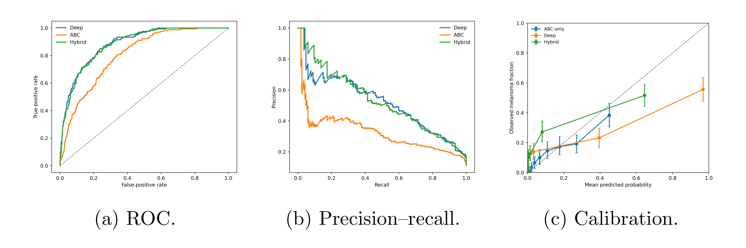
Figure 1: Primary HAM10000 lesion-level test curves for ABC-only, deep, and hybrid models. Calibration curves use equal-frequency bins with uncertainty intervals for the observed melanoma fraction.

3.2. ISIC label audit
The secondary ISIC 2018 Task 3 melanoma-label analysis used the same image corpus as HAM10000. Within this label-audit setting, all models showed higher apparent discrimination on the full 10,015-image set than on the held-out HAM10000 test split (Table 8), consistent with reuse of the same public image corpus.
The corresponding ROC, precision–recall, and calibration curves are provided in the Supplementary Material.
Table 8: Secondary ISIC 2018 Task 3 melanoma-label audit on the overlapping HAM10000/ISIC image corpus. Threshold = 0.5.
Model | AUC | PR-AUC | Brier | F1 | Sens | Spec | ACC
ABC (XGB) | 0.915 | 0.633 | 0.065 | 0.377 | 0.246 | 0.993 | 0.910
Deep (EffB0) | 0.979 | 0.916 | 0.032 | 0.834 | 0.884 | 0.970 | 0.961
Hybrid (ABC+Emb) | 0.982 | 0.935 | 0.022 | 0.872 | 0.820 | 0.992 | 0.973

3.3. BCN20000 validation
After duplicate screening against HAM10000, the frozen models were evaluated on 12,413 BCN20000 images. No retraining or fine-tuning was performed.
As shown in Table 9, external performance decreased relative to the internal HAM10000 test split, indicating dataset shift. The hybrid model achieved the strongest external ranking performance (AUC 0.761, PR-AUC 0.548), followed by the deep EfficientNet-B0 baseline (AUC 0.713, PR-AUC 0.472) and the ABC-only model (AUC 0.692, PR-AUC 0.379). DeLong testing confirmed that the hybrid model outperformed the deep-baseline model on BCN20000 by ROC-AUC (AUC difference 0.0482 in favor of hybrid, 95% CI [0.0405, 0.0558], Holm-adjusted p = 3.93 × 10−34). The hybrid model also outperformed the ABC-only model (AUC difference 0.0692, 95% CI [0.0574, 0.0810], Holm-adjusted p = 8.29 × 10−30). The deep model outperformed the ABC-only model by a smaller but significant margin (AUC difference 0.0210, 95% CI [0.0073, 0.0347], Holm-adjusted p = 0.008).
Raw Brier scores were similar across models (0.186–0.190). Bootstrap calibration tests showed no clear Brier-score difference between the deep and hybrid models on BCN20000 (mean difference 0.00084, 95% CI [-0.00214, 0.00398]), although ECE was lower for the deep model than for the hybrid model (mean difference deep minus hybrid -0.0088, 95% CI [-0.0130, -0.0040]). At threshold 0.5, all models operated conservatively: the ABC-only model had low melanoma sensitivity and high specificity, while the deep model achieved the highest sensitivity at lower specificity. External validation therefore changed ranking performance, calibration behavior, and operating-point behavior.
Table 9: Independent BCN20000 external validation after duplicate screening. Threshold = 0.5.
Model | AUC | PR-AUC | Brier | F1 | Sens | Spec | Acc
ABC (XGB) | 0.692 | 0.379 | 0.186 | 0.027 | 0.014 | 0.998 | 0.772
Deep (EffB0) | 0.713 | 0.472 | 0.190 | 0.337 | 0.232 | 0.957 | 0.790
Hybrid (ABC+Emb) | 0.761 | 0.548 | 0.189 | 0.244 | 0.143 | 0.991 | 0.796

The corresponding threshold-agnostic curves (Figure 2) and decision-curve analysis (Figure 3) show that model utility on BCN20000 was strongly threshold-dependent. In particular, the external calibration curve shows residual miscalibration, and the decision curves should be interpreted as threshold-specific evidence rather than global evidence of clinical usefulness.

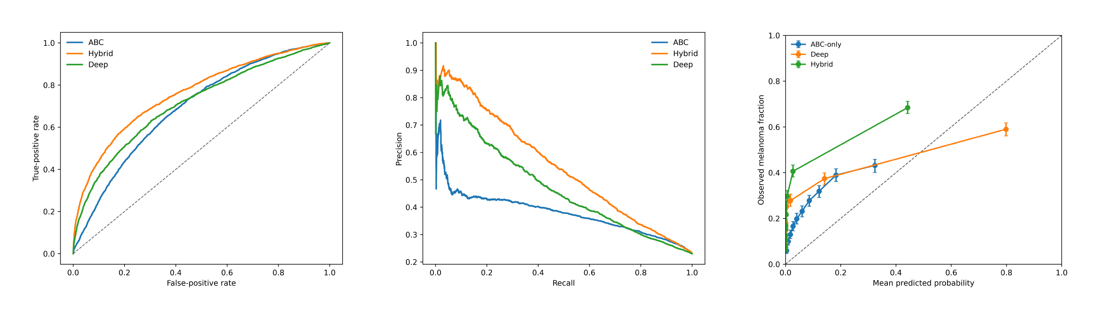
Figure 2: BCN20000 external-validation curves for ABC-only, deep, and hybrid models. Calibration curves use equal-frequency bins with uncertainty intervals.
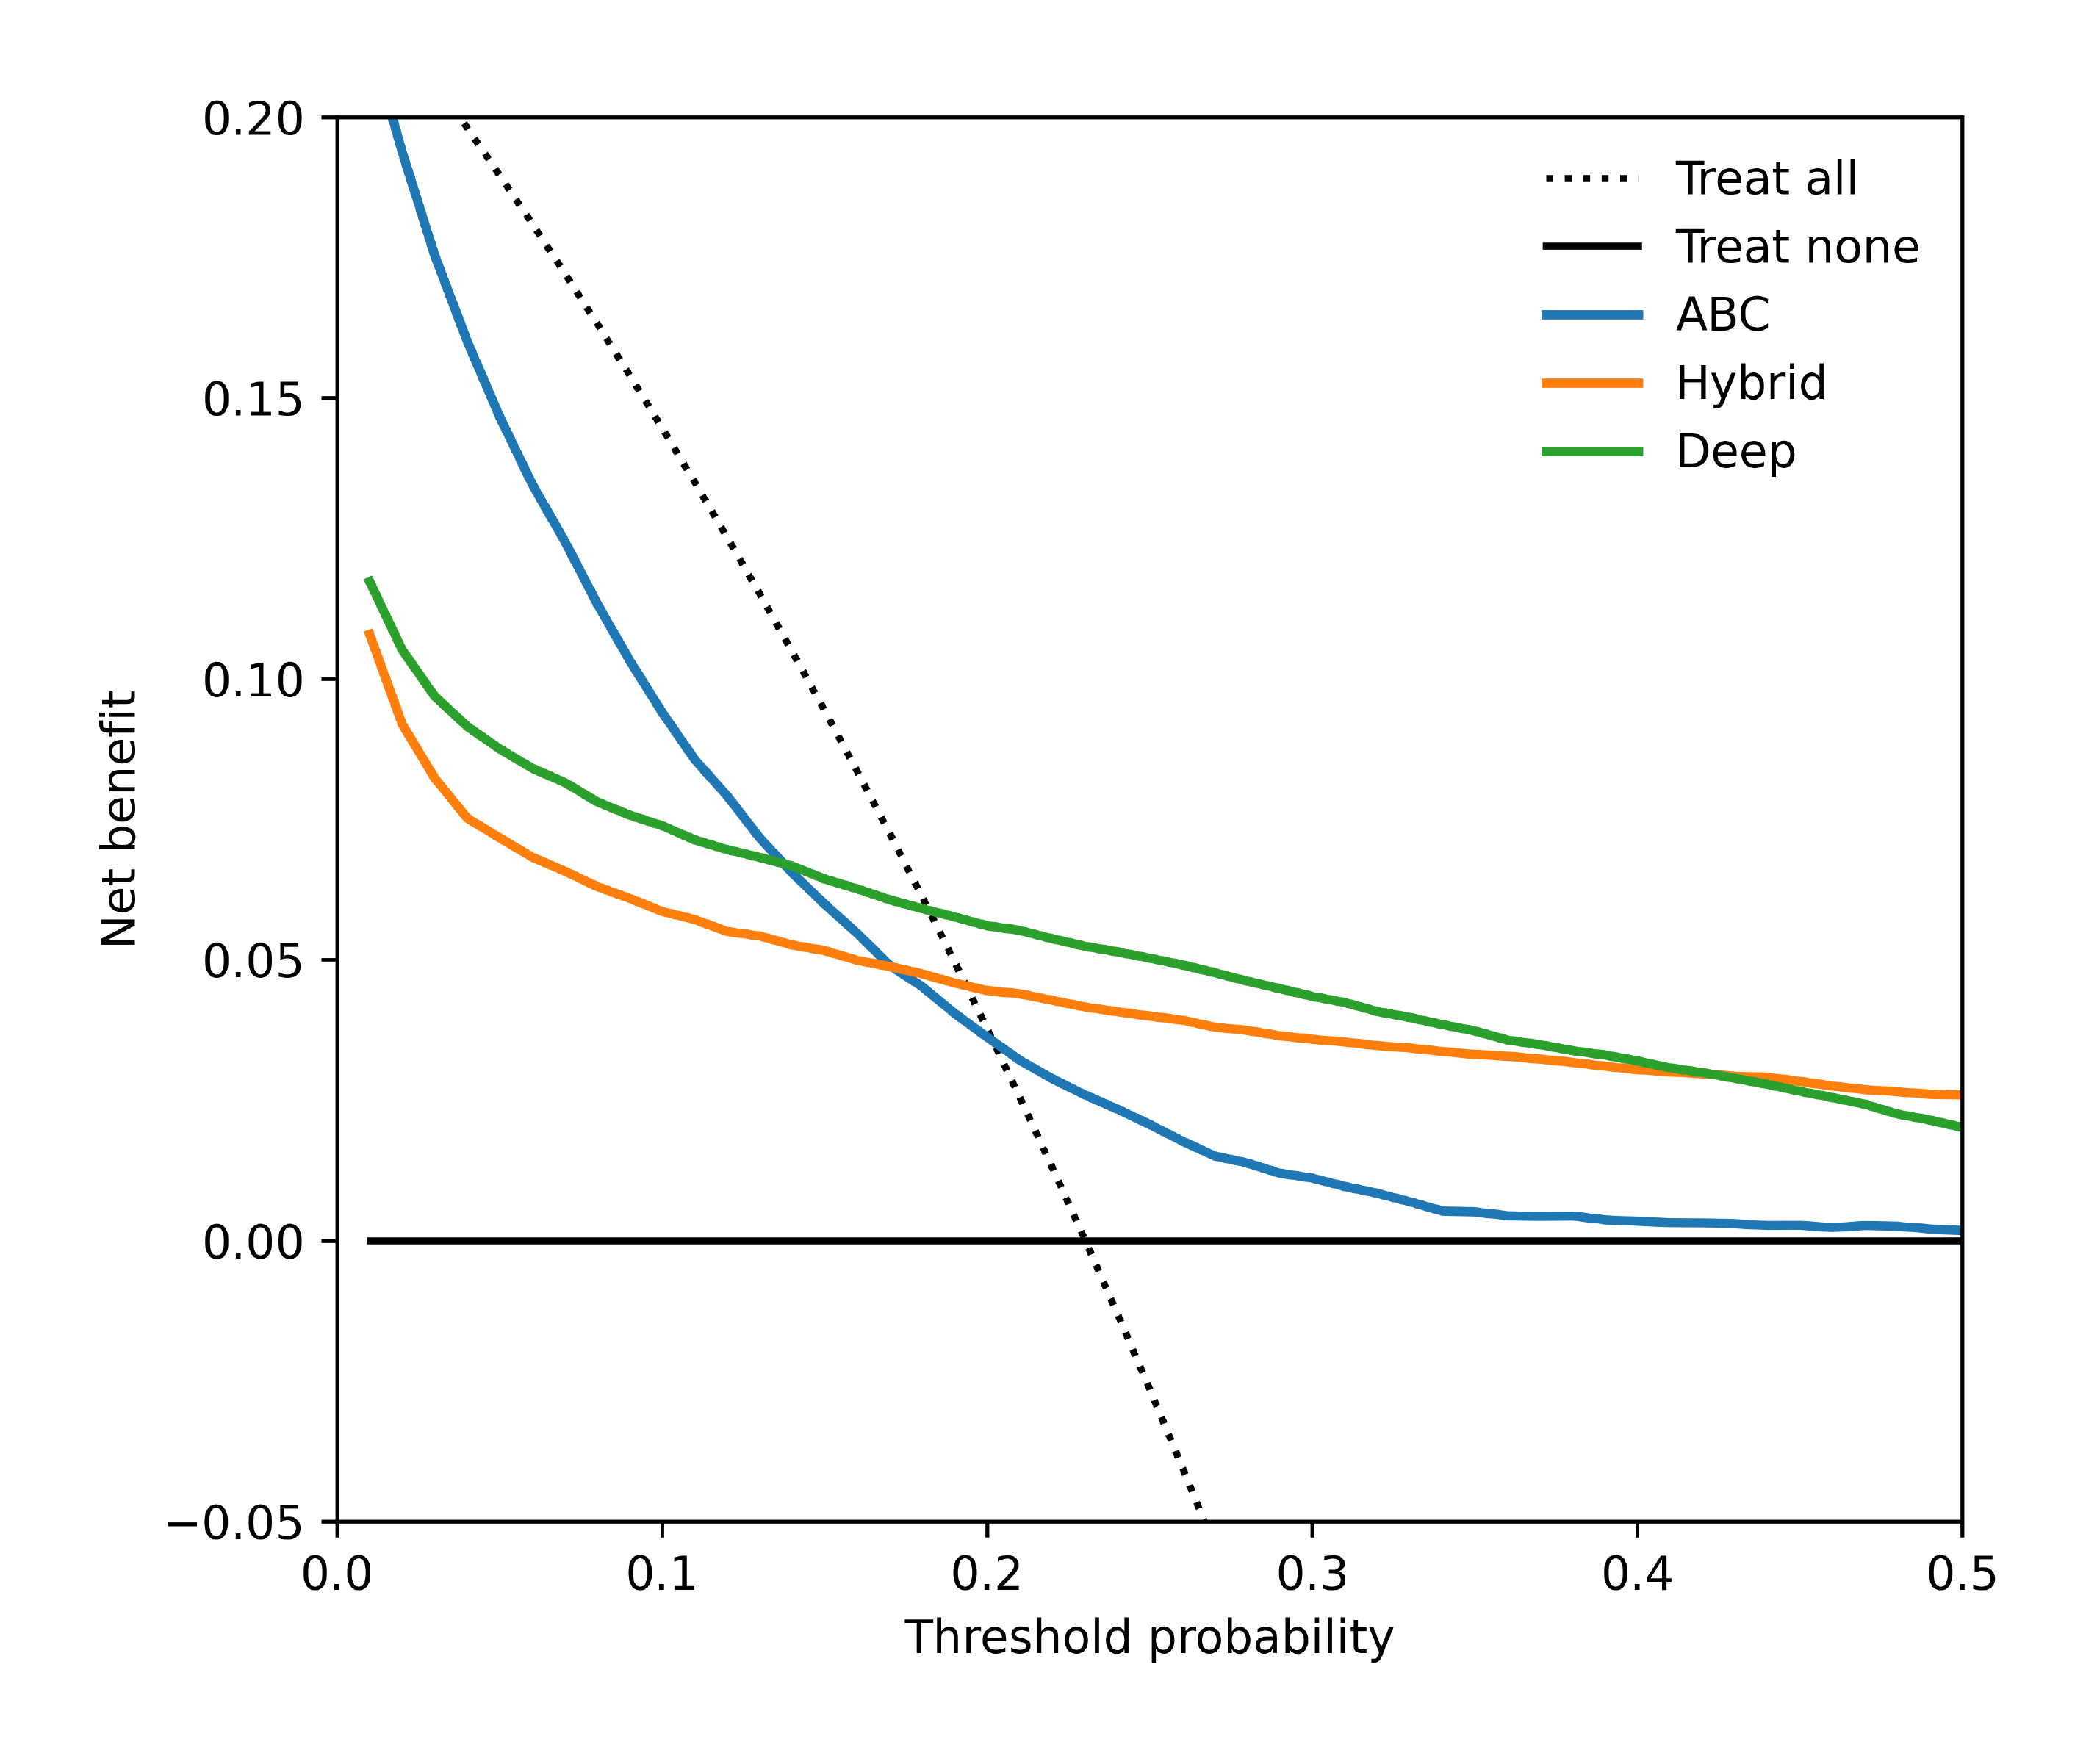
Figure 3: Decision-curve analysis on the independent BCN20000 cohort over threshold probabilities 0.02–0.50.

3.4. Dataset shift
Quantitative domain-shift analysis confirmed substantial covariate shift between HAM10000 test and BCN20000. The largest descriptor shifts were observed for saturation mean (SMD = -1.18), asymmetry (SMD = -1.06), GLCM contrast at distance 1 (SMD = -1.04), and GLCM contrast at distance 2 (SMD = -0.98). Kolmogorov–Smirnov tests were highly significant for these variables, supporting distributional divergence between the internal and external cohorts.
The embedding-space PCA projection showed that BCN20000 occupied a more compact and shifted region of the EfficientNet representation space relative to HAM10000 test images. Predicted-score distributions also differed between cohorts, with BCN20000 probabilities concentrated near low-risk values despite substantially higher melanoma prevalence. These analyses indicate that external performance degradation is not only a metric fluctuation but reflects measurable covariate and representation shift.
Table 10: Largest HAM10000-to-BCN20000 descriptor shifts. SMD denotes standardized mean difference for BCN20000 minus HAM10000 test.
Variable | SMD | Abs. SMD | KS statistic
C color mean saturation | -1.177 | 1.177 | 0.453
A asymmetry | -1.061 | 1.061 | 0.377
C GLCM contrast d1 | -1.037 | 1.037 | 0.443
C GLCM contrast d2 | -0.975 | 0.975 | 0.429
C GLCM homogeneity d1 | 0.482 | 0.482 | 0.194

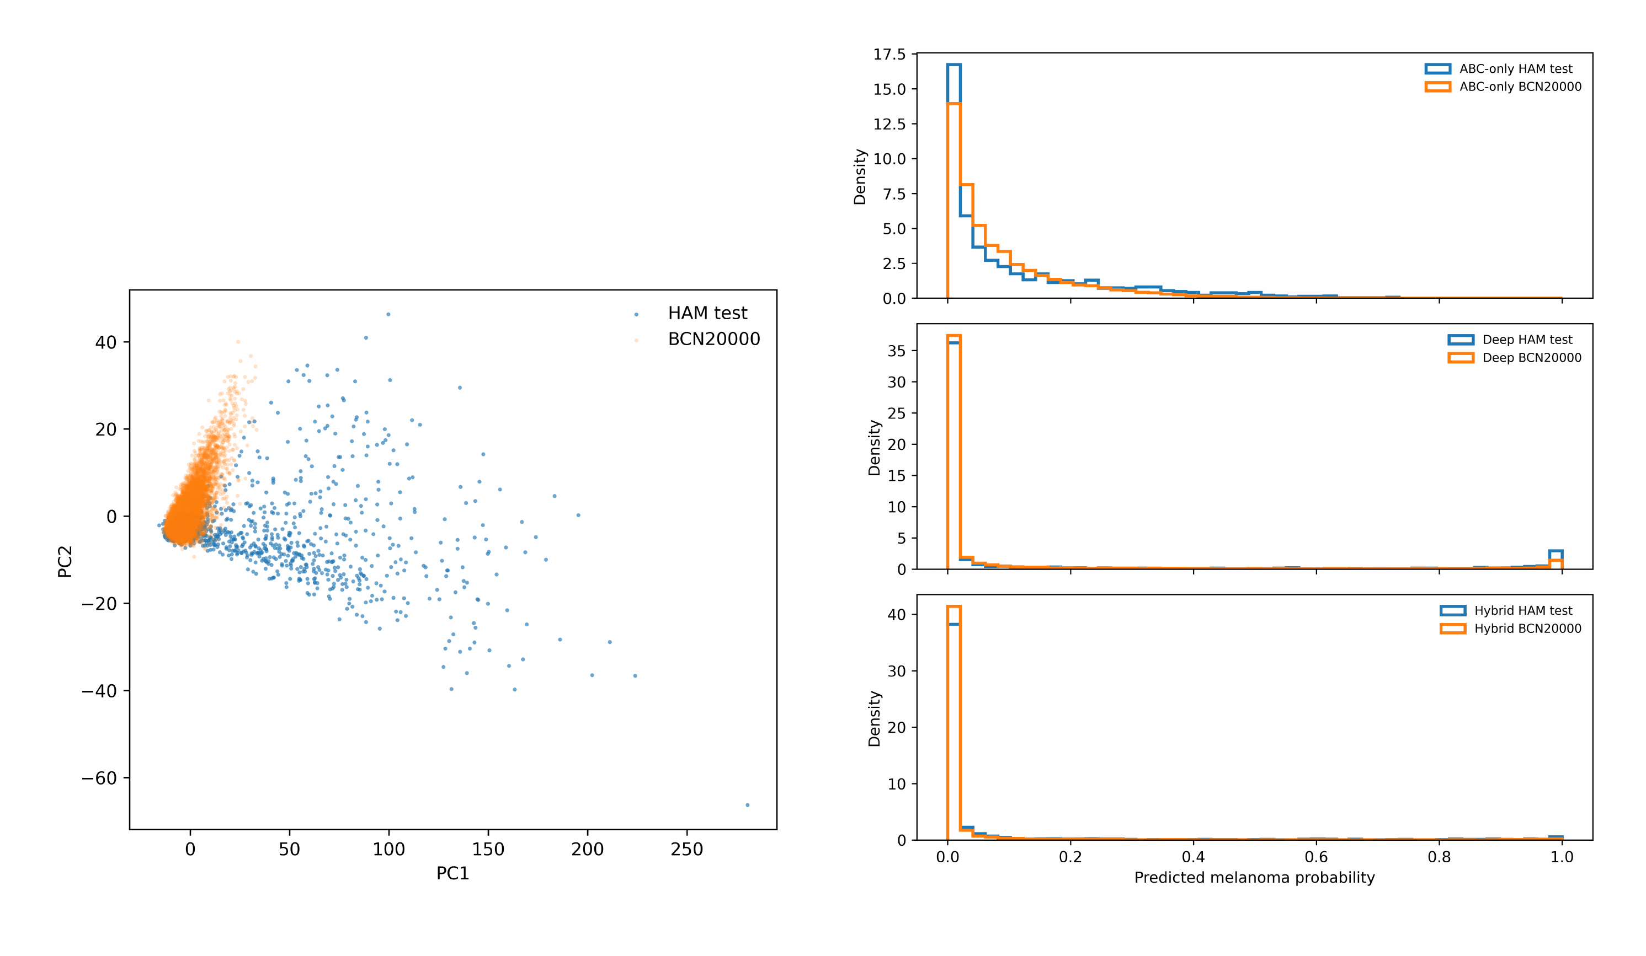
Figure 4: Domain-shift diagnostics comparing HAM10000 test and BCN20000. The PCA projection shows representation-space displacement, and the score distributions show cohort-specific probability concentration.

3.5. Score correction and decision curves
Post-hoc probability correction was evaluated on the HAM10000 test split and on the external BCN20000 cohort. For the deep-baseline model, Platt scaling, isotonic regression, and ABC-conditioned score correction were fitted on the HAM10000 validation split only and then evaluated without refitting.
On HAM10000, all three post-hoc approaches reduced Brier score relative to the raw deep probabilities. Raw deep predictions had Brier score 0.097, whereas Platt scaling, isotonic regression, and ABC-conditioned score correction reached Brier scores of 0.0716, 0.0720, and 0.0715, respectively. DeLong testing showed no significant AUC difference between raw deep scores and ABC-conditioned correction on HAM10000 (AUC difference 0.0025 in favor of raw, 95% CI [-0.0084, 0.0133], Holm-adjusted p = 1.000). ABC-conditioned correction therefore matched the global recalibration baselines by internal Brier score while preserving similar internal discrimination.
On BCN20000, global Platt scaling and isotonic regression achieved the best Brier scores among the evaluated probability scales (0.1746 for both), whereas ABC-conditioned correction improved over raw deep probabilities but remained worse by Brier score (0.1862 vs. 0.1897 raw). However, because the descriptor-conditioned transform is not rank-preserving, it changed case ranking and improved external ROC-AUC relative to raw deep scoring (0.7545 vs. 0.7126). This AUC gain was significant by DeLong testing (AUC difference 0.0419 in favor of ABC-conditioned correction, 95% CI [0.0335, 0.0503], Holm-adjusted p = 1.16 × 10−21). ABC-conditioned correction also outperformed Platt scaling and isotonic regression by ROC-AUC on BCN20000, but it did not outperform them by Brier score.
Ablation analysis showed descriptor-specific effects. On HAM10000, intercept-only correction (β-only) yielded the best Brier score (0.0710), ECE (0.0211), and mean net benefit (0.0466) among the evaluated variants. On BCN20000, C-only descriptors produced the highest ROC-AUC (0.7572), while A-only and B-only correction produced the best Brier and ECE values. Correction using all descriptors achieved AUC 0.7545, PR-AUC 0.5410, Brier score 0.1862, and mean net benefit 0.0453. Thus, descriptor-conditioned correction affected discrimination, calibration, and decision-curve utility differently depending on the descriptor subset.
Table 11: Deep-score correction summary. All correction models were fitted on HAM10000 validation only and evaluated without refitting.
Probability scale | HAM AUC | HAM Brier | HAM ECE | BCN AUC | BCN Brier | BCN ECE
Raw deep | 0.887 | 0.097 | 0.087 | 0.713 | 0.190 | 0.175
Platt | 0.887 | 0.072 | 0.021 | 0.713 | 0.175 | 0.137
Isotonic | 0.885 | 0.072 | 0.021 | 0.710 | 0.175 | 0.138
ABC-conditioned | 0.885 | 0.072 | 0.027 | 0.755 | 0.186 | 0.182

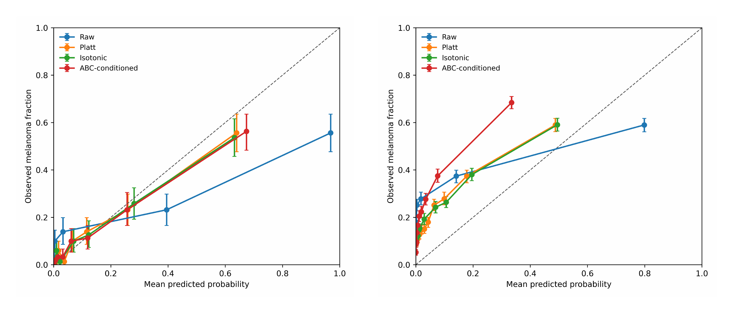
Figure 5: Calibration curves for raw deep probabilities, Platt scaling, isotonic regression, and ABC-conditioned score correction. Curves use equal-frequency bins with uncertainty intervals.
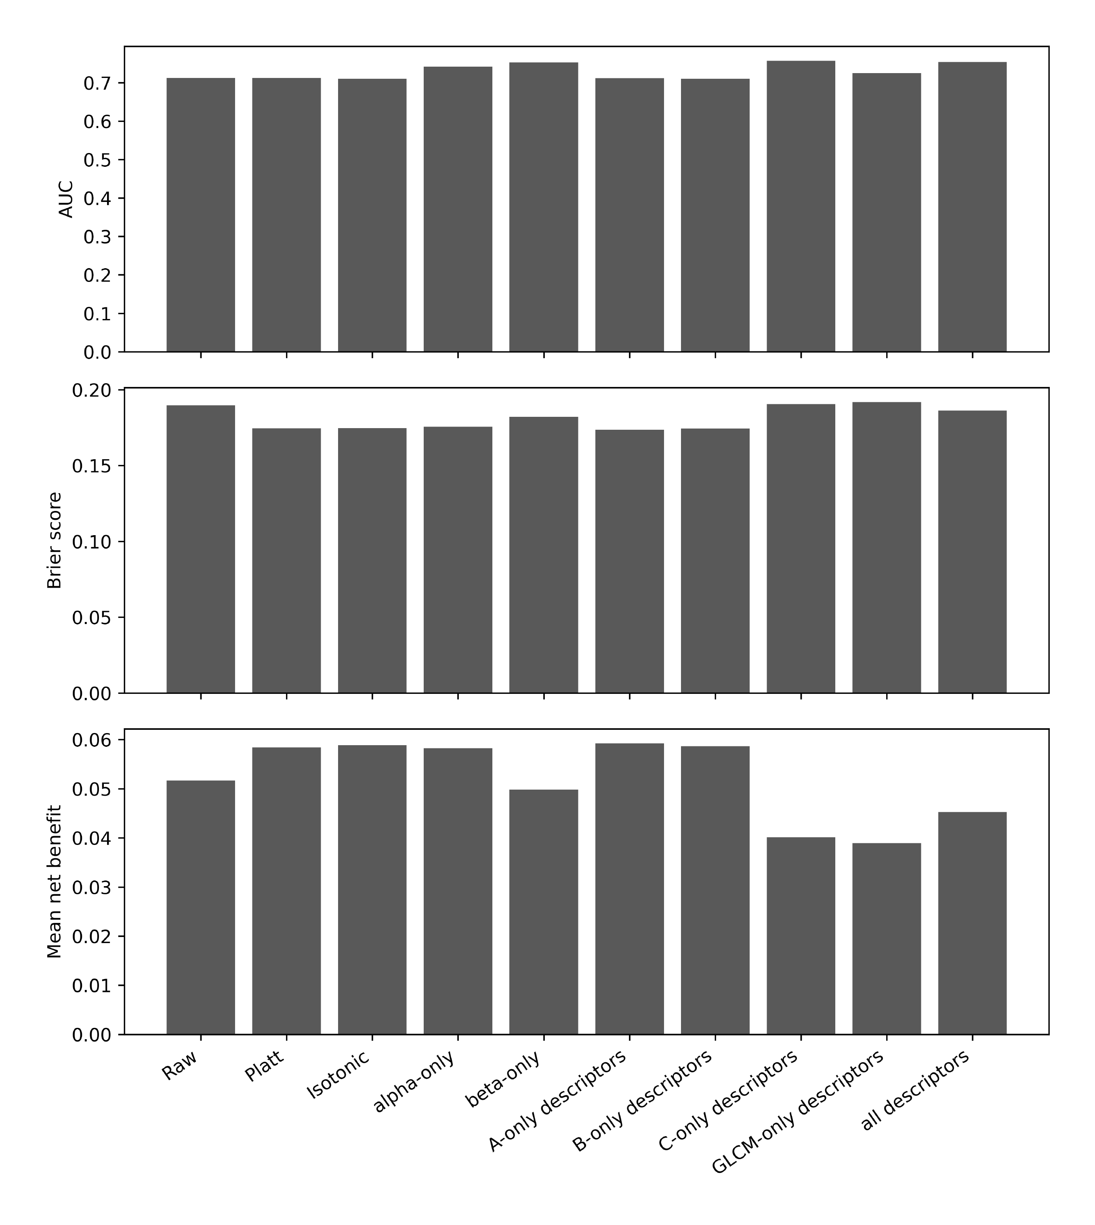
Figure 6: BCN20000 ablation of ABC-conditioned score correction. Bars compare AUC, Brier score, and mean decision-curve net benefit across correction variants. The results show that descriptor subsets affect discrimination, calibration, and decision-curve utility differently.
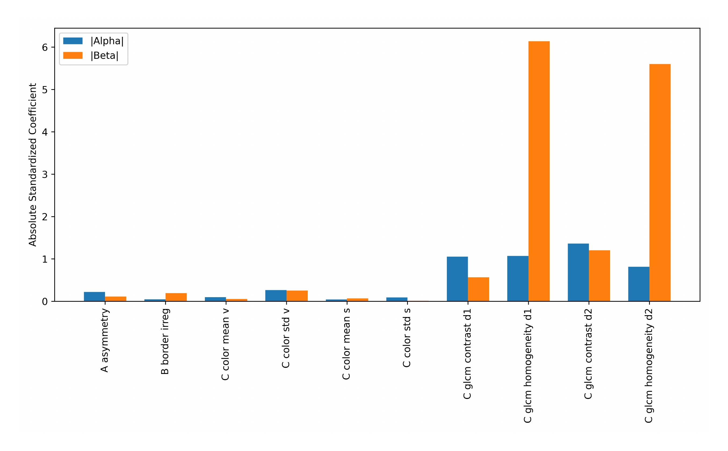
Figure 7: Absolute standardized coefficients for the ABC-conditioned score-correction model. Coefficients are shown separately for descriptor effects on the slope term (α) and intercept term (β). The fitted correction is dominated by texture-related GLCM descriptors, indicating that the score adjustment is primarily texture-conditioned rather than uniformly distributed across all ABC features.
Decision-curve analysis over threshold probabilities 0.02–0.50 showed threshold-dependent differences between probability scales. No single correction method dominated all thresholds and datasets; therefore, the decision-curve results are interpreted as operating-range-specific evidence rather than global evidence of clinical superiority.

3.6. Concept probes and subgroups
Linear probes trained on EfficientNet-B0 embeddings recovered several handcrafted descriptors, suggesting partial implicit encoding of classical concepts (Figure 8). Recoverability was strongest for HSV value statistics, with R² ≈ 0.67 for mean value and R² ≈ 0.60 for value standard deviation; it was substantial for border irregularity and saturation mean, and poor for asymmetry.
These results help explain why explicit descriptor fusion did not materially improve discrimination over embeddings-only XGBoost.
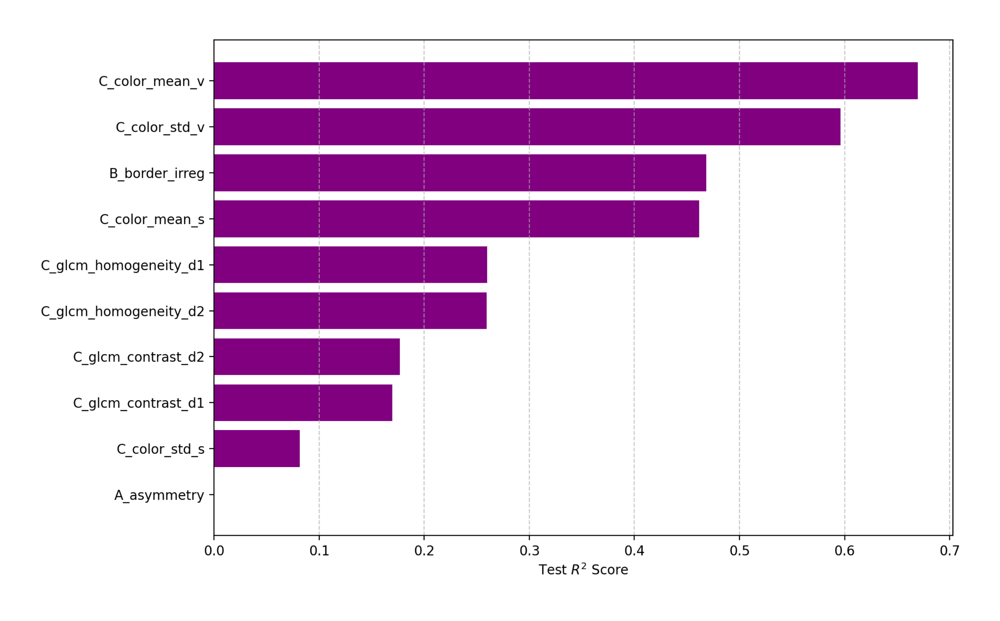
Figure 8: Implicit concept learning. Linear Ridge probes reconstruct handcrafted descriptors from EfficientNet-B0 embeddings; bars show test-set R².
Calibration varied across demographic and anatomical strata. On BCN20000, several strata showed observed melanoma prevalence above mean predicted probability, consistent with subgroup-level underprediction. Bootstrap estimates were stable for large strata but remained uncertain for small anatomical groups such as oral/genital and palms/soles. These analyses are reported in the Supplementary Material and are interpreted as transportability checks, not formal fairness tests.

3.7. Feature and saliency analysis
SHAP-style contributions for tree-based models identified asymmetry, border irregularity, and HSV intensity descriptors as clinically interpretable drivers in descriptor-level analyses (Figure 9). In the hybrid model, block-wise aggregation showed that EfficientNet embeddings dominated total contribution magnitude, while ABC descriptors contributed a small but auditable component. Feature-ranking stability between HAM test and the secondary Task 3-label set was high, but this should be interpreted within the shared-image-corpus limitation.
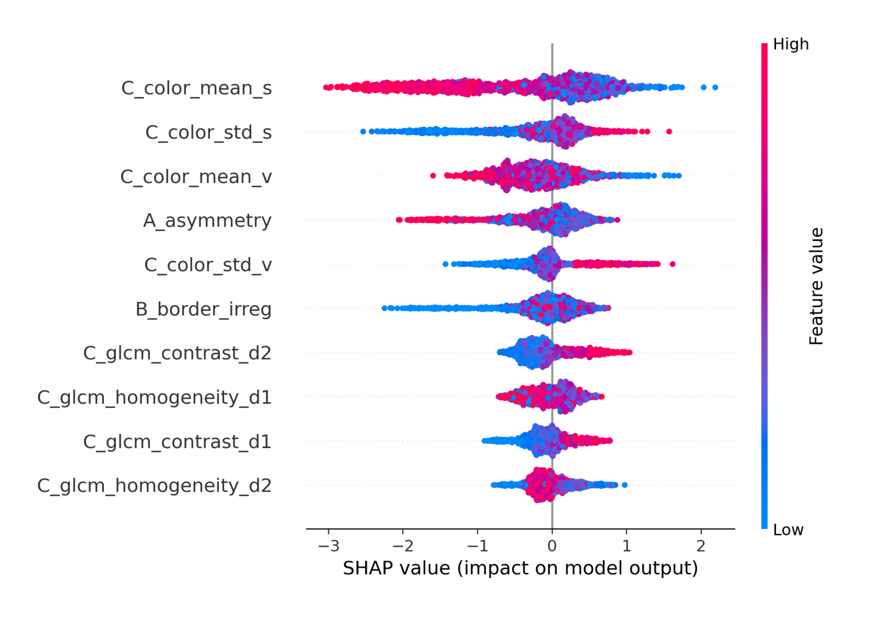
Figure 9: SHAP-style summary plot for the handcrafted ABC model.
Grad-CAM overlays showed heterogeneous saliency behavior across selected examples, including lesion-adjacent activation and low-information maps. Qualitative examples are provided in the Supplementary Material. Quantitative comparison with ISIC 2018 Task 1 lesion masks showed limited lesion localization: the fraction of top 20% saliency pixels inside the lesion mask was low (mean 0.154, median 0.000), and mean saliency was higher outside than inside the lesion mask (0.266 vs. 0.130). These results identify saliency leakage as a relevant failure mode for the deep-baseline model.
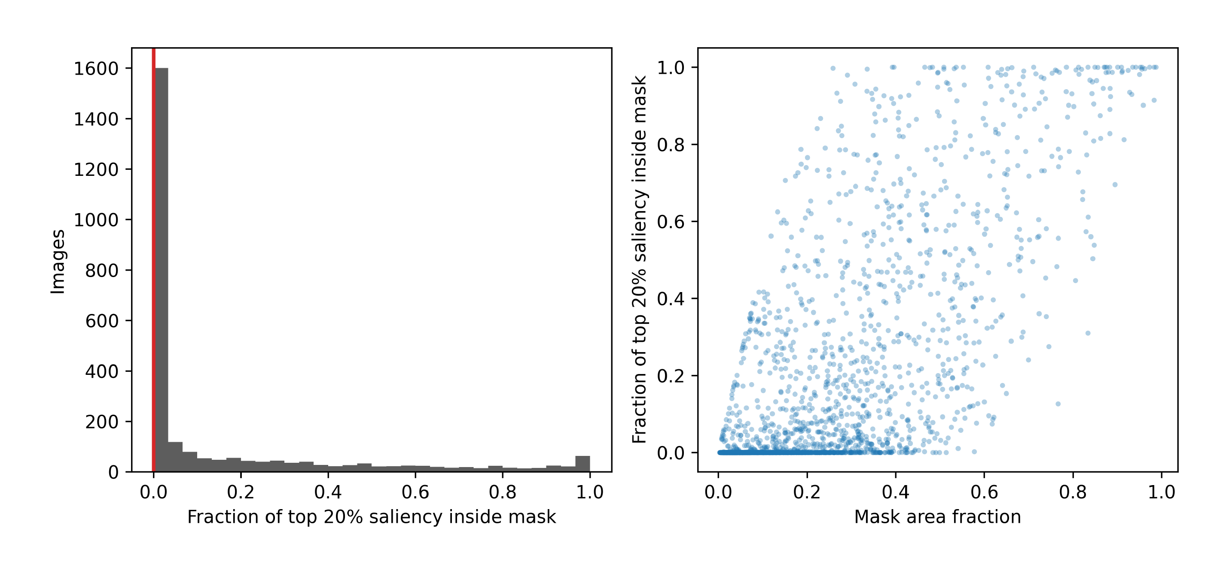
Figure 10: Grad-CAM localization sanity analysis using ISIC 2018 Task 1 lesion masks. The left panel shows the distribution of the fraction of top 20% saliency pixels falling inside the lesion mask. The right panel shows the relationship between lesion-mask area fraction and saliency-mask overlap. The concentration near zero indicates that many Grad-CAM maps do not localize primarily inside the lesion.

4. Discussion
This study presents a reproducible framework for evaluating dermoscopic melanoma classifiers under endpoint harmonization, duplicate screening, lesion-level separation, calibration analysis, decision-curve analysis, external validation, and saliency checking. The melanoma-only endpoint aligned HAM10000, ISIC 2018 Task 3 labels, and BCN20000 into a consistent binary task. The provenance audit showed complete overlap between the local ISIC 2018 Task 3 files and HAM10000, so those files were used as a label-audit corpus. Independent validation was performed on BCN20000 after duplicate screening.
Internal HAM10000 testing showed similar ROC discrimination for the deep and hybrid models, while raw probability reliability favored the hybrid model. DeLong testing found no significant internal AUC difference between these two models. On BCN20000, the hybrid model outperformed the deep and ABC-only models by ROC-AUC, but calibration and threshold-dependent behavior changed under external validation. These results support reporting discrimination, probability reliability, and decision-curve utility as distinct properties rather than reducing performance to a single metric.
The dataset-shift analysis explained part of the external performance drop. BCN20000 differed from HAM10000 in saturation, asymmetry, and GLCM contrast descriptors, and the PCA projection showed displacement in EfficientNet representation space. External degradation therefore reflected measurable covariate and representation shift.
The ABC-conditioned score-correction layer was the main methodological addition. Unlike Platt scaling and isotonic regression, the proposed correction is descriptor-conditioned and can change case ranking. On HAM10000, it achieved Brier scores comparable to global recalibration. On BCN20000, it improved ROC-AUC relative to raw deep scores and global recalibration, while Platt and isotonic regression retained better Brier scores. This pattern shows that descriptor-conditioned correction can improve external ranking while leaving probability reliability as a separate target.
The ablation results further showed that correction effects depended on descriptor group. Intercept-only correction performed well internally, whereas C-only and all-descriptor variants improved external ranking more strongly. The coefficient analysis showed dominant contributions from GLCM homogeneity and contrast, indicating that the correction was primarily texture conditioned.
Grad-CAM analysis identified saliency leakage as a model failure mode. Many heatmaps did not concentrate inside lesion masks, and mean saliency was higher outside than inside the lesion region. This supports quantitative saliency checking rather than reliance on visual heatmap inspection alone.
Overall, the framework provides a reproducible strategy for evaluating dermoscopic melanoma classifiers under internal testing, external validation, dataset shift, calibration, score correction, decision-curve analysis, and saliency audit. The hybrid model was the strongest external ranker among the evaluated model families, and ABC-conditioned score correction improved external ranking of deep scores under BCN20000 shift.

4.1. Implications for applied use
The framework is most useful for benchmarking, model auditing, retrospective validation, and threshold-selection studies. Applied use should begin with a prespecified triage role, acceptable false-negative burden, acceptable referral burden, and threshold probability range. The default threshold of 0.5 should be replaced by thresholds selected on local validation data using sensitivity, specificity, calibration, and decision-curve criteria.
The hybrid model was the strongest external ranker in this study, but local calibration and subgroup behavior should be checked before interpreting scores in a new acquisition setting. ABC-conditioned score correction provides an interpretable post-hoc adjustment layer that may improve external ranking under dataset shift; probability reliability still requires local validation or recalibration.

5. Limitations
HAM10000 lacks consistent patient-level identifiers, so splitting was enforced at the lesion level. This prevents lesion leakage but cannot fully exclude patient-level dependence. BCN20000 provides independent retrospective validation; prospective reader-in-the-loop validation remains necessary for workflow-level assessment. The descriptor pipeline also depends on segmentation quality. Although segmentation was benchmarked on ISIC 2018 Task 1, downstream sensitivity to alternative masks could not be tested because Otsu-derived HAM10000 and BCN20000 descriptor files were not retained.
Subgroup calibration analyses were descriptive, and some strata were small. ABC-conditioned score correction improved external ranking on BCN20000 but did not improve external Brier score relative to Platt or isotonic recalibration. Additional non-overlapping cohorts are needed to assess whether the transportability pattern observed here generalizes.

6. Conclusion
We present a reproducible framework for melanoma-only dermoscopic classification that harmonizes endpoint definition, documents dataset provenance, enforces lesion-level separation, and evaluates discrimination, calibration, decision-curve utility, dataset shift, and saliency behavior as distinct model properties. Internal HAM10000 testing showed similar discrimination between deep and hybrid models, while raw probability reliability favored the hybrid model. The local ISIC 2018 Task 3 files overlapped completely with HAM10000 and were used as a secondary label-audit corpus.
Independent BCN20000 validation demonstrated external dataset shift and reduced transportability. Under this shift, the hybrid model was the strongest external ranker among the evaluated model families. Dataset-shift analysis confirmed descriptor-level and representation-level differences between HAM10000 and BCN20000.
The ABC-conditioned score-correction layer provides a lightweight mechanism for modifying deep logits using segmentation-derived descriptors. It matched global recalibration internally and improved external ranking relative to raw deep scores on BCN20000, while Platt and isotonic regression retained better external Brier scores. The main contribution is a reproducible audit methodology for determining when dermoscopic melanoma classifiers discriminate, calibrate, generalize, and localize reliably under controlled internal and external evaluation.

Code and Data Availability
The complete source code and derived result files are permanently archived in a public repository and will be provided after acceptance. The repository contains the full reproducible pipeline for segmentation benchmarking, deep embedding extraction, hybrid modeling, external validation (ISIC Task 3, BCN20000), decision-curve analysis, and calibration auditing.
All experiments are fully reproducible using the provided configuration files and fixed random seeds. The archive includes the pre-extracted features and derived model artifacts necessary to independently replicate all tables and figures.
HAM10000 and ISIC 2018 datasets are publicly available from the International Skin Imaging Collaboration, and BCN20000 from its original repository. These datasets must be obtained directly from their official sources in accordance with their respective data use agreements.

Reproducibility
All experiments used fixed configuration files and random seed 42. Model architectures, hyperparameters, preprocessing settings, and split definitions are specified in the repository.

Declaration of Competing Interest
The authors declare no competing interests.

Ethics Approval
This study used publicly available, de-identified datasets (HAM10000, ISIC 2018, and BCN20000); ethical approval and informed consent were not required for this secondary analysis.

Declaration of Generative AI and AI-assisted Technologies in the Writing Process
During manuscript preparation, the authors used ChatGPT to assist with language editing, structural revision, and identification of reporting gaps. The authors reviewed and edited all content and take full responsibility for the final manuscript.

References
[1] A. S. Sambyal, U. Niyaz, N. C. Krishnan, D. R. Bathula, Understanding calibration of deep neural networks for medical image classification, Computer Methods and Programs in Biomedicine 242 (2023) 107816. doi:10.1016/j.cmpb.2023.107816.
[2] J. Carse, A. Alvarez Olmo, S. McKenna, Calibration of deep medical image classifiers: An empirical comparison using dermatology and histopathology datasets, in: C. H. Sudre, C. F. Baumgartner, A. Dalca, C. Qin, R. Tanno, K. Van Leemput, W. M. Wells III (Eds.), Uncertainty for Safe Utilization of Machine Learning in Medical Imaging, Springer Nature Switzerland, Cham, 2022, pp. 89–99. doi:10.1007/978-3-031-16749-2_9.
[3] A. Gerdes, The role of explainability in AI-supported medical decision-making, Discover Artificial Intelligence 4 (2024) 29. doi:10.1007/s44163-024-00119-2.
[4] M. Frasca, D. La Torre, G. Pravettoni, I. Cutica, Explainable and interpretable artificial intelligence in medicine: a systematic bibliometric review, Discover Artificial Intelligence 4 (2024) 15. doi:10.1007/s44163-024-00114-7.
[5] A. J. Vickers, E. B. Elkin, Decision curve analysis: a novel method for evaluating prediction models, Medical Decision Making 26 (6) (2006) 565–574. doi:10.1177/0272989X06295361.
[6] B. Van Calster, G. S. Collins, A. J. Vickers, L. Wynants, K. F. Kerr, L. Barreñada, G. Varoquaux, K. Singh, K. G. M. Moons, T. Hernandez-Boussard, D. Timmerman, D. J. McLernon, M. van Smeden, E. W. Steyerberg, Evaluation of performance measures in predictive artificial intelligence models to support medical decisions: overview and guidance, The Lancet Digital Health 7 (12) (2025) 100916. doi:10.1016/j.landig.2025.100916.
[7] P. Tschandl, C. Rosendahl, H. Kittler, The HAM10000 dataset, a large collection of multi-source dermatoscopic images of common pigmented skin lesions, Scientific Data 5 (2018) 180161. doi:10.1038/sdata.2018.161.
[8] N. C. F. Codella, D. Gutman, M. E. Celebi, B. Helba, M. A. Marchetti, S. W. Dusza, A. Kalloo, K. Liopyris, N. Mishra, H. Kittler, A. Halpern, Skin lesion analysis toward melanoma detection: A challenge at the 2017 International Symposium on Biomedical Imaging (ISBI), hosted by the International Skin Imaging Collaboration (ISIC), in: 2018 IEEE 15th International Symposium on Biomedical Imaging (ISBI 2018), IEEE, 2018, pp. 168–172. doi:10.1109/ISBI.2018.8363547.
[9] C. Hernández-Pérez, M. Combalia, S. Podlipnik, N. C. F. Codella, V. Rotemberg, A. C. Halpern, O. Reiter, C. Carrera, A. Barreiro, B. Helba, S. Puig, V. Vilaplana, J. Malvehy, BCN20000: Dermoscopic lesions in the wild, Scientific Data 11 (1) (2024) 641. doi:10.1038/s41597-024-03387-w.
[10] N. Otsu, A threshold selection method from gray-level histograms, IEEE Transactions on Systems, Man, and Cybernetics 9 (1) (1979) 62–66. doi:10.1109/TSMC.1979.4310076.
[11] S. Osher, J. A. Sethian, Fronts propagating with curvature-dependent speed: Algorithms based on Hamilton-Jacobi formulations, Journal of Computational Physics 79 (1) (1988) 12–49. doi:10.1016/0021-9991(88)90002-2.
[12] C. Li, C. Xu, C. Gui, M. D. Fox, Distance regularized level set evolution and its application to image segmentation, IEEE Transactions on Image Processing 19 (12) (2010) 3243–3254. doi:10.1109/TIP.2010.2069690.
[13] R. M. Haralick, K. Shanmugam, I. Dinstein, Textural features for image classification, IEEE Transactions on Systems, Man, and Cybernetics SMC-3 (6) (1973) 610–621. doi:10.1109/TSMC.1973.4309314.
[14] F. Nachbar, W. Stolz, T. Merkle, A. B. Cognetta, T. Vogt, M. Landthaler, P. Bilek, The ABCD rule of dermatoscopy: High prospective value in the diagnosis of doubtful melanocytic skin lesions, Journal of the American Academy of Dermatology 30 (4) (1994) 551–559. doi:10.1016/S0190-9622(94)70061-3.
[15] M. Tan, Q. V. Le, EfficientNet: Rethinking model scaling for convolutional neural networks, in: Proceedings of the 36th International Conference on Machine Learning, Vol. 97 of Proceedings of Machine Learning Research, PMLR, 2019, pp. 6105–6114.
[16] T. Chen, C. Guestrin, XGBoost: A scalable tree boosting system, in: Proceedings of the 22nd ACM SIGKDD International Conference on Knowledge Discovery and Data Mining, ACM, 2016, pp. 785–794. doi:10.1145/2939672.2939785.
[17] J. C. Platt, Probabilistic outputs for support vector machines and comparisons to regularized likelihood methods, in: A. J. Smola, P. Bartlett, B. Schölkopf, D. Schuurmans (Eds.), Advances in Large Margin Classifiers, MIT Press, Cambridge, MA, 1999, pp. 61–74.
[18] A. Niculescu-Mizil, R. Caruana, Predicting good probabilities with supervised learning, in: Proceedings of the 22nd International Conference on Machine Learning, ACM, 2005, pp. 625–632. doi:10.1145/1102351.1102430.
[19] S. M. Lundberg, S.-I. Lee, A unified approach to interpreting model predictions, in: Advances in Neural Information Processing Systems 30, 2017, pp. 4765–4774.
[20] R. R. Selvaraju, M. Cogswell, A. Das, R. Vedantam, D. Parikh, D. Batra, Grad-CAM: Visual explanations from deep networks via gradient-based localization, in: 2017 IEEE International Conference on Computer Vision (ICCV), IEEE, 2017, pp. 618–626. doi:10.1109/ICCV.2017.74.
[21] E. R. DeLong, D. M. DeLong, D. L. Clarke-Pearson, Comparing the areas under two or more correlated receiver operating characteristic curves: A nonparametric approach, Biometrics 44 (3) (1988) 837–845. doi:10.2307/2531595.

