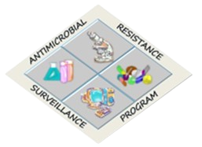

RITM-WEB Database
CRUD and Batch Work Instruction
Step-by-step user guide for creating, viewing, updating, deleting, copying, and reviewing database records

Document field | Value
System | RITM-WEB / ARSRL Referred Isolate Database
Focus | CRUD operations, batch creation/editing/deletion, record correction, settings CRUD, and safe verification steps
Audience | Encoders, checkers, verifiers, administrators, and laboratory users
Prepared date | June 19, 2026

Purpose
This instruction explains how users should perform CRUD operations in the database. CRUD means Create, Read, Update, and Delete. In this system, CRUD applies to batches, raw records, final records, antibiotic results, settings/master tables, WGS uploads, staff/accounts, and TAT configuration.

1. CRUD concept in this database
CRUD operations are the standard user actions for managing records. The same basic pattern appears throughout the system, although available buttons depend on the user role and the screen.
CRUD action | Meaning in the system | Typical buttons or pages
Create | Add a new batch, record, setting, staff account, TAT rule, or upload a new dataset. | Add Batch, Save Batch, Upload, Add, Register
Read | View, search, filter, expand, download, print, or inspect records without changing them. | View Raw Data, View Final Data, Search, Show Previous, Download, PDF
Update | Correct or revise an existing batch, record, final record, setting, staff profile, or configuration. | Edit, Update Batch, Save, inline update
Delete | Remove an individual record, batch, setting row, upload record, or all records in a controlled section. | Delete, Delete Batch, Delete All, delete by date/range

Important deletion rule
Delete actions should be treated as permanent user actions. Always verify accession number, batch name, year, and data type before confirming deletion.

2. Role rules for CRUD
Role | Create | Read | Update | Delete | Special notes
Admin | Yes | Yes | Yes | Yes | Can manage staff/accounts and most protected settings.
Verifier | Yes | Yes | Yes | Yes | Can manage settings and review/finalize records.
Encoder | Yes | Yes | Yes | Yes | Can usually manage operational data; batch management may be limited to batches created by the encoder.
Checker | No | Yes | No | No | View-only role for review and checking.

3. Creating a batch
A batch groups referred isolate records by site, referral date, batch number, total batch, and reference number. It also carries staff/signatory information used in reports.
- Open Add Batch from the left sidebar. 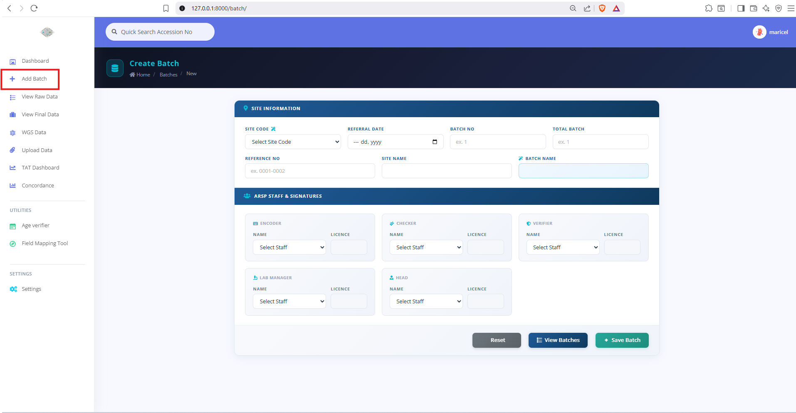
- Select or enter the Site Code. Confirm the generated Site Name if shown.
- Enter the Referral Date.
- Enter Batch No and Total Batch.
- Enter the Reference No.
- Review the generated Batch Name. The system builds the name from site, date, batch number, total batch, and reference number.
- Select staff/signatory fields as required. License fields may auto-fill from ARSP Staff records.
- Click Save Batch.
- Use View Batches or View Raw Data to confirm that the new batch exists.
Batch field | User instruction | Check before saving
Site Code | Choose the correct submitting/sentinel site. | Wrong site creates wrong batch name and report header.
Referral Date | Use the referral date on the official transmittal or source file. | Confirm month/day/year carefully.
Batch No | Enter the current batch number. | Must match source documents.
Total Batch | Enter total batch count for the referral. | Used in generated batch name.
Reference No | Enter the accession/reference range or code. | Must match uploaded accessions.
Batch Name | Review auto-generated value. | Do not manually alter unless intentionally correcting.
Staff/signatory fields | Select correct names. | Licenses should match the selected staff.

4. Reading/searching batch and record data
- Open View Raw Data or View Final Data.
- Use the search box to locate accession number, patient name, or specimen type.
- Use the year filter when reviewing historical data.
- Expand batch rows to see the records inside the batch.
- Review columns for identification, patient information, specimen, date, and antibiotic results.
- Use Download Raw or Download Final when an export is needed.
- Read-only users will see View only instead of edit/delete buttons.
- Use Show Previous in Raw Data when older records need to be shown.
- Use Batch Overview to inspect batch grouping and batch-level information.

5. Updating/editing a batch
- Open View Raw Data or View Final Data.
- Find the batch row.
- Click the batch edit/pencil action for the batch author/signatory area, or open the batch edit page directly if available.
- Correct site, referral date, batch number, total batch, reference number, or staff fields.
- Click Update Batch.
- Return to View Raw Data/View Final Data and confirm the batch name, staff names, and related report output.
Batch update caution
Changing batch identity fields can affect generated batch names, grouping, report headers, and downloads. Check one representative PDF after major batch edits.

6. Deleting a batch
- Open View Raw Data.
- Find the batch row and confirm the batch name and accession range.
- Click the Delete Batch action if your role permits it.
- Read the confirmation modal.
- Click Delete only after confirming that the whole batch should be removed.
- Search again for the batch name or accessions to confirm removal.
Do not delete batches for ordinary corrections
If only one patient field, specimen field, antibiotic value, or staff name is wrong, edit the record or batch instead of deleting the whole batch.

7. Raw record CRUD

7.1 Create raw records
Raw records are usually created by uploading mapped demographic files. They may also be created through operational forms where available.
- Prepare and map the source demographic workbook using Field Mapping Tool if needed.
- Open Upload Data.
- Upload Demographic Data.
- Open View Raw Data and search for several accessions from the upload.
- Confirm patient, site, specimen, organism, dates, and batch assignment.

7.2 Read raw records
- Use View Raw Data to inspect uploaded source data.
- Expand batch rows to read individual records.
- Use Antibiotic Results to inspect raw AST entries.
- Use Download Raw for spreadsheet export.

7.3 Update raw records
- Open View Raw Data.
- Search the accession.
- Click Edit record.
- Correct the needed field only.
- Save the record.
- Return to the list and confirm the correction.

7.4 Delete raw records
- Open View Raw Data.
- Search the accession or expand the correct batch.
- Click Delete record.
- Confirm deletion in the modal.
- Search the accession again to ensure the correct record was deleted.

8. Raw antibiotic result CRUD
Raw antibiotic entries contain sentinel site AST values and interpretations. They are usually created by upload, not manual entry.
Action | How to perform it | Verification
Create | Upload Sentinel Site Test Results from Upload Data. | Open View Raw Data and confirm antibiotic results appear in the antibiotic results column.
Read | Use Antibiotic Results or the antibiotic results column in View Raw Data. | Check MIC/disk values and S/I/R display.
Update | Edit the record or re-upload corrected mapped AST file according to site workflow. | Confirm interpretation recalculates where breakpoints exist.
Delete | Use row delete, delete by date, or delete all raw antibiotic actions only when intentionally clearing raw AST data. | Confirm affected accessions no longer show those raw AST values.

9. Copying raw data to final
Copy-to-final moves reviewed raw data into the final data workspace. This is not just a visual action; it creates or updates final records for final review, reporting, concordance, emerging checks, and downloads.
- Open View Raw Data.
- Review the raw batch or accession first.
- Use Copy to Final for a record or Copy Batch to Final for the full batch, depending on the available button and workflow.
- Open View Final Data.
- Search the accession or batch.
- Confirm the copied demographic details and antibiotic results.
- Use Undo Copy only if the wrong record or batch was copied and final review has not proceeded.
Best practice
Copy after demographic and raw AST review. Avoid repeatedly copying while users are editing final records, because it may overwrite or refresh data depending on the copy operation.

10. Final record CRUD

10.1 Create final records
- Final records are created by copy-to-final or by uploading mapped final demographic/final antibiotic files.
- Final antibiotic retest results are created by uploading ARSRL Test Results.

10.2 Read final records
- Open View Final Data.
- Search by accession, patient, specimen, batch, or year.
- Review demographic, specimen, organism, antibiotic, emerging, WGS, and concordance columns.
- Use Download Final when an export is needed.

10.3 Update final records
- Open View Final Data.
- Search for the accession.
- Click Edit record.
- Use the Sentinel Site Data tab for source/site fields.
- Use the ARSRL STY Results tab for final organism/retest fields.
- Use the WGS Classification tab when WGS classification must be reviewed.
- Save changes and re-check automatic emerging checkbox, antibiotic interpretation, and PDF output.

10.4 Delete final records
- Open View Final Data.
- Search for the accession.
- Click Delete record.
- Confirm the deletion modal only after verifying the accession and patient.
- Search again to confirm removal.

11. Final antibiotic/retest CRUD
Action | How to perform it | Important notes
Create | Upload ARSRL Test Results from Upload Data. | Retest columns such as *_RT should be treated as retest values.
Read | Check View Final Data antibiotic results and Final AST/antibiotic entry views. | Interpretation depends on breakpoint match.
Update | Correct final record/retest entries by edit form or corrected upload according to workflow. | After update, confirm S/I/R, emerging, concordance, and PDF output.
Delete | Delete individual final antibiotic entries, delete by date, or delete all only when intentionally clearing final AST data. | Avoid deleting final AST for accessions already used in reports unless correction is documented.

12. Settings/master table CRUD
Settings CRUD controls dropdowns, report logic, interpretation logic, and dashboard behavior. These actions are usually Admin/Verifier functions.
Settings area | Create | Read | Update | Delete
Organisms | Add or upload organism rows. | View/export organism list. | Edit organism code/name/group. | Delete selected row or delete all when replacing full list.
Antibiotics | Add or upload antibiotic rows. | View/export antibiotic list. | Edit code, name, method/panel details. | Delete selected row or all when replacing.
Breakpoints | Add or upload breakpoint workbook. | View/export breakpoints. | Edit guideline/year/method/organism/specimen/antibiotic/flags. | Delete selected row or all before clean replacement.
Site Code | Add or upload site codes. | View/export site codes. | Edit site name/address/head details. | Delete selected site row.
Specimen Types | Add or upload specimen codes. | View/export specimen types. | Edit code/group/name. | Delete selected row or all.
ARSP Staff | Add or upload staff. | View/export staff. | Edit name/license/role/account link. | Delete selected staff.
Accounts | Register/manage user accounts. | View registered accounts. | Adjust linked role/profile. | Disable/delete according to admin policy.
Phenotypes/Recommendations | Add or upload rows. | View/export lists. | Edit wording/codes. | Delete outdated rows.
TAT Configuration | Add or upload process steps. | View/export TAT config. | Edit owner/duration/step details. | Delete all only before controlled replacement.
Non-working Days | Add excluded dates. | View non-working list. | Correct date by deleting and adding correct value if edit unavailable. | Delete date when no longer excluded.

Settings replacement pattern
When replacing a full master table, export the current table first, then delete/replace only when the new file is verified. This is especially important for Breakpoints, Antibiotics, Organisms, and Specimen Types.

13. WGS data CRUD
WGS data is mostly upload-based CRUD. Each WGS output type has upload, show/view, delete individual row, delete all, and sometimes delete by date actions.
WGS dataset | Create | Read | Update | Delete
Sample Information | Upload Sample Information. | Show Sample Information or WGS Overview. | Re-upload corrected file if needed. | Delete selected row/all/by date.
BactScout | Upload BactScout. | Show BactScout or WGS Overview. | Re-upload corrected file if needed. | Delete selected row/all/by date.
GtdbTK | Upload GtdbTK. | Show GtdbTK or WGS Overview. | Re-upload corrected file if needed. | Delete selected row/all/by date.
Gambit | Upload Gambit. | Show Gambit or WGS Overview. | Re-upload corrected file if needed. | Delete selected row/all/by date.
MLST | Upload MLST. | Show MLST or WGS Overview. | Re-upload corrected file if needed. | Delete selected row/all/by date.
CheckM2 | Upload CheckM2. | Show CheckM2 or WGS Overview. | Re-upload corrected file if needed. | Delete selected row/all/by date.
Assembly Scan | Upload Assembly Scan. | Show Assembly Scan or WGS Overview. | Re-upload corrected file if needed. | Delete selected row/all/by date.
AMRFinderPlus | Upload AMRFinderPlus. | Show AMRFinderPlus or WGS Overview. | Re-upload corrected file if needed. | Delete selected row/all/by date.

14. TAT CRUD
Action | Procedure | Verification
Create TAT config | Settings > TAT Configuration > Add or Upload. | Open TAT config list and confirm step/order/owner/duration.
Read TAT records | Open TAT Dashboard, Running List, Review, or Analysis. | Confirm batch/accession and process step status.
Update TAT config | Edit the TAT configuration row. | Re-check dashboard calculations after editing.
Delete TAT config | Use delete-all only during controlled replacement. | Confirm replacement file was uploaded correctly.
Create non-working day | Settings > TAT Non-working Days > Add. | Confirm date appears in list.
Delete non-working day | Delete the date row. | Confirm TAT recalculation where applicable.

15. Report and output actions
Printing and downloads are read/output operations, but users should still verify that data is complete before generating official outputs.
Output action | Where | Before generating
Raw PDF | View Raw Data result/PDF action. | Confirm raw demographics and raw AST are visible.
Final PDF | View Final Data final result/PDF action. | Confirm final/retest AST, interpretation, organism, and recommendations.
Batch PDF | Raw or Final batch-level PDF action. | Confirm batch grouping and panel display.
Download Raw | View Raw Data. | Set year/date/search filters intentionally.
Download Final | View Final Data. | Set filters intentionally and confirm final status.
Download Emerging | Emerging Accessions. | Set referral date range if needed.
Concordance export | Concordance report detail/history. | Generate report after final review.
TAT export | TAT Dashboard/export pages. | Confirm TAT config and non-working days.

16. Safe CRUD checklist
- Before Create: confirm the correct module, year, batch, site, and source file.
- Before Read/export: confirm search, year, and date filters.
- Before Update: confirm accession, patient, batch name, and field to be corrected.
- Before Delete: confirm the action is necessary and not better handled by edit/update.
- After Create: search the newly created record or batch.
- After Update: reload the record and verify downstream interpretation/report output.
- After Delete: search the deleted accession/batch/settings row to confirm removal.
- After settings changes: spot-check affected dropdowns, interpretations, emerging list, and PDF panels.

17. Common CRUD mistakes and how to avoid them
Mistake | Impact | Prevention
Creating batch with wrong referral date | Wrong batch name and report grouping. | Verify date from source document before Save Batch.
Deleting a batch to fix one record | Unnecessary loss of multiple records. | Edit the record or batch instead.
Uploading AST before antibiotic settings | Antibiotic names/panels may not display correctly. | Load Antibiotics settings first.
Uploading/printing before breakpoints | No S/I/R interpretation or blank report panels. | Load Breakpoints before final review/printing.
Updating final data then copying raw again | Final corrections may be overwritten/refreshed. | Copy only after raw review, then edit final data.
Deleting settings without export backup | Hard to restore master data. | Export current table before delete-all.
Wrong WGS accession format | WGS data does not link to final record. | Normalize accession values before upload.
Using broad date deletion | Deletes more rows than intended. | Filter carefully and export backup first.

