Problem 1: Fitness Tracker

Problem Statement

You are tasked with creating a fitness tracker application that helps users track their daily activities and calculate their calorie burn. The program should perform the following tasks:

- Allow the user to input their weight (in kg), activity type (e.g., walking, running, cycling), and duration (in minutes).

- Use a predefined dictionary to map each activity type to its corresponding calorie burn rate per minute (e.g., walking burns 5 calories/min, running burns 10 calories/min, cycling burns 8 calories/min).

- Calculate the total calories burned based on the user's inputs.

- Loop through multiple activities for a single day and display the total calories burned at the end.

- If the user burns more than 500 calories in a day, congratulate them for achieving their daily goal.

Requirements

- Create a function calculate_calories(activity, duration, weight) that calculates the calories burned for a given activity.

- Use a loop to allow the user to input multiple activities for the same day.

3. Use conditionals to check if the user has achieved their daily goal.

4. Ensure proper error handling for invalid inputs (e.g., negative durations or weights).

Test Case 1: Valid Inputs

Input:

Weight: 70 kg

Activity: walking

Duration: 30 minutes

Activity: running

Duration: 20 minutes

Expected Output:

Calories burned for walking: 5×30×(70/70)=150 calories

Calories burned for running: 10×20×(70/70)=200 calories

Total calories burned: 150+200=350 calories

No congratulatory message since total calories burned is less than 500.

Test Case 2: Valid Inputs with Multiple Activities

Input:

Weight: 60 kg

Activity: cycling

Duration: 45 minutes

Activity: running

Duration: 30 minutes

Activity: walking

Duration: 15 minutes

Expected Output:

Calories burned for cycling: 8×45×(60/70)≈317.14 calories

Calories burned for running: 10×30×(60/70)≈257.14 calories

Calories burned for walking: 5×15×(60/70)≈64.29 calories

Total calories burned: 317.14+257.14+64.29≈638.57 calories

Congratulatory message since total calories burned is more than 500.

Test Case 3: Invalid Activity Type

Input:

Weight: 75 kg

Activity: swimming

Duration: 60 minutes

Expected Output:

Error message: "Invalid activity type: swimming"

Test Case 4: Negative Duration

Input:

Weight: 80 kg

Activity: running

Duration: -10 minutes

Expected Output:

Error message: "Duration cannot be negative"

Test Case 5: Negative Weight

Input:

Weight: -50 kg

Activity: walking

Duration: 30 minutes

Expected Output:

Error message: "Weight cannot be negative"

Test Case 6: Non-numeric Input for Weight

Input:

Weight: "abc"

Activity: cycling

Duration: 45 minutes

Expected Output:

Error message: "Invalid input. Please enter a valid number for weight."

Test Case 7: Non-numeric Input for Duration

Input:

Weight: 70 kg

Activity: running

Duration: "forty"

Expected Output:

Error message: "Invalid input. Please enter a valid number for duration."

Test Case 8: Valid Inputs with Exact 500 Calories

Input:

Weight: 70 kg

Activity: running

Duration: 50 minutes

Activity: walking

Duration: 25 minutes

Expected Output:

Calories burned for running: 10×50×(70/70)=500 calories

Calories burned for walking: 5×25×(70/70)=125 calories

Total calories burned: 500+125=625 calories

Congratulatory message since total calories burned is more than 500.

Test Case 9: No Activities Added

Input:

Weight: 65 kg

User selects "Display Total Calories Burned" without adding any activities

Expected Output:

Total calories burned: 0 calories

No congratulatory message since total calories burned is less than 500.

Test Case 10: Edge Case with Minimum Duration

Input:

Weight: 70 kg

Activity: walking

Duration: 1 minute

Activity: running

Duration: 1 minute

Activity: cycling

Duration: 1 minute

Expected Output:

Calories burned for walking: 5×1×(70/70)=5 calories

Calories burned for running: 10×1×(70/70)=10 calories

Calories burned for cycling: 8×1×(70/70)=8 calories

Total calories burned: 5+10+8=23 calories

No congratulatory message since total calories burned is less than 500.

Problem Statement 2: Health Monitoring System

Design a health monitoring system that tracks a patient's blood pressure readings over a week. The program should:

- Accept daily systolic and diastolic blood pressure readings from the user.

- Classify each reading as "Normal", "Elevated", or "High" based on the following criteria: Normal: Systolic < 120 and Diastolic < 80
Elevated: 120 ≤ Systolic < 130 and Diastolic < 80

High: Systolic ≥ 130 or Diastolic ≥ 80

- At the end of the week, display the number of days classified under each category.

- If more than 3 days are classified as "High", warn the user to consult a doctor.

Requirements

Create a function classify_bp(systolic, diastolic) that returns the classification of a blood pressure reading.

Use nested loops: one for the days of the week and another for collecting multiple readings per day.

Use conditionals to classify readings and count occurrences.

Display a summary report at the end of the week.

Test Case 1: Normal Readings for All Days

Input:

Monday: Systolic = 110, Diastolic = 70

Tuesday: Systolic = 115, Diastolic = 75

Wednesday: Systolic = 118, Diastolic = 78

Thursday: Systolic = 112, Diastolic = 72

Friday: Systolic = 114, Diastolic = 74

Saturday: Systolic = 116, Diastolic = 76

Sunday: Systolic = 113, Diastolic = 73

Expected Output:

Classification for each day: "Normal"

Summary Report:

Normal: 7 days

Elevated: 0 days

High: 0 days

No warning message

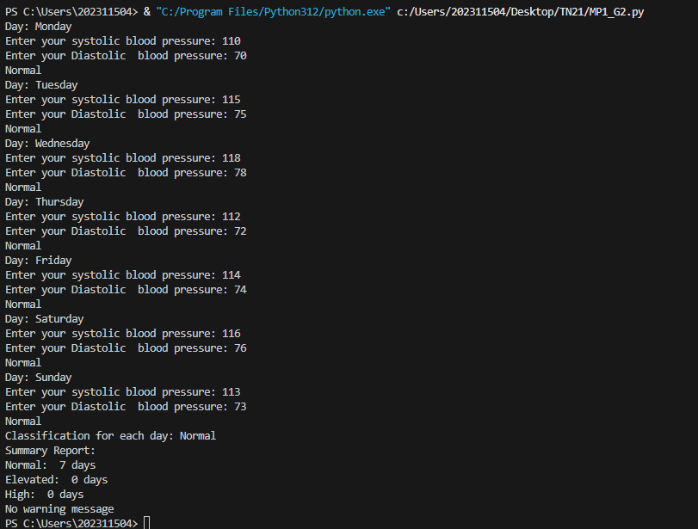

Test Case 2: Elevated Readings for All Days

Input:

Monday: Systolic = 125, Diastolic = 70

Tuesday: Systolic = 122, Diastolic = 75

Wednesday: Systolic = 128, Diastolic = 78

Thursday: Systolic = 121, Diastolic = 72

Friday: Systolic = 124, Diastolic = 74

Saturday: Systolic= 126, Diastolic = 76

Sunday: Systolic = 123, Diastolic = 73

Expected Output:

Classification for each day: "Elevated"

Summary Report:

Normal: 0 days

Elevated: 7 days

High: 0 days

No warning message

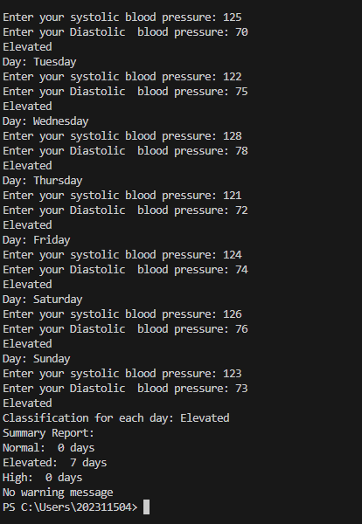

Test Case 3: High Readings for All Days

Input:

Monday: Systolic = 130, Diastolic = 80

Tuesday: Systolic = 135, Diastolic = 85

Wednesday: Systolic = 140, Diastolic = 90

Thursday: Systolic = 132, Diastolic = 82

Friday: Systolic = 134, Diastolic = 84

Saturday: Systolic = 136, Diastolic = 86

Sunday: Systolic = 133, Diastolic = 83

Expected Output:

Classification for each day: "High"

Summary Report:

Normal: 0 days

Elevated: 0 days

High: 7 days

Warning message: "Warning: More than 3 days classified as High. Please consult a doctor."

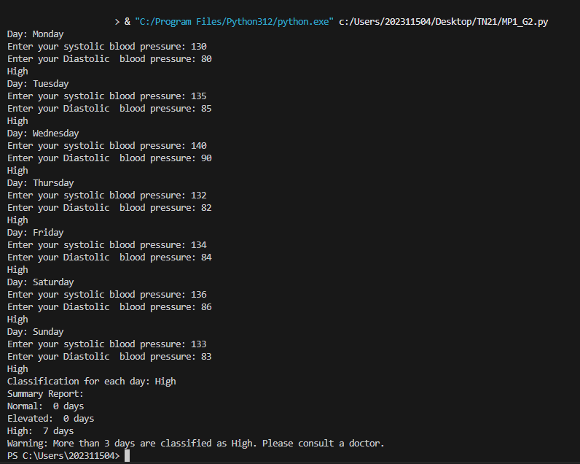
Test Case 4: Mixed Readings

Input:

Monday: Systolic = 110, Diastolic = 70 (Normal)

Tuesday: Systolic = 125, Diastolic = 75 (Elevated)

Wednesday: Systolic = 130, Diastolic = 80 (High)

Thursday: Systolic = 112, Diastolic = 72 (Normal)

Friday: Systolic = 124, Diastolic = 74 (Elevated)

Saturday: Systolic = 135, Diastolic = 85 (High)

Sunday: Systolic = 113, Diastolic = 73 (Normal)

Expected Output:

Classification for each day:

Monday: Normal

Tuesday: Elevated

Wednesday: High

Thursday: Normal

Friday: Elevated

Saturday: High

Sunday: Normal

Summary Report:

Normal: 3 days

Elevated: 2 days

High: 2 days

No warning message
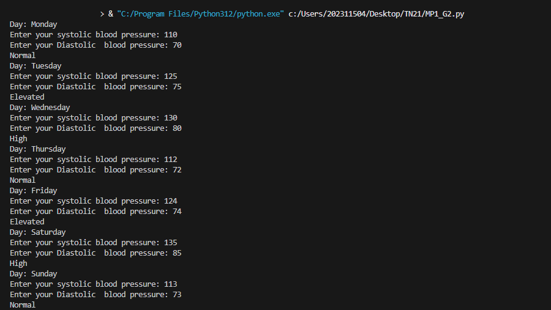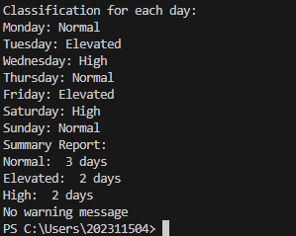

Test Case 5: Edge Case
Input:

Monday: Systolic = 119, Diastolic = 79 (Normal)

Tuesday: Systolic = 120, Diastolic = 79 (Elevated)

Wednesday: Systolic = 129, Diastolic = 79 (Elevated)

Thursday: Systolic = 130, Diastolic = 80 (High)

Friday: Systolic = 130, Diastolic = 79 (High)

Saturday: Systolic = 129, Diastolic = 80 (High)

Sunday: Systolic = 119, Diastolic = 79 (Normal)

Expected Output:

Classification for each day:

Monday: Normal

Tuesday: Elevated

Wednesday: Elevated

Thursday: High

Friday: High

Saturday: High

Sunday: Normal

Summary Report:

Normal: 2 days

Elevated: 2 days

High: 3 days

No warning message

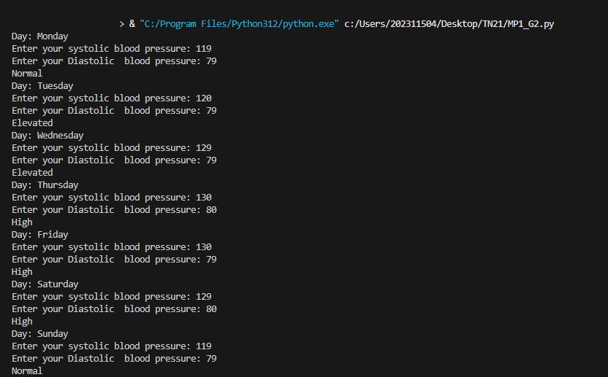

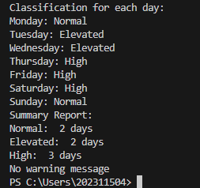

Test Case 6: Invalid Inputs

Input:

Monday: Systolic = -10, Diastolic = 70

Tuesday: Systolic = 120, Diastolic = "eighty"

Wednesday: Systolic = 130, Diastolic = 80

Thursday: Systolic = 112, Diastolic = 72

Friday: Systolic = 124, Diastolic = 74

Saturday: Systolic = 135, Diastolic = 85

Sunday: Systolic = 113, Diastolic = 73

Expected Output:

Error message for Monday: "Invalid input: Blood pressure readings cannot be negative."

Error message for Tuesday: "Invalid input: Please enter a valid number for diastolic blood pressure."

Classification for each valid day:

Wednesday: High

Thursday: Normal

Friday: Elevated

Saturday: High

Sunday: Normal

Summary Report:

Normal: 2 days

Elevated: 1 day

High: 2 days

No warning message

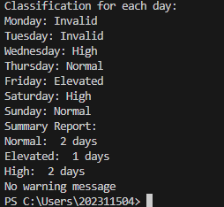
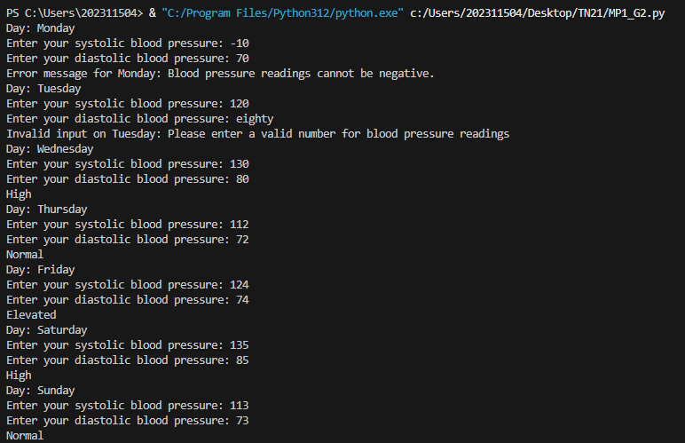

Test Case 7: Exact Boundary Values

Input:

Monday: Systolic = 120, Diastolic = 79 (Elevated)

Tuesday: Systolic = 129, Diastolic = 79 (Elevated)

Wednesday: Systolic = 130, Diastolic = 79 (High)

Thursday: Systolic = 129, Diastolic = 80 (High)

Friday: Systolic = 119, Diastolic = 79 (Normal)

Saturday: Systolic = 119, Diastolic = 79 (Normal)

Sunday: Systolic = 119, Diastolic = 79 (Normal)

Expected Output:

Classification for each day:

Monday: Elevated

Tuesday: Elevated

Wednesday: High

Thursday: High

Friday: Normal

Saturday: Normal

Sunday: Normal

Summary Report:

Normal: 3 days

Elevated: 2 days

High: 2 days

No warning message

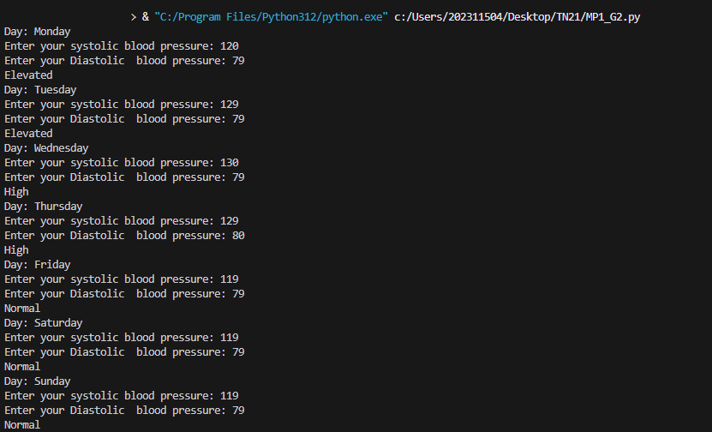
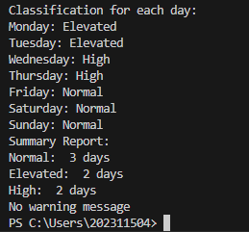
Problem 3: Banking Application

Problem Statement

Develop a simple banking application that allows users to manage their account balance. The program should:

- Start with an initial balance provided by the user.

- Allow the user to perform transactions (deposit, withdraw, or check balance) in a loop until they choose to exit.

- For withdrawals, ensure the user cannot withdraw more than their current balance.

- After each transaction, display the updated balance.

- At the end of the session, display a summary of all transactions performed.

Requirements

- Create functions deposit(amount), withdraw(amount), and check_balance() to handle transactions.

- Use a loop to repeatedly prompt the user for actions until they choose to exit.

- Use conditionals to validate withdrawal amounts and handle invalid inputs.

- Maintain a list of transactions (e.g., "Deposited $50", "Withdrew $30") and display them at the end.

Test Case 1: Basic Functionality

Input:

Initial balance: $100

Actions:

Deposit $50

Withdraw $30

Check balance

Exit

Expected Output:

After depositing $50: Updated balance = $150

After withdrawing $30: Updated balance = $120

After checking balance: Displayed balance = $120

Summary of transactions:

Deposited $50

Withdrew $30

Checked balance

End of session message

Test Case 2: Multiple Transactions

Input:

Initial balance: $200

Actions:

Deposit $100

Withdraw $50

Deposit $75

Withdraw $200

Check balance

Exit

Expected Output:

After depositing $100: Updated balance = $300

After withdrawing $50: Updated balance = $250

After depositing $75: Updated balance = $325

Attempt to withdraw $200: Error message "Insukicient funds. Transaction declined."

After checking balance: Displayed balance = $325

Summary of transactions:

Deposited $100

Withdrew $50

Deposited $75

Attempted to withdraw $200 (declined)

Checked balance

End of session message

Test Case 3: Invalid Inputs

Input:

Initial balance: $150

Actions:

Deposit $-50

Withdraw $-30

Deposit "abc"

Withdraw "xyz"

Check balance

Exit

Expected Output:

Error message for depositing $-50: "Invalid amount. Please enter a positive number."

Error message for withdrawing $-30: "Invalid amount. Please enter a positive number."

Error message for depositing "abc": "Invalid amount. Please enter a valid number."

Error message for withdrawing "xyz": "Invalid amount. Please enter a valid number."

After checking balance: Displayed balance = $150

Summary of transactions:

Attempted to deposit $-50 (declined)

Attempted to withdraw $-30 (declined)

Attempted to deposit "abc" (declined)

Attempted to withdraw "xyz" (declined)

Checked balance

End of session message

Test Case 4: Edge Cases

Input:

Initial balance: $0

Actions:

Deposit $0

Withdraw $0

Check balance

Exit

Expected Output:

After depositing $0: Updated balance = $0

Attempt to withdraw $0: Error message "Invalid amount. Please enter a positive number."

After checking balance: Displayed balance = $0

Summary of transactions:

Deposited $0

Attempted to withdraw $0 (declined)

Checked balance

End of session message

Test Case 5: Large Transactions

Input:

Initial balance: $1000

Actions:

Deposit $500

Withdraw $1200

Check balance

Exit

Expected Output:

After depositing $500: Updated balance = $1500

Attempt to withdraw $1200: Error message "Insukicient funds. Transaction declined."

After checking balance: Displayed balance = $1500

Summary of transactions:

Deposited $500

Attempted to withdraw $1200 (declined)

Checked balance

End of session message

Test Case 6: No Transactions

Input:

Initial balance: $500

Actions:

Check balance

Exit

Expected Output:

After checking balance: Displayed balance = $500

Summary of transactions:

Checked balance

End of session message

Test Case 7: Sequential Withdrawals

Input:

Initial balance: $300

Actions:

Withdraw $100

Withdraw $100

Withdraw $100

Withdraw $100

Check balance

Exit

Expected Output:

After withdrawing $100: Updated balance = $200

After withdrawing $100: Updated balance = $100

After withdrawing $100: Updated balance = $0

Attempt to withdraw $100: Error message "Insukicient funds. Transaction declined."

After checking balance: Displayed balance = $0

Summary of transactions:

Withdrew $100

Withdrew $100

Withdrew $100

Attempted to withdraw $100 (declined)

Checked balance

End of session message

Problem 4: Restaurant Order Management

Problem Statement

Create a restaurant order management system that processes customer orders. The program should:

- Display a menu with items and prices (e.g., Burger: $5, Pizza: $10, Salad: $7).

- Allow the user to select items and specify quantities in a loop until they finish ordering.

- Calculate the total bill, including a 10% service charge.

- Oker a discount of 5% if the total bill exceeds $50.

- Display the final bill with itemized details.

Requirements

- Create a function calculate_bill(order) that computes the total bill based on the user's order.

- Use a loop to allow the user to add multiple items to their order.

- Use conditionals to apply discounts and calculate the final amount.

- Display the bill in a clear format, showing each item, quantity, price, and the total.

Test Case 1: Basic Ordering

Input:

Menu:

Burger: $5

Pizza: $10

Salad: $7

Orders:

- Burgers

1 Pizza

Finish ordering

Expected Output:

Subtotal: 2×5+1×10=20

Service charge (10%): 20×0.10=2

Total before discount: 20+2=22

No discount (total bill < $50)

Final bill: $22

Itemized details:

- Burgers: $10

1 Pizza: $10

Total: $22

Test Case 2: Order Exceeding $50

Input:

Menu:

Burger: $5

Pizza: $10

Salad: $7

Orders:

- Burgers

3 Pizzas

2 Salads Finish ordering

Expected Output:

Subtotal: 5×5+3×10+2×7=25+30+14=69

Service charge (10%): 69×0.10=6.9

Total before discount: 69+6.9=75.9

Discount (5%): 75.9×0.05=3.795≈3.80

Final bill: 75.9−3.80=72.10

Itemized details:

- Burgers: $25

3 Pizzas: $30

2 Salads: $14

Total: $72.10

Test Case 3: Invalid Item

Input:

Menu:

Burger: $5

Pizza: $10

Salad: $7

Orders:

- Sushi

2 Burgers Finish ordering

Expected Output:

Error message for "Sushi": "Invalid item. Please select a valid menu item."

Subtotal: 2×5=10

Service charge (10%): 10×0.10=1

Total before discount: 10+1=11

No discount (total bill < $50)

Final bill: $11

Itemized details:

- Burgers: $10 Total: $11

Test Case 4: Negative Quantity

Input:

Menu:

Burger: $5

Pizza: $10

Salad: $7

Orders:

-1 Burgers

- Pizzas Finish ordering

Expected Output:

Error message for "-1 Burgers": "Invalid quantity. Please enter a positive number."

Subtotal: 2×10=20

Service charge (10%): 20×0.10=2

Total before discount: 20+2=22

No discount (total bill < $50)

Final bill: $22

Itemized details:

- Pizzas: $20 Total: $22

Test Case 5: Non-Numeric Quantity

Input:

Menu:

Burger: $5

Pizza: $10

Salad: $7

Orders:

"abc" Burgers

  - Pizzas Finish ordering

- Expected Output:**

Error message for "abc Burgers": "Invalid quantity. Please enter a valid number."

Subtotal: 2×10=20

Service charge (10%): 20×0.10=2

Total before discount: 20+2=22

No discount (total bill < $50)

Final bill: $22

Itemized details:

- Pizzas: $20 Total: $22

Test Case 6: No Orders

Input:

Menu:

Burger: $5

Pizza: $10

Salad: $7

Orders:

Finish ordering

- Expected Output:** Subtotal: $0

Service charge (10%): $0

Total before discount: $0 No discount (total bill < $50) Final bill: $0
Itemized details: No items ordered Total: $0

Test Case 7: Edge Case with Exact $50

Input:

Menu:

Burger: $5

Pizza: $10

Salad: $7

Orders:

- Pizzas Finish ordering

- Expected Output:** Subtotal: 5×10=50

Service charge (10%): 50×0.10=5

Total before discount: 50+5=55

Discount (5%): 55×0.05=2.75

Final bill: 55−2.75=52.25 Itemized details:

5 Pizzas: $50

Total: $52.25

