CS 008 Introduction to World Wide Web Design

Sydney Bertrand

Assignment: Join Us (1.0)

Join Us

Version <1.0>

Table Of Contents

Time Log 3

Introduction 4

Purpose 4

Definitions, acronyms, and abbreviations 4

Overall Description 4

Story Board 5

Assignment requirements 6

|  |  |  |  |
| --- | --- | --- | --- |
| Time Log | | | |
| Estimated time to complete assignment => | | | 2.5 Hours |
| Date | Time Spent  (in hours) | Description | Author |
| 3/7 | 0.5 | Created Lab 8 folder, copied over files, began copying code from GitHub | Sydney Bertrand |
| 3/9 | 3.0 | Copied rest of code, updated site map, checked validation and submitted lab | Sydney Bertrand |
|  |  |  |  |
|  |  |  |  |
|  |  |  |  |
|  |  |  |  |
|  |  |  |  |
|  |  |  |  |
|  |  |  |  |
|  |  |  |  |
|  |  |  |  |
|  |  |  |  |
|  |  |  |  |
|  |  |  |  |
|  |  |  |  |
|  |  |  |  |
|  |  |  |  |
|  |  |  |  |
|  |  |  |  |
|  |  |  |  |
|  | 3.5 | <=Total Time Spent |  |

# Introduction

### Purpose

The purpose of this document is to describe the requirement specification for the web site you have been building.

The intended audience for this document is two fold. First it is the contract between you and the client. Second it is for the developer of the site. Two primary goals are:

1. Client gets a very good understanding of what you will be delivering. If it is not on this document you are not doing it.
2. Developer has a very good understanding of what they are going to create. Ideally a developer would not need to ask you any questions on how you want the site built. It is the site’s blue print.

The web site to be created is a form and a home page to tell us why we should join.

### Definitions, acronyms, and abbreviations

HTML – Hypertext markup language – used to define your content.

PHP – Personal Home Page – language that helps to customize html.

CSS – Cascading Style Sheets – used to define the look of a web site.

W3 Validation – refers to the HTML and CSS validation tools provided by W3c.org.   
The HTML validator is located at:

<http://validator.w3.org/>

The CSS validator is located at:

<http://jigsaw.w3.org/css-validator/>

# Overall Description

A simple page to get us to fill out a simple form with our email address. We will be expanding this form over the next several labs.

# Story Board

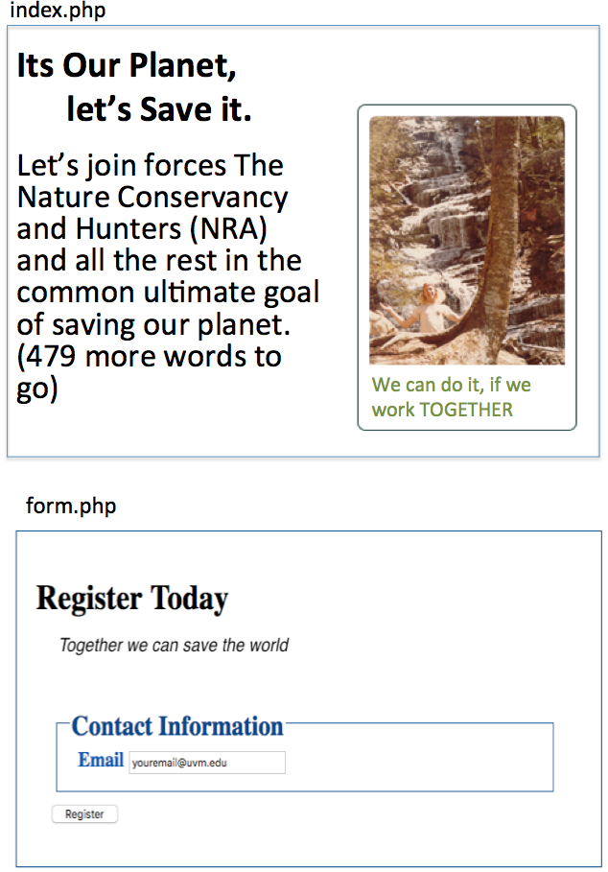

# Requirements

1. *Posted* – All files will be located in the www-root/cs008/__________ folder of your uvm Silk account. The lab web page and the submit process will detail the exact location. Failure to have your site located in the correct folder by the due dates will result in a zero on the assignment. Be sure to pay attention to the lowercase letters.
2. *Submitted* – Be sure to submit all files in Blackboard (zipped file is ok).
3. *Site map* – Be sure to update your sitemap (you do not need to link to top, header, nav and footer). When you are done, your sitemap should be structured like this (plus other lab links below it):  
   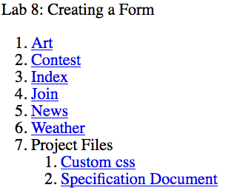
4. *Html Validation* – All pages will pass W3C Html validation for html 5. NOTE: top, header, nav and footer pages will not validate as they are not expected to be viewed by themselves.
5. *Meta Information* – All pages will contain a proper title tag, Meta tags (author, character set and description).
6. CSS Validation – All pages will pass W3C 3.0 CSS validation.
7. CSS – All pages will have a linked style sheet. I am not going to require a specific set of rules but you will be graded on your effort of what you try (just having my sample gets you a zero).
8. *Head Section* – Put the doctype and head section information in a file named top.php so you can include it all the pages.
9. *Navigation* – All pages will contain navigation to all other pages on the site using an ordered list. File name should be nav.php
10. *Content* – The index page will have a minimum of 500 words not counting titles, lists or links that introduces your site and encourages me to want to join. Be sure to use the correct elements to hold your content. The form page does not need to meet this requirement.
11. *Header* – All pages will contain a header. You need to add a logo to fit your site (be sure to use the figure element). File name should be header.php which you will include on all pages.
12. *Form* - We want to entice people to fill out our form so the home page content should do just that. The form will follow my sample on GitLab.
13. *Form* – Will contain fieldsets, legends, input type text for email address and a submit button. Code will include documentation as shows on GitLab.
14. *Form* – Will have your email address as the default value as set by php.
15. *Form* – Should be styled with CSS different than my default.
16. *Footer* – All pages will contain a footer with the content determined by you. Filename will be footer.php
17. *Images* – Each page will have a minimum of one image. Each image will be in the figure element with the figcaption element if needed. The form page does not need to meet this requirement.
18. *Footer* – All pages will contain a footer with your name. Be sure to use the correct element to contain the footer.
19. *File Names* – The form page should be called form.php. All other files keep the name they had before.
20. *Specification Document(this file)*: must be updated and saved as a specs.pdf (must use pdf format and correct filename in the same folder to be graded).