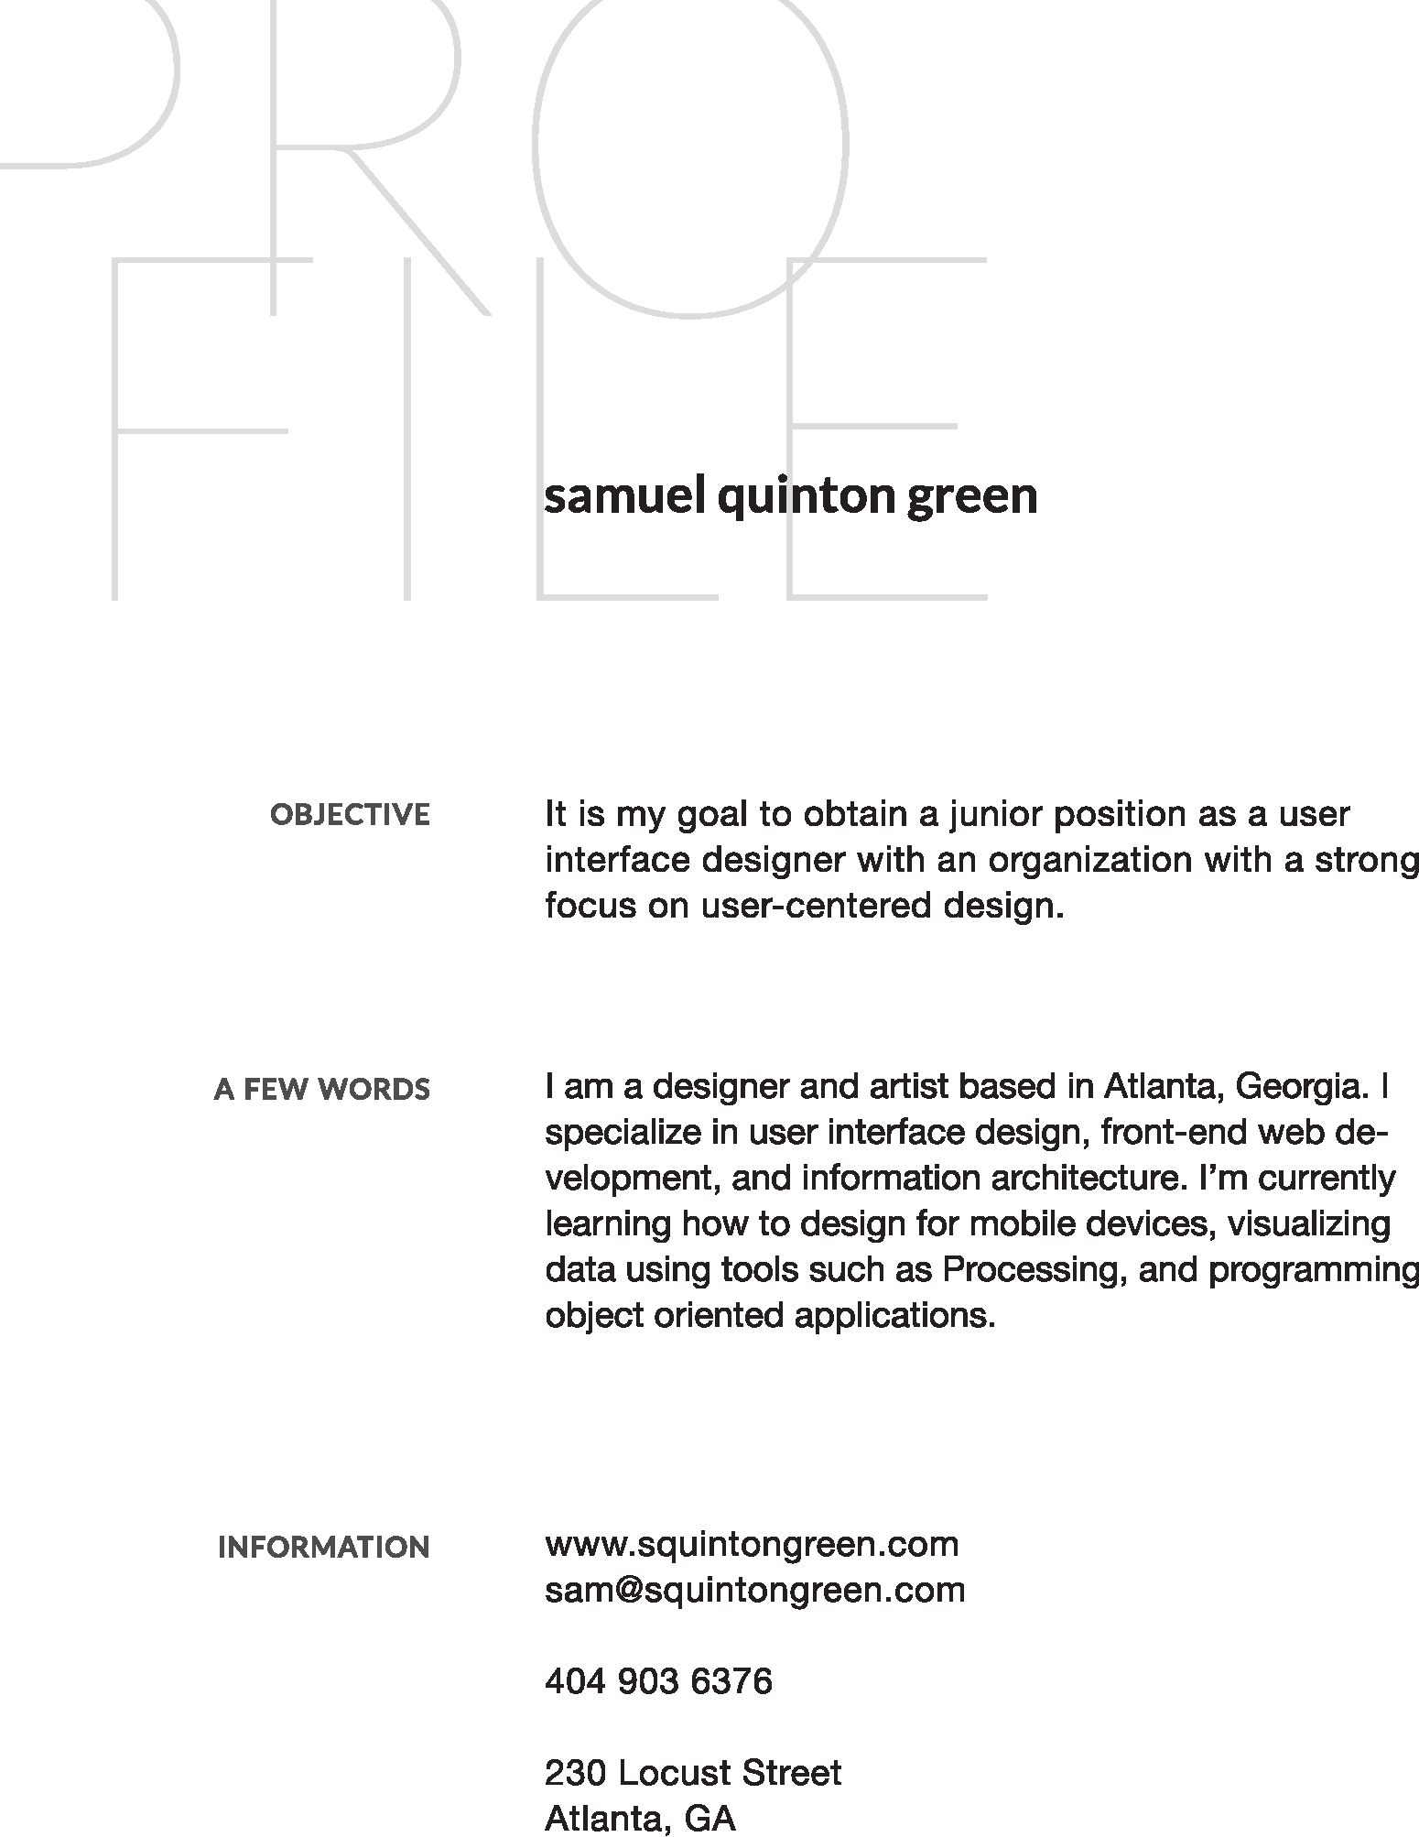




UI & Graphic Designer, Front-End Web Developer
Gerogia State University, Center for International Public Policy
- ﾭsets.
- Designed booklets, brochures, and marketing materials for annual summer training courses.
- Produced graphics for the web, images for the ﾭdrew Young School.
- Development of custom template types for the Reddot CMS.
- ﾭmedia module utilizing Drupal CMS.
- Day to day roles also included the photographing ﾭnars, as well as photo and video editing.


Graphic Designer, Front-End Web Developer
Blue Earth Network
- Brand deveopment and logo design.
- Print and new media design.
- ﾭects.
- Information graphics and data visualization.



