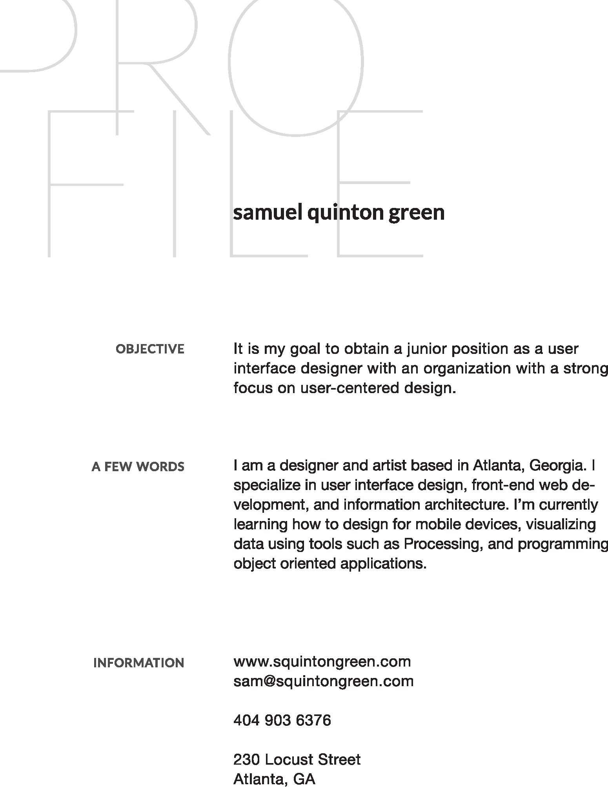






UI & Graphic Designer, Front-End Web Developer
Gerogia State University, Center for International Public Policy
- ﾭsets.
.
.
- Designed
d
g
d
d
g
d
d
g materials
r
l
r
g
s
r
l
r
g
s
r
l
r
g
- Produced
s
r
e
s
r
e
d
s
r
e
s
r
e
d
s
r
e
s
r
e ﾭdrew
g
w
g
w
g
- Development
f
m
e
s
r
e
t
f
m
e
s
r
e
t
f
m
e
s
r
e Reddot
t
t
- ﾭmedia
e
g
l
a
e
g
l
a
e
g
l
- Day
o
y
s
o
y
o
y
s
o
y
o
y
s
o included
e
g
d
e
g
d
e
g ﾭs
l
s
o
d
o
s
l
s
o
d
o
s
l
s
o
d
o



Graphic Designer, Front-End Web Developer
Blue Earth Network
- Brand
t
d
o
d
t
d
o
d
t
d
o
- Print
d
w
a
t
d
w
a
t
d
w
a
- ﾭects.
.
.
- Information
s
d
a
n
s
d
a
n
s
d
a

