Market Research Report: Tenant Empowerment App

Introduction
Renters and tenants make up a large share of the U.S. housing market, yet they often face significant barriers in communication, affordability, and transparency. While landlords and property managers have access to numerous digital platforms that streamline their operations, tenants remain underserved, particularly in areas of collective action, peer communication, and advocacy for fair housing practices. This report presents secondary market research into the target user group, the market size and opportunity, the competitive landscape, and the unique value proposition of a proposed tenant-focused mobile application. In addition, the report details the role of Generative AI tools in conducting and synthesizing this research.

User Group Profile
The primary target users for this app are adult renters in the United States. Roughly 102 million people currently live in renter-occupied housing units, representing about one-third of all U.S. households. The renter demographic skews younger, with adults under the age of 35 representing the largest share. A significant portion of renters are students, early-career professionals, and lower-income households, though middle-income renters are also common in metropolitan areas with high housing costs.
Renters tend to have lower household incomes compared to homeowners; more than half of renter households earn less than $50,000 annually. Many renters are single adults or small households, and urban areas remain the dominant geography for renter populations. Technology adoption is relatively high among this group, as most renters already use mobile platforms for banking, job searching, and communication. However, many still lack access to digital rent payment systems, transparent communication portals, or tools to engage with other tenants.
The major pain points are clear. Renters consistently report poor landlord communication, ranging from delayed responses to ignored maintenance requests. Financial stress is another central frustration: half of renter households are 'cost-burdened,' spending more than 30 percent of their income on rent and utilities. Renters also face difficulties accessing accurate legal information, verifying whether landlords are violating laws, and coordinating with fellow tenants to address shared issues. The lack of collective organization leaves individual renters with little leverage to negotiate rent increases or challenge unfair practices.

Market Size and Opportunity
The renter market is both vast and growing. In the U.S., there are approximately 44 million renter-occupied housing units. With more than 100 million individuals affected, even a small adoption rate presents a substantial opportunity. If just 5 percent of renters became early adopters of this type of platform, the app could realistically reach five million users.
The market opportunity is underscored by worsening affordability challenges. Recent reports show that rent burdens remain steady at high levels, with about half of all renters struggling to meet monthly costs. Racial disparities also exist: over 56 percent of Black renter households and nearly 55 percent of 'other race' renter households spend more than 30 percent of their income on rent, compared to 47 percent of White renters. These disparities highlight a systemic need for tools that not only facilitate payments but also strengthen accountability, equity, and access to information.
Demand for digital housing tools is rising. A majority of renters say they prefer digital rent payments and online communication with landlords, but only about half currently have access to such options. This adoption gap represents both a challenge and an opportunity: while landlord buy-in is inconsistent, renter demand is strong and largely unmet. Beyond payments, there is virtually no mainstream platform designed to support tenant-to-tenant communication, legal awareness, or collective bargaining.

Competitor Analysis
While property management software is widespread, the competitive landscape reveals important gaps for a tenant-centric solution.
TenantCloud is a well-established platform offering rent payments, maintenance requests, and messaging between tenants and landlords. Its primary customers, however, are small landlords, not renters. While convenient for payments, TenantCloud does not address collective tenant needs or provide resources for legal rights and advocacy.
RentRedi provides strong features for rent collection, tenant portals, and messaging. Like TenantCloud, it is primarily landlord-facing, designed to make property management easier. Renters benefit from smoother processes but remain dependent on landlord adoption, with no ability to connect with fellow tenants or pursue group action.
Hococo (Resident App) emphasizes tenant experience, offering real-time messaging, amenity booking, and community channels. While this suggests a more community-oriented design, the channels are typically controlled by property managers, limiting their usefulness for tenant organizing or advocacy.
Across these platforms, key gaps persist: little to no emphasis on tenant-to-tenant forums, minimal integration of legal and housing rights information, and no tools supporting collective bargaining or transparent documentation of landlord behavior. Reviews for these apps are generally positive for usability but mixed in terms of landlord responsiveness, which again highlights the limitations of landlord-controlled systems.

Unique Value Proposition
The proposed app distinguishes itself by focusing not on landlord convenience but on tenant empowerment. Its unique value proposition lies in four areas:
1. Collective Communication: Unlike existing apps, this platform allows tenants to connect with one another within a building, neighborhood, or city. By creating safe communication spaces, renters can coordinate responses to maintenance issues, share experiences, and even organize collectively when facing unfair practices.
2. Legal Awareness and Transparency: The app integrates housing law resources and region-specific legal protections, providing renters with clear, accessible knowledge. Documentation features allow users to store communications, upload evidence, and maintain records that could be used in disputes or legal proceedings.
3. Tenant-First Control: While other platforms are often mediated by landlords, this app is built for tenants. This shift in control gives renters agency over their data, communication, and organizational strategies.
4. Equity and Advocacy Tools: By offering forums, petitions, and reporting mechanisms, the app enables collective tenant action. It becomes not just a service tool but a platform for advocacy, strengthening renters’ ability to push for transparency and fairness in the housing market.

Visualization
The following chart illustrates cost burden disparities among U.S. renters (spending more than 30% of income on housing):
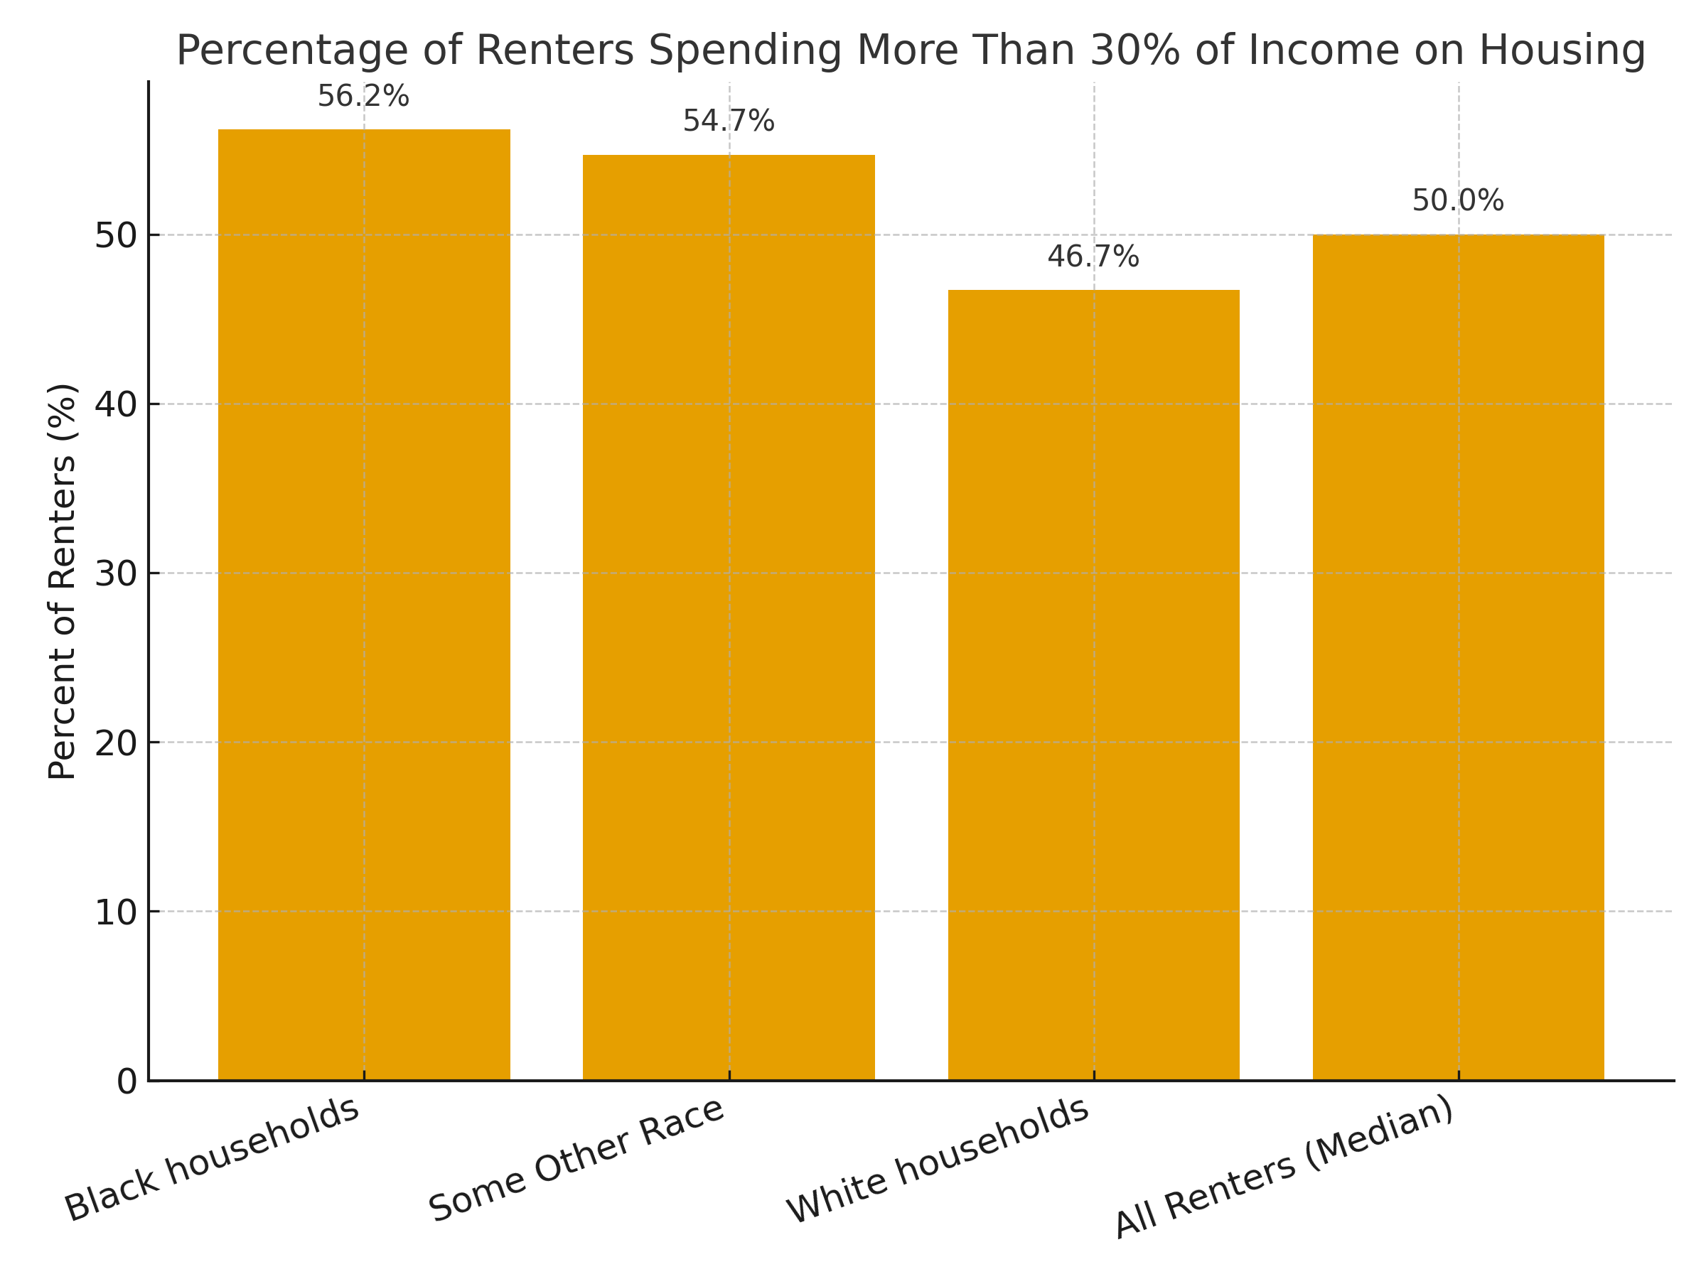

AI Use in Market Research
Generative AI tools were integral to this research. ChatGPT was used to structure the report, synthesize competitor comparisons, and generate an initial analysis of gaps in the market. Prompts included: 'What features are missing in property management and tenant apps?' and 'Compare existing apps for renters: features, strengths, and weaknesses.'
To ensure accuracy, all AI outputs were fact-checked using secondary sources, including Apartment List, RentCafe, Reuters, Shelterforce, and product descriptions from official websites. In cases where AI responses provided approximate figures, these were cross-referenced with multiple reliable datasets, such as the U.S. Census Bureau and industry housing reports. This triangulation ensured that the final report combined the efficiency of AI synthesis with the reliability of vetted data.

Conclusion
The renter population in the United States is large, diverse, and underserved by existing digital platforms. Current apps primarily cater to landlords and property managers, leaving critical gaps in tenant empowerment, legal awareness, and collective communication. With more than 100 million renters, half of whom are cost-burdened, the market opportunity is significant.
The proposed app offers a unique value proposition by focusing squarely on the renter experience. By enabling tenant-to-tenant communication, integrating legal resources, and supporting collective action, the platform positions itself not just as a convenience tool but as an empowerment engine. Given rising rent burdens, increased tenant dissatisfaction, and ongoing legal scrutiny of landlord practices, this is a timely and socially impactful opportunity.

