## 1 Cart Basic

**1.1**

**Issue:**

Phone number field allows alpha characters

**Expected Result:**

Entering alpha characters in the phone number field should either not allow typing or return an error to the user that the phone number is invalid.

**Actual Result:**

No error is given to the user when ‘lkslkslkslks’ is entered as the phone number and the user is able to proceed to the next step in the checkout process.

**Browser:**

Safari 13.0.4 on iMac 10.13.6

**Steps to Reproduce:**

1. Start at a product page such as <https://lovevery.com/products/the-block-set>
2. Add the product to the shopping cart
3. Click Continue to Checkout
4. In the phone field, enter ‘lkslkslkslks’ or other text containing non-numeric characters such as “;’select*fromusers’”
5. Provide other required fields for email, first & last name and address
6. Click Continue to shipping
7. Notice there is no error given regarding phone number field containing non-numeric characters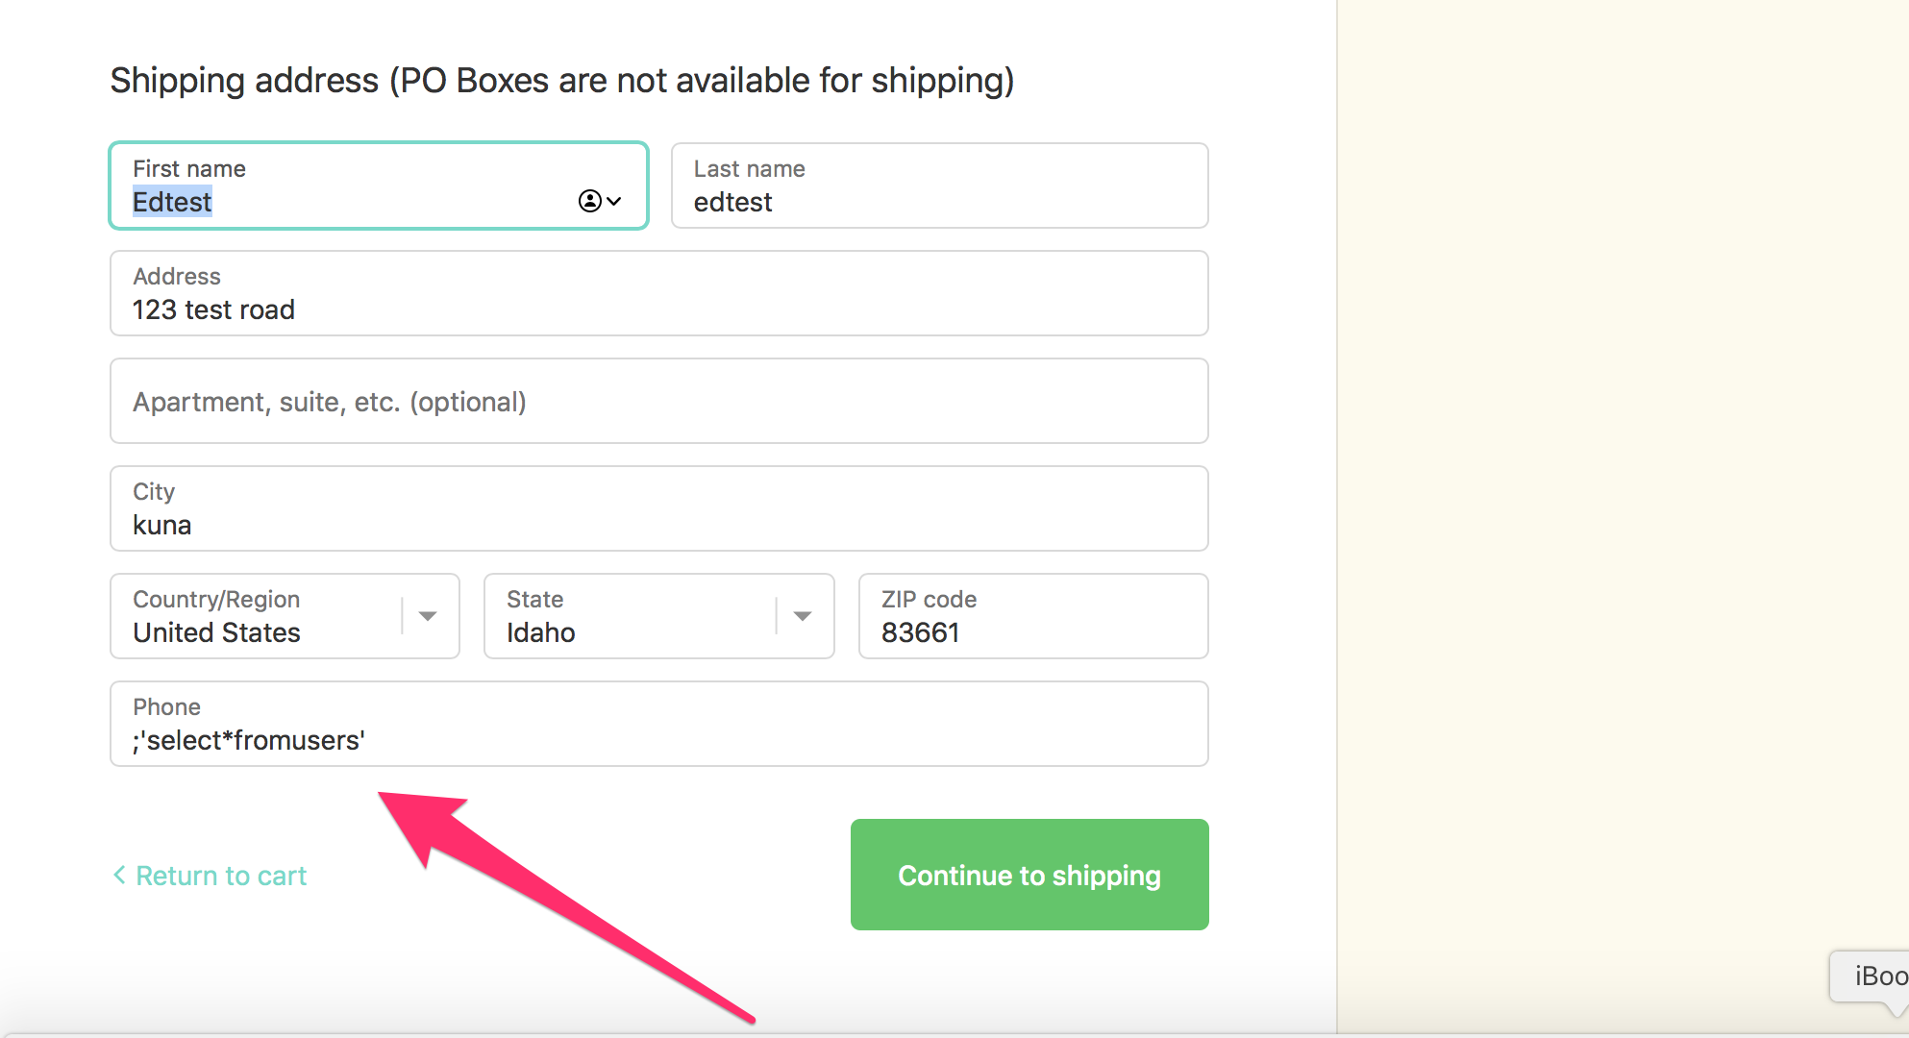

**1.2**

**Issue:**

Max character limits are set to 255 characters enforced on the contact information section

**Expected Result:**

Fields will only allow predetermined number of characters on contact and shipping information sections. An example would be first name not to exceed 50 characters and the character limit attribute is set on the field so user may not type more than 50 characters

**Actual Result:**

Character limits are not enforced on contact and shipping info until page is submitted

**Browser:**

Safari 13.0.4 on iMac 10.13.6

**Steps to Reproduce:**

1. Start at a product page such as <https://lovevery.com/products/the-block-set>
2. Add the product to the shopping cart
3. Click Continue to Checkout
4. In the contact and shipping fields like first and last name and city, enter long strings of characters over 255 characters
5. Provide other required fields for email, first & last name and address
6. Click Continue to shipping
7. Notice a pop up that asks if you would like to proceed with address
8. Click Proceed
9. Notice the user is redirected back to the shipping screen and error messages about fields being too long

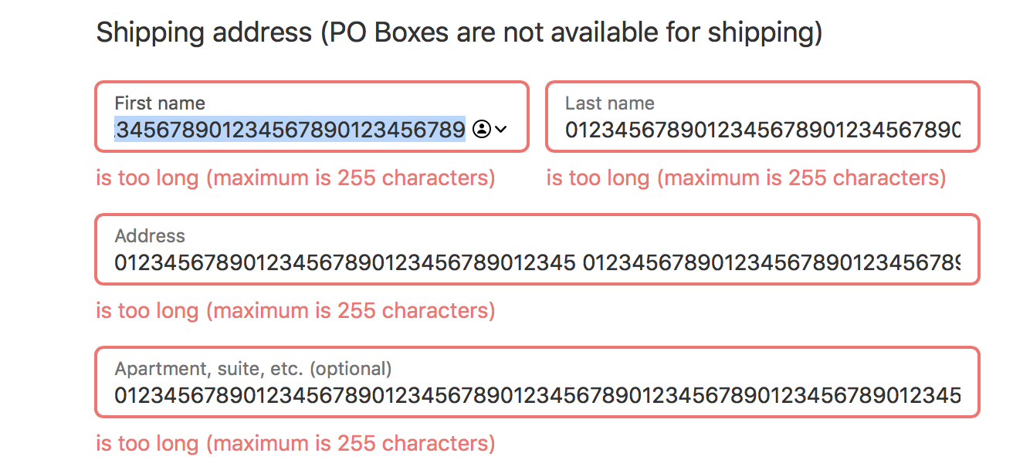

**1.3**

**Issue:**

Console error is thrown on the shipping page and payment page. TypeError:null is not an object(evaluating ‘document.getElementById(‘disclaimer’).style’)

**Expected Result:**

Console error should not be thrown

**Actual Result:**

Console error is thrown in both Safari and Chrome

**Browser:**

Safari 13.0.4 on iMac 10.13.6

Chrome 79.0 on iMac 10.13.6

**Steps to Reproduce:**

1 Start at a product page such as

2. Add the product to the shopping cart

3. Click Continue to Checkout

4. Provide required fields

5. Click Continue to shipping

6. Click Proceed (if prompted)

7. Open dev tools and look at the console

8. Notice on Shipping page a TypeError exists in the console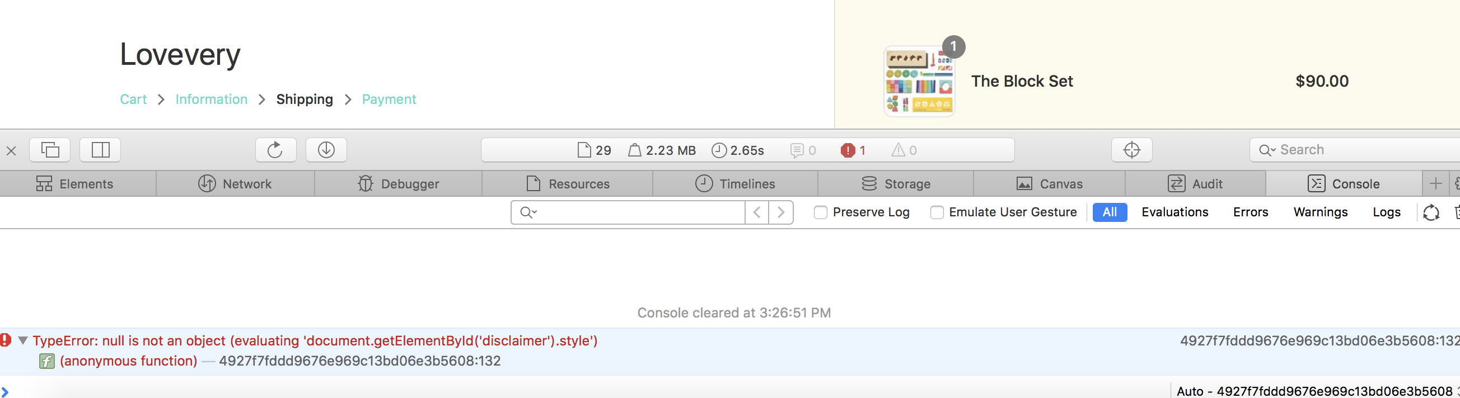

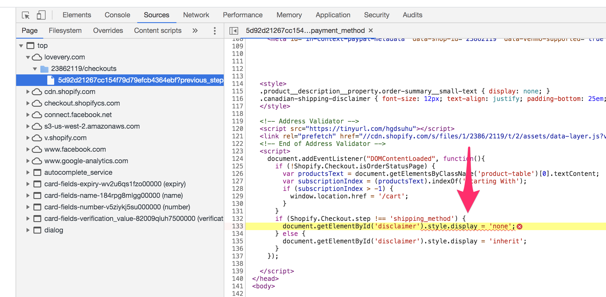

**1.4**

**Issue:**

Payment total displayed in USD although Canadian shipping address is provided.

**Expected Result:**

Currency would be updated to CAD when shipping address provided is for Canada

**Actual Result:**

Currency remains in USD

**Browser:**

Safari 13.0.4 on iMac 10.13.6

Chrome 79.0 on iMac 10.13.6

**Steps to Reproduce:**

1 Start at a product page such as

2. Add the product to the shopping cart

3. Click Continue to Checkout

4. Provide required fields with Canadian address

5. Click Continue to shipping

6. Click Proceed (if prompted)

7. Notice the currency displayed is still in USD

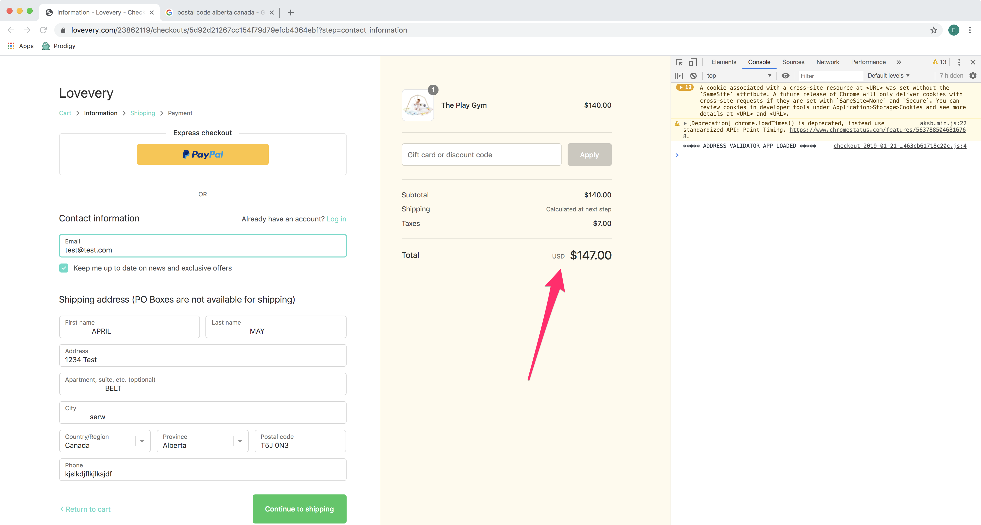

**1.5**

**Issue:**

Text ‘and more…’ near the payment icons in the payment section appears clickable, however nothing happens on click

**Expected Result:**

Cursor would remain as an arrow unless there is some clickable action which can be performed by the user at which time the cursor converts to show a click action is available

**Actual Result:**

Cursor is converted to the icon indicating that a click action can be performed, but on click ‘and more…’ text in the payment section, nothing happens.

**Browser:**

Safari 13.0.4 on iMac 10.13.6

Chrome 79.0 on iMac 10.13.6

**Steps to Reproduce:**

1 Start at a product page such as

2. Add the product to the shopping cart

3. Click Continue to Checkout

4. Provide required fields

5. Click Continue to shipping

6. Click Proceed (if prompted)

7. Choose shipping method and proceed

8. On the payment page, scroll to the payment section where credit card info would be entered and next to the payment icons, hover over the ‘and more…’ text

9. Notice the cursor converts to a clicking cursor, now attempt to click and notice nothing happens.

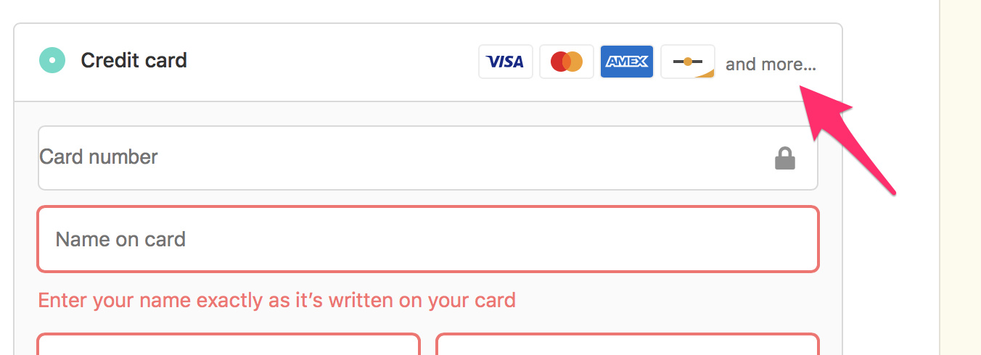

**1.6**

**Issue:**

Leading whitespace allowed in name and address fields

**Expected Result:**

Leading whitespace will be trimmed from fields to prevent mistakes and invalid data

**Actual Result:**

Leading whitespace is allowed in name and address fields.

**Steps To Reproduce:**

1 Start at a product page such as

2. Add the product to the shopping cart

3. Click Continue to Checkout

4. Provide required fields and add blank space to the beginning of name and address and city  
5. Click Continue to shipping

6. Click Proceed (if prompted)

7. Notice the address is allowed and the white space is preserved

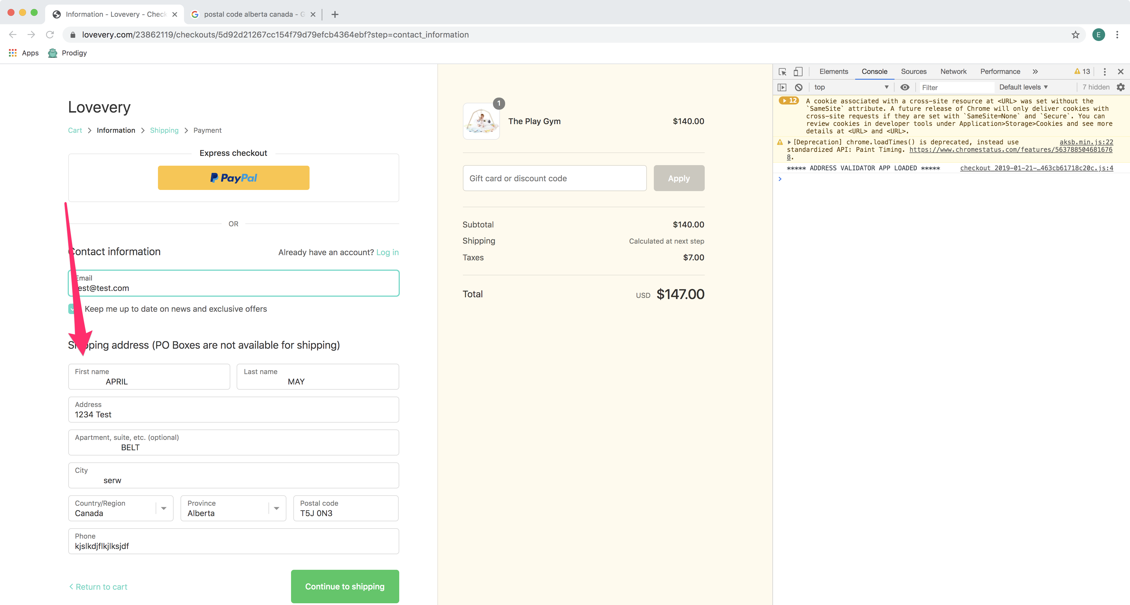

## 2. Cart Misc. (extra)

**2.1**

**After working on another browser and then clicking back to the shipping page after ~20 minutes and then clicking back to this Safari browser (could not reproduce in Chrome). I saw Failed to load resource: An SSL error has occurred - twice.**

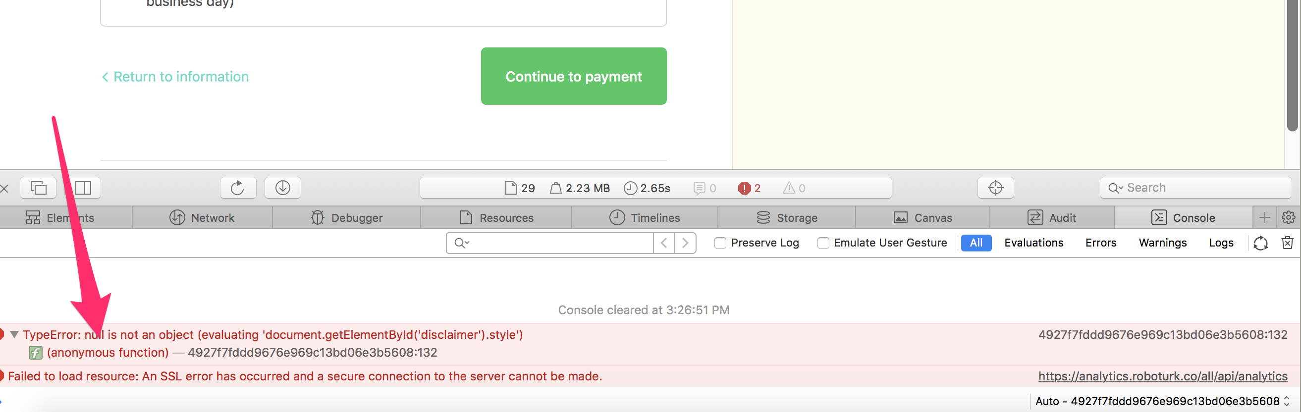

**2.2**

**When invalid address provided (does not prevent submission)**

**Steps to Reproduce:**

1. Add product to cart and proceed to shipping page
2. Change country from United States to Canada
3. Notice the Province defaults to Province
4. Click Continue to shipping
5. Notice the error thrown in the console (Failed to load resource: the server responded with a status of 429 ())

**2.3**

**Hanging double quote on payment with Canadian address entered**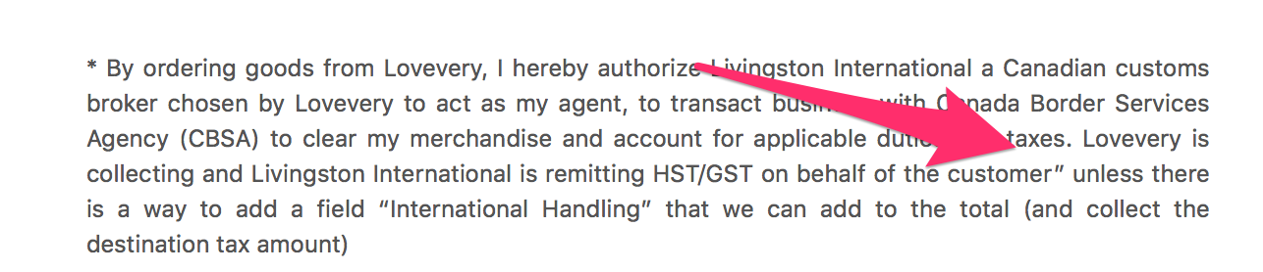

## 3. Input Fields

**3.1**

**Issue:**

Even though a limited number of years are provided, an error is displayed if user attempts to browser for a birthdate that is over 9 months in the future. The years 2018-2021 are provided, however, every date in 2021 provides user with an error message.

**Expected Result:**

Years would be added to a limited list only when they are valid values

**Actual Result:**

Years 2018-2021 are provided in the dropdown but 2021 is not actually yet a valid value.

**Browser:**

Safari 13.0.4 on iMac 10.13.6

Chrome 79.0 on iMac 10.13.6

**Steps To Reproduce:**

1. Navigate to <https://lovevery.com/products/the-play-kits/>
2. Scroll to the portion under Let’s Begin and enter a name and a birthdate that occurs in 2021
3. Notice the error message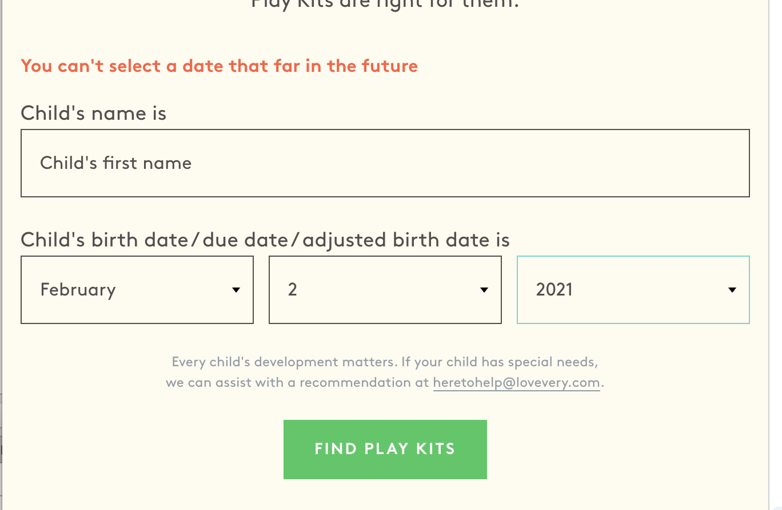

**3.2**

**Issue:**

Form should not submit when field is left blank and submit button is clicked for account recovery.

**Expected Result:**

Message should display to user to please enter an email address and form is not submitted.

**Actual Result:**

Form can be submitted without an input in the email field for account recovery

**Browser:**

Safari 13.0.4 on iMac 10.13.6

Chrome 79.0 on iMac 10.13.6

**Steps To Reproduce:**

1. Navigate to [https://lovevery.com/account/login#recover](https://lovevery.com/account/login%23recover)
2. Click the submit button while leaving the email field blank
3. Notice the message ‘No account found with that email.’

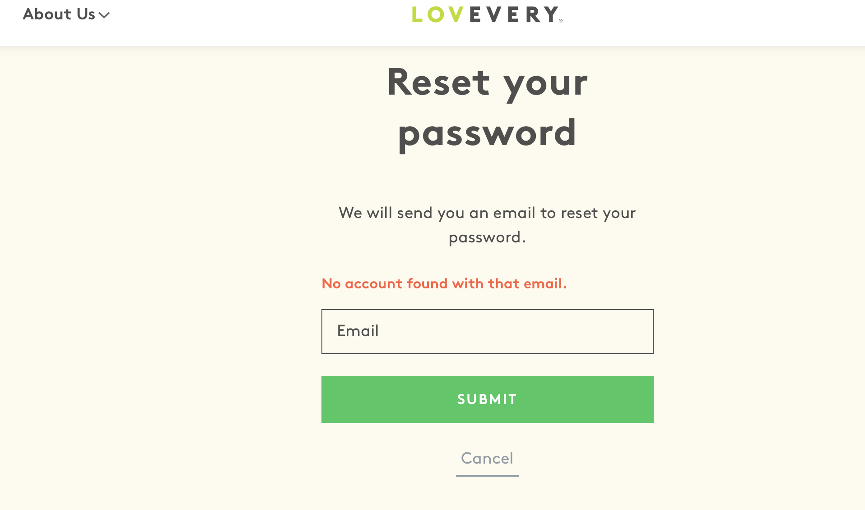

**3.3**

**Issue:**

First and last name fields should not allow characters like % and *. Fields should block invalid characters to protect from malicious activity.

**Expected Result:**

Special characters will not be allowed in first and last name fields.

**Actual Result:**

Special characters are allowed to be passed in for First and Last Name

**Steps to Reproduce:**

1. Add product to cart and proceed to shipping page
2. Enter first and last name with characters like ) ; % *
3. Notice there is no error message preventing these special characters
4. Click Continue to shipping
5. Notice user can proceed to the next step in checkout

