Fibonacci 10 Billion Calculator for reproducible computation and decimal output
Xudong Lu
Fengjing High School Affiliated to East China Normal University, Shanghai, China
Email: lusunrise@126.com

Abstract
We tested complete computation and decimal output of F(10¹⁰) on a 32 GB home computer using repeated WSL2/Linux trials and a native Windows MPIR run. Two different Windows GMP DLLs failed at the last F(8 billion) square. Independent sparse-square and C probes found the same adjacent outcomes in both DLLs: 2,147,352,576 operand bits succeeded and 2,147,352,577 failed with a wrapped 64-bit allocation request. Three WSL2 outputs and one MPIR output each contain 2,089,876,403 digits and match a new direct Linux GMP reference by SHA-256. The source expression behind the wrapped request remains unlocated; the observed boundary applies to the tested builds and sparse inputs.

Metadata
Table 1. Code metadata
Nr | Code metadata description | Metadata
C1 | Current code version | Python v4.3; tested native Windows MPIR release v1.1.0. Fixed Git source f0c5f2488432524d6edb781cbabe1bbca2a79b6d
C2 | Permanent link to code/repository used for this code version | https://github.com/sr-lxd/fibonacci-10-billion-calculator/tree/f0c5f2488432524d6edb781cbabe1bbca2a79b6d
C3 | Legal code license | Application: MIT (LICENSE in the pinned repository); MPIR dependency: LGPL, according to its source header
C4 | Code versioning system used | Git
C5 | Software code languages, tools and services used | Python; C; gmpy2; GMP; MPIR; MPFR; Tkinter; MSVC x64; Windows 11; WSL2 Ubuntu. Repeated measurements distinguish each runtime and endpoint.
C6 | Compilation requirements, operating environments and dependencies | Native Windows: Visual Studio 2019 x64 and static MPIR for source builds; packaged EXE uses the Windows backend without WSL2. Python 3 with gmpy2 and Tkinter. Ubuntu packages python3-gmpy2 and python3-tk. Tested host: 32 GB RAM. Reserve at least 3 GB for one decimal output; comparison reference needs additional storage. Record WSL memory and swap limits.
C7 | If available, link to developer documentation/manual | https://github.com/sr-lxd/fibonacci-10-billion-calculator/tree/f0c5f2488432524d6edb781cbabe1bbca2a79b6d (README and Chinese guide); supplementary 2026-10-15 experiment drivers and raw evidence supplied with manuscript.
C8 | Support email for questions | lusunrise@126.com

1 Motivation and significance
Large isolated integers are useful for examining arbitrary-precision arithmetic and representation conversion. Efficient recurrences reduce the number of index updates, but the output can still contain billions of digits. The software addresses the practical task of delivering a complete, checkable decimal file on a desktop, with enough diagnostics to investigate native-library failure.
Its mathematical ingredients are established. GMP documents the Fibonacci two-square recurrence [1], and multiple-precision arithmetic literature explains the dependence of arithmetic costs on operand size [2]. Radix conversion is an important part of that workflow [3]. The software contribution is their integration with explicit output construction, worker isolation, and inspectable execution records [4]. No new Fibonacci formula or universal performance advantage is claimed.
The public contribution is the complete, inspectable experiment rather than the recurrence alone: a 32 GB home computer produced and wrote all 2,089,876,403 digits, and newly generated outputs are compared in full with direct native GMP evaluation; older artifacts are audited separately as historical material. The project preserves the path from naive recursion, int64 overflow and matrix experiments through inter-process serialization costs, algorithm comparisons, Windows allocation failure, WSL2 completion, and native MPIR completion. Its Chinese narrative exposes why an attempt failed and how the next attempt changed. Together with source, diagnostic records, and full-output checks, that record is more useful for reproduction than an isolated runnable script.
The project began with naive recursion and matrix exponentiation, followed by fast doubling, Lucas and two-square algorithms. Despite repeated algorithmic improvements, attempts to compute and write the ten-billionth term failed for an extended period. The author's exploratory GitHub search did not locate a directly usable same-scale output record; its queries and date were not retained, so no priority claim follows. Layer diagnostics eventually placed the native Windows failure at a large-integer square. The error appeared to request about 4 GiB, but a full-width allocator trace later showed a request of 2⁶⁴ minus 369,632 bytes. An isolated square and a direct call to the same GMP DLL reproduced the failure without Fibonacci recurrence, decimal output or the gmpy2 binding. The target file was completed through WSL2/Linux GMP and native Windows MPIR. An earlier GMP development report documented an internal size overflow in large-integer multiplication [5]; its source-level cause is not assigned to the present binary.

2 Software description

2.1 Software architecture
The Python v4.3 program comprises a Windows Tkinter interface, an isolated computation worker, selectable arithmetic backends, a decimal writer, and a diagnostic parser. Small tasks can use native gmpy2.fib. Larger indices are handled by a Python-controlled two-square recurrence, with Linux execution available through WSL2. Both archived and newly repeated target-scale runs use that Python/WSL2 path. The native Windows C/MPIR route supplies a second completed backend; its timing is separate from the Python/WSL2 record.
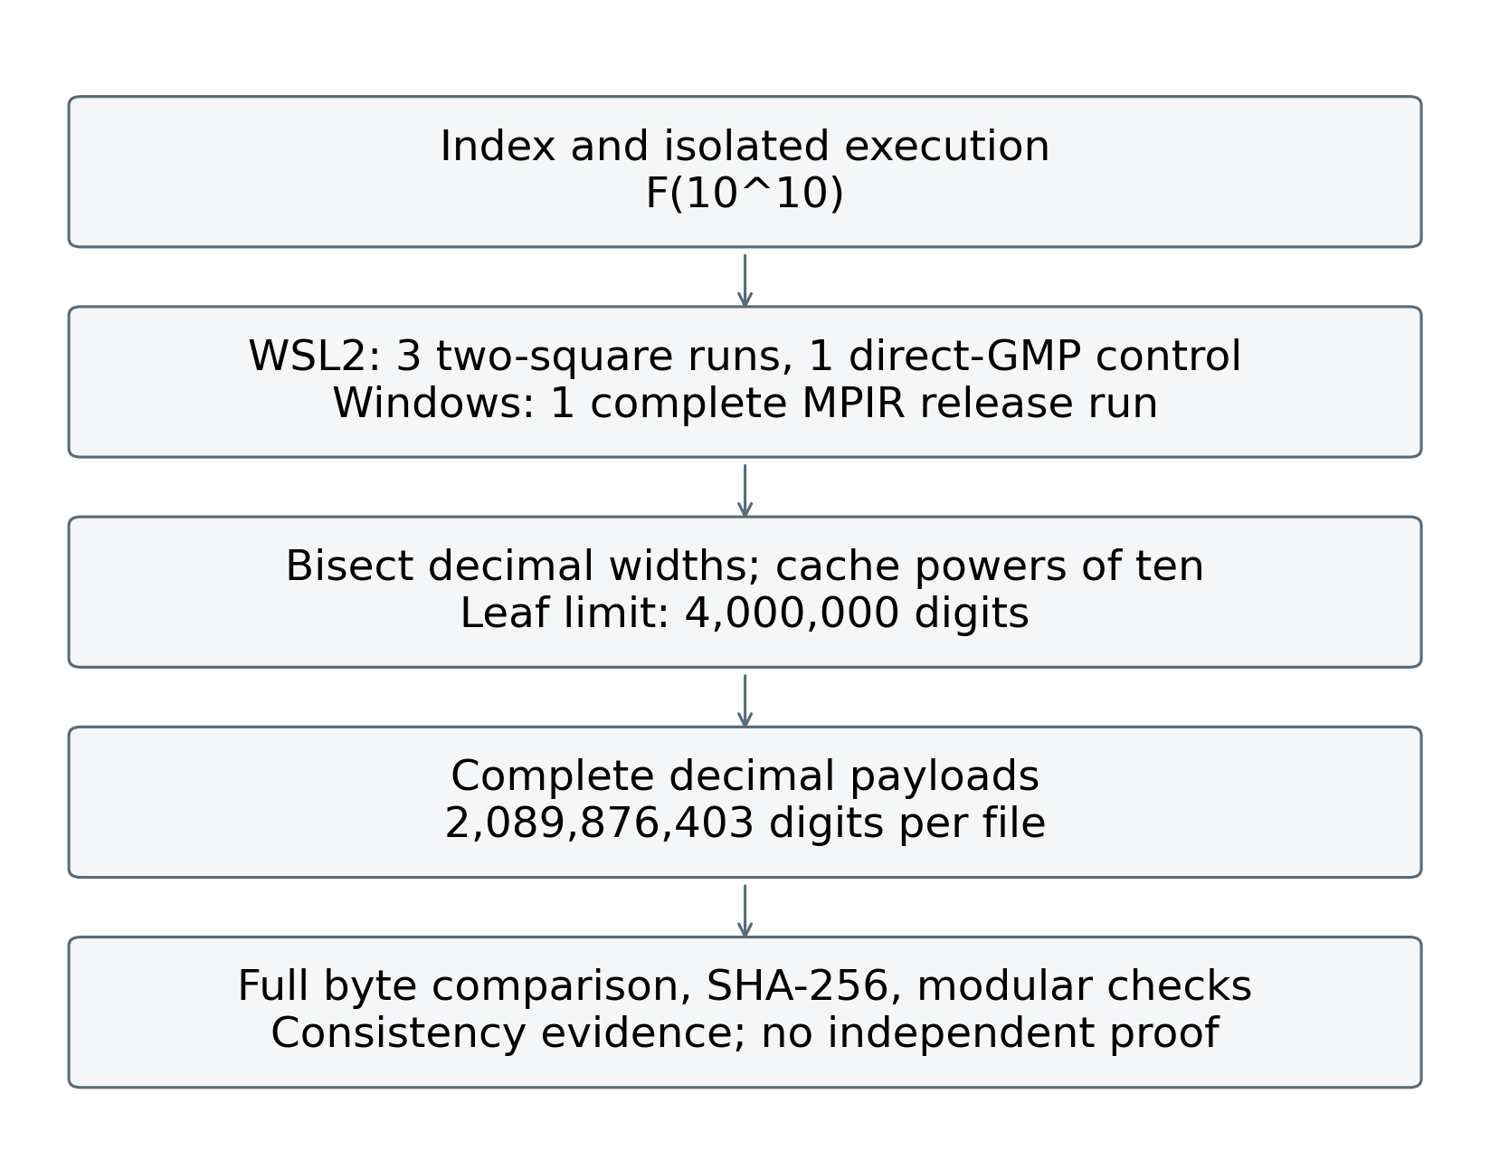
Figure 1. Measured execution and verification workflow. Trial counts distinguish two-square runs from the direct-library control; agreement checks are not an independent correctness proof.
The worker exchanges structured progress messages and records starts and completions of the large square operations. Logs include layer indices, operand lengths, interpreter and library versions, and resource fields when available. Each diagnostic record is flushed and fsynced. A native allocation failure can terminate the worker [6]; process isolation allows the interface and the final log record to survive [7]. It does not provide numerical checkpoint recovery.

2.2 Software functionalities
The main computation maintains two neighboring Fibonacci values and advances according to binary digits of the requested index. The target index has 34 bits and requires 33 loop iterations after initialization. Each iteration performs two squares and then forms the next state using additions, subtraction, and a parity-dependent correction. These identities follow the GMP algorithm [1].
The program uses a 256-bit MPFR evaluation to obtain a decimal-width candidate [8]. An explicit floor is applied; n=0 and n=1 have special handling. At n=10¹⁰, 256-bit and 1024-bit MPFR calculations have integer part 2,089,876,402, fractional part about 0.1503023355 and observed numerical difference about 1.11e-68; the new payload has 2,089,876,403 digits. This is not a formal interval certificate. gmpy2's documented one-digit overestimate for num_digits in some radices motivates avoiding that estimate as an unchecked padding width [9]. The fixed precision is not claimed to certify every possible index.
The decimal writer divides the integer into high and low blocks using a power of ten. It writes the high block first and pads the low block to its planned width. Leaves contain at most 4,000,000 decimal digits. Powers are cached within a task and released at completion. At the target size this yields 1,024 leaf conversions. A complete 2.09 GB string is avoided, although the large integer, recursive pending blocks, powers, and library temporaries remain in memory.
The automatic backend's threshold of 4,294,967,294 is an empirical policy for the examined Windows binding. GMP's native Fibonacci interface uses unsigned long [10]; Windows preserves a 32-bit long in its 64-bit data model [11]. The allocation error displays size=4294597664; this text alone does not establish the full-width allocation request. The separate allocator trace and its interpretation are reported below. The full-width trace and isolated direct-DLL probe establish a wrapped allocation request in the examined GMP build; they do not identify the exact source expression.

2.3 Native Windows MPIR backend
The native Windows MPIR v1.1.0 release provides an execution path without WSL2. It uses a uint64_t application index, a two-square C implementation and an MPIR arithmetic backend [12]. The release EXE was run once at n=10¹⁰ in this revision; its identity and results are reported below. This replaces the previous draft's build-only status for that version. The change is a library and deployment replacement, not a change to Windows LLP64 [11]. The pre-existing v1.0.0 archive remains separately identified. Current source, older source snapshot and tested release binary are not conflated.

3 Illustrative examples

3.1 A small expected-output check
For a worker run at n=100, the expected decimal payload is 354224848179261915075. The command below uses an ASCII filename alias supplied with the supplementary source snapshot; its bytes are identical to the repository's Python v4.3 source.
python3 fibonacci_calculator_v4_3.py --worker 100 full auto F_100.txt diagnostic_100.log v1
The output contains a two-line metadata header followed by the digits. Validation should compare the numeric payload rather than confusing task metadata with digits. A non-digit, wrong length, leading zero, or mismatching payload must be rejected by the supplementary verifier.

3.2 Complete output at n=10^10
Experiments were run on 15 October 2026 on an Intel Core i5-14400F host with 10 physical cores, 16 logical processors and 34,072,674,304 bytes of visible physical memory. Windows reported build 27766. The failing native path used Python 3.13.7 and gmpy2 2.3.1 with GMP 6.3.0; a downloaded PyPI wheel (SHA-256 74235fcce8a1bee207bf8d43955cb04563f71ba8231a3bbafc6dd7869503d05c) supplied gmpy2 2.2.1 for two further failure trials. Its bundled `libgmp-10.dll` has SHA-256 `fb2d312ca861c18e8b23648ac8440b0b613b1930ceff58f48b48ba2d3bd6b186`, distinct from the 2.3.1 DLL. Both report GMP 6.3.0; compiler and build flags are not established by wheel metadata. WSL2 Ubuntu used Python 3.12.3, gmpy2 2.1.5 and GMP 6.3.0, with a 5.15.167.4 WSL2 kernel. Its visible memory was 16,240,976 KiB and swap 4 GiB. These are distinct runtime builds, not an operating-system-only controlled comparison. Raw environment records accompany every Linux trial.
The archived Python v4.3 source has SHA-256 f40028d222e33178aff8fd27714c4642bb2510d8cd23e1916587f948b7ee108b. It matches the pinned Git source after LF/CRLF normalization. The arithmetic and decimal-writer functions were imported without changing their formulas. A separate driver supplied native GMP, conventional fast doubling, Lucas and two-square runs. Each algorithm was measured five times at n=10⁷, 10⁸, 5×10⁸ and 10⁹, in fresh processes with a cyclically rotated order. All benchmark processes ran sequentially; normal host background activity was not eliminated. Arithmetic timing disables the application diagnostics callback (diag=None); it excludes module import and process startup. Timed results therefore do not include the original worker's per-layer diagnostic logging. Main tables report medians; supplementary arithmetic_summary.csv supplies inclusive linearly interpolated quartiles and ranges; no significance test is inferred from five observations.
Three WSL2 two-square trials at n=8×10⁹ tested the former failure scale without decimal output. Three complete n=10¹⁰ WSL2 two-square runs were recorded, with one complete native Windows MPIR v1.1.0 release run following the first Linux trial. A final Linux native gmpy2.fib call generated a new reference at n=10¹⁰, bypassing the application's Windows-derived dispatch cutoff. The MPIR executable is identified by SHA-256 bda33f884b98676548124096be8e747a336330355e6c8a34acaf882cd9f50921; its bytes were tested directly. Current C source, an older C snapshot and the release executable are distinguished rather than assumed to be one rebuilt object.
Linux perf_counter intervals separate arithmetic from decimal conversion and file close. The instrumented driver writes an ASCII digit-only payload using the original writer. An explicit fsync interval is recorded afterwards and excluded from conversion time; verification is timed separately. Linux resource.getrusage and /usr/bin/time -v record kernel cumulative process peak RSS. The arithmetic checkpoint and full-run peak are cumulative high-water values, not disjoint per-stage peaks. Native MPIR is timed externally from process creation to termination; its stdout stage timings have one-second granularity and are not substituted for the precise Linux intervals. Windows memory is sampled every 50 ms and includes the operating system's peak-working-set and peak-pagefile counters up to the last successful query. A final short-lived peak after that query cannot be excluded. Working set, RSS and private commitment are reported under their own names.
Each Linux result is checked modulo 1,000,000,007, 1,000,000,009, 2,147,483,647 and 10¹⁰⁰ by a bounded-integer fast-doubling implementation. These checks test arithmetic consistency but do not prove every digit correct. The new native reference was streamed once more: decimal digit sums gave mod 9 = 6 and mod 11 = 0, matching bounded Fibonacci residues. Cassini's identity held modulo 1,000,000,007, 1,000,000,009 and 2,147,483,647; a period-based check gave last five digits 46875 and a separate 90-digit logarithm gave first five digits 14135. The other four new payloads share the reference's SHA-256. Each complete output is counted, checked for non-digits and hashed in bounded chunks. Primary byte comparisons use the new native GMP file and the four new repair-path outputs, removing documented headers and ASCII whitespace. Retained 2024 artifacts are compared separately for the historical audit. Full agreement is a stronger artifact check than endpoints alone; shared algorithms and libraries still limit implementation independence.
The two native gmpy2 2.3.1 trials and two isolated gmpy2 2.2.1 trials failed at layer 32/32, the first square of a 2,776,967,654-bit operand, before decimal conversion. The preserved stderr contains GNU MP: Cannot allocate memory (size=4294597664). The current 2.3.1 trials exited with code 3 rather than the historical report's 0xC0000409. No watchdog termination was involved. Median peak working set and private commitment were 1.82 and 2.46 GiB for gmpy2 2.3.1, and 1.81 and 2.46 GiB for 2.2.1, respectively; these are distinct Windows counters. In the two gmpy2 2.3.1 runs, more than 10 GiB of physical memory remained available at the last pre-failure diagnostic. Available physical memory alone does not identify the failure; the full-width allocation trace and isolated tests below resolve the nature of the requested size.
A separate allocator trace delegated to the original GMP allocation functions and recorded full-width size_t arguments before gmpy2 initialization. Its allocation values and log are supplied separately; traced timings are excluded from performance summaries. The largest recorded request was 18,446,744,073,709,181,984 bytes. This near-limit 64-bit size_t value has low 32 bits equal to 4,294,597,664, matching the displayed stderr size. The request equals 2⁶⁴ minus 369,632 bytes; interpreted as a signed 64-bit integer, the same bit pattern is -369,632.
On 16 October 2026, protected processes squared b-bit sparse operands with only the highest bit set. Binary search recorded adjacent outcomes: b=2,147,352,576 succeeded and b=2,147,352,577 failed. The first failed input equals 2³¹-2¹⁷+1 bits; its mathematical square has 4,294,705,153 bits or 67,104,769 64-bit limbs. GMP documents 32-bit `mpz_t` size fields in limb units [13]; 67,104,769 is far below 2,147,483,647 limbs, so that generic capacity does not explain the observed boundary. The same adjacent outcomes were reproduced by direct DLL calls and by a separately compiled Visual Studio 2019 x64 C program. Its core calls are `mpz_init_set_ui(x,1); mpz_init(y); mpz_mul_2exp(x,x,b-1); mpz_mul(y,x,x);`; the complete guarded reproducer is supplied. The installed 2.3.1 binary was `C:/Users/lusun/AppData/Roaming/Python/Python313/site-packages/gmpy2.libs/libgmp-10.dll` (SHA-256 `829adcf025d22e641c6816b431fbe5b226a39b390c7205192d480151646fe9c9`). The distinct 2.2.1 wheel DLL (SHA-256 `fb2d312ca861c18e8b23648ac8440b0b613b1930ceff58f48b48ba2d3bd6b186`) had the same adjacent outcomes and a full-width failed request of 2⁶⁴-523,232 bytes. The C runs confirmed both binaries, but did not measure the internal FFT rounded length or identify a source expression. The fault is therefore in the examined DLLs' large-operand square/multiplication paths or allocation-size propagation, rather than requiring the Fibonacci recurrence, decimal conversion or Python binding. The observed wraparound supports a size-arithmetic fault; its specific expression and internal multiplication branch remain unlocated. The isolated probes, full-width traces and both DLL hashes are supplied with the supplementary evidence. The adjacent pair is an observed sparse-input transition, not a proven universal minimum; FFT rounding length remains unmeasured.
Table 2. Adjacent observed outcomes for sparse-operand squaring in the tested DLL
Operand bits b | Result bits | 64-bit limbs | Observed result
2,147,352,576 | 4,294,705,151 | 67,104,768 | Succeeded
2,147,352,577 | 4,294,705,153 | 67,104,769 | Wrapped request
At the same Fibonacci index, WSL2 two-square completed all three trials, with median arithmetic time 48.18 s and median peak RSS 2.81 GiB. The native Windows MPIR release also completed the larger n=10¹⁰ full-output task once; the instrumented MPIR build completed three arithmetic trials at each of n=8×10⁹ and n=10¹⁰. These observations demonstrate two usable execution paths around the observed failure. They do not constitute a patch to the original GMP binary, nor establish that all Windows GMP builds fail or that all Linux builds succeed.
For n=10¹⁰, WSL2 two-square arithmetic had median 56.95 s and conversion with file close median 551.98 s; the median sum of those measured stages was 608.93 s. The median output-stage share was 90.65%. Individual trials, explicit fsync intervals and full ranges are retained in the supplementary CSV. The median cumulative full-run peak RSS was 5.10 GiB. The historical 53.6 s, 527.8 s and approximately 5 GiB estimate remain archival observations and are superseded by the new protocol for current performance claims.
One native Windows MPIR v1.1.0 full-output run completed with external process wall time 2592.93 s and observed peak working set 8.05 GiB. Its total includes the program's width correction, initialization, progress thread and file close; no durable-file-sync measurement was added to the release executable. Because this endpoint differs from the Linux stage sum, these endpoints are not presented as a controlled implementation speedup. In particular, Python/WSL2 timings are not attributed to MPIR.
Table 3. New complete Linux output trials
Run | Arithmetic / s | Output / s | Stage sum / s | Peak RSS / MiB
Native | 48.12 | 542.81 | 590.94 | 5219.6
2S-1 | 58.60 | 557.22 | 615.81 | 5219.7
2S-2 | 53.88 | 548.49 | 602.37 | 5219.4
2S-3 | 56.95 | 551.98 | 608.93 | 5221.6
Note: Native is one direct gmpy2.fib control in the same WSL2/Linux environment. It is excluded from the 2S-1/2/3 medians, quartiles and figure error bars. Columns are rounded independently to two decimal places; stage sums use unrounded intervals, so adding displayed components can differ by 0.01 s. Peak is cumulative RSS; fsync and verification are separate.
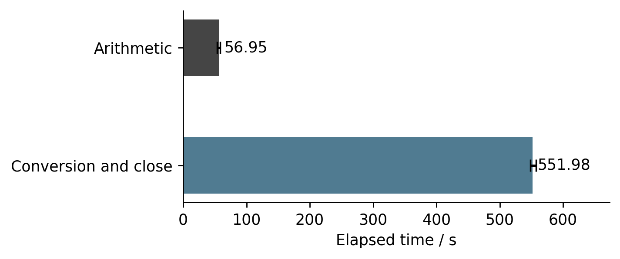
Figure 2. Three WSL2 two-square full-output trials at n=10¹⁰; bars are medians and error bars the observed range. The Native control is excluded. Conversion includes close; fsync is separate.
All five newly generated files contain 2,089,876,403 decimal digits. The digit-only payloads agree in SHA-256 and full byte comparison after the MPIR prefix is removed. Their common digest is shown below.
6fa62cdd9d65374354899719d9a58122
2c1d497492b9bcddcb859c32bc469662
The first five digits are 14135 and the last five 46875. The new reference is an author-generated result of the direct Linux GMP API, with its source, command, runtime versions, environment, original stdout and resource record supplied. It provides a reproducible generation chain without relying exclusively on the old external attribution. It is not a third-party certified standard or an independent-library result. Historical files are audited only for continuity with retained material and are not primary validation evidence. Their original machine, generation command and third-party provenance remain unauthenticated; details are supplied in historical_provenance.md.
The retained C and Python writers both use 4,000,000-digit leaves, but C calls MPIR mpz_tdiv_qr/mpz_get_str and fwrite whereas Python calls GMP f_divmod/digits and writes through a Python file object. The MPIR release also performs width correction and status reporting. Linux output was written under WSL2 /tmp and Windows output to C:. Conversion, padding, runtime I/O and storage waits were not measured separately, so the timing gap cannot be attributed to any one of them. Retained C source is not a binary-matched rebuild of the release.
The sampling protocol was amended after the first MPIR full-output run revealed a much longer conversion stage. The target release run was preserved, while repetition was concentrated on five complete n=10⁹ MPIR runs and three arithmetic-only trials at each of n=8×10⁹ and n=10¹⁰. The compute-only executable was rebuilt from the retained C snapshot with QueryPerformanceCounter around the unchanged Fibonacci function and an exit branch before decimal conversion. Its source, build command, library hash and executable hash are supplied separately from the release. Arithmetic medians were 107.97 s and 122.22 s at the two large indices. The single complete MPIR target run is not presented as a repeated full-output statistic. The first release run's sampler was replaced while preserving its numeric process; the protocol amendment and both memory traces are retained, and that run's wall clock uses the operating-system process creation timestamp to observed exit.
Table 4. MPIR measurements by endpoint and sample size
Index | Mode | Trials | Time / s | Peak WS / GiB
10⁹ | Full | 5 | 185.50 | 0.78
8×10⁹ | Compute | 3 | 107.97 | 5.18
10¹⁰ | Compute | 3 | 122.22 | 6.47
10¹⁰ | Full | 1 | 2592.93 | 8.05

4 Impact
The software makes the arithmetic-to-file path inspectable on the recorded 32 GB host. Source, commands, failure diagnostics, repeated timing and resource measurements allow users to check the reported boundaries and distinguish a failed arithmetic worker from an unfinished decimal conversion. The measured Windows failure and completed WSL2/MPIR outputs demonstrate an operational use for backend selection and process isolation.
There is no documented independent adoption study or downstream scientific publication using this software. Reuse value is demonstrated through the supplied interfaces, examples and reproduction artifacts, rather than invented user counts.
The study uses one host and recorded builds. Five small-scale repeats and three Linux full-scale repeats describe local variability, without establishing population-level performance or asymptotic superiority. Host background activity and file caches were not controlled through dedicated-machine isolation; the fixed rotated algorithm order was not randomized. Linux and Windows resource endpoints differ, and cumulative kernel peaks cannot locate every allocation's contribution. The separate allocator trace changes instrumentation and is excluded from untraced timing summaries.
The wrapped allocation size is established by the full-width callback and direct DLL probe; the responsible source expression has not been established by a binary-matched source build or native stack analysis. A successful replacement backend demonstrates an operational remedy, not correction of that expression. The new reference has a documented generation chain but shares GMP and established identities with one test path. Modular checks and cross-backend agreement reduce several error risks without providing formal verification. The 2024 file's original supercomputer execution and redistribution rights remain unverified, and a public archival DOI for the new data has not been assigned.

5 Conclusions
New experiments demonstrate a reproducible native Windows GMP failure and two completed large-integer output paths on the recorded home computer. Three WSL2 runs and one native MPIR release run each produced the complete ten-billionth Fibonacci number, with recorded runtime and memory evidence and full agreement with a newly generated native GMP reference. Decimal conversion accounts for a median 90.65% of the WSL2 stage total. In this experiment, backend selection, temporary-memory handling and output engineering determine whether an established arithmetic algorithm can deliver a complete artifact. Broader platform claims and the specific overflowing source expression require additional controlled evidence.
Full output agrees with direct library evaluation, and modular checks satisfy the tested arithmetic relations. This is consistency evidence: the Linux paths share GMP and established identities, and matching SHA-256 digests do not independently prove numerical correctness. No independent implementation or formal correctness proof is provided.

Availability and declarations
The software remains MIT-licensed at the pinned public Git revision [4]. Supplementary experiment drivers, raw measurements, environment files, source and binary hashes, failure diagnostics, the isolated square/direct-DLL probes of 16 October 2026, numeric verification manifests and the reference-generation command are supplied with this revision. The new full numeric outputs are retained locally and identified by file hashes; the package does not claim that a public archive or DOI already exists. Historical files retain their original provenance qualifications. Software citation follows version-specific identification [14].
Xudong Lu, Fengjing High School Affiliated to East China Normal University, Shanghai, China, is the author and corresponding author; email: lusunrise@126.com. AI tools assisted software development, experimental orchestration and evidence processing, manuscript organization, and English editing. The author is responsible for scientific judgment, evidence verification, and the final submission text, and takes responsibility for all content in the manuscript.

References
[1] The GNU MP developers. 2023a. Fibonacci Numbers Algorithm. GNU MP 6.3.0 manual. https://gmplib.org/manual/Fibonacci-Numbers-Algorithm
[2] Brent RP, Zimmermann P. 2010. Modern Computer Arithmetic. Cambridge University Press. https://doi.org/10.1017/CBO9780511921698
[3] The GNU MP developers. 2023e. Binary to Radix. GNU MP 6.3.0 manual. https://gmplib.org/manual/Binary-to-Radix
[4] Lu X. 2026. Fibonacci 10 Billion Calculator. Python v4.3, Git revision f0c5f2488432524d6edb781cbabe1bbca2a79b6d. MIT license. https://github.com/sr-lxd/fibonacci-10-billion-calculator/tree/f0c5f2488432524d6edb781cbabe1bbca2a79b6d
[5] Sofroniou M. 2013. mpn_mul_fft type overflow issue. GMP developers mailing list, 18 September 2013. https://gmplib.org/list-archives/gmp-devel/2013-September/003365.html
[6] The GNU MP developers. 2023c. Memory Management. GNU MP 6.3.0 manual. https://gmplib.org/manual/Memory-Management
[7] Python Software Foundation. n.d.-a. subprocess: Subprocess management. Python 3.13 documentation. Accessed 14 October 2026. https://docs.python.org/3.13/library/subprocess.html
[8] Fousse L, Hanrot G, Lefèvre V, Pélissier P, Zimmermann P. 2007. MPFR: A multiple-precision binary floating-point library with correct rounding. ACM Transactions on Mathematical Software 33(2):13. https://doi.org/10.1145/1236463.1236468
[9] The gmpy2 contributors. n.d. Multiple-precision integers. gmpy2 documentation. Accessed 14 October 2026. https://gmpy2.readthedocs.io/en/latest/mpz.html
[10] The GNU MP developers. 2023d. Number Theoretic Functions. GNU MP 6.3.0 manual. https://gmplib.org/manual/Number-Theoretic-Functions
[11] Microsoft. n.d.-a. Abstract data models. Windows application development documentation. Accessed 14 October 2026. https://learn.microsoft.com/en-us/windows/win32/winprog64/abstract-data-models
[12] The MPIR contributors. n.d. MPIR Windows source and Win64 definitions. Inspected revision 5e0c2061af105c151970d41c8394ce956f77e455. https://github.com/BrianGladman/mpir/blob/5e0c2061af105c151970d41c8394ce956f77e455/gmp-h.in
[13] The GNU MP developers. 2023f. Integer Internals. GNU MP 6.3.0 manual. https://gmplib.org/manual/Integer-Internals
[14] Smith AM, Katz DS, Niemeyer KE, FORCE11 Software Citation Working Group. 2016. Software citation principles. PeerJ Computer Science 2:e86. https://doi.org/10.7717/peerj-cs.86

