Teaching a 2B-parameter model to use memory, with reinforcement learning
clbench-verifiers · GRPO on the Continual Learning Bench `exploitable_poker` task · 2026-05-07
The question
When an AI plays a series of related rounds — say, several poker hands against the same opponent — a smart agent should remember what it learned earlier and use it later. Most language models can't: each round looks fresh. A common workaround is to give the model a notepad it can write to during one round and read from on the next.
Can we train a small open-source model — Qwen3.5-2B, 2 billion parameters — using reinforcement learning (GRPO), to actually use a notepad well? Specifically: can it learn on its own to jot down useful observations about its opponent in early hands and exploit them in later hands?
Test bed: heads-up Texas Hold'em against a deliberately exploitable opponent ("calling station," who calls every bet). Compare the same model trained two ways — with and without the notepad — on a held-out evaluation.
What we built
- End-to-end training pipeline on Prime Intellect's hosted GRPO trainer, with the CLBench exploitable_poker task wrapped as a verifiers `MultiTurnEnv` (env package `sr-networks/clbench-poker`, current v0.1.16, Apache-2.0).
- Cost-controlled rollouts: a 100-step training run lands at ≈$3.40 end-to-end. The uncapped baseline burned $3.26 on a single 2-step smoke before token caps.
- Schema-enforcement bug found and shipped: pre-fix, the `notepad_update` field was nominally required but the env's own injection clobbered the constraint, so vLLM let the model omit notes entirely. After v0.1.16, notepad writes per rollout climbed from 4.5 to 6.5; the memory channel works.
- Held-out eval harness `eval_remote.py` runs CLBench's official `run_benchmark` against any OpenAI-compatible endpoint (Prime deployments, vLLM serve). Stateful + stateless phases give the canonical `mean_gain` metric.
Training: notepad-on policy crosses positive after the schema fix
Final-hand reward, averaged over the last 10 of 100 training steps:
Run | Start (steps 0-9) | End (steps 90-99) | Δ
ON memory (v0.1.16, post-fix) | −1.17 chips/hand | +0.28 | +1.45
OFF memory (v0.1.14, control) | −0.91 | −0.53 | +0.38
ON memory (v0.1.14, broken schema) | −0.74 | −0.78 | flat
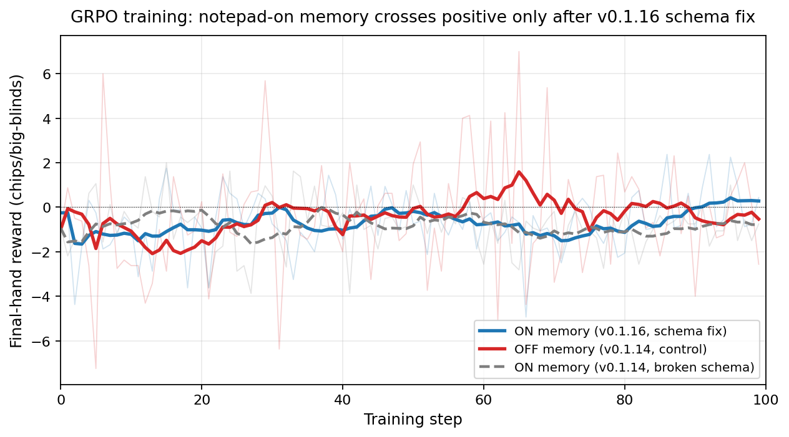
Training reward over 100 GRPO steps. The notepad-on policy crosses positive only after the v0.1.16 schema fix lands. Smoothed with a 10-step rolling mean.
Held-out eval: memory effect inside noise band at this scale
Trained notepad-on policy evaluated on 20 task seeds × 5 permutation orderings × 2 instances = 200 hand-evaluations against the same opponent. `mean_gain` = stateful (notepad active across instances) minus stateless baseline (system reset every instance):
Mean gain = +0.21 chips/hand (95% CI [−0.70, +1.11], SE = 0.45 across seeds)
Point estimate is positive but not statistically distinguishable from zero. Per-seed variance dominates — a single all-in pot can swing a 12-hand mean by ±5 chips. The earlier single-seed result of −0.45 was inside this same noise band; moving to 20 seeds flipped the sign and shrank the standard error by 2×.
What we can claim · what we cannot
- ✓ The training pipeline works end-to-end at sub-$5 cost per 100-step run.
- ✓ GRPO improves the policy — the notepad-trained model plays one-shot poker meaningfully better than the no-memory control (+1.10 chips/hand at the stateless baseline level).
- ✓ The schema-enforcement fix resurrected the memory channel: notepad writes/rollout rose 4.5 → 6.5; final reward at end of training crossed positive (+0.28).
- ⚠ Memory contribution at inference is suggestive (+0.21) but inside noise — we cannot yet claim memory helps with statistical confidence at this training scale.
- ✗ We cannot claim memory hurts — the worry from the v0.1.14 evaluation that notepad training was net-negative is retired; that finding was a single-seed artifact.
Next steps, ranked by expected value
- Longer training (300-500 steps at v0.1.16 settings). 100 steps was ~75 effective steps with a working memory channel; GRPO likely needs more iterations to learn what to write, not just to fill the field.
- Larger eval (60-80 seeds) would tighten the `mean_gain` CI to roughly ±0.3 — enough to firmly cross zero either side. ~$3, 1.5 hours.
- Harder opponents (`tight_aggressive`, scheduled mixes). The calling station is so exploitable a constant raise-everything strategy already does well, suppressing the value of memory.
Repository: github.com/sr-networks/clbench-verifiers · Env package: sr-networks/clbench-poker on Prime Intellect Hub · Author: sr-networks

