**ONLINE RECRUITMENT SYSTEM**

**ABSTRACT**

Campus Recruitment System (CRS) is web-based software to reduce communication gap between student and Admin. The Main objective of this solution is to make easy the recruitment process of any organization. This CRS is designed by keeping in mind both student and company. CRS allows student to register their details like skills and experience with the system, and then on the other hand even it allows company to post their requirements with the system through admin. Campus Recruitment Management system is helpful for the companies which are in need of employees, students who are in need of job. This portal main aim is to provide the vacancies available for the students. CRS will automatically send mails to all students whose skills are matched with the requirement. Similarly, this portal holds the list of cultural events and also the student could make use of this portal to apply for the event.

1. **INTRODUCTION**

Now days we all are using the internet to do multiple things like booking, academic search, blogging, apply for any job, etc. This system can be used as an application to manage student information to related placement. The system handles student as well as company data and efficiently displays all this data to respective sides. This System do all work regarding placement like collecting student records, Authenticate & activate the student profiles, notifying eligible students via automated E-mail message, Check the number and percentage of placed & unplaced students. Proper login with time & role based secured access is provided to Admin and students. Students logging should be able to upload their information in the form of a Resume. Admin can access, view information of the users and prepare schedule of all activities regarding placements. Company can give their own application procedure by providing link. Since the automated system is demanded now-a-days, educational infrastructures like colleges needed their manual system to function on computer system. One of such system which is of major importance is placement automation for campus recruitment. This project is aimed at developing a web application for the Placement and cultural events of the college. This system can be used as an application for the recruitment and cultural events of the college to manage the student information with regards to placement and events. Students logging should be able to upload their information in the form of a resume. So, all the information will store the details of the students including their background information, educational qualification, personal details, and all the information related to their resume. This system helps Company to access the student information with regards to placement. Computer based information system are designed to improve existing system.

1. **IMPLEMENTATION**

The goal of this website is to get automated in the online registration all the user, activation of the user and deactivation of the user, personalization to the user, resources to be provided online. The admin can see the user information and will validate it, generate the student list on the basis of company criteria; company details can be provided to the user, searching and sorting can be done, and reports to be generated. Similarly, they could use the same portal for the registering in the cultural events.

**EXISTING SYSTEM**

In the existing Placement and cultural event system, maximum work goes manually and it takes time for any changes in the system. This big problem is the searching; sorting and updating of the student data and no any notification method available for giving information to student except the notice board. Currently there is no such specific online system used by the college dedicated to the placement. Existing system does all process manually. This is tedious and time consuming, lack of security of data, took more man power.so by developing this application automation process is upgraded. If any modification or updates are required in the profile of any student, it has to be done manually. This is tedious and time consuming, lack of security of data, took more man power, consumes large volume of paper and space. In existing system all the work is done by manually, so there were maximum chances of errors. The interface between the student and administer is maximum. Due to the above problems every procedure becomes time consuming.

**PROPOSED SYSTEM:**

The aim of the proposed system is to develop a system with improved facilities. The proposed system can overcome all the limitation of the existing system, such as student’s information is maintained in the database, it gives more security to data. This application can save the time for the students. To prevent the applications from crashing issues the databases are stored online and not on the application thus making it light enough to run on the majority of Android devices. This system makes sure that all major activities are performed from the application by the user with the help of user-friendly interface and efficient functionalities. In order to avoid above existing placement and cultural event problem we are planning to design a system for online placement and event registration, so that placement and event activities becomes more interactive, automated and effective.

1. Reduce the paper work and create data base of student.

2. Save time & work load for TPC.

3. Easy to access

4. Avoid fake Entry.

5. Only eligible students get chance.

6. Improve accuracy in result.

7. User friendly interface.

1. **DESCRIPTION OFMODULES:**

There are two modules that are used,

* Student
* Admin

**Student Module:**

* Register
* Login
* dashboard
* Company Details

**Student Details**

**Register** – User has to register their basic details to get access with this application service. In this module user can add the personal details. Like name, email, Mob. User and the authorized person to access this module. Other user doesn’t get rights to access this module for security purpose.

**Login** – Once they have registered, they need to login to avail the service at the needy time. Here user has to login by using their unique user name and password. User and the authorized person to access user module for security  
purpose when the password is strictly confidential. So other  
unauthorized person can’t get rights to access this module.

**Dashboard:**

In this module student can view the company recruitment and cultural event details. Like name of the company, designation, Annual package etc., Similarly, Foe cultural events the name of the college, event list etc., will be provided. User and the authorized person to access this module. Other  
user doesn’t get rights to access this module for security purpose.

**Company Details:**

In this module student can view the Company details. Like Company name,  
Designation, Job location, Interview process, Annual salary etc. If the student wishes to apply for the job, they could directly register through their college portal. City or Street in order to donate their excess food to the specified location.

**Admin**

* Login.
* Dashboard.
* Add company.

**Login**:  
Here administrator has to login by using their unique user’s name and  
password. administrator and the authorized person to access user  
module for security purpose when the password is strictly  
confidential. So other unauthorized person can’t get rights to access  
this module  
**Dashboard**:

In this module, admin can view total number of companies/ total number of cultural events that are going to appear in the upcoming year. The administrator and the authorized person to access this module. Other user doesn’t get rights to access this module for security purpose.  
**Add company:**

In this module, admin can insert the company information regarding the recruitment process Through this only the student could able to apply for jobs using their college portal. That could be edited or deleted only by the authorized person. Other user doesn’t get rights to access this module for security purpose.

1. **SYSTEM SPECIFICATION**

**HARDWARE SPECIFICATION**

* System : Inteli3
* Hard Disk : 500 GB.
* Monitor : 15 VGA Colour.
* Mouse : Logitech.
* Ram : 4 GB.
* Keyboard : 101 Keyboard

**SOFTWARE SPECIFICATION**:

* Operating System : Windows 10
* Front End : PHP version 7
* Back End : MySQL version 7
* Server : XAMPP server

**SOFTWARE SPECIFICATION**

**SOFTWARE DESCRIPTION**

**XAMPP:**

XAMPP is a [free and open source](https://en.wikipedia.org/wiki/Free_software) [cross-platform](https://en.wikipedia.org/wiki/Cross-platform) [web server](https://en.wikipedia.org/wiki/Web_server) [solution stack](https://en.wikipedia.org/wiki/Solution_stack) package developed by Apache Friends, consisting mainly of the [Apache HTTP Server](https://en.wikipedia.org/wiki/Apache_HTTP_Server), [Maria DB](https://en.wikipedia.org/wiki/MariaDB) [database](https://en.wikipedia.org/wiki/Database), and [interpreters](https://en.wikipedia.org/wiki/Interpreter_%28computing%29) for scripts written in the [PHP](https://en.wikipedia.org/wiki/PHP) and [Perl](https://en.wikipedia.org/wiki/Perl) [programming languages](https://en.wikipedia.org/wiki/Programming_language).

XAMPP stands for Cross-Platform (X), Apache (A), Maria DB (M), PHP (P) and Perl (P). It is a simple, lightweight Apache distribution that makes it extremely easy for developers to create a local web server for testing and deployment purposes.

Everything needed to set up a web server – server application (Apache), database (Maria DB), and scripting language (PHP) – is included in an extractable file. XAMPP is also cross-platform, which means it works equally well on Linux, Mac and Windows.

XAMPP's designers intended it for use only as a development tool, to allow website designers and programmers to test their work on their own computers without any access to the Internet.

**CROSS PLATFORM**

Cross-platform software is a type of software application that which works on multiple operating systems or devices, which are often referred to as platforms. A platform means an operating system such as Windows, Mac OS, Android or iOS. When a software application works on more than one platform, the user can utilize the software on a wider choice of devices and computers.

**BENEFITS OF CROSS PLATFORM**

The benefit of a cross-platform software app or program is that you can use the same program whether you’re on a Windows PC or whether you’re logging in from your laptop or smartphone. The Microsoft Office suite of applications, which includes Word, Excel, and PowerPoint, are available on Windows, Mac OS, iOS (iPhone/iPad) and Android. While there are differences based on how the platforms work, you’ll have a similar experience within the application between all of your devices.

Having a similar experience across any platform means there’s a much smaller learning curve, if one even exists at all, so you’ll be more productive and be able to use a software product you’re familiar with regardless of the operating system or device you choose. In addition, your files can be moved much more easily between your devices so you can use the software with whatever device you have with you at the time. And there’s a way to keep all of your work in sync across all of your devices, by using the cloud.

**EXAMPLES OF CROSS PLATFORM**

# Unity3D

First, let’s talk about Unity3D. I think the game engine should be preferred by people who want to write mobile games.  
You can develop games on 17 platforms using multiple languages, including Linux. Of course, ios, android and windows phone is also the most ideal game engine to develop games.

You can develop your application using C #, JS, C ++.

Link to: [https://unity3d.com](https://unity3d.com/)

# Xamarin

Xamarin Some time ago, it was purchased by Microsoft and is a perfect fit for developers using C #.

Because it is a C # language, it has a lot of documentation, and because of Microsoft support, Xamarin is the choice for C # developers.

In addition, you can do everything you can do in Objective-C, Swift and Javada with the Xamarian library.

Link to: [https://xamarin.com](https://xamarin.com/)

# React Native

React Native is an open-source JavaScript library developed by the new generation of React — Facebook, which was open to Github in 2013. Native application creation means writing applications only for a specific operating system. React Native helps developers reuse their code over the web and on the mobile. Developers will not have to create the same app from scratch for iOS and Android. They will be able to reuse the code in each operating system. The great thing about React Native is that there is little difference between a finished application in Objective-C or Java and an application built using React Native. Android and iOS code development environments are very different. So it takes time to remove the application to two different platforms. However, with React Native, only one developer can write on different mobile operating systems.

**APACHE:**

The Apache HTTP Server, colloquially called Apache is a [free and open-source](https://en.wikipedia.org/wiki/Free_and_open-source) [cross-platform](https://en.wikipedia.org/wiki/Cross-platform) [web server](https://en.wikipedia.org/wiki/Web_server) software, released under the terms of [Apache License](https://en.wikipedia.org/wiki/Apache_License) 2.0. Apache is developed and maintained by an open community of developers under the auspices of the [Apache Software Foundation](https://en.wikipedia.org/wiki/Apache_Software_Foundation).

The vast majority of Apache HTTP Server instances run on a [Linux distribution](https://en.wikipedia.org/wiki/Linux_distribution), but current versions also run on [Microsoft Windows](https://en.wikipedia.org/wiki/Microsoft_Windows), [OpenVMS](https://en.wikipedia.org/wiki/OpenVMS),  and a wide variety of [Unix-like](https://en.wikipedia.org/wiki/Unix-like) systems. Past versions also ran on [NetWare](https://en.wikipedia.org/wiki/NetWare), [OS/2](https://en.wikipedia.org/wiki/OS/2) and other operating systems,  including ports to mainframes.

Originally based on the [NCSA HTTPd](https://en.wikipedia.org/wiki/NCSA_HTTPd) server, development of Apache began in early 1995 after work on the NCSA code stalled. Apache played a key role in the initial growth of the [World Wide Web](https://en.wikipedia.org/wiki/World_Wide_Web), quickly overtaking NCSA HTTPd as the dominant [HTTP](https://en.wikipedia.org/wiki/HTTP) server. In 2009, it became the first web server software to serve more than 100 million [websites](https://en.wikipedia.org/wiki/Website). As of January 2021, [Netcraft](https://en.wikipedia.org/wiki/Netcraft" \o "Netcraft) estimated that Apache served 24.63% of the million busiest websites, while [Nginx](https://en.wikipedia.org/wiki/Nginx) served 23.21% and Microsoft is in third place at 6.85% (for some of Netcraft's other stats Nginx is ahead of Apache), while according to W3Techs, Apache is ranked first at 35.0% and Nginx second at 33.0% and Cloudflare Server third at 17.3%.

**LANGUAGE SPECIFICATION**

**PHP**

**INTRODUCTION OF PHP**

PHP started out as a small open source project that evolved as more and more people found out how useful it was. Rasmus Lerdorf unleashed the first version of PHP way back in 1994.

* PHP is a recursive acronym for "PHP: Hypertext Preprocessor".
* PHP is a server side scripting language that is embedded in HTML. It is used to manage dynamic content, databases, session tracking, even build entire e-commerce sites.
* It is integrated with a number of popular databases, including MySQL, PostgreSQL, Oracle, Sybase, Informix, and Microsoft SQL Server.
* PHP is pleasingly zippy in its execution, especially when compiled as an Apache module on the Unix side. The MySQL server, once started, executes even very complex queries with huge result sets in record-setting time.
* PHP supports a large number of major protocols such as POP3, IMAP, and LDAP. PHP4 added support for Java and distributed object architectures (COM and CORBA), making n-tier development a possibility for the first time.
* PHP is forgiving: PHP language tries to be as forgiving as possible.
* PHP Syntax is same as C language.

**What is a PHP File?**

* PHP files can contain text, HTML, CSS, JavaScript, and PHP code.
* PHP code are executed on the server, and the result is returned to the browser as plain HTML.
* PHP files have extension ".php".

**What Can PHP Do?**

* PHP can generate dynamic page content and it can create, open, read, write, delete, and close files on the server and it can collect form data.
* PHP can send and receive cookie and it can add, delete, modify data in your database and it can be used to control user-access and encrypt data.

**Why PHP?**

* PHP runs on various platforms (Windows, Linux, Unix, Mac OS X, etc.).
* PHP is compatible with almost all servers used today (Apache, IIS, etc.).
* PHP supports a wide range of databases.
* PHP is free.
* PHP is easy to learn and runs efficiently on the server side.

## **What is Database?**

* A database is a separate application that stores a collection of data. Each database has one or more distinct APIs for creating, accessing, managing, searching and replicating the data it holds.
* Other kinds of data stores can be used, such as files on the file system or large hash tables in memory but data fetching and writing would not be so fast and easy with those types of systems.
* So nowadays, we use relational database management systems (RDBMS) to store and manage huge volume of data. This is called relational database because all the data is stored into different tables and relations are established using primary keys or other keys known as foreign keys.

**MySQL Database**

* MySQL is released under an open-source license. So you have nothing to pay to use it. MySQL is a very powerful program in its own right. It handles a large subset of the functionality of the most expensive and powerful database packages.
* MySQL uses a standard form of the well-known SQL data language. MySQL works on many operating systems and with many languages including PHP, PERL, C, C++, JAVA, etc. MySQL works very quickly and works well even with large data sets.
* MySQL is very friendly to PHP, the most appreciated language for web development. MySQL supports large databases, up to 50 million rows or more in a table.
* The default file size limit for a table is 4GB, but you can increase this (if your operating system can handle it) to a theoretical limit of 8 million terabytes (TB).MySQL is customizable.
* The open-source GPL license allows programmers to modify the MySQL software to fit their own specific environments

**TABLE CREATION**

* Name of the table
* Names of fields
* Definitions for each field
* Field Attribute **NOT NULL** is being used because we do not want this field to be NULL. So if user will try to create a record with NULL value, then MySQL will raise an error.
* Field Attribute **AUTO_INCREMENT** tells MySQL to go ahead and add the next available number to the id field.
* Keyword **PRIMARY KEY** is used to define a column as primary key. You can use multiple columns separated by comma to define a primary key.

## **ADMINISTRATIVE MYSQL COMMAND**

* **USE DATABASE NAME**: This will be used to select a particular database in MySQL work area.
* **SHOW DATABASES:** Lists the databases that are accessible by the MySQL DBMS.
* **SHOW TABLES:** Shows the tables in the database once a database has been selected with the use command.
* **SHOW COLUMNS FROM Table name:** Shows the attributes, types of attributes, key information, whether NULL is permitted, defaults, and other information for a table.
* **SHOW INDEX FROM Table name:** Presents the details of all indexes on the table, including the PRIMARY KEY

## **CREATING TABLES USING PHP SCRIPT:**

Create new table in any existing database you would need to use PHP function **mysqli_query()**.

## **Dropping Tables Using PHP Script:**

Drop an existing table in any database, you would need to use PHP function **mysqli_query()**.

## **INSERTING DATA USING PHP SCRIPT:**

**CREATE**

Create table statement is used to create a table in MySQL.

**SELECT**

The SELECT statement is used to select data from one or more tables.

**UPDATE**

The UPDATE statement is used to update existing records in a table:

## **DELETE**

The DELETE statement is used to delete records from a table:

**DATABASE DESIGN:**

The data in the system has to be stored and retrieved from database. Designing the database is part of system design. Data elements and data structures to be stored have been identified at analysis stage.

They are structured and put together to design the data storage and retrieval system. A database is a collection of interrelated data stored with minimum redundancy to serve many users quickly and efficiently.

The general objective is to make database access easy, quick, inexpensive and flexible for the user. Relationships are established between the data items and unnecessary data items are removed.

Normalization is done to get an internal consistency of data and to have minimum redundancy and maximum stability. This ensures minimizing data storage required, minimizing chances of data inconsistencies and optimizing for updates.

**INPUT DESIGN**

The Input design is the main feature of the system. Input design determines the format and validations criteria for data entering the system. Inputs originate with end-users; human factors play a significant role in input design. The input design is designed to control the input, to avoid delay, errors in data, to avoid extra steps, to keep the process simple. The design of input focuses on controlling the amount of input required, controlling the errors, avoiding delay, avoiding extra steps and keeping the process simple. The input is designed in such a way so that it provides security and ease of use with retaining the privacy.

The following are the general principles, which are considered in designing inputs are,

* + - Enter only variable data
    - Do not input data that can be calculated
    - List of values
    - Sequence entry

**OUTPUT DESIGN**

Designing the output is more important than working up with few layout charts and reports. The outputs are designed based on the issue encountered. It will also take care of who will receive the output, what for it is produced how much details are needed, when it is needed and by what method.

The outputs designed in this system are easy to use and useful for their jobs. The outputs are simple to read interpret. The outputs obtained from this system are designed by using a few guidelines, which are given below. The information should be clear and accurate, yet concise and restricted to relevant data. Reports should have titles, the data and descriptive heading for columns of data, numbered pages and so on.

**SYSTEM TESTING**

System testing is the process of exercising software with the intent of finding and ultimately correcting errors. This fundamental philosophy does not change for web applications, because Web-based systems and application reside on a network and interoperate with many different operating system, browsers, hardware platforms, and communication protocols; the search for errors represents a significant challenge for web application.

The distributed nature of client/server environments, the performance issues associated with transaction processing, the potential presence of a number of different hardware platforms, the complexities of network communication, the need to serve multiple clients from a centralized database and the requirements imposed on the server all combine to make testing of client\server architectures.

Testing issues

* Client GUI considerations
* Target environment and platform diversity considerations
* Distributed database considerations
* Distributed processing considerations

**TYPES OF TESTING**

1. Unit Testing

2. Integration Testing

3. Validation Testing

4. User acceptance Testing

5. System Testing

**Unit Testing**

All modules were tested and individually as soon as they were completed were checked for their correct functionality. Unit testing is carried out by verify and recover errors within the boundary of the smallest unit or a module. In this testing step, each module was found to be working satisfactory per the expected output of the module. In the package development, each module is tested separately after it has been completed and checked with valid data.

**Integration Testing**

The entire project was split into small programs; each of these single programs gives a frame as an output. These programs were tested individually; at last all these programs where combined together by creating another program where all these constructions were used. It gives a lot of problem by not functioning in an integrated manner.

The user interface testing is important since the user has to declare that the arrangements made in the frames are convenient and it is satisfied. When the frames are the test, the end user gave suggestion. Since they were much exposed to do the work manually.

**Validation Testing**

At the culmination of the black box testing software is completely assembled as a package. Interfacing errors have been uncovered and corrected and a final series of test i.e., validation succeeds when the software functions in a manner that can be reasonably accepted by the customer.

**User Acceptance Testing**

User acceptance testing of the system is the key factor the success of any system. The system under consideration is tested for user acceptance by constantly keeping in touch with prospective system at the time of development and making change whenever required. This is done with regard to the input screen design and output screen design.

**System Testing**

This is to verify that all the system elements have been properly integrated and perform allocated functions. Testing is executing a program to test the logic changes made in it and with intention of finding errors. Tests are also conducted to find discrepancies between system and its original objective, current specification and documents.

**SYTEM IMPLEMENTATION**

Implementation is the stage in the project where the theoretical design is turned into a working system. The most crucial stage is achieving a successful new system & giving the user confidence in that the new system will work efficiently & effectively in the implementation state.

The stage consists of

* + - Testing the developed program with simple data.
    - Detection’s and correction of error.
    - Creating whether the system meets user requirements.
    - Testing whether the system.
    - Making necessary changes as desired by the user.
    - Training user personnel.

**Implementation Procedures**

The implementation phase is less creative than system design. A system project may be dropped at any time prior to implementation, although it becomes more difficult when it goes to the design phase.

The final report to the implementation phase includes procedural flowcharts, record layouts, report layouts, and a workable plan for implementing the candidate system design into an operational one. Conversion is one aspect of implementation.

**System Maintenance**

Maintenance is actually the implementation of the review plan. As important as it is, many programmers and analysts are to perform or identify themselves with the maintenance effort. There are psychological, personality and professional reasons for this. Analysts and programmers spend far more time maintaining programs than they do writing them. Maintenance accounts for 50-80 percent of total system development.

Maintenance is expensive. One way to reduce the maintenance costs are through maintenance management and software modification audits.

* Maintenance is not as rewarding as exciting as developing systems. It is perceived as requiring neither skill not experience.
* Users are not fully cognizant of the maintenance problem or its high cost.
* Few tools and techniques are available for maintenance.
* A good test plan is lacking.
* Standards, procedures, and guidelines are poorly defined and enforced.
* Programs are often maintained without care for structure and documentation.
* There are minimal standards for maintenance.
* Programmers expect that they will not be in their current commitment by time their programs go into the maintenance cycle.

**SYSTEM DESIGN**

System design is "the process of studying a procedure or business in order to identify its goals, purposes and create systems and procedures that will achieve them in an efficient way". Another view sees system analysis as a problem-solving technique that breaks down a system into its component pieces for the purpose of the studying how well those component parts work and interact to accomplish their purpose.

The field of system analysis relates closely to requirements analysis or to operations research. It is also "an explicit formal inquiry carried out to help a decision maker identify a better course of action and make a better decision than they might otherwise have made."

* **DESIGN NOTATION**

Design notations are used when planning and should be able to communicate the purpose of a program without the need for formal code. Commonly used design notations are:

* DFD
* ERD
* **DFD (DATA FLOW DIAGRAM):**

A data flow diagram (DFD) is a graphical representation of the "flow" of data through an [information system](https://en.wikipedia.org/wiki/Information_system), modeling its process aspects. A DFD is often used as a preliminary step to create an overview of the system without going into great detail, which can later be elaborated. DFDs can also be used for the [visualization](https://en.wikipedia.org/wiki/Data_visualization) of [data processing](https://en.wikipedia.org/wiki/Data_processing) (structured design). A DFD shows what kind of information will be input to and output from the system, how the data will advance through the system, and where the data will be stored. It does not show information about the timing of process or information about whether processes will operate in sequence or in parallel unlike a [flowchart](https://en.wikipedia.org/wiki/Flowchart) which also shows this information.

Data flow diagrams were popularized in the late 1970s, arising from the book Structured Design, by computing pioneers Ed Yourdon and Larry Constantine. They based it on the “data flow graph” computation models by David Martin and Gerald Estrin. The structured design concept took off in the software engineering field, and the DFD method took off with it. It became more popular in business circles, as it was applied to business analysis, than in academic circles

.

**DFD SYMBOLS:**

Process that transforms data flow

Source or Destination of data

Data flow

Data store

* **ENTITY RELATIONSHIP DIAGRAM**

The relation upon the system is structure through a conceptual ER-Diagram, which not only specifies the existential entities but also the standard relations through which the system exists and the cardinalities that are necessary for the system state to continue. The Entity Relationship Diagram (ERD) depicts the relationship between the data objects. The ERD is the notation that is used to conduct the data modeling activity the attributes of each data object noted is the ERD can be described resign a data object descriptions.

The set of primary components that are identified by the ERD are

* + Data object
  + Relationships
  + Attributes
  + Various types of indicators

The primary purpose of the ERD is to represent data objects and their relationships.

**ER-DIAGRAM SYMBOL**

Entity

Relationship

Flow

* **INPUT DESIGN**

The input design is the link between the information system and the user. It comprises the developing specification and procedures for data preparation and those steps are necessary to put transaction data into a usable form for processing can be achieved by inspecting the computer to read data from a written or printed document or it can occur by having people keying the data directly into the system. The design of input focuses on controlling the amount of input required, controlling the errors, avoiding delay, avoiding extra steps and keeping the process simple. The input is designed in such a way so that it provides security and ease of use with retaining the privacy.

Input Design is the process of converting a user-oriented description of the input into a computer-based system. This design is important to avoid errors in the data input process and show the correct direction to the management for getting correct information from the computerized system. It is achieved by creating user-friendly screens for the data entry to handle large volume of data.

The goal of designing input is to make data entry easier and to be free from errors. The data entry screen is designed in such a way that all the data manipulates can be performed. It also provides record viewing facilities. When the data is entered it will check for its validity. Data can be entered with the help of screens.

* **DATABASE DESIGN**

Data base is designed to manage large bodies of information. The management of data involves both the definitions of structures for the storage of information. In addition the data base system must provide for the safety of the information solved, despite system crashes or due to attempts at unauthorized access. For developing an efficient database user have to fulfill certain conditions such as controlled redundancy.

* Defining the data
* Inputting the data
* Locating the data
* Accessing the data
* Communicating the data

Revising the data

**Objectives of Database design**

For designing data base design several objectives have to be met as follows:

* Ease of use
* Control of data integrity
* Control of redundancy
* Control of security
* Data independence (logical & physical)
* Data storage protection
* System performance
* **OUTPUT DESIGN**

A quality output is one, which meets the requirements of the end user and presents the information clearly. In any system results of processing are communicated to the users and to other system through outputs. In output design it is determined how the information is to be displaced for immediate need and also the hard copy output. It is the most important and direct source information to the user. Efficient and intelligent output design improves the system’s relationship to help user decision-making.

Output design generally refers to the results and information that are generated by the system for many end-users; output is the main reason for developing the system and the basis on which they evaluate the usefulness of the application.

In this Online Repository System project output is to view customer details, employee list, order tracking details and attendance percentage result.

**SYSTEM FLOW DIAGRAM**

**DATA FLOW DIAGRAM**

**LEVEL 0:**

Student

Admin

Search for company

Request

Get results

Response

**LEVEL 1:**

Student

Login/Register

Dashboard

Company details

**Level 2**

Admin

Login

Dashboard

(All Company)

Add company

(Edit/ Delete)

Manage data

**Use case diagram**

USER

ADMIN

Register/ Login

Login

Add and manage Company

Company details

Dashboard

Apply

User

Admin

**ER Digram**

**DATABASE DESIGN:**

**Table Name: admin**

|  |  |  |  |
| --- | --- | --- | --- |
| **FIELD NAME** | **DATA TYPE** | **LENGTH** | **DESCRIPTION** |
| id | Int | 11 | unique id |
| Admin_name | Varchar | 255 | Admin name |
| Admin_email | Varchar | 255 | Admin email id |
| Admin_password | Varchar | 255 | Admin password |

**Table Name: student**

|  |  |  |  |
| --- | --- | --- | --- |
| **FIELD NAME** | **DATA TYPE** | **LENGTH** | **DESCRIPTION** |
| id | Int | 11 | student unique id |
| F_name | Varchar | 255 | student name |
| F_mobile | Varchar | 255 | Student mobile number |
| F_email | Varchar | 255 | Student email id |
| F_address | Text |  | Student address |
| F_city | Varchar | 255 | Student city |
| F_password | Varchar | 255 | Student password |

**Table Name: company**

|  |  |  |  |
| --- | --- | --- | --- |
| **FIELD NAME** | **DATA TYPE** | **LENGTH** | **DESCRIPTION** |
| id | Int | 11 | company unique id |
| c_name | Varchar | 255 | Company name |
| c_mobile | Varchar | 255 | Company contact number |
| c_email | Varchar | 255 | Company mail id |
| c_address | Text |  | Company address |
| c_eligiblity | Text |  | Eligibility for job |
| c_list | Varchar | 255 | List of jobs |

**CONCLUSION:**

Many features are enhanced to this system. Most of the time is saved. It makes successfully log in to system; the authorized person can register them. In our system admin can check the student list those eligible according to criteria. The admin can see the user information and will validate it. It generates the student list on the basis of company criteria; company details can be provided to the user. In the same case admin can check the student details as per the cultural criteria in order to achieve the accurate sorting of the student data which saves the time. The big problem of sorting updating and searching student data and no any notification in existing system so we provide this facility to the student. The System gets automated in the registration of all the user, activation and also deactivation of the user.

**SCREENSHOT:**

**Admin Dashboard:**

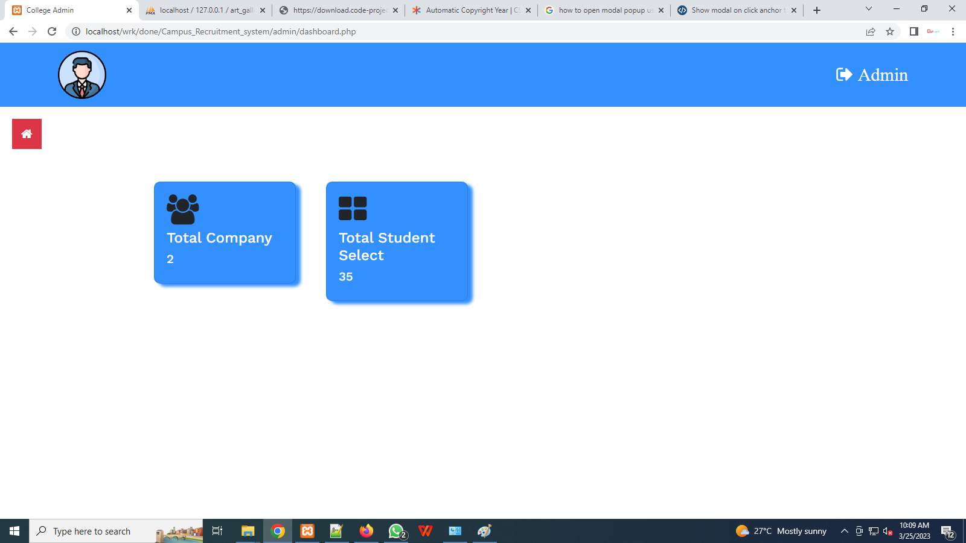

**Admin Add Company Page:**

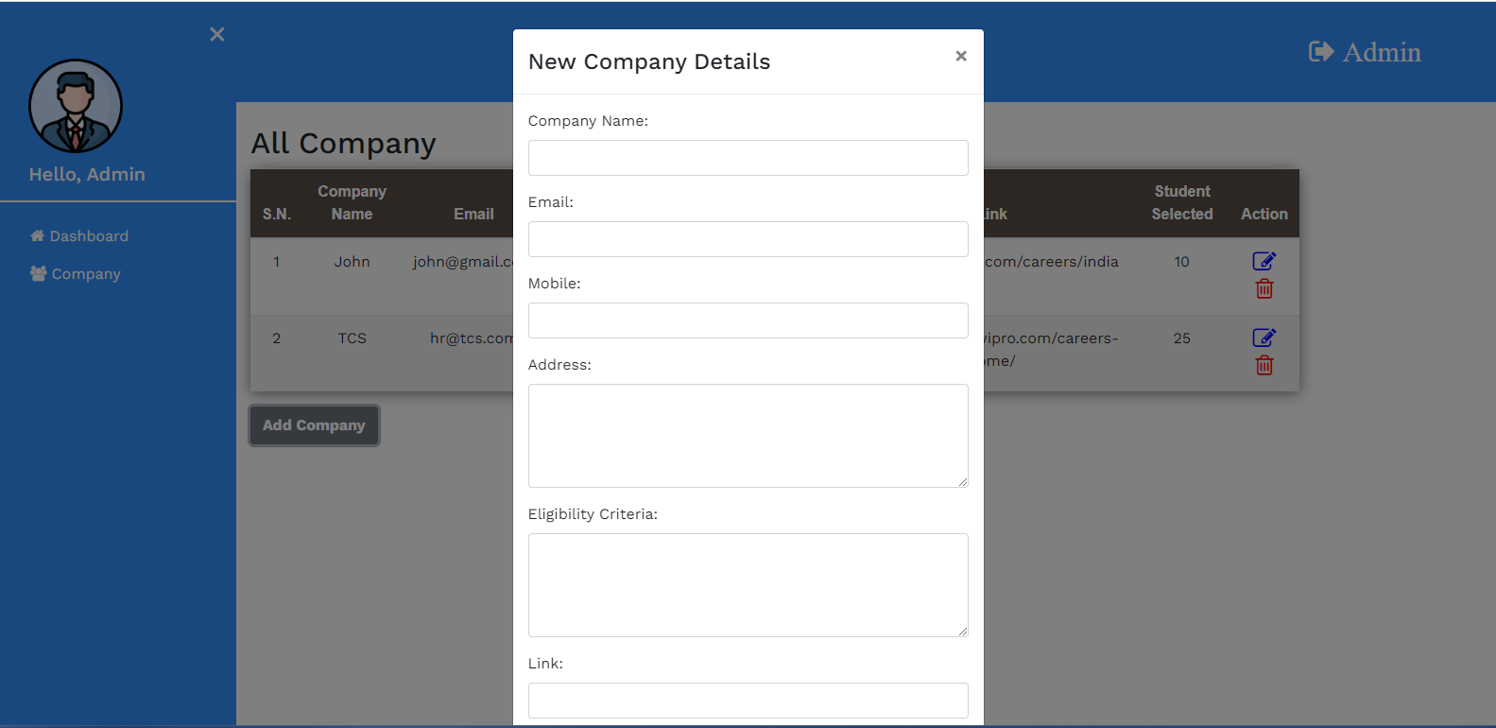

**Admin Manage company pages:**

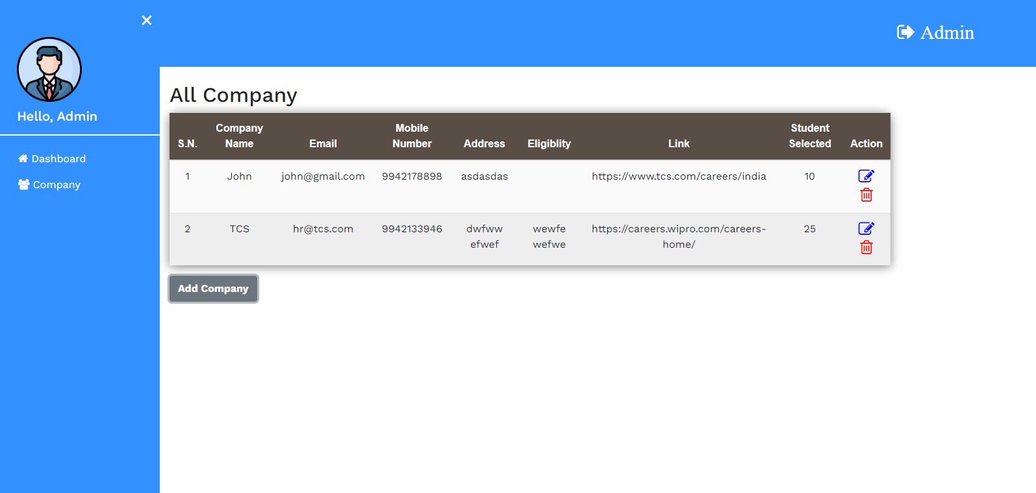

**Student Login page:**

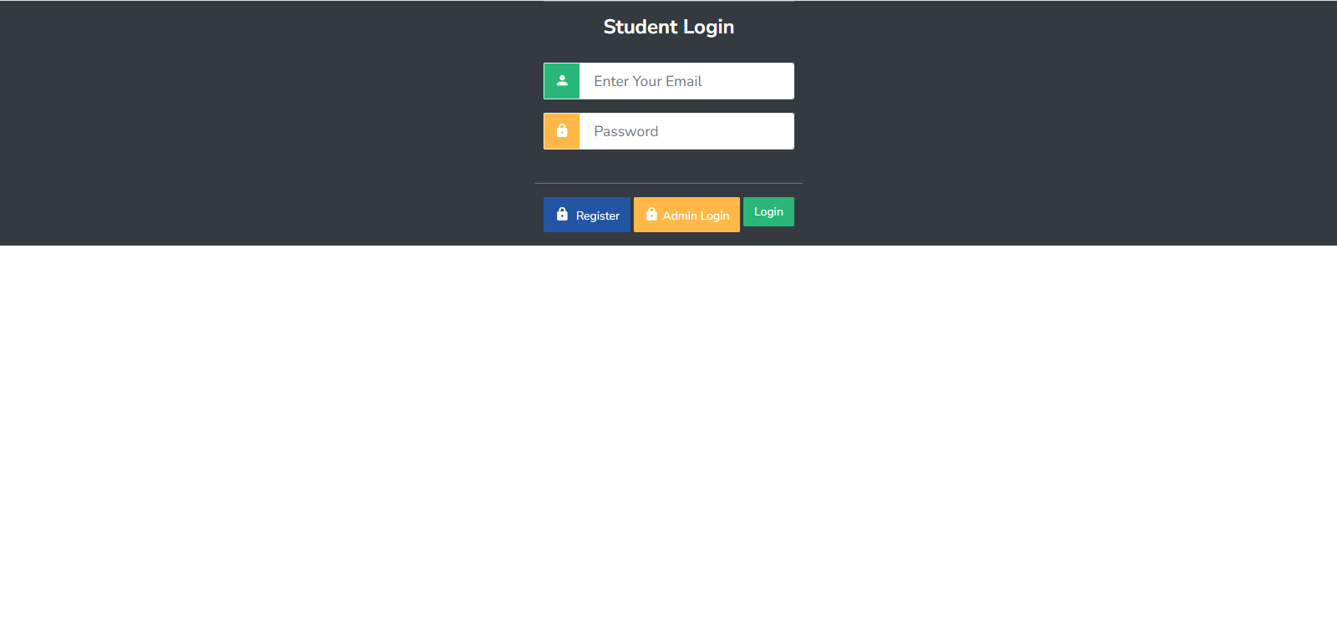

**Stdent Register:**

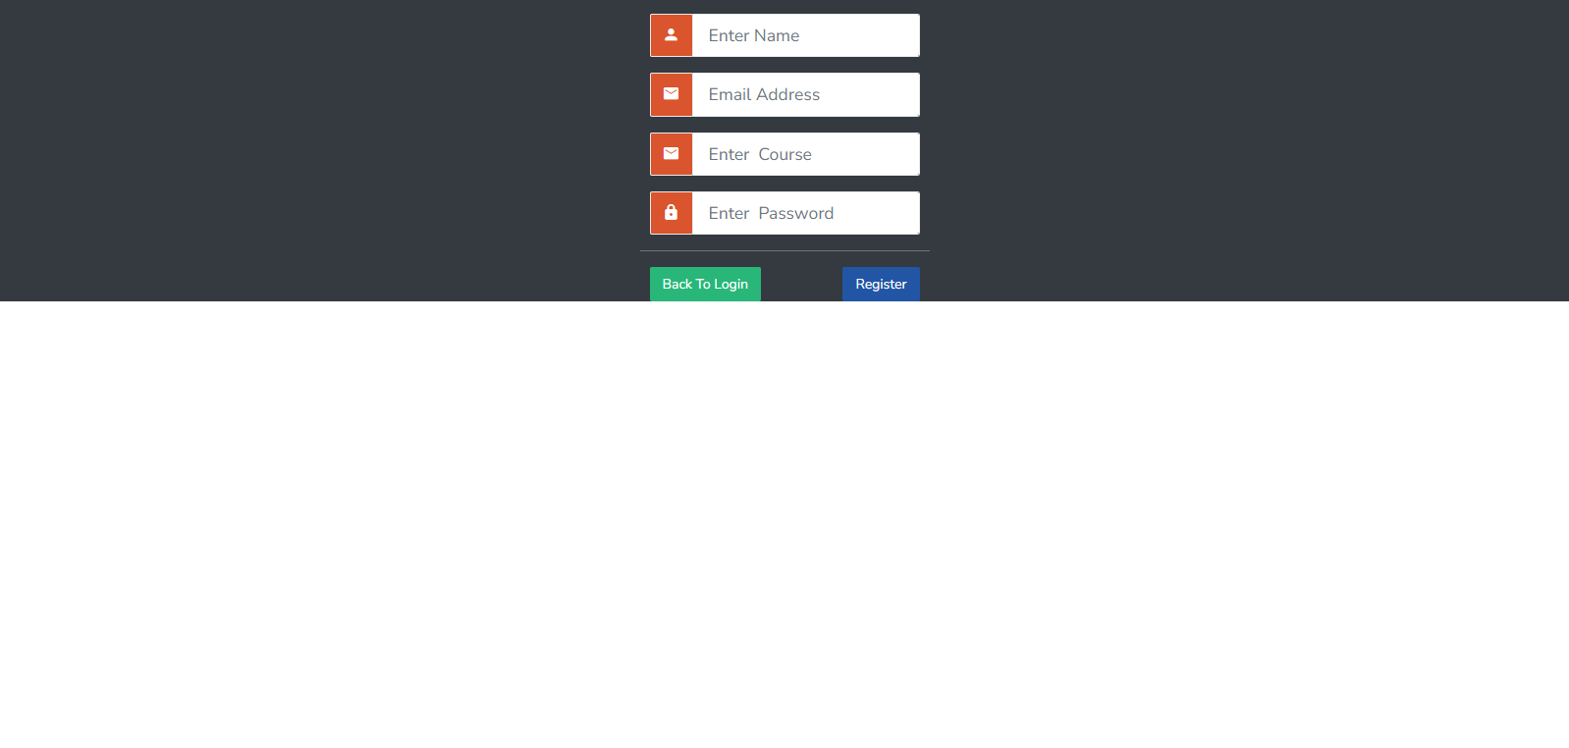

**Student Dashboard:**

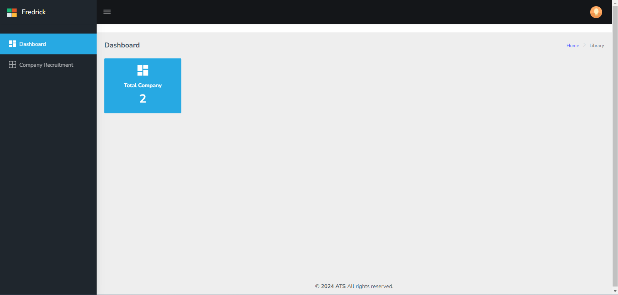

**Student company details Screen:**

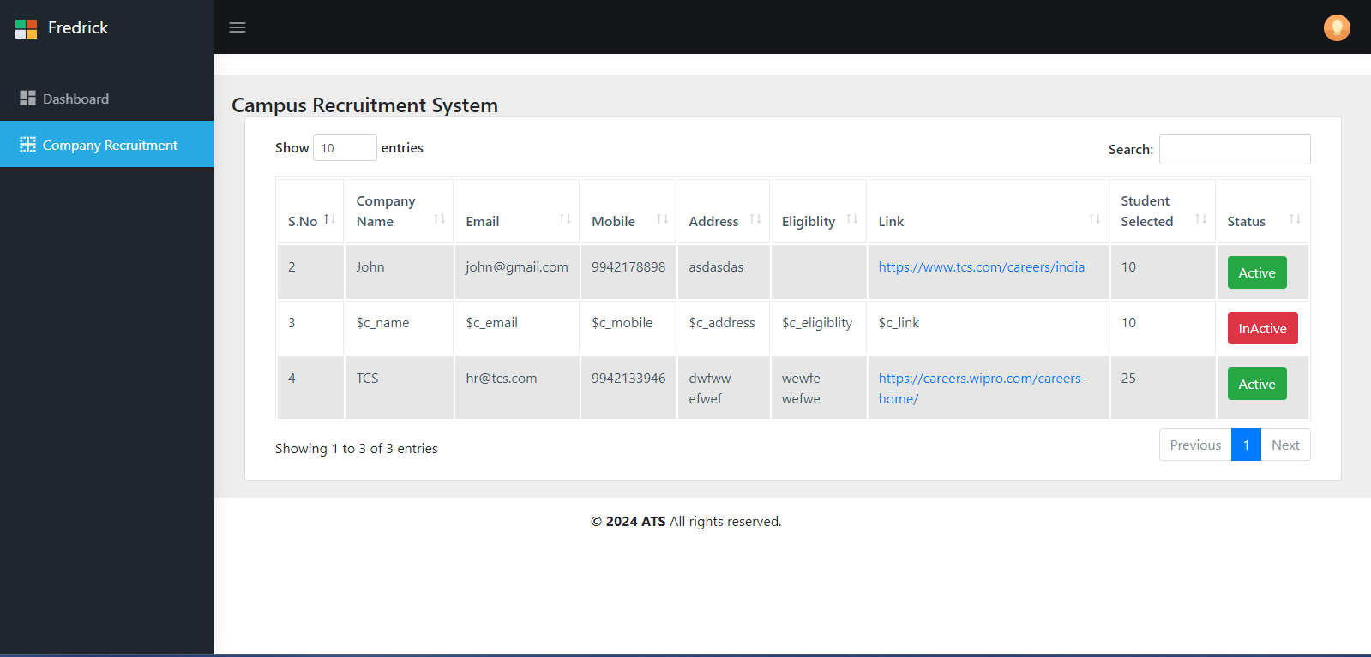

**BIBLIOGRAPHY**

**BOOKS:**

* Luke Welling, Laura Thomson, **“PHP and MYSQL Web Development”,** Fourth Edition, Publisher: Pearson Education Inc, Year: 2008.
* RasmusLerdof, Kevin Tatroe, **“PROGRAMMING PHP”** Second Edition, and Publisher: O’Reilly Media Inc, Year: 2006.
* W.Jason Gilmore, **“BEGINNING PHP and MYSQL: From Novice to Professional”** Third Edition, Publisher: Apress, year: 2008.
* Brad Bulger, Jay Greenspan, David Wall, **“MySQL and PHP Database Applications”,** Second Edition, publisher: Wiley, Year: 2003.
* Matt Zandstra, **“Sams Teach Yourself PHP in 24 Hours”,** Third Edition, Publisher: Sams Publishing, year: 2003.
* Michael Kofler, **“The Definitive Guide to MySQL 5”,** Third Edition, Publisher: Apress, Year: 2005.

**WEB SITE REFRENCE:**

* www.php.net
* www.mysql.com
* www.planet-php.net
* www.w3schools.com

**Sample Code**

<?php

require_once("header.php");

require_once("db.php");

if(isset($_SESSION["id"]))

{

$id=$_SESSION["id"];

echo "sesion_id".$id;

}

else{

echo "session not created";

}

?>

<link href="https://cdnjs.cloudflare.com/ajax/libs/twitter-bootstrap/4.0.0-beta.2/css/bootstrap.css" rel="stylesheet" />

<!-- Page wrapper -->

<!-- ============================================================== -->

<div class="page-wrapper">

<!-- ============================================================== -->

<!-- Bread crumb and right sidebar toggle -->

<!-- ============================================================== -->

<div class="page-breadcrumb">

<div class="row">

<div class="col-12 d-flex no-block align-items-center">

<h4 class="page-title">Campus Recruitment System</h4>

</div>

</div>

<!-- ============================================================== -->

<!-- End Bread crumb and right sidebar toggle -->

<!-- ============================================================== -->

<!-- ============================================================== -->

<!-- Container fluid -->

<!-- ============================================================== -->

<div class="container-fluid">

<!-- ============================================================== -->

<!-- Start Page Content -->

<!-- ============================================================== -->

<div class="row">

<div class="col-12">

<div class="card">

<div class="card-body">

<div class="table-responsive">

<table

id="zero_config"

class="table table-striped table-bordered"

>

<thead>

<tr>

<th>S.No</th>

<th>Company Name</th>

<th>Email</th>

<th>Mobile</th>

<th>Address</th>

<th>Eligiblity</th>

<th>Link</th>

<th>Student Selected</th>

<th>Status</th>

</tr>

</thead>

<tbody>

<?php

$sql="SELECT * from company ";

$result=$con-> query($sql);

$count=1;

if ($result-> num_rows > 0){

while ($row=$result-> fetch_assoc()) {

if($row['status']==1)

{

$status='<button type="button" class="btn btn-success">Active</button>';

}

else{

$status='<button type="button" class="btn btn-danger">InActive</button>';

}

?>

<tr>

<td><?php echo $row['id'];?></td>

<td><?php echo $row['c_name'];?></td>

<td><?php echo $row['c_email'];?></td>

<td><?php echo $row['c_mobile'];?></td>

<td><?php echo $row['c_address'];?></td>

<td><?php echo $row['c_eligiblity'];?></td>

<?php if($status=='<button type="button" class="btn btn-success">Active</button>'){

?>

<td><a href="<?php echo $row['c_link'];?>" target="_blank"><?php echo $row['c_link'];?></a></td>

<?php }else{?>

<td><?php echo $row['c_link'];?></td>

<?php } ?>

<td><?php echo $row['c_studentselect'];?></td>

<td><?php echo $status;?></td>

</tr>

<?php

}}

?>

</tbody>

</table>

</div>

</div>

</div>

</div>

</div>

<!-- ============================================================== -->

<!-- End PAge Content -->

<!-- ============================================================== -->

<!-- ============================================================== -->

<!-- Right sidebar -->

<!-- ============================================================== -->

<!-- .right-sidebar -->

<!-- ============================================================== -->

<!-- End Right sidebar -->

<!-- ============================================================== -->

</div>

<!-- ============================================================== -->

<!-- End Container fluid -->

<!-- ============================================================== -->

<!-- ============================================================== -->

</div>

<!-- ============================================================== -->

<!-- End Page wrapper -->

<!-- ============================================================== -->

</div>

<!-- ============================================================== -->

<!-- End Wrapper -->

<!-- ============================================================== -->

<!-- ============================================================== -->

<!-- All Jquery -->

<!-- ============================================================== -->

<!-- Modal -->

<script src="https://cdnjs.cloudflare.com/ajax/libs/jquery/3.2.1/jquery.min.js"></script>

<script src="https://unpkg.com/popper.js"></script>

<script src="https://cdnjs.cloudflare.com/ajax/libs/twitter-bootstrap/4.0.0-beta/js/bootstrap.min.js"></script>

<?php

require_once("footer.php");

?>

<script>

/****************************************

* Basic Table *

****************************************/

$("#zero_config").DataTable();

</script>

</body>

</html>